LAB 10: DATABASES – PART I\

1] Design a web site using Django, which is a website directory – A site containing
links to other websites. A web page has different categories.
• A category table has a name, number of visits, and number of likes.
• A page table refers to a category, has a title, URL, and many views.
Design a form that populates the above database and displays it.

Code:
DirectoryProject/settings.py:
INSTALLED_APPS = [
'directory',
'django.contrib.admin',
'django.contrib.auth',
'django.contrib.contenttypes',
'django.contrib.sessions',
'django.contrib.messages',
'django.contrib.staticfiles',
]
directory/models.py:
from django.db import models

# Category Table
class Category(models.Model):
name = models.CharField(max_length=100)
visits = models.IntegerField(default=0)
likes = models.IntegerField(default=0)

def __str__(self):
return self.name

# Page Table
class Page(models.Model):
category = models.ForeignKey(Category, on_delete=models.CASCADE)
title = models.CharField(max_length=100)
url = models.URLField()
views = models.IntegerField(default=0)

def __str__(self):
return self.title

directory/admin.py:
from django.contrib import admin
from .models import Category, Page

admin.site.register(Category)
admin.site.register(Page)

directory/forms.py:
from django import forms
from .models import Category, Page

class CategoryForm(forms.ModelForm):
class Meta:
model = Category
fields = ['name', 'visits', 'likes']

class PageForm(forms.ModelForm):
class Meta:
model = Page
fields = ['category', 'title', 'url', 'views']

directory/views.py:
from django.shortcuts import render, redirect
from .models import Category, Page
from .forms import CategoryForm, PageForm

# Add Category
def add_category(request):
form = CategoryForm()
if request.method == 'POST':
form = CategoryForm(request.POST)
if form.is_valid():
form.save()
return redirect('home')
return render(request, 'add_category.html', {'form': form})

# Add Page
def add_page(request):
form = PageForm()
if request.method == 'POST':
form = PageForm(request.POST)
if form.is_valid():
form.save()
return redirect('home')
return render(request, 'add_page.html', {'form': form})

# Display Data
def home(request):
categories = Category.objects.all()
pages = Page.objects.all()

return render(request, 'home.html', {
'categories': categories,
'pages': pages
})

directory/urls.py:
from django.urls import path
from . import views

urlpatterns = [
path('', views.home, name='home'),
path('add_category/', views.add_category, name='add_category'),
path('add_page/', views.add_page, name='add_page'),
]

DirectoryProject/urls.py:
from django.contrib import admin
from django.urls import path, include

urlpatterns = [
path('admin/', admin.site.urls),
path('', include('directory.urls')),
]

directory/templates/home.html:
<html>
<body>

<h2>Categories</h2>
<ul>
{% for c in categories %}
<li>{{ c.name }} (Visits: {{ c.visits }}, Likes: {{ c.likes }})</li>
{% endfor %}
</ul>

<h2>Pages</h2>
<ul>
{% for p in pages %}
<li>{{ p.title }} - {{ p.url }} (Views: {{ p.views }})</li>
{% endfor %}
</ul>

<br>

<a href="/add_category/">Add Category</a><br>
<a href="/add_page/">Add Page</a>

</body>
</html>

directory/templates/add_category.html:
<html>
<body>

<h2>Add Category</h2>

<form method="POST">
{% csrf_token %}
{{ form.as_p }}
<button type="submit">Save</button>
</form>

</body>
</html>

directory/templates/add_page.html:
<html>
<body>

<h2>Add Page</h2>

<form method="POST">
{% csrf_token %}
{{ form.as_p }}
<button type="submit">Save</button>
</form>

</body>
</html>

Terminal:
(djangoenv) VI_WPL_A2@csl-11:~/Documents/A2/L10$ django-admin startproject DirectoryProject
(djangoenv) VI_WPL_A2@csl-11:~/Documents/A2/L10$ cd DirectoryProject
(djangoenv) VI_WPL_A2@csl-11:~/Documents/A2/L10/DirectoryProject$ python manage.py startapp directory
(djangoenv) VI_WPL_A2@csl-11:~/Documents/A2/L10/DirectoryProject$ python manage.py makemigrations
Migrations for 'directory':
directory/migrations/0001_initial.py
+ Create model Category
+ Create model Page
(djangoenv) VI_WPL_A2@csl-11:~/Documents/A2/L10/DirectoryProject$ python manage.py migrate
Operations to perform:
Apply all migrations: admin, auth, contenttypes, directory, sessions
Running migrations:
Applying contenttypes.0001_initial... OK
Applying auth.0001_initial... OK
Applying admin.0001_initial... OK
Applying admin.0002_logentry_remove_auto_add... OK
Applying admin.0003_logentry_add_action_flag_choices... OK
Applying contenttypes.0002_remove_content_type_name... OK
Applying auth.0002_alter_permission_name_max_length... OK
Applying auth.0003_alter_user_email_max_length... OK
Applying auth.0004_alter_user_username_opts... OK
Applying auth.0005_alter_user_last_login_null... OK
Applying auth.0006_require_contenttypes_0002... OK
Applying auth.0007_alter_validators_add_error_messages... OK
Applying auth.0008_alter_user_username_max_length... OK
Applying auth.0009_alter_user_last_name_max_length... OK
Applying auth.0010_alter_group_name_max_length... OK
Applying auth.0011_update_proxy_permissions... OK
Applying auth.0012_alter_user_first_name_max_length... OK
Applying directory.0001_initial... OK
Applying sessions.0001_initial... OK
(djangoenv) VI_WPL_A2@csl-11:~/Documents/A2/L10/DirectoryProject$ python manage.py createsuperuser
Username (leave blank to use 'vi_wpl_a2'):
Email address: gautam@gamil.com
Password:
Password (again):
This password is too short. It must contain at least 8 characters.
This password is too common.
This password is entirely numeric.
Bypass password validation and create user anyway? [y/N]: y
Superuser created successfully.
(djangoenv) VI_WPL_A2@csl-11:~/Documents/A2/L10/DirectoryProject$ python manage.py runserver
Watching for file changes with StatReloader
Performing system checks...

System check identified no issues (0 silenced).
Error: That port is already in use.
(djangoenv) VI_WPL_A2@csl-11:~/Documents/A2/L10/DirectoryProject$ python manage.py runserver 8002
Watching for file changes with StatReloader
Performing system checks...

System check identified no issues (0 silenced).
March 23, 2026 - 09:56:35
Django version 5.2.12, using settings 'DirectoryProject.settings'
Starting development server at http://127.0.0.1:8002/
Quit the server with CONTROL-C.

WARNING: This is a development server. Do not use it in a production setting. Use a production WSGI or ASGI server instead.
For more information on production servers see: https://docs.djangoproject.com/en/5.2/howto/deployment/
[23/Mar/2026 09:56:38] "GET / HTTP/1.1" 200 178
[23/Mar/2026 09:56:57] "GET /add_category/ HTTP/1.1" 200 671

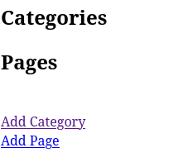
Output:
a)

b)
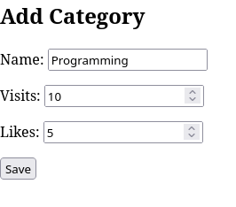

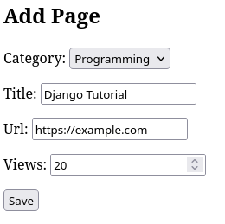
c)

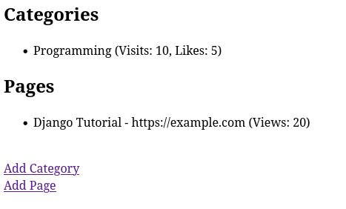
d)

2]Consider the following tables:
WORKS(person-name,Company-name,Salary)
LIVES(Person_name, Street, City)
Assume Table data suitably. Design a Django webpage and include an option to
insert data into WORKS table by accepting data from the user using TextBoxes.
Also, include an option to retrieve the names of people who work for a
particular company along with the cities they live in (particular company name
must be accepted from the user).

Code:
CompanyProject/settings.py:
INSTALLED_APPS = [
'companyapp',
'django.contrib.admin',
'django.contrib.auth',
'django.contrib.contenttypes',
'django.contrib.sessions',
'django.contrib.messages',
'django.contrib.staticfiles',
]

companyapp/models.py:
from django.db import models

# WORKS table
class Works(models.Model):
person_name = models.CharField(max_length=100)
company_name = models.CharField(max_length=100)
salary = models.IntegerField()

def __str__(self):
return self.person_name

# LIVES table
class Lives(models.Model):
person_name = models.CharField(max_length=100)
street = models.CharField(max_length=100)
city = models.CharField(max_length=100)

def __str__(self):
return self.person_name

companyapp/admin.py:
from django.contrib import admin
from .models import Works, Lives

admin.site.register(Works)
admin.site.register(Lives)

companyapp/forms.py:
from django import forms
from .models import Works

# Form for inserting WORKS data
class WorksForm(forms.ModelForm):
class Meta:
model = Works
fields = ['person_name', 'company_name', 'salary']

# Form for searching company
class SearchForm(forms.Form):
company_name = forms.CharField(max_length=100)

companyapp/views.py:
from django.shortcuts import render, redirect
from .models import Works, Lives
from .forms import WorksForm, SearchForm

# Insert into WORKS table
def add_work(request):

form = WorksForm()

if request.method == 'POST':
form = WorksForm(request.POST)
if form.is_valid():
form.save()
return redirect('home')

return render(request, 'add_work.html', {'form': form})

# Search employees by company
def search_company(request):

results = []

form = SearchForm()

if request.method == 'POST':
form = SearchForm(request.POST)

if form.is_valid():
company = form.cleaned_data['company_name']

works = Works.objects.filter(company_name=company)

for w in works:
try:
city = Lives.objects.get(person_name=w.person_name).city
except:
city = "Not Found"

results.append({
'name': w.person_name,
'city': city
})

return render(request, 'search.html', {
'form': form,
'results': results
})

# Home page
def home(request):
return render(request, 'home.html')

companyapp/urls.py:
from django.urls import path
from . import views

urlpatterns = [
path('', views.home, name='home'),
path('add/', views.add_work, name='add_work'),
path('search/', views.search_company, name='search_company'),
]

CompanyProject/urls.py:
from django.contrib import admin
from django.urls import path, include

urlpatterns = [
path('admin/', admin.site.urls),
path('', include('companyapp.urls')),
]

companyapp/templates/home.html:
<html>
<body>

<h2>Company Database</h2>

<a href="/add/">Add Employee Work</a><br><br>
<a href="/search/">Search by Company</a>

</body>
</html>

companyapp/templates/add_work.html:
<html>
<body>

<h2>Add WORKS Data</h2>

<form method="POST">
{% csrf_token %}
{{ form.as_p }}
<button type="submit">Save</button>
</form>

</body>
</html>

companyapp/templates/search.html:
<html>
<body>

<h2>Search Employees by Company</h2>

<form method="POST">
{% csrf_token %}
{{ form.as_p }}
<button type="submit">Search</button>
</form>

<br>

{% if results %}
<h3>Results:</h3>
<ul>
{% for r in results %}
<li>{{ r.name }} - {{ r.city }}</li>
{% endfor %}
</ul>
{% endif %}

</body>
</html>
Terminal:
(djangoenv) VI_WPL_A2@csl-11:~/Documents/A2/L10$ django-admin startproject CompanyProject
(djangoenv) VI_WPL_A2@csl-11:~/Documents/A2/L10$ cd CompanyProject
(djangoenv) VI_WPL_A2@csl-11:~/Documents/A2/L10/CompanyProject$ python manage.py startapp companyapp
(djangoenv) VI_WPL_A2@csl-11:~/Documents/A2/L10/CompanyProject$ python manage.py makemigrations
Migrations for 'companyapp':
companyapp/migrations/0001_initial.py
+ Create model Lives
+ Create model Works
(djangoenv) VI_WPL_A2@csl-11:~/Documents/A2/L10/CompanyProject$ python manage.py migrate
Operations to perform:
Apply all migrations: admin, auth, companyapp, contenttypes, sessions
Running migrations:
Applying contenttypes.0001_initial... OK
Applying auth.0001_initial... OK
Applying admin.0001_initial... OK
Applying admin.0002_logentry_remove_auto_add... OK
Applying admin.0003_logentry_add_action_flag_choices... OK
Applying contenttypes.0002_remove_content_type_name... OK
Applying auth.0002_alter_permission_name_max_length... OK
Applying auth.0003_alter_user_email_max_length... OK
Applying auth.0004_alter_user_username_opts... OK
Applying auth.0005_alter_user_last_login_null... OK
Applying auth.0006_require_contenttypes_0002... OK
Applying auth.0007_alter_validators_add_error_messages... OK
Applying auth.0008_alter_user_username_max_length... OK
Applying auth.0009_alter_user_last_name_max_length... OK
Applying auth.0010_alter_group_name_max_length... OK
Applying auth.0011_update_proxy_permissions... OK
Applying auth.0012_alter_user_first_name_max_length... OK
Applying companyapp.0001_initial... OK
Applying sessions.0001_initial... OK
(djangoenv) VI_WPL_A2@csl-11:~/Documents/A2/L10/CompanyProject$ companyapp/admin.py
bash: companyapp/admin.py: Permission denied
(djangoenv) VI_WPL_A2@csl-11:~/Documents/A2/L10/CompanyProject$ python manage.py createsuperuser
Username (leave blank to use 'vi_wpl_a2'):
Email address: gautam@gmail.com
Password:
Password (again):
This password is too short. It must contain at least 8 characters.
This password is too common.
This password is entirely numeric.
Bypass password validation and create user anyway? [y/N]: y
Superuser created successfully.
(djangoenv) VI_WPL_A2@csl-11:~/Documents/A2/L10/CompanyProject$ python manage.py runserver
Watching for file changes with StatReloader
Performing system checks...

System check identified no issues (0 silenced).
Error: That port is already in use.
(djangoenv) VI_WPL_A2@csl-11:~/Documents/A2/L10/CompanyProject$ python manage.py runserver 8002
Watching for file changes with StatReloader
Performing system checks...

System check identified no issues (0 silenced).
March 23, 2026 - 10:11:21
Django version 5.2.12, using settings 'CompanyProject.settings'
Starting development server at http://127.0.0.1:8002/
Quit the server with CONTROL-C.

WARNING: This is a development server. Do not use it in a production setting. Use a production WSGI or ASGI server instead.
For more information on production servers see: https://docs.djangoproject.com/en/5.2/howto/deployment/

Output:

a)
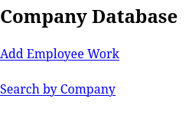

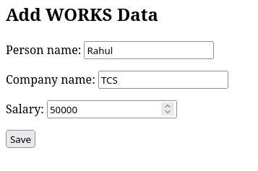
b)

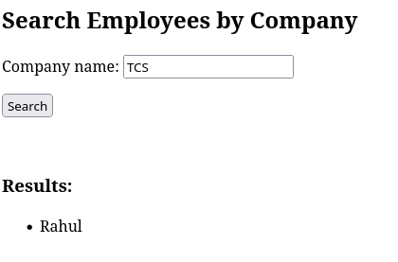
c)

