
INDIAN INSTITUTE OF TECHNOLOGY DELHI
Department of Electrical Engineering
ELL305: Computer Architecture

ELL305 Term Paper - Draft 1
Work Done as of 24 August 2026
Modern Processor Design Beyond Monolithic Scaling: Chiplet Architectures and 3D-Stacked Cache in AMD Zen Processors

Submitted by
Ishan Krishna Agrawal | 2024MT60860 | mt6240860@maths.iitd.ac.in
Vaidik Goyal | 2024EE11030 | ee1241030@ee.iitd.ac.in
Moon Saraswat | 2024EE11163 | ee1241163@ee.iitd.ac.in
24 August 2026
Abstract
This independent milestone report records the work completed on the ELL305 term-paper project as of 24 August 2026. The group has selected a question-driven study of chiplet-based processor organization and 3D-stacked cache, with AMD Zen processors as the principal case study. The topic has been mapped to Chapters 9-12 of the course textbook, and an initial set of six technical sources has been identified and examined at a preliminary level. The report also records the present work-package status and a provisional semester schedule.
Keywords: processor architecture, chiplets, memory hierarchy, 3D-stacked cache, AMD Zen, ELL305.

Contents
1 Work Done as of 24 August 2026 | 3
1.1 Chosen Topic and Present Scope | 3
1.2 Mapping to the ELL305 Textbook | 3
1.2.1 Chapter 9 - Processor Design | 3
1.2.2 Chapter 10 - Principles of Pipelining | 3
1.2.3 Chapter 11 - The Memory System | 4
1.2.4 Chapter 12 - Multiprocessor Systems | 4
1.3 Preliminary Technical Survey | 5
1.4 Preliminary Research Directions | 6
1.5 Work Packages and Progress | 6
2 Provisional Semester Schedule | 8
3 References Identified and Examined So Far | 9
4 Immediate Next Steps | 9

1 Work Done as of 24 August 2026

1.1 Chosen Topic and Present Scope
The term paper studies how modern processor design is moving beyond the traditional assumption that most major processor resources must be integrated on a single large monolithic die. The principal case study will be AMD's Zen family of processors, with particular emphasis on two developments: chiplet-based processor organization and three-dimensional stacked last-level cache through AMD 3D V-Cache technology.
The present working research question is:
How do chiplet-based organization and 3D-stacked cache help modern processors address limitations in performance, scalability, memory latency, power, and die-level integration, and what new trade-offs do these techniques introduce?
The intention is not to write a product-history comparison of AMD and Intel. Instead, AMD Zen will be used as a modern case study through which processor-organization and memory-system concepts from ELL305 can be investigated in greater depth. A limited comparison with contemporary Intel approaches may later be included where it helps clarify alternative architectural choices.

1.2 Mapping to the ELL305 Textbook
The primary textbook is Smruti R. Sarangi's Basic Computer Architecture, Version 3.09 [1].
An initial mapping of the proposed work to the course text has been completed. The connections are to Chapters 9-12.
Figure 1 summarizes how these textbook foundations lead to the two modern scaling questions examined through the AMD Zen case study.
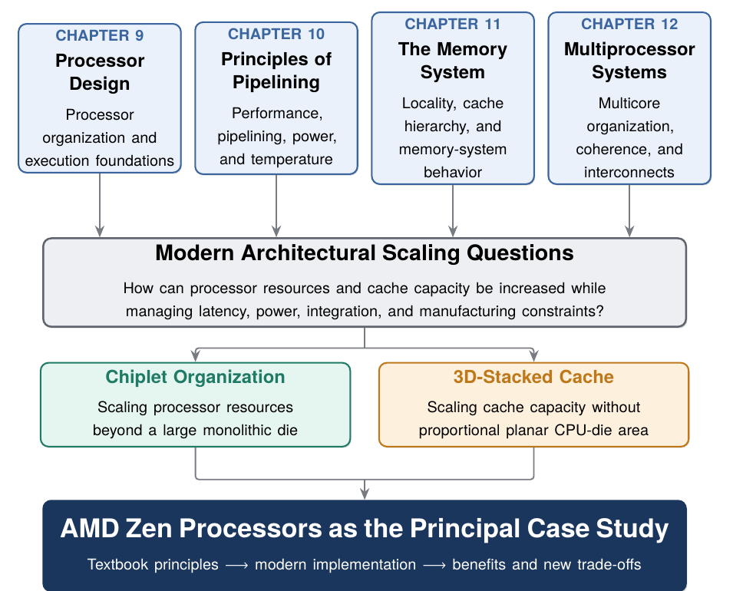
Figure 1: ELL305 textbook foundations, the two scaling problems, and the AMD Zen case study.

1.2.1 Chapter 9 - Processor Design
The chapter provides the basic model of processor organization, including the fetch, execution and memory-access units, data path, and control path. This will serve as the baseline processor model before modern partitioned and chiplet-based implementations are considered.

1.2.2 Chapter 10 - Principles of Pipelining
The relevant topics include pipelining, performance metrics, advanced processor techniques, and power/temperature considerations. These concepts provide a framework for studying processor performance and for understanding why increasing clock frequency alone cannot indefinitely provide performance scaling.

1.2.3 Chapter 11 - The Memory System
This chapter provides a direct mapping to the cache component of the proposed paper. It introduces temporal and spatial locality, cache hierarchy, cache design, cache misses, hit time, miss penalty, and memory-system optimization. These concepts provide the theoretical basis for studying the motivation and performance implications of increased last-level-cache capacity and 3D V-Cache.

1.2.4 Chapter 12 - Multiprocessor Systems
The chapter introduces private and shared caches, cache coherence, banked caches, multicore organization, and interconnection networks. These ideas are useful when extending the discussion from a conventional multicore processor toward systems containing multiple compute dies connected through an interconnect fabric.
As advised, the group has chosen Prof. Sumantra Dutta Roy for consultation because the proposed work maps primarily to material contained within Chapters 9-12. No formal consultation has taken place yet. This consultation will be used for advice on the paper.
The initial chapter-reading plan is shown in Table 1. The percentages represent orientation progress as of the milestone date, not completed close readings.
Table 1: Initial textbook reading plan and progress as of 24 August 2026.
Chapter | Target date | Progress
Chapter 9 - Processor Design | 28 Aug 2026 | 15%
Chapter 10 - Principles of Pipelining | 3 Sep 2026 | 10%
Chapter 11 - The Memory System | 27 Sep 2026 | 10%
Chapter 12 - Multiprocessor Systems | 6 Oct 2026 | 5%

1.3 Preliminary Technical Survey
A preliminary literature and technical survey has been initiated to determine whether the topic has sufficient technical depth and reliable primary material for the final term paper.
One important source identified is Samuel Naffziger, Kevin Lepak, Milam Paraschou, and Mahesh Subramony's paper, "AMD Chiplet Architecture for High-Performance Server and Desktop Products," presented at ISSCC 2020 [2]. This source is particularly relevant because it discusses the architectural and engineering motivation behind AMD's chiplet approach, including the increasing difficulty and cost associated with large leading-edge dies and the limited benefit of advanced process scaling for many I/O structures.
A second source identified is the AMD Zen 2 presentation by Suggs et al. at Hot Chips 31 [3]. Zen 2 is important to the proposed study because the compute-die/I/O-die organization became central to both mainstream Ryzen and second-generation EPYC processors. The material provides an initial basis for studying the Core Complex Die (CCD), I/O Die (IOD), and AMD Infinity Fabric.
For the cache component, an official ISSCC 2022 record identified is John Wuu et al.'s "3D V-Cache: The Implementation of a Hybrid-Bonded 64MB Stacked Cache for a 7nm x86-64 CPU" [4]. Its IEEE PDF is a presentation-only abstract record rather than a full technical paper, so it is used here only to establish the stated motivation and scope of the work.
A fuller primary source for the same development is Raja Swaminathan's AMD presentation at Hot Chips 33 [5]. It places 3D V-Cache within AMD's broader advanced-packaging roadmap and documents the first-generation stack using a 64MB L3 cache die, direct copper-to-copper hybrid bonding, and through-silicon vias over a Zen 3 Core Complex Die. Its quantitative power, density, and prototype-performance comparisons are AMD-provided results and will therefore be attributed as such rather than treated as independent benchmark evidence.
AMD's technical documentation for the Zen 3 EPYC generation has also been shortlisted [6]. It gives a useful architectural description of the relationship between Zen 3 cores, the Core Complex, the Core Complex Die, and the shared L3 cache.
At this stage, these references have been examined at a preliminary level: bibliographic details, abstracts, architectural summaries, and selected technical material. Six sources are cited in this report, but none is recorded as having received a complete close reading. A structured source-by-source reading log will be maintained during the next phase.

1.4 Preliminary Research Directions
The initial survey suggests that the chiplet discussion should not be reduced to the observation that a processor contains several pieces of silicon. The important architectural questions concern what is partitioned, why the partition is made, and what costs are introduced by moving communication across die boundaries.
The chiplet portion of the paper is therefore expected to examine subjects such as:
- Core Complex Dies and I/O Dies;
- Infinity Fabric and die-to-die communication;
- latency and bandwidth;
- process-node specialization;
- manufacturing and die-size considerations;
- scalability with core count;
- interconnect power; and
- cache organization and coherence.
The 3D V-Cache portion has an especially direct connection to Chapter 11. A hierarchical memory system attempts to satisfy a large fraction of memory accesses in relatively small, fast caches. Increasing last-level-cache capacity can reduce expensive accesses to lower levels for workloads that benefit from the additional working-set capacity. However, conventional cache expansion also involves area, latency, power, and implementation costs.
3D V-Cache is therefore interesting as an architectural case study because it modifies part of this trade-off: additional SRAM capacity can be integrated vertically through a stacked cache die.
This leads to several questions for later study:
- Under what workload conditions does additional L3 capacity provide substantial performance improvement?
- How should increased cache capacity be evaluated against access latency and clock frequency?
- Why are some workloads more cache-sensitive than others?
- What thermal and power constraints arise when cache is vertically stacked?
- How does the cache hierarchy interact with the chiplet organization of the processor?
- To what extent are observed performance gains attributable to cache, core microarchitecture, frequency, memory bandwidth, or other factors?

1.5 Work Packages and Progress
The following is a tentative breakdown of the work packages and their current progress.
Table 2: Collective work-package progress as of 24 August 2026.
WP | Task | Progress
WP1 | Topic selection, scope refinement, research question, and mapping to Chapters 9-12 | 75%
WP1 | Initial textbook orientation and selective review of relevant processor, performance, cache, and multiprocessor sections | 10%
WP2 | Literature search planning and identification of technical and primary sources | 30%
WP2 | Bibliographic verification and collection of accessible primary source material | 5%
WP2 | Structured close reading of shortlisted references | 0%
WP3 | Focused AMD case study: Zen 2 to Zen 3 to X3D development | 5%
WP4 | Careful comparative study of Intel and/or alternative approaches | 0%
WP5 | Experimental or simulation methodology, if appropriate | 0%
WP6 | Long-form synthesis, subsequent drafts, revision, and final 150-page paper | 0%
The percentages are approximate because this first milestone occurs very early in a semester-long project. The present progress is concentrated primarily on defining a viable research problem, mapping it to ELL305, and identifying an appropriate primary literature base.

2 Provisional Semester Schedule
The semester plan presently consists of the following phases:
- Late August-mid September: complete the textbook foundation and organize the research material;
- Late August-September: expand and systematically read the literature;
- September: conduct a focused study of Zen 2 chiplet organization and Infinity Fabric;
- Late September-October: study Zen 3 cache organization and 3D V-Cache;
- October-early November: conduct comparative and quantitative analysis;
- October-November: complete long-form section writing and synthesis; and
- November: integrate the sections, audit citations, revise, and prepare the final submission.

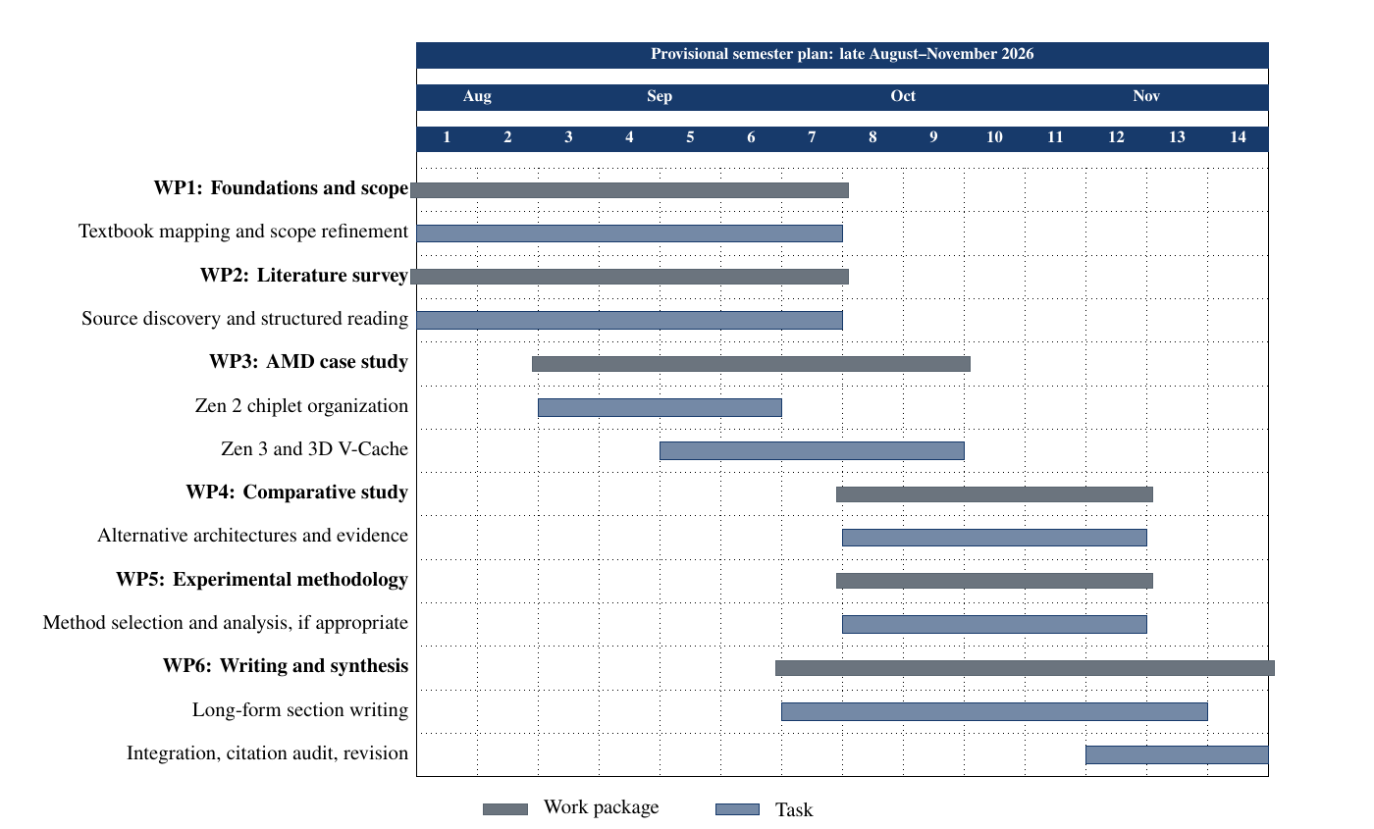
Figure 2: Tentative work-package schedule for Draft 1.

3 References Identified and Examined So Far
The initial source set consists of the primary course textbook, Hot Chips presentations on Zen 2 and AMD advanced packaging, an ISSCC paper on AMD's chiplet architecture, an ISSCC presentation-only abstract record on 3D V-Cache, and AMD's technical overview of EPYC 7003 processors. These sources are listed because they have been identified and examined at a preliminary level; inclusion here does not imply that a complete close reading has already been performed.

Initial bibliography
[1] S. R. Sarangi, Basic Computer Architecture, Version 3.09. Author's online edition, 2025.
[2] S. Naffziger, K. Lepak, M. Paraschou, and M. Subramony, "AMD chiplet architecture for high-performance server and desktop products," in 2020 IEEE International Solid-State Circuits Conference (ISSCC), IEEE, 2020, pp. 44-45. doi: 10.1109/ISSCC19947.2020.9063103.
[3] D. Suggs, D. Bouvier, M. Clark, K. Lepak, and M. Subramony, "AMD Zen 2," in 2019 IEEE Hot Chips 31 Symposium (HCS), IEEE, 2019.
[4] J. Wuu et al., "3D V-Cache: The implementation of a hybrid-bonded 64MB stacked cache for a 7nm x86-64 CPU," in 2022 IEEE International Solid-State Circuits Conference (ISSCC), IEEE, 2022, pp. 428-429. doi: 10.1109/ISSCC42614.2022.9731565.
[5] R. Swaminathan, "Advanced Packaging: Enabling Moore's Law's Next Frontier Through Heterogeneous Integration," in 2021 IEEE Hot Chips 33 Symposium (HCS), Virtual: IEEE, 2021. Available: https://hc33.hotchips.org/assets/program/tutorials/2021%20Hot%20Chips%20AMD%20Advanced%20Packaging%20Swaminathan%20Final%20%2020210820.pdf.
[6] Advanced Micro Devices, Inc., "AMD EPYC 7003 processor microarchitecture overview," Advanced Micro Devices, Inc., 57075, 2022. Available: https://www.amd.com/content/dam/amd/en/documents/epyc-technical-docs/white-papers/overview-amd-epyc7003-series-processors-microarchitecture.pdf.

4 Immediate Next Steps
The immediate next tasks are to consult Prof. Sumantra Dutta Roy; complete the scheduled textbook passes through Chapters 9-12; organize the initial references; maintain one structured note per major source; and expand the literature search to independent research on chiplet systems, die-to-die interconnects, 3D integration, cache scaling, and memory-system performance.
After this first literature-review stage, a decision will be made on whether the final paper should contain an original small-scale cache simulation or benchmark-based analysis in addition to the literature-based AMD case study.

