TSW Controller Utility Profile | TCA Airbus
 | ChrisTrains NS ICMm (Koploper) |  | 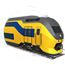
From https://www.arthurstreinenpagina.nl
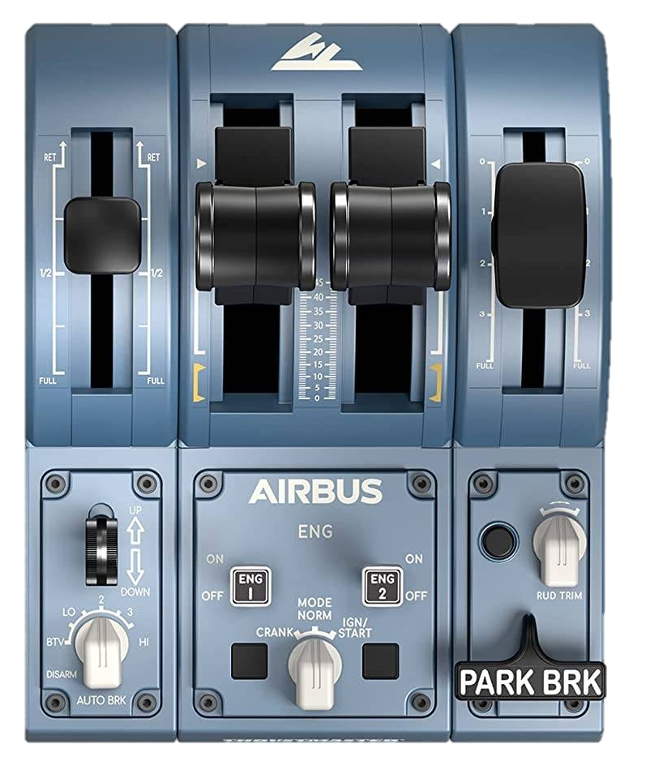
Recommended initial position of lever / knob
Reverser
Throttle
Brake
2
2
Destination
boards
↶0/1 3/4↷
Horn High
Horn Low
Deadman reset
Wipers
Sander
Headlights
←dec inc→
Doors
←L R→
Meter lights
Deadman I/O
ATB
I/O

Cab setup | Cleared to depart
- Open doors  - Set headlights  - Set destination board  - Set meter lights  - Turn on safety system (ATB)  - Turn on vigilance (Deadman) | - Check signal  - Set reverser to forward  - Release brakes  - Apply power

Note: For ChrisTrains NS ICMm version 2 https://christrains.com/en/ts_product_nsicmm.html | ©TheJAG

