 | TSW Controller Utility Profile | TCA Airbus |  | 
 | NS ICMm (Koploper)
From https://www.arthurstreinenpagina.nl
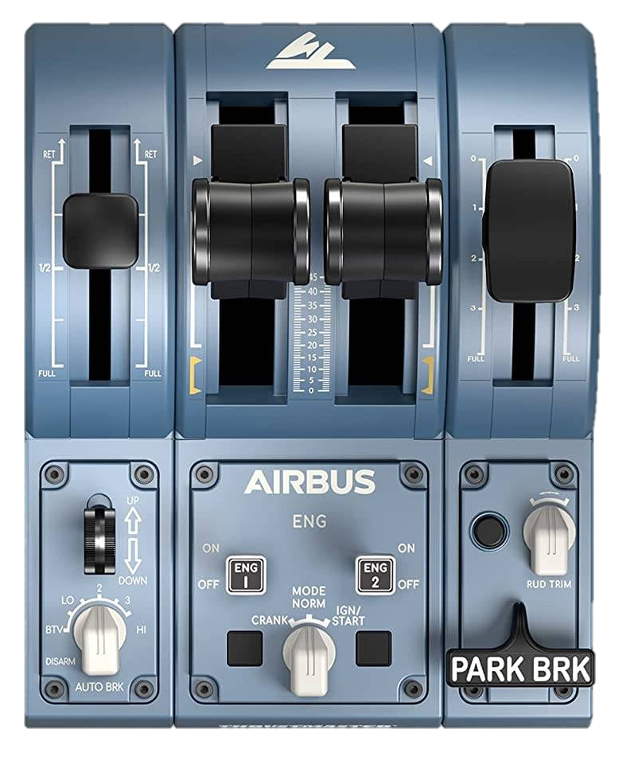
2
0: -
BTV: Off
LO: Shunting (C)
2: Head lights (LRC)
3: Tail lights (LR)
HI: Emergency
Lights
Compressor
Open / Close
←L Doors R→
Master key
Brake key
Forward

Off

Reverse

Driving

Off

Parking

Cleaning

Main mode selector
Recommended initial position of lever / knob
Reverser
Throttle
Brake
2
Horn Low
Horn High
Deadman reset
xx
Wipers
←dec inc→
Meter lights
xx

Cab setup | Cleared to depart
- Insert master key  - Set main mode control  - Insert brake key  - Set meter lights  - Turn on safety system (ATB)  - Turn on vigilance (Deadman) | - Check signal  - Set reverser to forward  - Release brakes  - Apply power

Note: For https://store.steampowered.com/app/3663610/Train_Sim_World_6_Spoorlijn_Zwolle__Groningen_Route_AddOn/ | ©TheJAG

