 |  | 
 | TSW Controller Utility Profile | TCA Airbus
 | DB BR 440
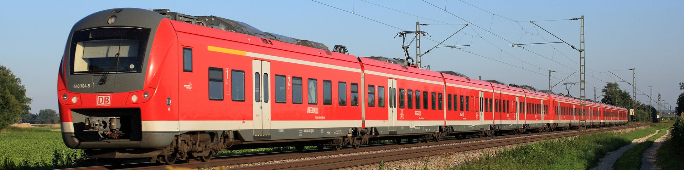
From https://www.deutschebahn.com/
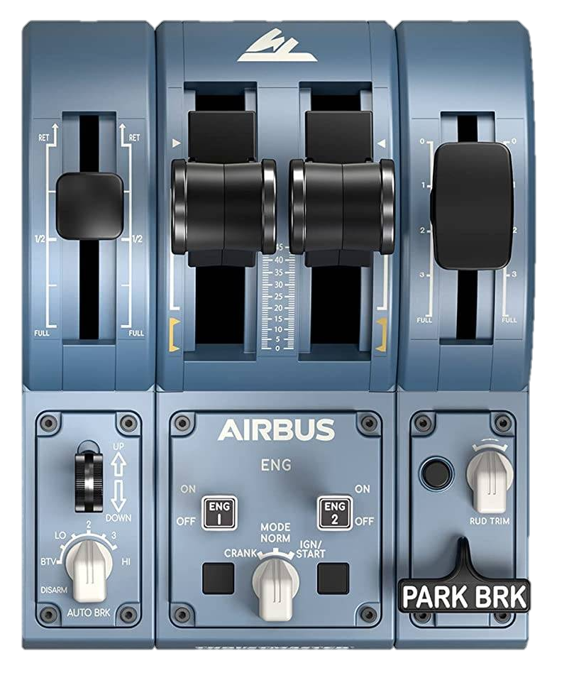
PZB Befehl
Wipers
←dec | inc→
Horn
PZB Acknowledge
PZB Release
LO
L
Train brake
Power / brake
Reverser
Reading light
Bright

Off
Forward

Neutral

Reverse
Headlights
Sand
SiFa reset
SiFa ⏻
PZB ⏻
Open / Close
←L Doors R→
Master key
Recommended initial position of lever / knob

0: -
BTV: Off / tail
LO: On
2: Dim
3: On + beam
HI: -
Cab setup | Cleared to depart
- Insert master key  - Set reverser to neutral  - Raise pantograph, close MCB  - Turn on PZB and SiFa  - Set headlights  - Open doors | - Close doors  - Check signal  - Set reverser to forward  - Train brake to Drive  - Apply power

DLC: | https://store.steampowered.com/app/4678800/Train_Sim_World_7/

