TSW Controller Utility Profile | TCA Airbus
 | ChrisTrains NS Mat’64 (Plan V/T) |  | 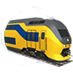
From https://www.arthurstreinenpagina.nl
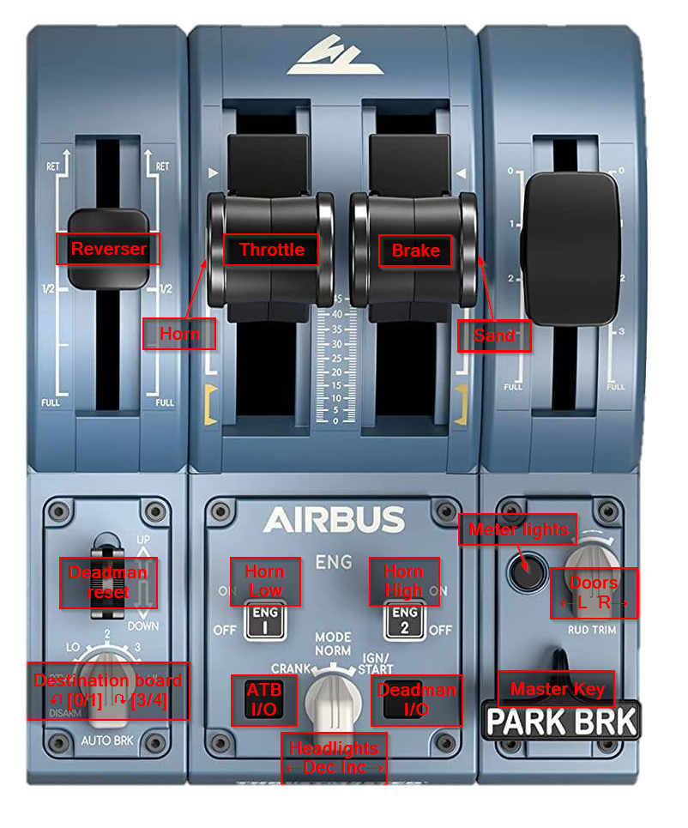

Cab setup | Cleared to depart
- Set headlights  - Set destination  - Turn on ATB  - Turn on Deadman  - Set meter lights | - Check signal  - Set reverser to forward  - Release brakes  - Apply power

Note: For ChrisTrains version 1 https://christrains.com/en/ts_product_nsmat64.html | ©TheJAG

