TSW Controller Utility Profile | TCA Airbus
 | Dutch Classics NS 1300 |  | 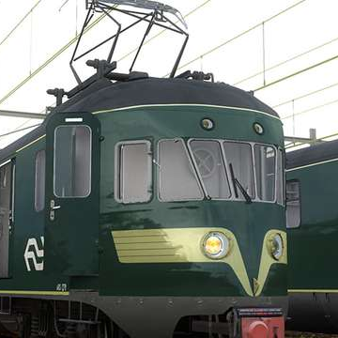
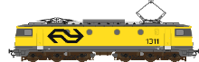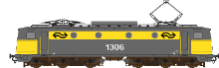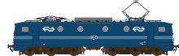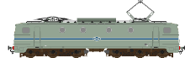
From https://www.arthurstreinenpagina.nl
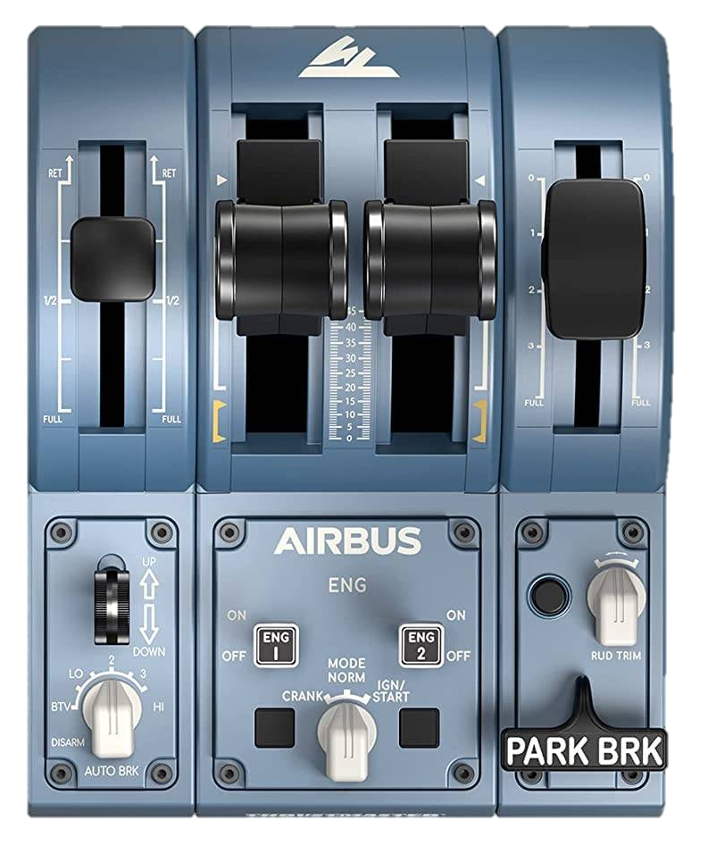

Master switch
Panto
back
Panto
front
Line breaker
←reset I/O→
Horn high
Reverser
Throttle
Brake
Weak field
Expert / simple mode
Deadman reset
Horn low
Doors
←L R→
Deadman I/O
ATB
I/O
Toggles
0: -
BTV: Compressor
LO: Fan
2: Headlight R|L
3: Parking brake
HI: -
Recommended initial position of lever / knob
Cab setup  - Select expert mode  - Set master (stuurstroom) & open doors  - Raise pantographs (front/back)  - Set & reset line breaker (snelschakelaar)  - Set compressor to automatic  - Set engine fans  - Set headlights  - Set HD brake | - Release parking brake  Cleared to depart  - Check signal  - Set reverser to forward  - Release brakes  - Apply power  - >30kph, lower front panto  - Use weak field!

Note: For Dutch Classics NS 1300 https://www.dutch-classics.com/en/dutch-classics-4-ns-1300.html | ©TheJAG

