 | TSW Controller Utility Profile | TCA Airbus |  | Firefly Simulations
 | Class 375
From https://commons.wikimedia.org/
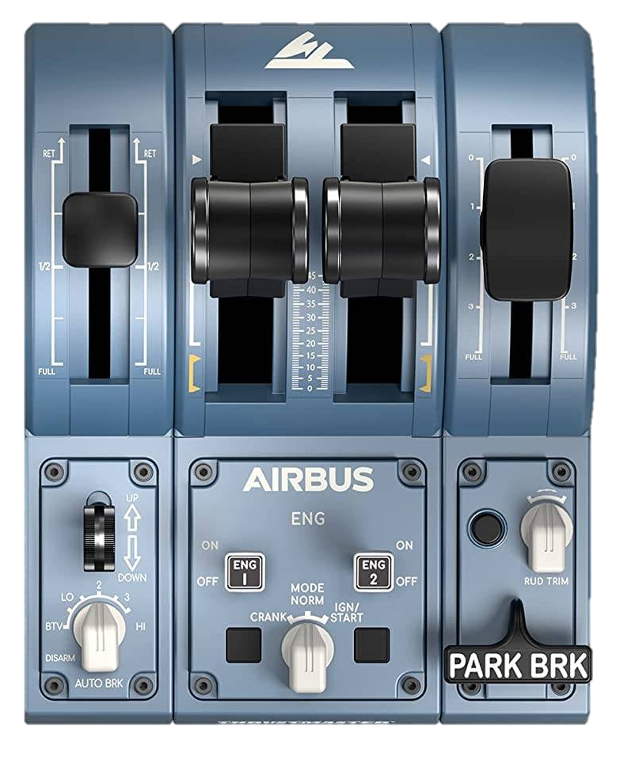
DSD ⏻
PBC
Headlights
Cab lights
Sand
AWS reset
2
0
AWS ⏻
Off

Forward

Neutral

Backward

Open / Close
←L Doors R→
Master key
Recommended initial position of lever / knob
Reverser
Horn Low
Horn High
Wipers
←dec inc→

0: -
BTV: Off
LO: Day running
2: Marker lights only
3: Night running
HI: Tail lights
Cab setup | Cleared to depart
- Insert master key  - Set reverser to neutral  - Open doors  - Turn on safety system (AWS)  - Turn on vigilance system (DSD)  - Set headlights / taillights | - Check signal  - Set reverser to forward  - Release brakes  - Apply power

DLC: | https://store.steampowered.com/app/4035800/Train_Sim_World_6_Medway_Valley_Line_Strood__Tonbridge_Route_AddOn/ | ©TheJAG

