 | TSW Controller Utility Profile | TCA Airbus |  | 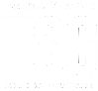
 | DB BR 145
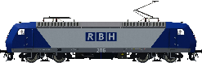
From https://steamcommunity.com/sharedfiles/filedetails/?id=1948213106
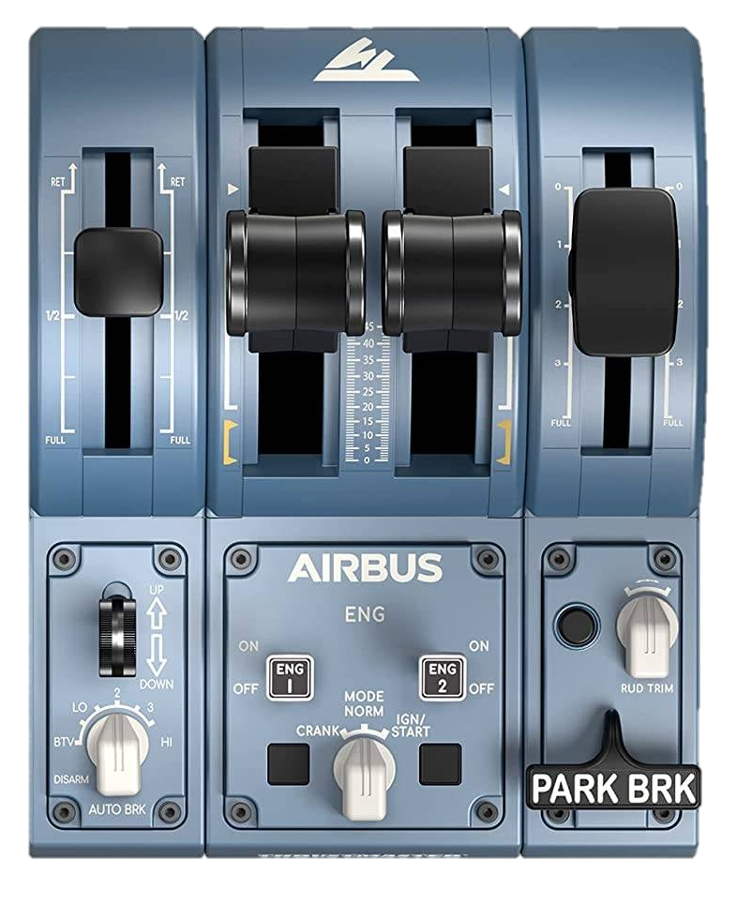
Full

Half

Off

Shutdown

Forward

Secure

Recovery

Reverse
Cab light
Headlights
Combined throttle & brake
Cab lights
Sand
AWS reset
2
0
AWS ⏻
Vigilance ⏻
Open / Close
←L Doors R→
Master key
Recommended initial position of lever / knob
Reverser
Horn High
Horn Low
Wipers
←dec inc→

0: -
BTV: Day running
LO: Day back-up
2: Marker lights only
3: Night back-up
HI: Night running
Cab setup | Cleared to depart
- Insert master key  - Set reverser to neutral  - Open doors  - Turn on safety system (AWS)  - Turn on vigilance system  - Set headlights and taillights | - Check signal  - Set reverser to forward  - Release brakes  - Apply power

DLC: https://store.steampowered.com/app/3879910/Train_Sim_World_6_Expert_DB_BR_145_Loco_AddOn/#app_reviews_hash | ©TheJAG

