 | TSW Controller Utility Profile | TCA Airbus |  | 
 | Class 314
From https://www.gaugemasterretail.com/
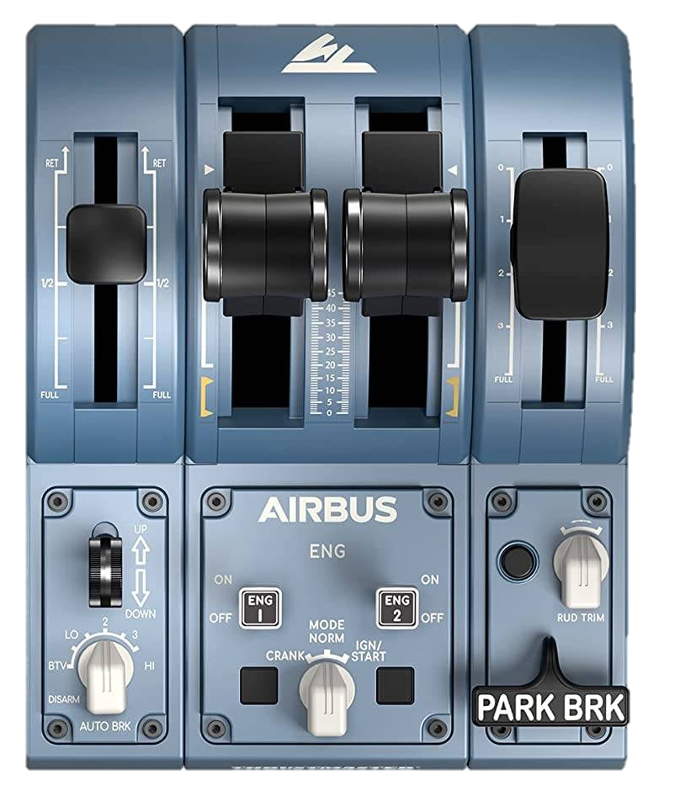
DSD ⏻
Throttle
Brake
Headlights
Cab lights
Sand
AWS reset
2
0
AWS ⏻
Off

Forward

Neutral

Backward

Open / Close
←L Doors R→
Master key
Recommended initial position of lever / knob
Reverser
Horn Low
Horn High
Wipers
←dec inc→

0: -
BTV: Off
LO: Marker lights
2: Head + marker lights
3: Tail lights
HI: Off
Cab setup | Cleared to depart
- Insert master key  - Set reverser to neutral  - Open doors  - Turn on safety system (AWS)  - Turn on vigilance system (DSD)  - Set headlights / taillights | - Check signal  - Set reverser to forward  - Release brakes  - Apply power

Note: https://store.steampowered.com/app/3662560/Train_Sim_World_6_Cathcart_Circle_Line_Glasgow__Neilston__Newton_AddOn/ | ©TheJAG

