 |  | 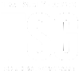
 | TSW Controller Utility Profile | TCA Airbus
 | HR1500
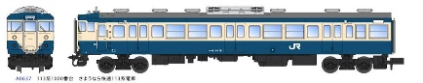
From https://steamcommunity.com/sharedfiles/filedetails/?id=1948213106
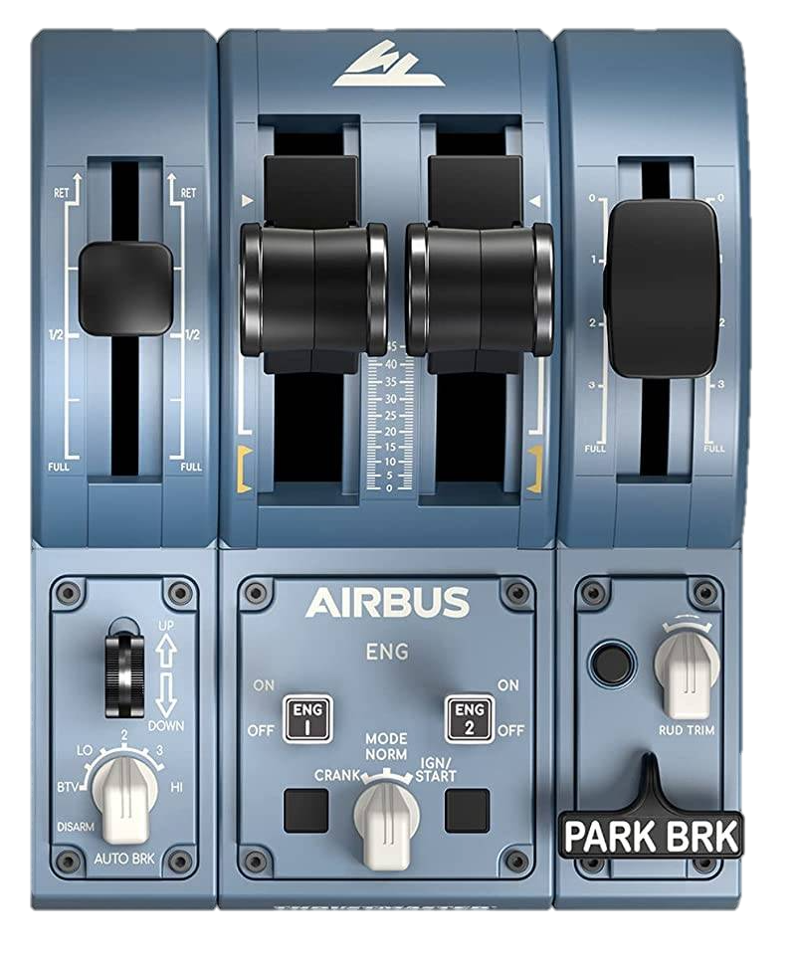
AFB ⏻
Signallights tail | off | head
Horn
LZB/PZB Acknowledge
LZB/PZB Release
2
L
Train brake
Throttle
AFB
Direct brake
Release

Hold

Apply

140/160 km/h

0 km/h
Reverser
Sand
SiFa reset
AWS ⏻
Vigilance ⏻
Open / Close
←L Doors R→
Master key
Recommended initial position of lever / knob
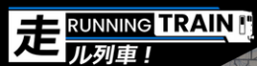
0: -
BTV: Reverse
LO: Off
2: Neutral
3: Forward
HI: -
Cab setup | Cleared to depart
- Insert master key  - Set reverser to neutral  - Open doors  - Turn on safety system (AWS)  - Turn on vigilance system  - Set headlights and taillights | - Check signal  - Set reverser to forward  - Release brakes  - Apply power

DLC: | https://store.steampowered.com/app/3879910/Train_Sim_World_6_Expert_DB_BR_145_Loco_AddOn/
Cold and dark
- Ensure the locomotive is under overhead wires.  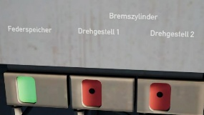  - Ensure at least one brake is applied. This is indicated by a red square with a black dot.  - Enter the locomotive through Cab 1 and enable the battery.  - Ensure that all circuit breakers on this backwall are closed.  - Check the normal position of all the switches on the backwall.  - Set headlights as required.  - Set brake mode as required (R for passengers/light, P/G for freight depending on weight).  - Check that the Auxiliary Controls are off (side of cab for shunting / auxiliary operation).  - Insert the reverser and set it to V (Forward).  - Set Signal & Instrument Lights to on.  - Ensure AFB is off.  - Release the brakes until C-pressure is at 0.5 bar or lower. |  | - Ensure the Parking Brake is on (light illuminated).  - In the engine room, ensure every circuit breaker is closed.  - Ensure PZB, LZB and Sifa are in their normal position.  - Open the Sifa Cut-Off Valve.  - Ensure the Pantograph Cut-Off Valve is open.  - Ensure the Driver’s Brake Cut-Off Valve is closed.  - Walk to Cab 2 and check that all circuit breakers are closed.  - Check the normal position of all the switches on the backwall.  - Set headlights as required.  - Ensure the Direct Brake is set to the “Hold” position.  - Test the Horn Pedal.  - Ensure that the Air Compressor Switch is on.  - Set Signal & Instrument Lights to on.  - Return to Cab 1.  - Raise the Pantograph and close the Main Circuit Breaker.  - Enable the Air Compressor

Brake System Preparation
- Ensure that the Brake Pipe stays at 5 bar.  - Move the Reverser to M (Neutral)  - Ensure that the Brake Pipe stays at 5 bar.  - Move the Reverser to V.  - Decouple the Dynamic Brake.  - Reduce Brake Pipe Pressure by 0.8 bar with the Train Brake and monitor the Brake Pipe gauge.  - Release the brakes.  - Go to the “Prüfen” page. [W → Prüfen]  - Press SoftKey 5 “BrR 2 Ein” and await the HSM change.  - Decouple the Dynamic Brake.  - Reduce Brake Pipe Pressure by 0.8 bar with the Train Brake and monitor the Brake Pipe gauge.  - Release the brakes. | - Apply the Direct Brake and monitor the C-pressure gauge.  - Release the Direct Brake and monitor the C-pressure gauge.  - Perform a PZB/LZB test and a Sifa test.  - Apply the Direct Brake.  - Release the Parking Brake.  - Turn the Machine Room Lights and Cabin Lighting off if necessary.  - Test the Horn Pedal.  - Perform a rolling test:  - Release all brakes.  - Apply a small amount of power.  - Roll for a few metres.  - Reduce power to 0.  - Apply a medium amount of Direct Brake force and stop.

