4.2.2.c

S → S ( S ) S
| ε
String: ( ( ) ( ) )

Left most parse:
S → S ( S ) S
→ ε ( S ) S
→ ( S ( S ) S ) S
→ ( S ( S ) S ( S ) S ) S
→ ( ε ( S ) S ( S ) S ) S
→ ( ( ε ) S ( S ) S ) S
→ ( ( ) ε ( S ) S ) S
→ ( ( ) ( ε ) S ) S
→ ( ( ) ( ) ε ) S
→ ( ( ) ( ) ) ε
→ ( ( ) ( ) )

Right mose Parse:
S → S ( S ) S
→ S ( S ) ε→ S ( S ( S ) S )
→ S ( S ( S ( S ) S ) S )
→ S ( S ( S ) S ( S ) ε )
→ S ( S ( S ) S ( ε ) )
→ S ( S ( S ) ε ( ) )
→ S ( S ( ε ) ( ) )
→ S ( ε ( ) ( ) )
→ ε ( ( ) ( ) )
→ ( ( ) ( ) )

Parse Tree:
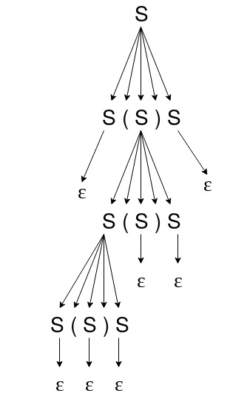

The grammer is ambigous since with the input (()()), we can create two different parse trees with the same grammer.

The Language generates parentheses where every left parentheses closes with a right parentheses.

4.2.3.a

S → 1 S
| 01 S
| ε

4.4.1.c

S → S ( S ) S
| ε

S → S_{R}

S_{R} → ( S ) S S_{R}
| ε

First ( S ) = { (, ε ) }

First ( S_{R} ) = { (, ε }

Folow ( S ) = { ), (, $ }

Follow ( S_{R} ) = { ), (, $ }

 | ( | ) | $
S | S → S_{R} | S → S_{R} | S → S_{R}
S_{R} | S_{R} → ( S ) S S_{R} | S_{R} → ε | S_{R} → ε

