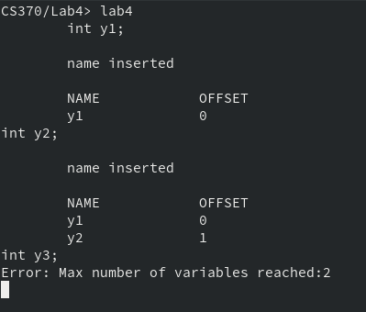
if you define more than the MAX number of variables, then you error:

you cannot declare a variable more than once:
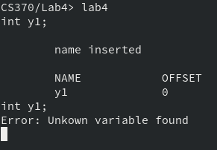

you cannot use a variable that is not defined:
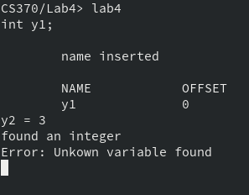

a declared variable can be set and used:
