Jeffrey Lansford

Homework #1

9/30/20

1.1

1) To execute user programs on computer hardware in a convenient and efficient environment.

2) To allocate the resources of the computer to solve the given problem.

3) TO be a control program that manages the execution of user programs to prevent errors and improper use of the computer and the operation and control of I/O devices.

1.15

Symmetric multiprocessing treats all processors as peers, and I/O can be processed on any CPU. Asymmetric multiprocessing has one master CPU and the reminder CPUs are slaves. The master distributes task to the slaves and I/O is done by the master CPU.

Advantages

* Can save money by not duplicating power supplies, housing, and peripherals.
* They can execute programs more quickly
* Can have increased reliably

Disadvantages:

* More complex in hardware and software then uniprocessor systems.

1.19

Interrupts’ purpose is to signal the CPU to tell it stop its current activity and execute new code depending on the interrupt. It transfers program control from some address to another address. Traps are software-generated interrupts caused either by an error or by a specific request from a user-program. Traps can be generated by a user program for debugging like catching arithmetic errors

2.1

System calls provide an interface to the services made available by an operating system.

2.13

Registers, Blocks, Stacks

2.21

Microkernel has many benefits. It is easier to extend a microkernel, easier to port the OS to new architectures, more reliable and secure. The system services and the user program communicate through the microkernel by message passing. They never communicate directly, instead exchanging messages through the microkernel. The main disadvantage of the microkernel is the performance overhead of user space to the kernel space communication.

3.8

Short-term scheduler selects which process should be executed next and allocates CPU and a long-term scheduler selects which process should be brought into the ready queue. Short-term are usually fast and invoked frequently while long-term are can be slow and called infrequently. Long-term also controls the degree of multiprogramming. Medium-term scheduler can be added to decrease the degree of multiple programming. It removes the process from memory to reduce the degree of multiprogramming and later reintroduces the process back into memory, continuing where it left off. Medium-term scheduling is an intermediate scheduling for time sharing systems.

3.9

When a context switch occurs, the kernel saves the context of the old process in its PCB and loads the saved context of the new process scheduled to run.

3.12

16 process

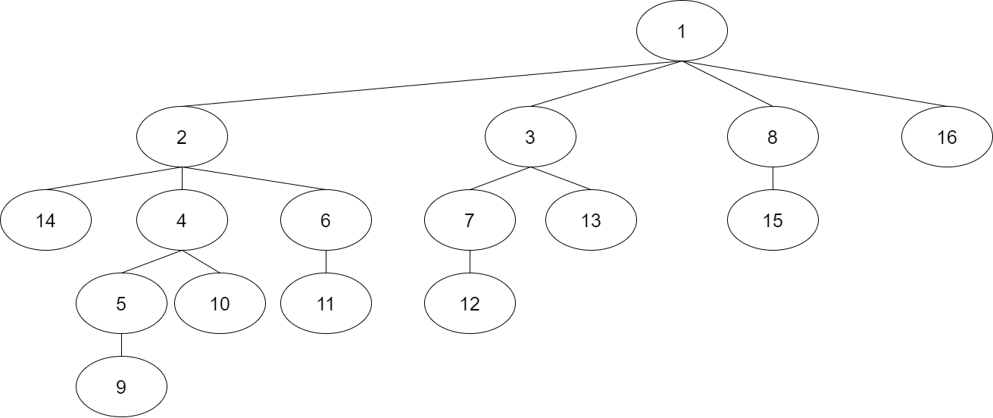

Q4

1. 4 processes

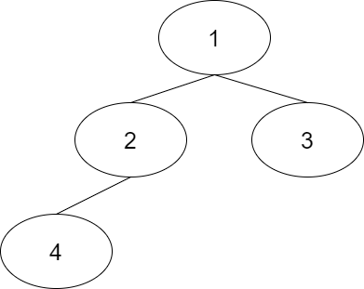

“n = 30 mult = 1 n = 55 mult = 1 n = 30 mult = 1 n = 55 mult = 1 n = 30 mult = 1 n = 50 mult = 50 n = 30 mult = 1 n = 50 mult = 50”

4.7

A multi-threaded solution can provide better performance than a single-threaded solution when the program has to wait for other system events. In the multi-thread solution, the waiting task can be thrown on another thread while it can continue running the program, while the single-thread solution has to wait on that event.

4.10

Heap and Global variables

4.14

1) Worse Performance. Kernel threads can not make full use of processors.

2) Better Performance. All processors can be utilized simultaneously

3) Best Performance. A blocked kernel thread could be swapped out for the blocked thread with a kernel thread that is ready to execute.