Supporting information
Predictive and Interpretable Data-Driven Framework for Deciphering Chiral Emergence of Conjugated Polymers
Sanghyun Jeon^{1,†}, Hang Zhang^{2,†}, Nahyun Ahn², Ayse Senlik², Yejin Shim², Janice Baek¹, Priyotosh Bairagya², Pravini S. Fernando², Justin Scott Neu⁴, Duyen Tran⁵, Kousseff Christina⁶, Anna M. Österholm⁷, Samson A. Jenekhe⁵, Iain McCulloch⁶, Wei You⁴, John R. Reynolds^{7,}*, Nicholas E. Jackson^{1,2,3,8,}*, Ying Diao^{1,2,3,8,}*
¹Department of Materials Science and Engineering, University of Illinois Urbana−Champaign, 600 S. Mathews Avenue, Urbana, Illinois 61801, United States
²Department of Chemical and Biomolecular Engineering, University of Illinois Urbana−Champaign, 600 S. Mathews Avenue, Urbana, Illinois 61801, United States
³Department of Chemistry, Department of Materials Science and Engineering, University of Illinois Urbana−Champaign, 600 S. Mathews Avenue, Urbana, Illinois 61801, United States
⁴Department of Chemistry, University of North Carolina, Chapel Hill, North Carolina 27599, United States
⁵Department of Chemical Engineering, University of Washington, Seattle, Washington 98195, United States
⁶Department of Chemistry, University of Oxford, Oxford, UK
⁷School of Chemistry and Biochemistry, School of Materials Science and Engineering, Georgia Institute of Technology, Atlanta, Georgia 30322, United States
⁸Beckman Institute for Advanced Science and Technology, University of Illinois Urbana−Champaign, Urbana, Illinois 61801, United States

†These authors contributed equally to this work.

For correspondence:
yingdiao@illinois.edu, jacksonn@illinois.edu, reynolds@chemistry.gatech.edu

Table of Contents
Section S1. Experimental Details for Chirality Measurements and Dataset Construction. 4
Section S2. Details on features considered in this study. 17
Section S3. Selection of machine-learning framework. 18
Section S4. Family related RF classification model performance. 21
Section S5. Solubility-based evidence supporting the proposed mechanism of chiral LLC formation. 24
Section S6. Additional results for feature analysis. 29

List of Supporting Figures
Figure S1. Four-scan method for extraction of the true CD signal from aligned LLC samples. 4
Figure S2. Spectral regions used to distinguish intrinsic CD from artifact-dominated signals and to evaluate the dissymmetry factor. 6
Figure S3. Complete list of the 77 features considered in this study. 17
Figure S4. SHAP importance and importance-rank stability of the top 20 features for the RF classification model trained on the full polymer dataset. 20
Figure S5. Distributions of negative and positive cases with respect to top features. 24
Figure S6. Experimental distribution of assembly outcome in the two-dimensional space defined by the FASTSOLV-derived monomer and backbone solubility descriptors. 25
Figure S7. Relationship between monomer FASTSOLV and assembly outcome. 26
Figure S8. RF prediction score of $log⁡10∣g∣≥-3$ in the two-dimensional space defined by the FASTSOLV-derived monomer and backbone solubility descriptors for the expanded polymer–solvent dataset. 27
Figure S9. Experimentally observed assembly outcomes plotted as a function of normalized side-chain content. 29
Figure S10. SHAP importance and importance-rank stability of the top 20 features for the RF classification model trained on the thiophene family subset. 30
Figure S11. SHAP importance and importance-rank stability of the top 20 features for the RF classification model trained on the NDI family subset. 31
Figure S12. Concentration-resolved experimental assembly outcomes for NDI-family polymers. 32

List of Supporting Tables
Table S1. Dataset used for machine-learning analysis. 7
Table S2. Comparison between ML frameworks on the classification task. 18
Table S3. Comparison between ML frameworks on the regression task. 18
Table S4. Results of leave-one-family-out evaluation. 21
Table S5. Results of leave-one-solvent-out evaluation. 22
Table S6. Performance of the RF classification models on the total dataset and family-specific subsets. 23

Section S1. Experimental Details for Chirality Measurements and Dataset Construction.

Figure S1. Four-scan method for extraction of the true CD signal from aligned LLC samples. (a) Schematic illustration of the measurement geometry. CD spectra were collected at four sample orientations defined by (θ, β) = (0°, 0°), (90°, 0°), (0°, 180°), and (90°, 180°), where θ and β denote the in-plane and out-of-plane rotation angles, respectively.
To extract the true circular dichroism signal (CD_{true}) from aligned LLC samples, we employed the previously reported four-scan method¹. This procedure separates the measured CD signal from contributions arising from linear dichroism/linear birefringence (CD_{LDLB}) and residual static birefringence associated with the photoelastic modulator (CD_{α}). CD spectra were collected at four sample orientations defined by the in-plane rotation angle, θ, and the out-of-plane rotation angle, β: (θ, β) = (0°, 0°), (90°, 0°), (0°, 180°), and (90°, 180°), and the true CD signal was obtained by averaging the four measurements:
CD_{true} = [CD_{(θ=0°, β=0°)} + CD_{(θ=90°, β=0°)} + CD_{(θ=0°, β=180°)} + CD_{(θ=90°, β=180°)}] / 4
The CD_{LDLB} contributions for the two out-of-plane orientations were calculated as:
CD_{LDLB, β=180°} = [CD_{(θ=0°, β=180°)} + CD_{(θ=90°, β=180°)} − 2CD_{true}] / 2
CD_{LDLB, β=0°} = [CD_{(θ=0°, β=0°)} + CD_{(θ=90°, β=0°)} − 2CD_{true}] / 2
Similarly, the CD_{α} contributions for the two in-plane orientations were calculated as:
CD_{α, θ=90°} = [CD_{(θ=90°, β=0°)} + CD_{(θ=90°, β=180°)} − 2CD_{true}] / 2
CD_{α, θ=0°} = [CD_{(θ=0°, β=0°)} + CD _{(θ=0°, β=180°)} − 2CD_{true}] / 2
Thus, averaging the four measurements isolates the orientation-independent CD_{true} component, while the remaining pairwise deviations provide estimates of the CD_{LDLB} and CD_{α} contributions.

Figure S2. Spectral regions used to distinguish intrinsic CD from artifact-dominated signals and to evaluate the dissymmetry factor. Representative $g$-factor, CD, and absorbance spectra are shown as a function of wavelength. The blue-shaded region denotes the absorption-active spectral range, where the CD response is attributed primarily to the intrinsic chiroptical response of the polymer assembly. The red-shaded region corresponds to wavelengths with negligible absorbance, where the observed CD signal is more likely dominated by anisotropy- or scattering-induced artifacts². The $g$-factor was evaluated within the indicated wavelength region associated with the absorption-active CD response.

Table S1. Dataset used for machine-learning analysis.
Each entry lists the polymer, solvent, temperature, concentration, structural classification, and data origin. Samples were classified as chiral (c), isotropic (i), or aggregated (a), and the origin of each entry was identified as either literature-derived or generated in this work. For isotropic or aggregated samples tested over a concentration range of 100–300 mg/mL, the range is shown as a single entry in the table for simplicity. However, for machine-learning analysis, these conditions were treated as three separate data points corresponding to 100, 200, and 300 mg/mL. When multiple CD measurements were collected under the same experimental condition, each measurement was treated as an independent data point. For example, for p(g₄2T-TT) in chloroform at 25 °C and 100 mg/mL, two separate CD measurements were obtained and both exhibited CD signals; these were therefore counted as two independent data points in the ML dataset.
Polymer name | Solvent | Temp. | Conc. | Type | Origin
p(g₄(2T-TT)) | Chloroform | 25 | 50mgmL | c | This work + DOI: 10.1002/adma.74130
p(g₄(2T-TT)) | Chloroform | 25 | 100mgmL | c | This work + DOI: 10.1002/adma.74130
 |  |  |  | c | This work + DOI: 10.1002/adma.74130
p(g₄(2T-TT)) | Chloroform | 25 | 200mgmL | c | This work + DOI: 10.1002/adma.74130
p(g₄(2T-TT)) | Chloroform | 25 | 300mgmL | c | This work + DOI: 10.1002/adma.74130
p(g₄(2T-TT)) | Anisole | 25 | 100-300mgmL | a | This work + DOI: 10.1002/adma.74130
p(g₄(2T-TT)) | Anisole | 50 | 100-300mgmL | a | This work + DOI: 10.1002/adma.74130
p(g₄(2T-TT)) | Anisole | 70 | 100-300mgmL | a | This work + DOI: 10.1002/adma.74130
p(g₄(2T-TT)) | Anisole | 90 | 300mgmL | c | This work + DOI: 10.1002/adma.74130
p(g₄(2T-TT)) | Anisole | 110 | 300mgmL | c | This work + DOI: 10.1002/adma.74130
p(g₄(2T-TT)) | Anisole | 130 | 300mgmL | c | This work + DOI: 10.1002/adma.74130
p(g₄(2T-TT)) | o-dichlorobenzene | 25 | 100-300mgmL | a | This work + DOI: 10.1002/adma.74130
p(g₄(2T-TT)) | o-dichlorobenzene | 130 | 300mgmL | c | This work + DOI: 10.1002/adma.74130
 |  |  |  | c | This work + DOI: 10.1002/adma.74130
p(g₄(2T-TT)) | Chlorobenzene | 25 | 100-300mgmL | a | This work + DOI: 10.1002/adma.74130
p(g₄(2T-TT)) | 1-Chloronaphthalene | 25 | 100-300mgmL | a | This work + DOI: 10.1002/adma.74130
p(g₄(2T-TT)) | 1-Chloronaphthalene | 130 | 300mgmL | c | This work + DOI: 10.1002/adma.74130
p(g₄(2T-TT)) | Dimethylformamide | 25 | 100-300mgmL | a | This work
p(g₄(2T-TT)) | 14dioxane | 25 | 100-300mgmL | a | This work
p(g₄(2T-TT)) | 13dioxane | 25 | 100-300mgmL | a | This work
p(g₄(2T-TT)) | Trichloroethylene | 25 | 100-300mgmL | a | DOI: 10.1002/adma.74130
p(g₄(2T-TT)) | Toluene | 25 | 100-300mgmL | a | DOI: 10.1002/adma.74130
p(g₄(2T-TT)) | o-xylene | 25 | 100-300mgmL | a | This work
p(g₄(2T-TT)) | p-xylene | 25 | 100-300mgmL | a | This work
p(g₄(2T-TT)) | Propylene Glycol Methyl Ether Acetate | 25 | 100-300mgmL | a | DOI: 10.1002/adma.74130
p(g₄(2T-TT)) | Propylene Glycol Methyl Ether Acetate | 130 | 100-300mgmL | a | DOI: 10.1002/adma.74130
p(g₄(2T-TT)) | Ethanol | 25 | 100-300mgmL | a | This work
p(g₃(2T-TT)) | Chloroform | 25 | 300mgmL | c | This work + DOI: 10.1002/adma.74130
 |  |  |  | c | This work + DOI: 10.1002/adma.74130
 |  |  |  | c | This work + DOI: 10.1002/adma.74130
p(g₃(2T-TT)) | Anisole | 25 | 100-300mgmL | a | This work + DOI: 10.1002/adma.74130
p(g₃(2T-TT)) | Anisole | 130 | 200mgmL | c | This work + DOI: 10.1002/adma.74130
p(g₃(2T-TT)) | o-dichlorobenzene | 25 | 100-300mgmL | a | This work + DOI: 10.1002/adma.74130
p(g₃(2T-TT)) | o-dichlorobenzene | 130 | 200mgmL | c | This work + DOI: 10.1002/adma.74130
p(g₃(2T-TT)) | Chlorobenzene | 25 | 100-300mgmL | a | This work
p(g₃(2T-TT)) | Dimethylformamide | 25 | 100-300mgmL | a | This work
p(g₃(2T-TT)) | 1-Chloronaphthalene | 25 | 100-300mgmL | a | This work
p(g₃(2T-TT)) | 14dioxane | 25 | 100-300mgmL | a | This work
p(g₃(2T-TT)) | 13dioxane | 25 | 100-300mgmL | a | This work
p(g₃(2T-TT)) | Trichloroethylene | 25 | 100-300mgmL | a | This work
p(g₃(2T-TT)) | Toluene | 25 | 100-300mgmL | a | This work
p(g₃(2T-TT)) | o-xylene | 25 | 100-300mgmL | a | This work
p(g₃(2T-TT)) | p-xylene | 25 | 100-300mgmL | a | This work
p(g₃(2T-TT)) | Propylene Glycol Methyl Ether Acetate | 25 | 100-300mgmL | a | This work
p(g₃(2T-TT)) | Propylene Glycol Methyl Ether Acetate | 130 | 100-300mgmL | a | This work
p(g₃(2T-TT)) | Ethanol | 25 | 100-300mgmL | a | This work
p(g₃(2T-T)) | Chloroform | 25 | 300mgmL | c | This work + DOI: 10.1002/adma.74130
 |  |  |  | c | This work + DOI: 10.1002/adma.74130
p(g₃(2T-T)) | Anisole | 25 | 200mgmL | c | This work + DOI: 10.1002/adma.74130
p(g₃(2T-T)) | o-dichlorobenzene | 25 | 200mgmL | c | This work + DOI: 10.1002/adma.74130
p(g₃(2T-T)) | Propylene Glycol Methyl Ether Acetate | 25 | 100-300mgmL | a | This work + DOI: 10.1002/adma.74130
p(g₃(2T-T)) | Propylene Glycol Methyl Ether Acetate | 130 | 200mgmL | c | This work + DOI: 10.1002/adma.74130
 |  |  |  | c | This work + DOI: 10.1002/adma.74130
 |  |  |  | c | This work + DOI: 10.1002/adma.74130
p(g₃(2T-T)) | Ethanol | 25 | 100-300mgmL | a | This work + DOI: 10.1002/adma.74130
p(g₃(2T-T)) | Chlorobenzene | 25 | 300mgmL | c | This work + DOI: 10.1002/adma.74130
p(g₃(2T-T)) | 1-Chloronaphthalene | 25 | 300mgmL | c | This work + DOI: 10.1002/adma.74130
p(g₃(2T-T)) | Dimethylformamide | 25 | 300mgmL | c | This work + DOI: 10.1002/adma.74130
p(g₃(2T-T)) | Trichloroethylene | 25 | 300mgmL | c | This work + DOI: 10.1002/adma.74130
p(g₃(2T-T)) | Toluene | 25 | 300mgmL | c | This work + DOI: 10.1002/adma.74130
p(g₃(2T-T)) | p-xylene | 25 | 300mgmL | i | This work + DOI: 10.1002/adma.74130
PBTTT-EG3 | Chloroform | 25 | 100mgmL | c | This work + DOI: 10.1002/adma.74130
PBTTT-EG3 | Chloroform | 25 | 200mgmL | c | This work + DOI: 10.1002/adma.74130
 |  |  |  | c | This work + DOI: 10.1002/adma.74130
PBTTT-EG3 | Chloroform | 25 | 300mgmL | c | This work + DOI: 10.1002/adma.74130
 |  |  |  | c | This work + DOI: 10.1002/adma.74130
PBTTT-EG3 | Anisole | 25 | 100-300mgmL | a | DOI: 10.1002/adma.74130
PBTTT-EG3 | Propylene Glycol Methyl Ether Acetate | 25 | 100-300mgmL | a | This work
PBTTT-EG3 | Ethanol | 25 | 100-300mgmL | a | This work
PBTTT-C14 | Chloroform | 25 | 100-300mgmL | a | This work
PBTTT-C14 | Anisole | 25 | 100-300mgmL | a | This work
PBTTT-C14 | Anisole | 130 | 100-300mgmL | i | This work
PBTTT-C14 | o-dichlorobenzene | 25 | 100-300mgmL | i | This work
PBTTT-C14 | o-dichlorobenzene | 130 | 100-300mgmL | i | This work
PBTTT-C14 | chlorobenzene | 25 | 100-300mgmL | a | This work
PBTTT-C14 | chlorobenzene | 80 | 100-300mgmL | i | This work
PBTTT-C14 | Dimethylformamide | 25 | 100-300mgmL | a | This work
PBTTT-C14 | Dimethylformamide | 130 | 100-300mgmL | a | This work
PBTTT-C14 | 1-Chloronaphthalene | 25 | 100-300mgmL | a | This work
PBTTT-C14 | Propylene Glycol Methyl Ether Acetate | 25 | 100-300mgmL | a | This work
PBTTT-C14 | Propylene Glycol Methyl Ether Acetate | 130 | 100-300mgmL | a | This work
PBTTT-C14 | 1,4-Dioxane | 25 | 100-300mgmL | a | This work
PBTTT-C14 | 1,4-Dioxane | 70 | 100-300mgmL | a | This work
PBTTT-C14 | Trichloroethylene | 25 | 100-300mgmL | i | This work
PBTTT-C14 | Toluene | 25 | 100-300mgmL | a | This work
PBTTT-C14 | Ethanol | 25 | 100-300mgmL | a | This work
P3HT | Chloroform | 25 | 100-300mgmL | i | This work
P3HT | Chlorobenzene | 25 | 100-300mgmL | i | This work
P3HT | Trichlorobenzene | 25 | 100-300mgmL | i | This work
P3HT | Toluene | 25 | 100-300mgmL | a | This work
P3HT | o-dichlorobenzene | 25 | 100-300mgmL | i | This work
P3HT | Anisole | 25 | 100-300mgmL | a | This work
P3HT | 1-Chloronaphthalene | 25 | 100-300mgmL | i | This work
P3HT | Dimethylformamide | 25 | 100-300mgmL | a | This work
P3HT | p-xylene | 25 | 100-300mgmL | a | This work
P3HT | Ethanol | 25 | 100-300mgmL | a | This work
P3HT | Propylene Glycol Methyl Ether Acetate | 25 | 100-300mgmL | a | This work
P3MEEMT | Chloroform | 25 | 300mgmL | c | This work
P3MEEMT | Propylene Glycol Methyl Ether Acetate | 25 | 100-300mgmL | a | This work
AcDOT-[C10]2-co-[OE3]2 | Chloroform | 25 | 10mgmL | i | DOI:10.1021/10.1021/jacs.5c07995
AcDOT-[C10]2-co-[OE3]2 | Chloroform | 25 | 50mgmL | i | DOI:10.1021/10.1021/jacs.5c07995
AcDOT-[C10]2-co-[OE3]2 | Chloroform | 25 | 100mgmL | c | DOI:10.1021/10.1021/jacs.5c07995
AcDOT-[C10]2-co-[OE3]2 | Chloroform | 25 | 200mgmL | c | DOI:10.1021/10.1021/jacs.5c07995
AcDOT-[C10]2-co-[OE3]2 | Methanol | 25 | 100-300mgmL | a | This work
AcDOT-[C10]2-co-[OE3]2 | Chloroform (75wt%) + Methanol (25wt%) | 25 | 100-150mgmL | a | This work
AcDOT-[CH3,C10]-co-[CH3,OE3] | Chloroform | 25 | 100-300mgmL | i | DOI:10.1021/acs.chemmater.4c03394
AcDOT-[C3-C10] | Chloroform | 25 | 100-300mgmL | a | This work
AcDOT-[OE3]2 | Chloroform | 25 | 100-300mgmL | a | This work
AcDOT-[C10]2 | Chloroform | 25 | 100-300mgmL | i | DOI:10.1021/acs.chemmater.4c03394
PTQ-10 | Chloroform | 25 | 100-300mgmL | i | This work
PTQ-10 | Chlorobenzene | 25 | 100-300mgmL | i | This work
PTQ-2bO2 | Chloroform | 25 | 100-300mgmL | i | This work
PTQ-2bO2 | Chloroform | 50 | 100-300mgmL | i | This work
PTQ-2bO2 | Anisole | 25 | 100-300mgmL | a | This work
PTQ-2bO2 | Anisole | 130 | 100-300mgmL | a | This work
PTQ-2bO2 | o-dichlorobenzene | 25 | 100-300mgmL | a | This work
PTQ-2bO2 | o-dichlorobenzene | 130 | 100-300mgmL | i | This work
PTQ-2bO2 | Chlorobenzene | 25 | 10-200mgmL | a | DOI:10.1021/10.1021/jacs.5c07995
PTQ-4bO2 | Chloroform | 25 | 200mgmL | c | DOI: 10.1002/adma.74130
PTQ-4bO2 | chlorobenzene | 25 | 100mgmL | i | DOI:10.1021/10.1021/jacs.5c07995
PTQ-4bO2 | chlorobenzene | 25 | 150mgmL | c | DOI:10.1021/10.1021/jacs.5c07995
PTQ-4bO2 | chlorobenzene | 25 | 200mgmL | c | DOI:10.1021/10.1021/jacs.5c07995
PTQ-4bO2 | chlorobenzene | 25 | 300mgmL | c | DOI:10.1021/10.1021/jacs.5c07995
 |  |  |  | c | DOI:10.1021/10.1021/jacs.5c07995
PTQ-4bO2 | o-dichlorobenzene | 25 | 100-300mgmL | i | DOI: 10.1002/adma.74130
PTQ-4bO2 | o-dichlorobenzene | 100 | 200mgmL | c | DOI: 10.1002/adma.74130
PTQ-4bO2 | 70% chlorobenzene + 30% Methanol | 25 | 40mgmL | i | This work
PTQ-4bO2 | 70% chlorobenzene + 30% Methanol | 25 | 70mgmL | i | This work
PTQ-4bO2 | 70% chlorobenzene + 30% Methanol | 25 | 100mgmL | c | This work
 |  |  |  | c | This work
PTQ-4bO2 | 70% chlorobenzene + 30% Methanol | 25 | 150mgmL | c | This work
PTQ-4bO2 | 30% chlorobenzene + 70% Methanol | 25 | 100-300mgmL | a | This work
PTQ-6bO | Chloroform | 25 | 200mgmL | c | DOI: 10.1002/adma.74130
PTQ-6bO | o-dichlorobenzene | 25 | 100-300mgmL | a | DOI: 10.1002/adma.74130
PTQ-6bO | o-dichlorobenzene | 100 | 200mgmL | c | DOI: 10.1002/adma.74130
PTQ-6bO | Anisole | 25 | 100-300mgmL | a | DOI: 10.1002/adma.74130
PTQ-6bO | Anisole | 100 | 200mgmL | c | DOI: 10.1002/adma.74130
PTQ-6bO | Propylene Glycol Methyl Ether Acetate | 25 | 100-300mgmL | a | DOI: 10.1002/adma.74130
PTQ-6bO | Propylene Glycol Methyl Ether Acetate | 130 | 100-300mgmL | a | DOI: 10.1002/adma.74130
PTQ-6O | Chlorobenzene | 25 | 10-300mgmL | a | DOI:10.1021/10.1021/jacs.5c07995
PTQ-6bO2 | chlorobenzene | 25 | 100mgmL | c | DOI:10.1021/10.1021/jacs.5c07995
PTQ-6bO2 | chlorobenzene | 25 | 200mgmL | c | DOI:10.1021/10.1021/jacs.5c07995
PTQ-6bO2 | chlorobenzene | 25 | 250mgmL | c | DOI:10.1021/10.1021/jacs.5c07995
 |  |  |  | c | DOI:10.1021/10.1021/jacs.5c07995
PTQ-6bO2 | chlorobenzene | 25 | 300mgmL | c | DOI:10.1021/10.1021/jacs.5c07995
N2200 - 3.6 k | Chlorobenzene | 25 | 100-300mgmL | i | DOI:10.1021/10.1021/jacs.5c07995
N2200 - 5.7 k | Chlorobenzene | 25 | 100-300mgmL | i | DOI:10.1021/10.1021/jacs.5c07995
N2200 - 5.7 k | Chloroform | 25 | 100-300mgmL | i | This work
N2200 - 5.7 k | Anisole | 25 | 100-300mgmL | i | This work
N2200 - 9.1 k | Chloroform | 25 | 50mgmL | c | This work + DOI:10.1021/10.1021/jacs.5c07995
 |  |  |  | c | This work + DOI:10.1021/10.1021/jacs.5c07995
 |  |  |  | c | This work + DOI:10.1021/10.1021/jacs.5c07995
N2200 - 9.1 k | Chloroform | 25 | 100mgmL | c | This work + DOI:10.1021/10.1021/jacs.5c07995
 |  |  |  | c | This work + DOI:10.1021/10.1021/jacs.5c07995
 |  |  |  | c | This work + DOI:10.1021/10.1021/jacs.5c07995
N2200 - 9.1 k | Chloroform | 25 | 200mgmL | c | This work + DOI:10.1021/10.1021/jacs.5c07995
 |  |  |  | c | This work + DOI:10.1021/10.1021/jacs.5c07995
 |  |  |  | c | This work + DOI:10.1021/10.1021/jacs.5c07995
N2200 - 9.1 k | chlorobenzene | 25 | 50mgmL | c | This work + DOI:10.1021/10.1021/jacs.5c07995
 |  |  |  | c | This work + DOI:10.1021/10.1021/jacs.5c07995
 |  |  |  | c | This work + DOI:10.1021/10.1021/jacs.5c07995
N2200 - 9.1 k | chlorobenzene | 25 | 100mgmL | c | This work + DOI:10.1021/10.1021/jacs.5c07995
 |  |  |  | c | This work + DOI:10.1021/10.1021/jacs.5c07995
 |  |  |  | c | This work + DOI:10.1021/10.1021/jacs.5c07995
 |  |  |  | c | This work + DOI:10.1021/10.1021/jacs.5c07995
 |  |  |  | c | This work + DOI:10.1021/10.1021/jacs.5c07995
 |  |  |  | c | This work + DOI:10.1021/10.1021/jacs.5c07995
 |  |  |  | c | This work + DOI:10.1021/10.1021/jacs.5c07995
 |  |  |  | c | This work + DOI:10.1021/10.1021/jacs.5c07995
N2200 - 9.1 k | chlorobenzene | 25 | 200mgmL | c | This work + DOI:10.1021/10.1021/jacs.5c07995
 |  |  |  | c | This work + DOI:10.1021/10.1021/jacs.5c07995
 |  |  |  | c | This work + DOI:10.1021/10.1021/jacs.5c07995
 |  |  |  | c | This work + DOI:10.1021/10.1021/jacs.5c07995
 |  |  |  | c | This work + DOI:10.1021/10.1021/jacs.5c07995
 |  |  |  | c | This work + DOI:10.1021/10.1021/jacs.5c07995
 |  |  |  | c | This work + DOI:10.1021/10.1021/jacs.5c07995
 |  |  |  | c | This work + DOI:10.1021/10.1021/jacs.5c07995
N2200 - 9.1 k | chlorobenzene | 25 | 300mgmL | c | This work + DOI:10.1021/10.1021/jacs.5c07995
 |  |  |  | c | This work + DOI:10.1021/10.1021/jacs.5c07995
 |  |  |  | c | This work + DOI:10.1021/10.1021/jacs.5c07995
N2200 - 9.1 k | o-dichlorobenzene | 25 | 50mgmL | c | This work
 |  |  |  | c | This work
 |  |  |  | c | This work
N2200 - 9.1 k | o-dichlorobenzene | 25 | 100mgmL | c | This work
 |  |  |  | c | This work
 |  |  |  | c | This work
N2200 - 9.1 k | o-dichlorobenzene | 25 | 200mgmL | c | This work
 |  |  |  | c | This work
 |  |  |  | c | This work
N2200 - 9.1 k | Toluene | 25 | 50mgmL | i | This work
 |  |  |  | i | This work
 |  |  |  | c | This work
N2200 - 9.1 k | Toluene | 25 | 100mgmL | c | This work
 |  |  |  | c | This work
 |  |  |  | c | This work
N2200 - 9.1 k | Toluene | 25 | 200mgmL | c | This work
 |  |  |  | c | This work
 |  |  |  | c | This work
N2200 - 9.1 k | p-xylene | 25 | 50mgmL | i | This work
 |  |  |  | i | This work
 |  |  |  | c | This work
N2200 - 9.1 k | p-xylene | 25 | 100mgmL | c | This work
 |  |  |  | c | This work
 |  |  |  | c | This work
N2200 - 9.1 k | p-xylene | 25 | 200mgmL | c | This work
 |  |  |  | c | This work
 |  |  |  | c | This work
N2200 - 9.1 k | Anisole | 25 | 50mgmL | i | This work
 |  |  |  | c | This work
 |  |  |  | c | This work
N2200 - 9.1 k | Anisole | 25 | 100mgmL | c | This work
 |  |  |  | c | This work
 |  |  |  | c | This work
N2200 - 9.1 k | Anisole | 25 | 200mgmL | c | This work
 |  |  |  | c | This work
 |  |  |  | c | This work
N2200 - 22.0 k | Chlorobenzene | 25 | 10mgmL | i | This work + DOI:10.1021/10.1021/jacs.5c07995
N2200 - 22.0 k | Chlorobenzene | 25 | 70mgmL | c | This work + DOI:10.1021/10.1021/jacs.5c07995
N2200 - 22.0 k | Chlorobenzene | 25 | 100mgmL | c | This work + DOI:10.1021/10.1021/jacs.5c07995
 |  |  |  | c | This work + DOI:10.1021/10.1021/jacs.5c07995
N2200 - 22.0 k | Chlorobenzene | 25 | 150mgmL | c | This work + DOI:10.1021/10.1021/jacs.5c07995
N2200 - 22.0 k | Chlorobenzene | 25 | 200mgmL | c | This work + DOI:10.1021/10.1021/jacs.5c07995
 |  |  |  | c | This work + DOI:10.1021/10.1021/jacs.5c07995
 |  |  |  | c | This work + DOI:10.1021/10.1021/jacs.5c07995
 |  |  |  | c | This work + DOI:10.1021/10.1021/jacs.5c07995
N2200 - 22.0 k | Chlorobenzene | 25 | 300mgmL | c | This work + DOI:10.1021/10.1021/jacs.5c07995
N2200 - 50.0 k | Chlorobenzene | 25 | 10mgmL | i | DOI:10.1021/10.1021/jacs.5c07995
N2200 - 50.0 k | Chlorobenzene | 25 | 100mgmL | c | DOI:10.1021/10.1021/jacs.5c07995
N2200 - 50.0 k | Chlorobenzene | 25 | 150mgmL | c | DOI:10.1021/10.1021/jacs.5c07995
N2200 - 50.0 k | Chlorobenzene | 25 | 200mgmL | c | DOI:10.1021/10.1021/jacs.5c07995
N2200 - 50.0 k | Chlorobenzene | 25 | 300mgmL | c | DOI:10.1021/10.1021/jacs.5c07995
N2200 - 50.0 k | o-dichlorobenzene | 25 | 300mgmL | c | This work
N2200 - 50.0 k | tetrachloroethylene | 25 | 300mgmL | c | This work
N2200 - 130.0 k | Chlorobenzene | 25 | 10mgmL | i | DOI:10.1021/10.1021/jacs.5c07995
N2200 - 130.0 k | Chlorobenzene | 25 | 30mgmL | i | DOI:10.1021/10.1021/jacs.5c07995
N2200 - 130.0 k | Chlorobenzene | 25 | 50mgmL | c | DOI:10.1021/10.1021/jacs.5c07995
N2200 - 130.0 k | Chlorobenzene | 25 | 100mgmL | c | DOI:10.1021/10.1021/jacs.5c07995
N2200 - 130.0 k | Chlorobenzene | 25 | 150mgmL | c | DOI:10.1021/10.1021/jacs.5c07995
N2200 - 130.0 k | Chlorobenzene | 25 | 200mgmL | c | DOI:10.1021/10.1021/jacs.5c07995
N2200-OEG | Chloroform | 25 | 200mgmL | c | DOI: 10.1002/adma.74130
 |  |  |  | c | DOI: 10.1002/adma.74130
N2200-OEG | Anisole | 25 | 100-300mgmL | a | DOI: 10.1002/adma.74130
N2200-OEG | Anisole | 70 | 200mgmL | c | DOI: 10.1002/adma.74130
N2200-OEG | Chlorobenzene | 25 | 300mgmL | c | This work
N2200-OEG | o-dichlorobenzene | 25 | 300mgmL | c | This work
N2200-OEG | Toluene | 25 | 100-300mgmL | a | This work
N2200-OEG | p-xylene | 25 | 100-300mgmL | a | This work
N2200-OEG | tetrachloroethylene | 25 | 100-300mgmL | a | This work
p(C₃NDI-T) | Chloroform | 25 | 100-200mgmL | a | This work
p(C₃NDI-T) | chlorobenzene | 25 | 100-200mgmL | a | This work
p(C₃NDI-T) | o-dichlorobenzene | 25 | 100-200mgmL | a | This work
p(C₃NDI-T) | Toluene | 25 | 100-200mgmL | a | This work
p(C₃NDI-T) | p-xylene | 25 | 100-200mgmL | a | This work
p(C₃NDI-T) | Anisole | 25 | 100-200mgmL | a | This work
p(C₆NDI-T) | Chloroform | 25 | 100-200mgmL | a | This work
p(C₆NDI-T) | chlorobenzene | 25 | 100-200mgmL | a | This work
p(C₆NDI-T) | o-dichlorobenzene | 25 | 100-200mgmL | a | This work
p(C₆NDI-T) | Toluene | 25 | 100-200mgmL | a | This work
p(C₆NDI-T) | p-xylene | 25 | 100-200mgmL | a | This work
p(C₆NDI-T) | Anisole | 25 | 100-200mgmL | a | This work
PII | Chlorobenzene | 25 | 10mgmL | i | DOI:10.1021/10.1021/jacs.5c07995
PII | Chlorobenzene | 25 | 140mgmL | c | DOI:10.1021/10.1021/jacs.5c07995
PII | Chlorobenzene | 25 | 170mgmL | c | DOI:10.1021/10.1021/jacs.5c07995
PII | Chlorobenzene | 25 | 200mgmL | c | DOI:10.1021/10.1021/jacs.5c07995
PII-T | Chlorobenzene | 25 | 100mgmL | i | This work
PII-T | Chlorobenzene | 25 | 200mgmL | c | This work
PII-T | Chlorobenzene | 25 | 300mgmL | c | This work
PII-TT | Chlorobenzene | 25 | 10mgmL | i | DOI:10.1021/10.1021/jacs.5c07995
PII-TT | Chlorobenzene | 25 | 100mgmL | c | DOI:10.1021/10.1021/jacs.5c07995
 |  |  |  | c | DOI:10.1021/10.1021/jacs.5c07995
 |  |  |  | c | DOI:10.1021/10.1021/jacs.5c07995
PII-TT | Chlorobenzene | 25 | 150mgmL | c | DOI:10.1021/10.1021/jacs.5c07995
PII-TT | Chlorobenzene | 25 | 200mgmL | c | DOI:10.1021/10.1021/jacs.5c07995
PTII-2T | Chlorobenzene | 25 | 10mgmL | i | DOI:10.1021/10.1021/jacs.5c07995
PTII-2T | Chlorobenzene | 25 | 80mgmL | c | DOI:10.1021/10.1021/jacs.5c07995
PTII-2T | Chlorobenzene | 25 | 150mgmL | c | DOI:10.1021/10.1021/jacs.5c07995
PTII-2T | Chlorobenzene | 25 | 200mgmL | c | DOI:10.1021/10.1021/jacs.5c07995
PII-3T | Chlorobenzene | 25 | 10-300mgmL | a | DOI:10.1021/10.1021/jacs.5c07995
PII-3T | Trichlorobenzene | 25 | 10-200mgmL | a | This work
PII-3T | Trichlorobenzene | 190 | 10-200mgmL | a | This work
PII-TTT | Chlorobenzene | 25 | 100-300mgmL | a | DOI:10.1021/10.1021/jacs.5c07995
PII-TTT | Chloroform | 25 | 300mgmL | i | This work
PII-TTT | tetrachloroethylene | 25 | 300mgmL | i | This work
PII-2T (C8-C10) | Chloroform | 25 | 50mgmL | c | This work
 |  |  |  | c | This work
 |  |  |  | c | This work
PII-2T (C8-C10) | Chloroform | 25 | 100mgmL | c | This work
 |  |  |  | c | This work
 |  |  |  | c | This work
PII-2T (C8-C10) | Chloroform | 25 | 200mgmL | c | This work
 |  |  |  | c | This work
 |  |  |  | c | This work
PII-2T (C8-C10) | chlorobenzene | 25 | 50mgmL | c | This work
 |  |  |  | c | This work
 |  |  |  | c | This work
PII-2T (C8-C10) | chlorobenzene | 25 | 100mgmL | c | This work
 |  |  |  | c | This work
 |  |  |  | c | This work
PII-2T (C8-C10) | chlorobenzene | 25 | 200mgmL | c | This work
 |  |  |  | c | This work
 |  |  |  | c | This work
PII-2T (C8-C10) | o-dichlorobenzene | 25 | 50mgmL | c | This work
 |  |  |  | c | This work
 |  |  |  | c | This work
PII-2T (C8-C10) | o-dichlorobenzene | 25 | 100mgmL | c | This work
 |  |  |  | c | This work
 |  |  |  | c | This work
PII-2T (C8-C10) | o-dichlorobenzene | 25 | 200mgmL | c | This work
 |  |  |  | c | This work
 |  |  |  | c | This work
PII-2T (C8-C10) | Toluene | 25 | 50mgmL | c | This work
 |  |  |  | c | This work
 |  |  |  | c | This work
PII-2T (C8-C10) | Toluene | 25 | 100mgmL | c | This work
 |  |  |  | c | This work
 |  |  |  | c | This work
PII-2T (C8-C10) | Toluene | 25 | 200mgmL | c | This work
 |  |  |  | c | This work
 |  |  |  | c | This work
PII-2T (C8-C10) | p-xylene | 25 | 50mgmL | i | This work
 |  |  |  | i | This work
 |  |  |  | i | This work
PII-2T (C8-C10) | p-xylene | 25 | 100mgmL | c | This work
 |  |  |  | c | This work
 |  |  |  | c | This work
PII-2T (C8-C10) | p-xylene | 25 | 200mgmL | c | This work
 |  |  |  | c | This work
 |  |  |  | c | This work
PII-2T (C8-C10) | Anisole | 25 | 50-200mgmL | i | This work
PII-2T (C10-C10) - 18.8k | chlorobenzene | 25 | 10mgmL | i | DOI:10.1021/10.1021/jacs.5c07995
PII-2T (C10-C10) - 18.8k | chlorobenzene | 25 | 70mgmL | i | DOI:10.1021/10.1021/jacs.5c07995
PII-2T (C10-C10) - 18.8k | chlorobenzene | 25 | 130mgmL | c | DOI:10.1021/10.1021/jacs.5c07995
PII-2T (C10-C10) - 18.8k | chlorobenzene | 25 | 200mgmL | c | DOI:10.1021/10.1021/jacs.5c07995
PII-2T (C10-C10) - 22.8k | o-dichlorobenzene | 55 | 60mgmL | i | DOI:10.1002/adma.202203055
PII-2T (C10-C10) - 22.8k | o-dichlorobenzene | 55 | 130mgmL | c | DOI:10.1002/adma.202203055
PII-2T (C10-C10) - 22.8k | o-dichlorobenzene | 55 | 200mgmL | c | DOI:10.1002/adma.202203055
PII-2T (C10-C10) - 22.8k | Decane | 25 | 60-200mgmL | a | DOI:10.1002/adma.202203055
PII-2T (C10-C10) - 22.8k | Decane | 60 | 60-200mgmL | a | DOI:10.1002/adma.202203055
PII-2T (C10-C10) - 22.8k | Chloronaphthalene | 25 | 60-200mgmL | i | DOI:10.1002/adma.202203055
PII-2T (C10-C10) - 22.8k | Chloronaphthalene | 115 | 60-200mgmL | i | DOI:10.1002/adma.202203055
PII-2T (C10-C10) - 23.8k | Chloroform | 25 | 50mgmL | i | This work
 |  |  |  | i | This work
 |  |  |  | i | This work
PII-2T (C10-C10) - 23.8k | Chloroform | 25 | 100mgmL | c | This work
 |  |  |  | c | This work
 |  |  |  | c | This work
PII-2T (C10-C10) - 23.8k | chlorobenzene | 25 | 50mgmL | c | This work
 |  |  |  | c | This work
 |  |  |  | c | This work
PII-2T (C10-C10) - 23.8k | chlorobenzene | 25 | 100mgmL | c | This work
 |  |  |  | c | This work
 |  |  |  | c | This work
PII-2T (C10-C10) - 23.8k | chlorobenzene | 25 | 200mgmL | c | This work
 |  |  |  | c | This work
 |  |  |  | c | This work
PII-2T (C10-C10) - 23.8k | o-dichlorobenzene | 25 | 50mgmL | i | This work
 |  |  |  | i | This work
 |  |  |  | i | This work
PII-2T (C10-C10) - 23.8k | o-dichlorobenzene | 25 | 100mgmL | c | This work
 |  |  |  | c | This work
 |  |  |  | c | This work
PII-2T (C10-C10) - 23.8k | Tetrahydrofuran | 25 | 200mgmL | c | This work
PII-2T (C10-C10) - 23.8k | Toluene | 25 | 100-300mgmL | i | This work
PII-2T (C10-C10) - 23.8k | p-xylene | 25 | 100-300mgmL | a | This work
PII-2T (C10-C10) - 23.8k | Anisole | 25 | 100-300mgmL | a | This work
DPP2T-T4 | Chlorobenzene | 25 | 60mgmL | i | DOI: 10.1021/acscentsci.3c00775
DPP2T-T4 | Chlorobenzene | 25 | 100mgmL | c | DOI: 10.1021/acscentsci.3c00775
DPP2T-T4 | Chlorobenzene | 25 | 160mgmL | c | DOI: 10.1021/acscentsci.3c00775
DPP2T-T4 | Chlorobenzene | 25 | 200mgmL | c | DOI: 10.1021/acscentsci.3c00775
DPP2T-T2F2 | Chlorobenzene | 25 | 60mgmL | c | DOI: 10.1021/acscentsci.3c00775
DPP2T-T2F2 | Chlorobenzene | 25 | 100mgmL | c | DOI: 10.1021/acscentsci.3c00775
DPP2T-T2F2 | Chlorobenzene | 25 | 160mgmL | c | DOI: 10.1021/acscentsci.3c00775
DPP2T-T2F2 | Chlorobenzene | 25 | 200mgmL | c | DOI: 10.1021/acscentsci.3c00775
DPP-T2M2 | Chlorobenzene | 25 | 60mgmL | i | DOI: 10.1021/acscentsci.3c00775
DPP-T2M2 | Chlorobenzene | 25 | 100mgmL | i | DOI: 10.1021/acscentsci.3c00775
DPP-T2M2 | Chlorobenzene | 25 | 160mgmL | c | DOI: 10.1021/acscentsci.3c00775
DPP-T2M2 | Chlorobenzene | 25 | 200mgmL | c | DOI: 10.1021/acscentsci.3c00775
DPP2T-TT | Chlorobenzene | 25 | 10mgmL | i | DOI:10.1021/10.1021/jacs.5c07995
DPP2T-TT | Chlorobenzene | 25 | 100mgmL | c | DOI:10.1021/10.1021/jacs.5c07995
DPP2T-TT | Chlorobenzene | 25 | 200mgmL | c | DOI:10.1021/10.1021/jacs.5c07995
DPP2T-TT | Chlorobenzene | 25 | 230mgmL | c | DOI:10.1021/10.1021/jacs.5c07995
DPP2T-Btz | Chlorobenzene | 25 | 10mgmL | i | DOI:10.1021/10.1021/jacs.5c07995
DPP2T-Btz | Chlorobenzene | 25 | 100mgmL | c | DOI:10.1021/10.1021/jacs.5c07995
DPP2T-Btz | Chlorobenzene | 25 | 200mgmL | c | DOI:10.1021/10.1021/jacs.5c07995
DPP-DTT | Chloroform | 25 | 50mgmL | c | This work
 |  |  |  | c | This work
 |  |  |  | c | This work
DPP-DTT | Chloroform | 25 | 100mgmL | c | This work
 |  |  |  | c | This work
 |  |  |  | c | This work
DPP-DTT | Chloroform | 25 | 200mgmL | c | This work
 |  |  |  | c | This work
 |  |  |  | c | This work
DPP-DTT | chlorobenzene | 25 | 50mgmL | c | This work
 |  |  |  | c | This work
 |  |  |  | i | This work
DPP-DTT | chlorobenzene | 25 | 100mgmL | c | This work
 |  |  |  | c | This work
 |  |  |  | c | This work
DPP-DTT | chlorobenzene | 25 | 200mgmL | c | This work
 |  |  |  | c | This work
 |  |  |  | c | This work
DPP-DTT | o-dichlorobenzene | 25 | 50mgmL | c | This work
 |  |  |  | c | This work
 |  |  |  | c | This work
DPP-DTT | o-dichlorobenzene | 25 | 100mgmL | c | This work
 |  |  |  | c | This work
 |  |  |  | c | This work
DPP-DTT | o-dichlorobenzene | 25 | 200mgmL | c | This work
 |  |  |  | c | This work
 |  |  |  | c | This work
DPP-DTT | Tetrahydrofuran | 25 | 150mgmL | c | This work
DPP-DTT | Methanesulfonic acid | 25 | 100-300mgmL | a | This work
DPP-DTT | Toluene | 25 | 50mgmL | i | This work
DPP-DTT | p-xylene | 25 | 50-100mgmL | a | This work
DPP-DTT | tetrachloroethylene | 25 | 50mgmL | i | This work
PyDPP-2T (C8C10) | tetrachloroethylene | 25 | 100mgmL | c | This work
 |  |  |  | c | This work
 |  |  |  | c | This work
PyDPP-2T (C10C12) | tetrachloroethylene | 25 | 60mgmL | c | This work
 |  |  |  | c | This work
PyDPP-2T (C10C12) | tetrachloroethylene | 25 | 100mgmL | c | This work
 |  |  |  | c | This work
 |  |  |  | c | This work
PyDPP-2T2F | tetrachloroethylene | 25 | 50mgmL | c | This work
PyDPP-2T2F | tetrachloroethylene | 25 | 100mgmL | c | This work
 |  |  |  | c | This work
PE2-biOE2 | 1,3-dioxane | 25 | 10mgmL | i | DOI:10.1021/10.1021/jacs.5c07995
PE2-biOE2 | 1,3-dioxane | 25 | 90mgmL | c | DOI:10.1021/10.1021/jacs.5c07995
PE2-biOE2 | o-dichlorobenzene | 25 | 200mgmL | c | This work
 |  |  |  | c | This work
PE2-biOE2 | Anisole | 25 | 200mgmL | c | This work
PE2-biOE3 | 1,3-dioxane | 25 | 10mgmL | i | DOI:10.1021/10.1021/jacs.5c07995
PE2-biOE3 | 1,3-dioxane | 25 | 150mgmL | c | DOI:10.1021/10.1021/jacs.5c07995
ProDOT(OE3)-co-ProDOT(Oct) | Chloroform | 25 | 100-300mgmL | i | This work
ProDOT(OE3)-co-ProDOT(EtHx) | Chloroform | 25 | 10mgmL | i | DOI:10.1021/10.1021/jacs.5c07995
ProDOT(OE3)-co-ProDOT(EtHx) | Chloroform | 25 | 50mgmL | i | DOI:10.1021/10.1021/jacs.5c07995
ProDOT(OE3)-co-ProDOT(EtHx) | Chloroform | 25 | 100mgmL | c | DOI:10.1021/10.1021/jacs.5c07995
ProDOT(OE3)-co-ProDOT(EtHx) | Chloroform | 25 | 200mgmL | c | DOI:10.1021/10.1021/jacs.5c07995
PE2-biOE2OE3 - 16k | Chlorobenzene | 25 | 50mgmL | i | This work
PE2-biOE2OE3 - 16k | Chlorobenzene | 25 | 100mgmL | c | This work
PE2-biOE2OE3 - 16k | Chlorobenzene | 25 | 200mgmL | c | This work
PE2-biOE2OE3 - 16k | 1,3-dioxane | 25 | 200mgmL | c | This work
PE2-biOE2OE3 - 16k | 60% chlrobenzene + 40% anisole | 25 | 50mgmL | i | This work
PE2-biOE2OE3 - 16k | 60% chlrobenzene + 40% anisole | 25 | 100mgmL | c | This work
PE2-biOE2OE3 - 16k | 60% chlrobenzene + 40% anisole | 25 | 200mgmL | c | This work
PE2-biOE2OE3 - 19.8k | Chlorobenzene | 25 | 50mgmL | i | This work
PE2-biOE2OE3 - 19.8k | Chlorobenzene | 25 | 100mgmL | c | This work
PE2-biOE2OE3 - 19.8k | Chlorobenzene | 25 | 150mgmL | c | This work
PE2-biOE2OE3 - 20k | 1,3-dioxane | 25 | 10mgmL | i | DOI:10.1038/s41467-025-62915-3, DOI:10.1021/10.1021/jacs.5c07995
PE2-biOE2OE3 - 20k | 1,3-dioxane | 25 | 60mgmL | i
PE2-biOE2OE3 - 20k | 1,3-dioxane | 25 | 90mgmL | c
PE2-biOE2OE3 - 20k | 1,3-dioxane | 25 | 100mgmL | c
PE2-biOE2OE3 - 20k | 1,3-dioxane | 25 | 120mgmL | c
PE2-biOE2OE3 - 20k | 1,3-dioxane | 25 | 150mgmL | c
PE2-biOE2OE3 - 20k | diglyme | 25 | 60mgmL | i
PE2-biOE2OE3 - 20k | diglyme | 25 | 90mgmL | c
PE2-biOE2OE3 - 20k | diglyme | 25 | 120mgmL | c
PE2-biOE2OE3 - 20k | diglyme | 25 | 150mgmL | c
PE2-biOE2OE3 - 20k | 1,4-Dioxane | 25 | 60-150mgmL | i
PM7 | Chlorobenzene | 25 | 100-300mgmL | a | DOI:10.1021/10.1021/jacs.5c07995
PM7 D1 | Chlorobenzene | 25 | 100-300mgmL | i | DOI:10.1021/10.1021/jacs.5c07995
PM7 D2 | Chlorobenzene | 25 | 100-300mgmL | i | DOI:10.1021/10.1021/jacs.5c07995
PM7 3ET2 | Chlorobenzene | 25 | 100-300mgmL | i | DOI:10.1021/10.1021/jacs.5c07995
PM7 2ET2 | Chlorobenzene | 25 | 100-300mgmL | i | DOI:10.1021/10.1021/jacs.5c07995
TPT(alkyl)-E | Chlorobenzene | 25 | 100-300mgmL | i | This work
TPT(alkyl)-2E | Chlorobenzene | 25 | 100-300mgmL | i | This work
TPT(mixed)-E | chloroform | 25 | 100-300mgmL | i | This work
TPT(OEG)-E | Chloroform | 25 | 100-300mgmL | i | This work
TPT(OEG)-E | Anisole | 25 | 100-300mgmL | i | This work
TPT(OEG)-E | Anisole | 130 | 100-300mgmL | i | This work
TPT(OEG)-E | o-dichlorobenzene | 25 | 100-300mgmL | i | This work
TPT(OEG)-E | o-dichlorobenzene | 130 | 100-300mgmL | i | This work
TPT(OEG)-E | chlorobenzene | 25 | 100-300mgmL | i | This work
TPT(OEG)-E | Toluene | 25 | 100-300mgmL | i | This work
TPT(OEG)-E | p-xylene | 25 | 100-300mgmL | i | This work
TPT-T | Chlorobenzene | 25 | 100-300mgmL | i | This work
BBL4 - 58.0k | methanesulfonic acid | 25 | 45mgmL | c | This work
BBL4 - 58.0k | methanesulfonic acid : dipropylamine = 20:1 | 25 | 45mgmL | c | This work
BBL4 - 58.0k | methanesulfonic acid : dipropylamine = 10:1 | 25 | 45mgmL | c | This work
BBL4 - 58.0k | methanesulfonic acid : dipropylamine = 5:1 | 25 | 45mgmL | c | This work
BBL4 - 58.0k | methanesulfonic acid : dipropylamine = 3:1 | 25 | 45mgmL | c | This work
BBL4 - 58.0k | methanesulfonic acid : dipropylamine = 2:1 | 25 | 45mgmL | a | This work
BBL2 - 39.3k | methanesulfonic acid | 25 | 45mgmL | c | This work
BBL12 - 102.5k | methanesulfonic acid | 25 | 45mgmL | c | This work
BBB - 59.7k | methanesulfonic acid | 25 | 45mgmL | i | This work
BBB - 59.7k | methanesulfonic acid | 25 | 300mgmL | i | This work
BBB - 59.7k | Chloroform | 25 | 300mgmL | a | This work
BBB - 59.7k | Chlorobenzene | 25 | 300mgmL | a | This work
BBB - 40.8k | methanesulfonic acid | 25 | 45mgmL | i | This work
BBB - 40.8k | methanesulfonic acid | 25 | 300mgmL | i | This work
BBB - 40.8k | Chloroform | 25 | 300mgmL | a | This work
BBB - 40.8k | Chlorobenzene | 25 | 300mgmL | a | This work
D18 | Chloroform | 25 | 35mgmL | c | This work
 |  |  |  | c | This work
 |  |  |  | c | This work
D18 | Chloroform | 25 | 50mgmL | c | This work
D18 | Chloroform | 25 | 70mgmL | c | This work
IDTBT | Chlorobenzene | 25 | 10mgmL | i | DOI:10.1021/10.1021/jacs.5c07995
IDTBT | Chlorobenzene | 25 | 150mgmL | c | DOI:10.1021/10.1021/jacs.5c07995
IDTBT | Chlorobenzene | 25 | 200mgmL | c | DOI:10.1021/10.1021/jacs.5c07995
F8BT | Chlorobenzene | 25 | 150mgmL | c | This work
F8BT | Chlorobenzene | 25 | 200mgmL | c | This work
F8BT | Chlorobenzene | 25 | 250mgmL | c | This work
F8BT | Chlorobenzene | 25 | 300mgmL | c | This work
F8BT | Toluene | 25 | 300mgmL | c | This work
F8BT | Chloroform | 25 | 300mgmL | c | This work

Section S2. Details on features considered in this study.
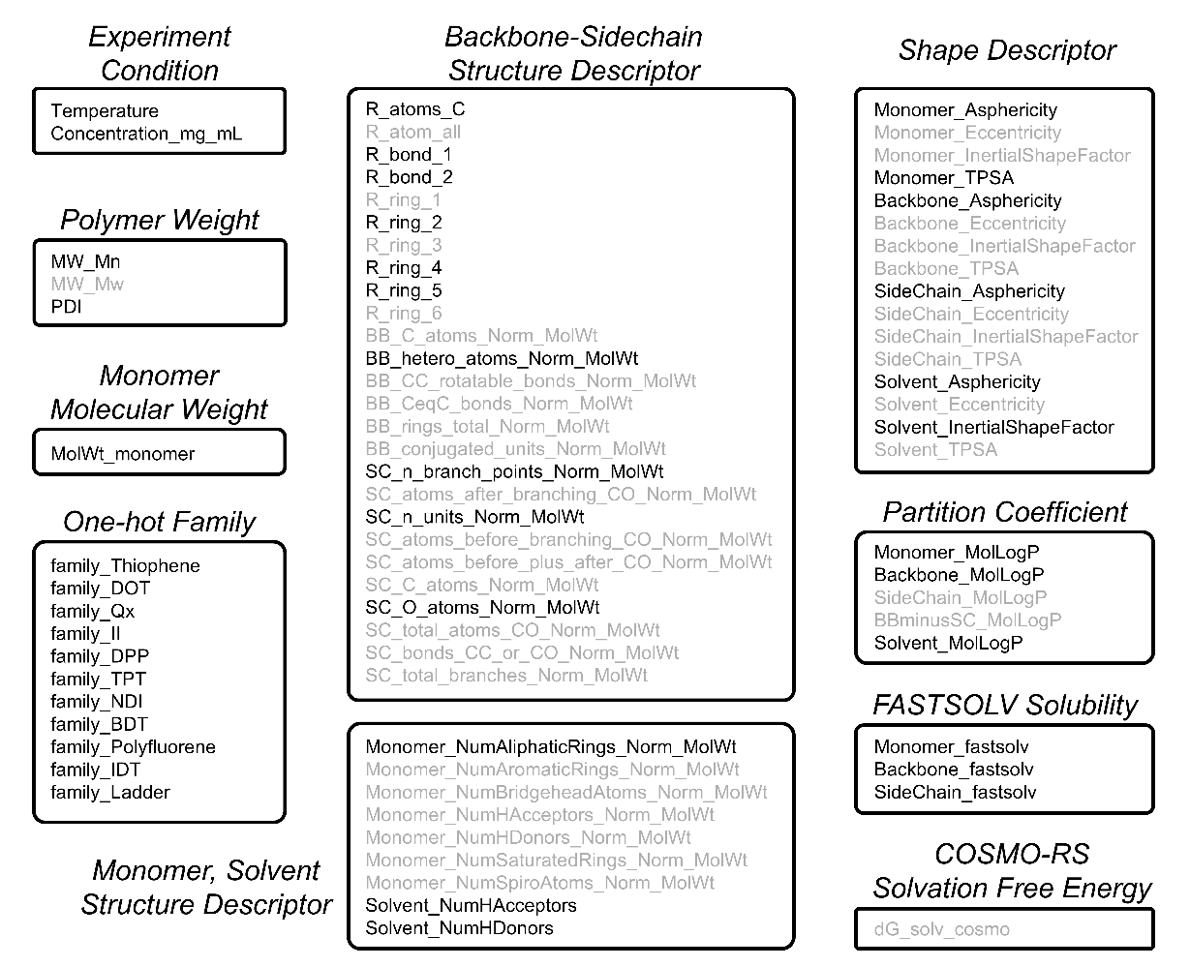
Figure S3. Complete list of the 77 features considered in this study. Features shown in black are the 41 retained after correlation-based feature pruning and used to train the ML models. Features shown in gray are the 36 excluded because of their high correlations with retained features.
A total of 77 features were considered in this study. Among them, Temperature, Concentration_mg_mL, Mw_Mn, Mw_Mw, and PDI were obtained directly from experimental measurements. MolWt_monomer was calculated from the monomer structure, whereas one-hot-encoded family features were generated from the assigned polymer families. Backbone (BB) and side-chain (SC) structural descriptors were manually derived from the polymer structures, following the definitions described in the previous work.³ Additional molecular-structure descriptors, shape descriptors, and partition coefficients were calculated using RDKit. FASTSOLV solubility descriptors were predicted using the FASTSOLV model,⁴ and COSMO-RS solvation free energies were calculated using ORCA 6.0.⁵ Additional details of the feature-generation workflow are provided in an example Jupyter notebook included in the Supporting Information.

Section S3. Selection of machine-learning framework.
To identify a suitable machine-learning framework for the present task, we compared random forest (RF), support vector machine (SVM), and a fully connected neural network (NN) using the initial processed ML dataset. For the classification task, systems with ($\left|g\right|≥0.001$) were labeled as positive cases. For the regression task, only positive cases were included, and ($\log_{10}\left|g\right|$) was used as the prediction target.
The hyperparameters of each framework were optimized using Optuna⁶ over 80 trials. During cross-validation, all measurements associated with the same polymer–solvent pair were assigned to the same fold. This grouping prevented information leakage between measurements of the same polymer–solvent pair collected at different concentrations or temperatures. Five-fold grouped cross-validation was used during hyperparameter optimization. Average precision (AP) was selected as the primary classification metric because it summarizes precision–recall performance across thresholds and is well suited to imbalanced datasets. Root-mean-square error (RMSE) was used as the primary regression metric.
After hyperparameter optimization, the best-performing configuration of each framework was evaluated using 20 repeats of grouped five-fold out-of-fold (OOF) cross-validation. Different random group assignments were used for each repeat, while measurements from the same polymer–solvent pair remained within a single fold. Model performance is reported as the mean and standard deviation across the 20 repeats in Table S2 and Table S3.

Table S2. Comparison between ML frameworks on the classification task.
 | OOF AP | OOF Precision@0.5 | Baseline Positive Rate
Random Forest (RF) | 0.781 ± 0.019 | 0.738 ± 0.019 | 0.360
Supporting Vector Machine (SVM) | 0.751 ± 0.018 | 0.715 ± 0.023 | 0.360
Neural Network (NN) | 0.781 ± 0.027 | 0.702 ± 0.032 | 0.360

Table S3. Comparison between ML frameworks on the regression task.
 | OOF RMSE | OOF R² | Baseline Mean Value RMSE
Random Forest (RF) | 0.568 ± 0.008 | -0.005 ± 0.028 | 0.566
Supporting Vector Machine (SVM) | 0.563 ± 0.011 | 0.011 ± 0.038 | 0.566
Neural Network (NN) | 0.647 ± 0.038 | -0.309 ± 0.155 | 0.566

AP summarizes the precision–recall curve as a weighted average of precision across classification thresholds, with the increase in recall at each threshold serving as the weight:
As shown in Table S2, RF exhibited the highest classification performance among the three frameworks and was therefore selected for subsequent classification and interpretation analyses. The final RF classifier used 1,100 trees, a maximum tree depth of 12, a minimum of two samples per leaf, a minimum of two samples required to split an internal node, 50% of the features considered at each split, balanced class weights, and bootstrap sampling.
In contrast, all three regression frameworks showed limited predictive performance for the magnitude of chirality, as indicated by their low or negative grouped OOF coefficient of determination, R², values in Table S3.
These results suggest that the current features contain sufficient information to distinguish whether detectable chirality emerges but do not adequately capture the continuous magnitude of ($\left|g\right|$). This limitation may arise from the smaller number of positive training examples, experimental variability in the measured g-factors, and lack of relevant molecular or assembly-level information that is not represented by the current feature set. Consequently, the RF classification model, rather than the regression models, was used as the primary predictive framework in this study.

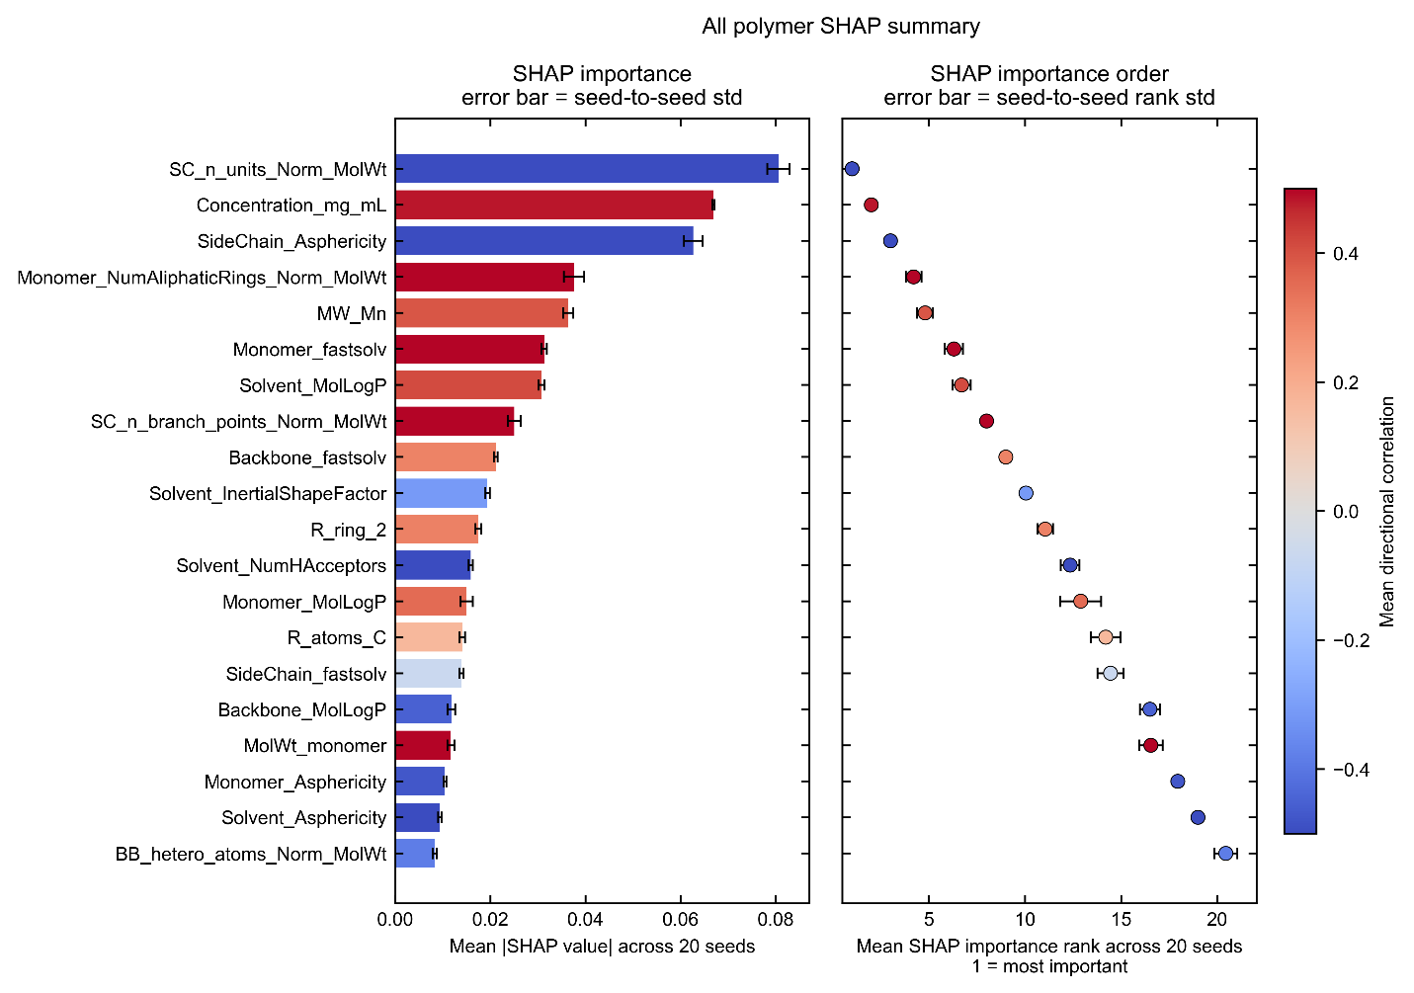
Figure S4. SHAP importance and importance-rank stability of the top 20 features for the RF classification model trained on the full polymer dataset. The left panel shows the mean absolute SHAP value of each feature averaged over 20 random seeds, with error bars indicating the seed-to-seed standard deviation. The right panel shows the corresponding mean SHAP importance rank, where a lower rank indicates greater importance, with error bars indicating the seed-to-seed standard deviation in rank. Features are colored according to their mean directional correlation with the model output, with red indicating a positive association and blue indicating a negative association.

Section S4. Family related RF classification model performance.
Table S4. Results of leave-one-family-out evaluation.
Family Name | Data Point Number | Positive Rate | AP | Precision @0.5 | Recall @0.5
Thiophene | 248 | 0.129 | 0.101 | 0.000 | 0.000
NDI | 143 | 0.469 | 0.754 | 0.671 | 0.634
II | 130 | 0.546 | 0.872 | 0.578 | 0.803
Qx | 69 | 0.232 | 0.326 | 0.320 | 0.550
DPP | 65 | 0.723 | 0.899 | 0.963 | 0.551
DOT | 37 | 0.486 | 0.641 | 0.500 | 0.006
TPT | 36 | 0.000 | NaN | 0.000 | NaN
BDT | 20 | 0.250 | 0.363 | NaN | 0.000
Ladder | 16 | 0.438 | 0.292 | NaN | 0.000
Polyfluorene | 6 | 1.000 | 1.000 | NaN | 0.000
IDT | 3 | 0.667 | 1.000 | NaN | 0.000

The RF classifier was primarily designed to predict untested solvent and processing conditions for polymers represented in the training dataset, rather than to extrapolate to entirely unseen polymer chemistries. Nevertheless, we assessed the cross-family transferability of the modeling framework using a leave-one-family-out analysis. In each iteration, all data points belonging to one polymer family were withheld as the test set, and an RF classifier was trained using data from all remaining families. Model performance was evaluated using average precision (AP), with the positive fraction of each held-out family used as the corresponding random-ranking baseline. Predictions at a RF prediction score threshold of 0.5 were also examined to assess threshold-dependent classification performance.
The concatenated leave-one-family-out predictions yielded an overall AP of 0.614, compared with an overall positive-rate baseline of 0.351, indicating that certain predictive information is transferable across polymer families. For the held-out NDI, II, Qx, DPP, and DOT families, the AP values exceeded their respective positive-rate baselines. The strongest relative improvements were observed for NDI and II, followed by DPP and DOT, whereas the improvement for Qx was more modest. These results indicate that the descriptors learned from the remaining families retain some ability to rank positive and negative cases within these held-out families.
However, an AP above the positive-rate baseline does not necessarily imply that the RF prediction scores are well calibrated for the unseen family. For example, the DOT family exhibited an AP of 0.641, compared with a positive rate of 0.486, but only a few of its data points were classified as positive at a RF prediction score threshold of 0.5. Thus, the model retained useful ranking information for this family, while systematically assigning RF prediction scores below 0.5. Similar family-dependent differences between ranking performance and threshold-based classification indicate that a decision threshold established using the training families may not transfer directly to a structurally distinct family.
For the Thiophene and Ladder groups, the AP values were lower than their positive-rate baselines, indicating little or no useful cross-family ranking performance. In particular, the Thiophene family contained a relatively low positive fraction and occupied a substantial portion of the dataset, yet its positive cases were not successfully distinguished by a model trained without thiophene-based polymers. The Ladder category also showed poor transferability, which is unsurprising because it shows very different structure compared to other polymers.
The TPT family contained no positive data points; therefore, AP and recall were undefined for this held-out set. At a RF prediction score threshold of 0.5, the model incorrectly classified 9 of 36 TPT data points as positive. These false-positive predictions further demonstrate that models trained on the remaining families cannot reliably establish the absolute classification boundary for these unseen chemical families.
Overall, the leave-one-family-out analysis demonstrates partial but strongly family-dependent transferability. The current descriptors capture relationships that generalize to several polymer families, but the model does not consistently extrapolate across all backbone and side-chain chemistries, and its RF prediction score calibration can shift substantially for an unseen family. Therefore, predictions for polymers outside the chemical domain represented in the training dataset should be treated as exploratory and require experimental validation or model updating with representative data from the new polymer family.
We also performed leave-one-polymer-out and leave-one-solvent-out analyses. Pooling the held-out predictions yielded overall APs of 0.671 and 0.680, respectively, supporting the model’s ability to generalize to unseen polymers within represented polymer families. The results of ten most frequent solvents in the dataset are shown in Table S5, the obvious larger AP comparing to baseline indicates the good performance to unseen solvents.
Table S5. Results of leave-one-solvent-out evaluation.
Solvent Name | Data Point Number | Positive Rate | AP | Precision @0.5 | Recall @0.5
Chlorobenzene | 206 | 0.510 | 0.845 | 0.942 | 0.463
Chloroform | 113 | 0.478 | 0.735 | 0.960 | 0.444
o-Dichlorobenzene | 83 | 0.422 | 0.934 | 0.888 | 0.766
  o-Dichlorobenzene
Anisole | 72 | 0.125 | 0.389 | 0.357 | 0.556
Toluene | 46 | 0.348 | 0.884 | 0.765 | 0.813
p-Xylene | 43 | 0.256 | 0.731 | 0.786 | 1.000
PGMEA | 39 | 0.077 | 1.000 | 0.247 | 1.000

Table S6. Performance of the RF classification models on the total dataset and family-specific subsets.
ML Dataset | Baseline Positive Rate | OOF AP | OOF Precision@0.5
All Polymer | 0.351 | 0.798 ± 0.017 | 0.733 ± 0.018
Thiophene Family | 0.127 | 0.511 ± 0.066 | 0.503 ± 0.074
NDI Family | 0.469 | 0.848 ± 0.019 | 0.804 ± 0.035

To examine whether the factors governing chiral emergence differ among polymer families, we separately trained RF classification models on the Thiophene and NDI subsets and subsequently performed family-specific SHAP analyses. The predictive performance of these models is summarized in Table S6. For these family-specific datasets, the OOF AP was substantially higher than the corresponding positive-rate baseline, indicating that the models captured nonrandom relationships between the input features and the classification labels within each family. The NDI model showed particularly strong predictive performance, whereas the Thiophene model exhibited lower absolute performance but still substantially exceeded its low positive-rate baseline. These results support the use of SHAP analysis to interpret the feature–prediction relationships learned by the family-specific RF models, while recognizing that the resulting feature importance reflects patterns within each individual family rather than universally transferable design rules.

Section S5. Solubility-based evidence supporting the proposed mechanism of chiral LLC formation.
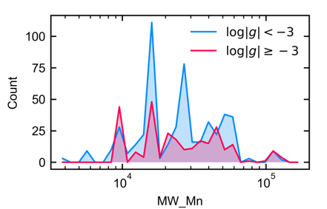
Figure S5. Distributions of negative $\left(log∣g∣<-3\right)$ and positive $\left(log∣g∣≥-3\right)$ cases with respect to the polymer molecular weight used in the SHAP analysis of RF classification models trained on full processed ML dataset. Achiral cases dominate below approximately ${10}^{4}$, chiral cases are most prevalent around this molecular-weight range, and the relative fraction of achiral cases increases again at higher molecular weights.
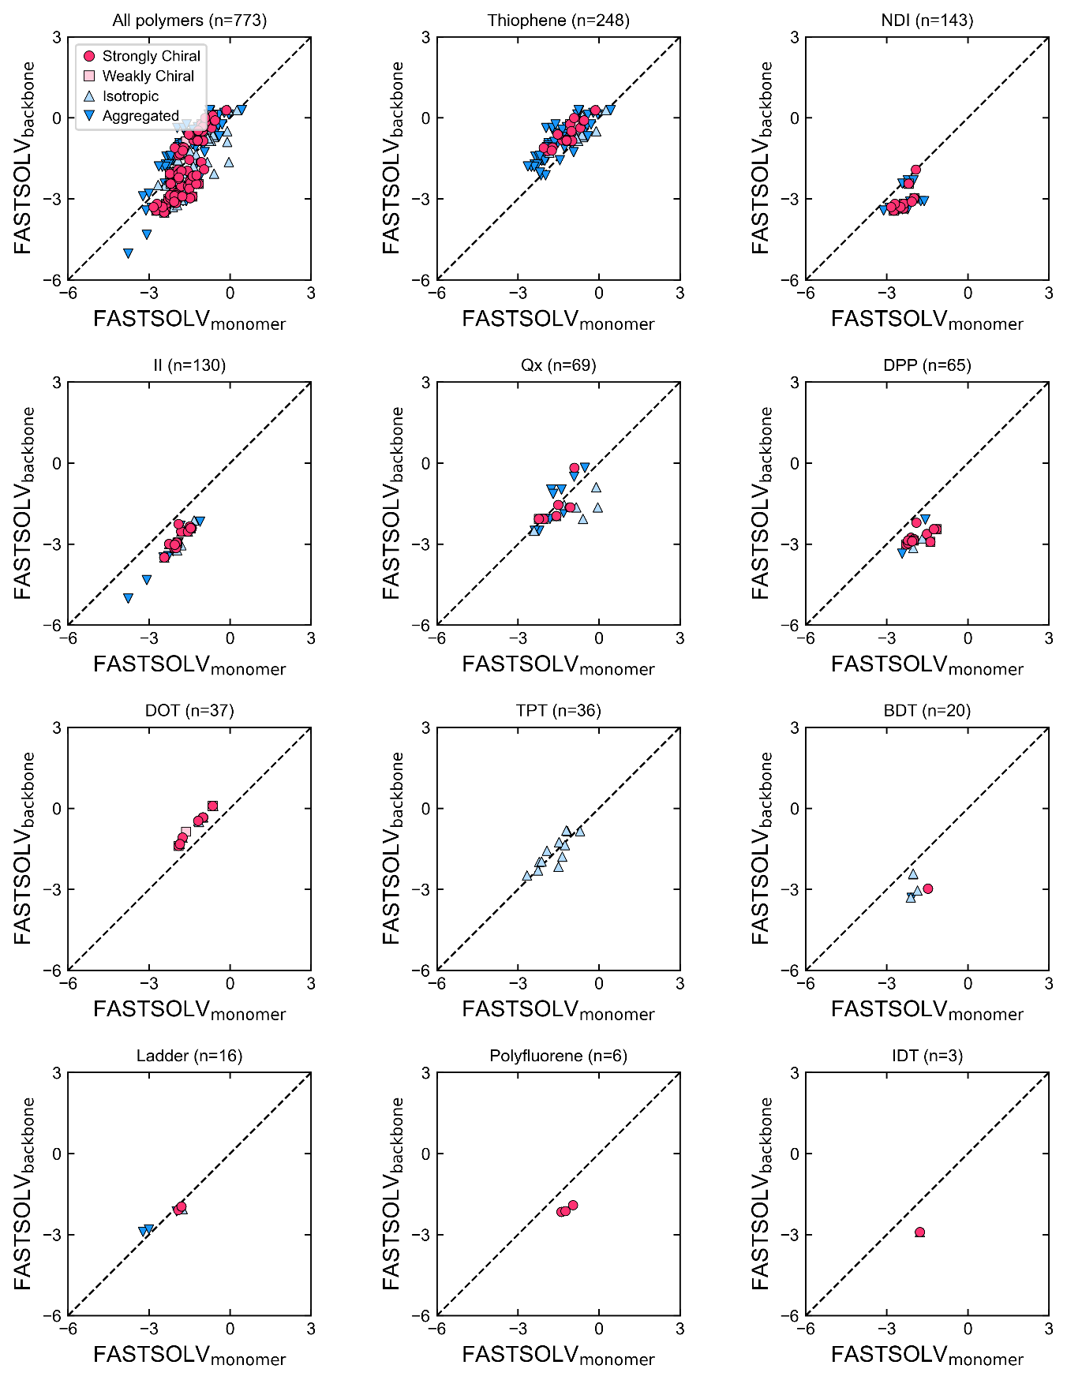
Figure S6. Experimental distribution of assembly outcome in the two-dimensional space defined by the FASTSOLV-derived monomer and backbone solubility descriptors. Results are shown for the complete dataset and individual polymer families. The number of experimental data points in full processed ML dataset are indicated by $n$ in the title of each panel.
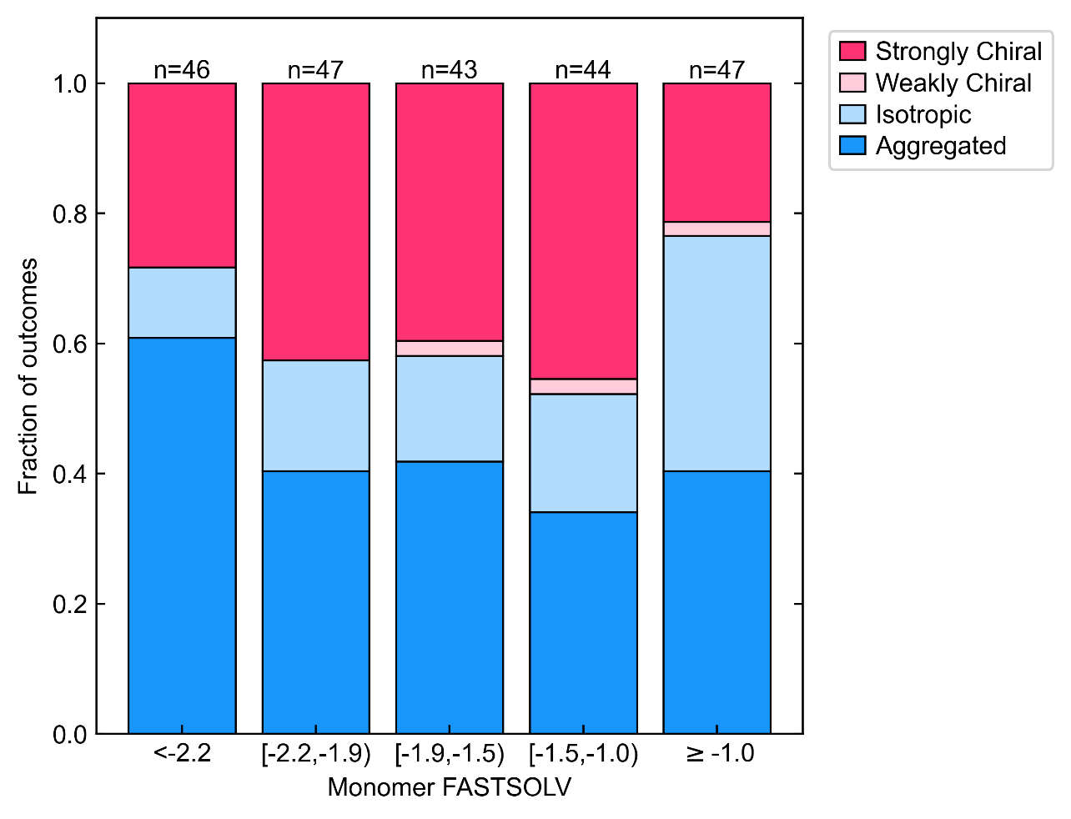
Figure S7. Relationship between monomer FASTSOLV and assembly outcome. Assembly outcomes are grouped into five monomer FASTSOLV ranges and shown as binned fractions of strongly chiral (red), weakly chiral (light red), isotropic (light blue), and aggregated (blue) outcomes. The number above each bar indicates the total number of polymer–solvent–temperature conditions within each FASTSOLV range. At higher monomer FASTSOLV values, isotropic outcomes become increasingly prevalent, whereas chiral outcomes are most enriched within an intermediate FASTSOLV regime.

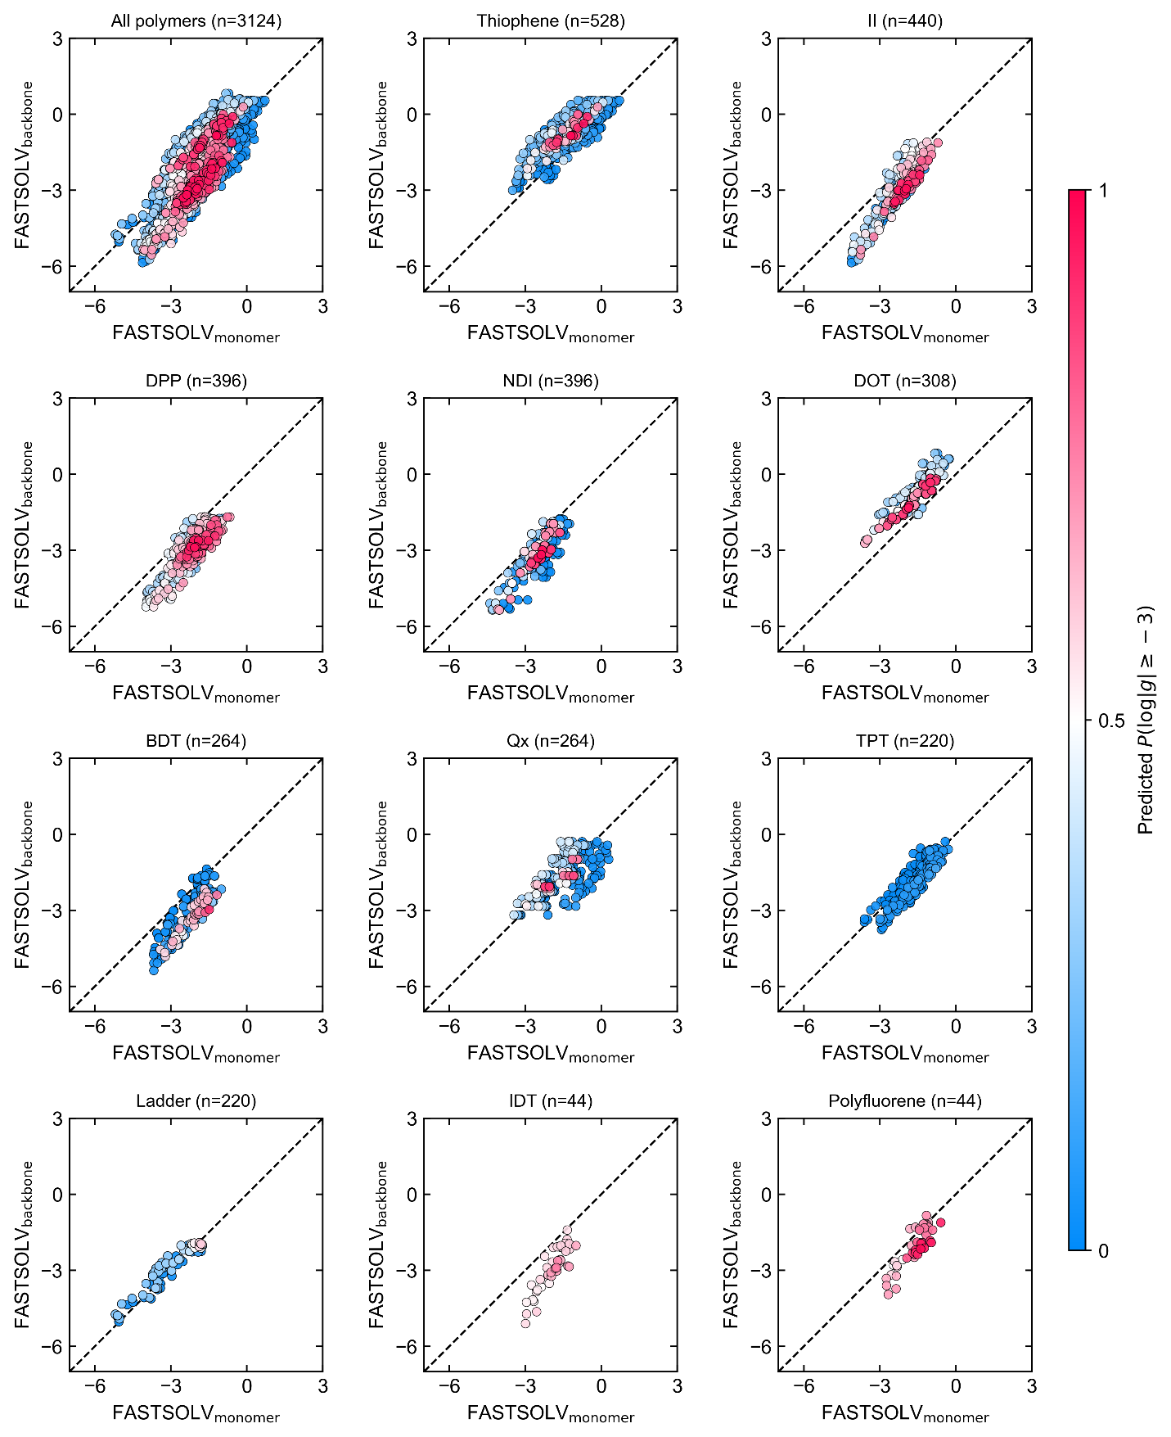
Figure S8. RF prediction score of ${log⁡}_{10}∣g∣≥-3$ in the two-dimensional space defined by the FASTSOLV-derived monomer and backbone solubility descriptors for the expanded polymer–solvent dataset. The number of generated polymer–solvent pairs (number of polymers × 44 solvents) are indicated by $n$ in the title of each panel.
The experimental and RF-predicted distributions with respect to the solubility-related descriptors are summarized in Figures S4-S8. The one-dimensional distributions in Figure S4 do not show a simple monotonic relationship between chiral emergence and FASTSOLV-derived monomer solubility descriptor. Instead, positive cases are concentrated predominantly within intermediate range, whereas the lowest and highest values contain comparatively fewer positive cases. This qualitative trend suggests that chiral LLC formation may require an optimal solvent environment rather than simply increasing with solubility.
The experimental data were further projected onto the two-dimensional plane defined by the FASTSOLV-derived monomer and backbone solubility descriptors (Figure S5). Across the full dataset, positive cases and larger ($\left|g\right|$) values occur primarily within an intermediate region of this plane.
To examine the model response over a broader polymer–solvent chemical space, we plotted RF prediction scores for the expanded set of polymer–solvent combinations (Figure S7). The RF model generally assigns higher RF prediction scores of ($\log_{10}\left|g\right|≥-3$) within intermediate solubility regimes, while lower RF prediction scores are observed toward the extreme high- and low-solubility regions.
Taken together, these observations are consistent with a balanced-solvation hypothesis for chiral LLC formation. An intermediate solvent regime may provide a balance between solubilization and intermolecular association that facilitates chiral mesophase formation. The present analysis identifies a statistical association consistent with the hypothesis but does not by itself establish a causal mechanism.
The FASTSOLV descriptors should nevertheless be interpreted with caution. FASTSOLV was developed primarily to predict the solubility of small organic molecules⁴ and does not explicitly account for polymer molecular weight, chain conformation, aggregation, crystallinity, or polymer-specific solution thermodynamics. Here, FASTSOLV predictions for the monomer, backbone, and side-chain fragments are therefore used as proxy descriptors of relative polymer–solvent compatibility rather than as quantitative predictions of whole-polymer solubility. Furthermore, the RF prediction score maps in Figure S7 are generated by an RF model that uses these FASTSOLV descriptors as input features and should therefore be viewed as visualizations of the relationships learned by the model, rather than as independent validation of the solubility hypothesis. Predictions in sparsely represented or extrapolative regions of the descriptor space remain uncertain. Polymer-specific solvation models and additional experimental measurements will be required to quantitatively resolve how solvent quality governs chiral LLC formation.

Section S6. Additional results for feature analysis.
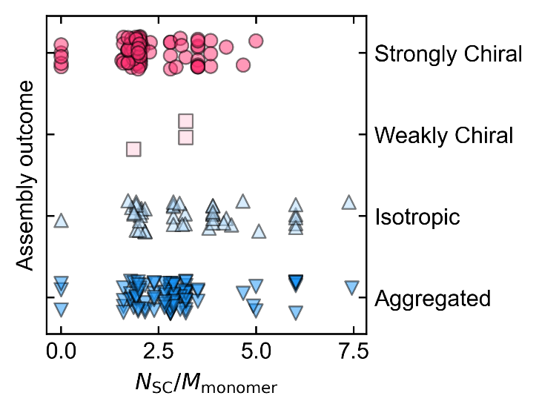
Figure S9. Experimentally observed assembly outcomes plotted as a function of normalized side-chain content. Each condition is classified as strongly chiral, weakly chiral, isotropic, or aggregated outcomes.

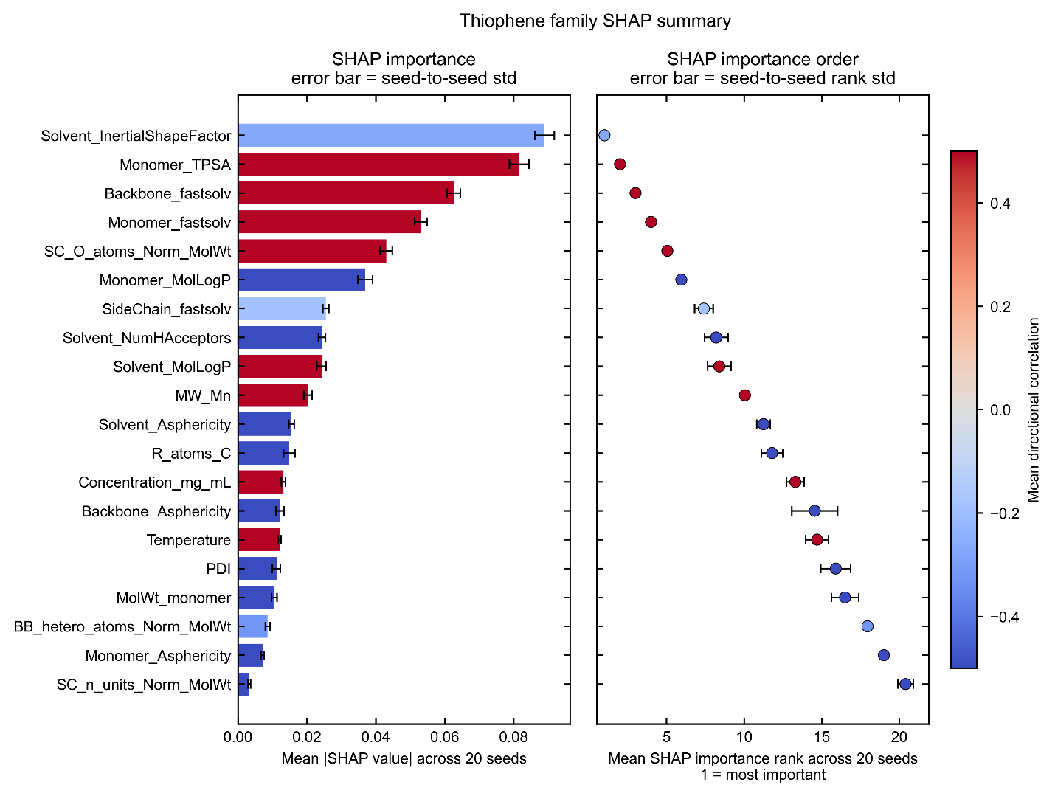
Figure S10. SHAP importance and importance-rank stability of the top 20 features for the RF classification model trained on the thiophene family subset. All quantities, error bars, and color conventions are defined as in Figure S4.

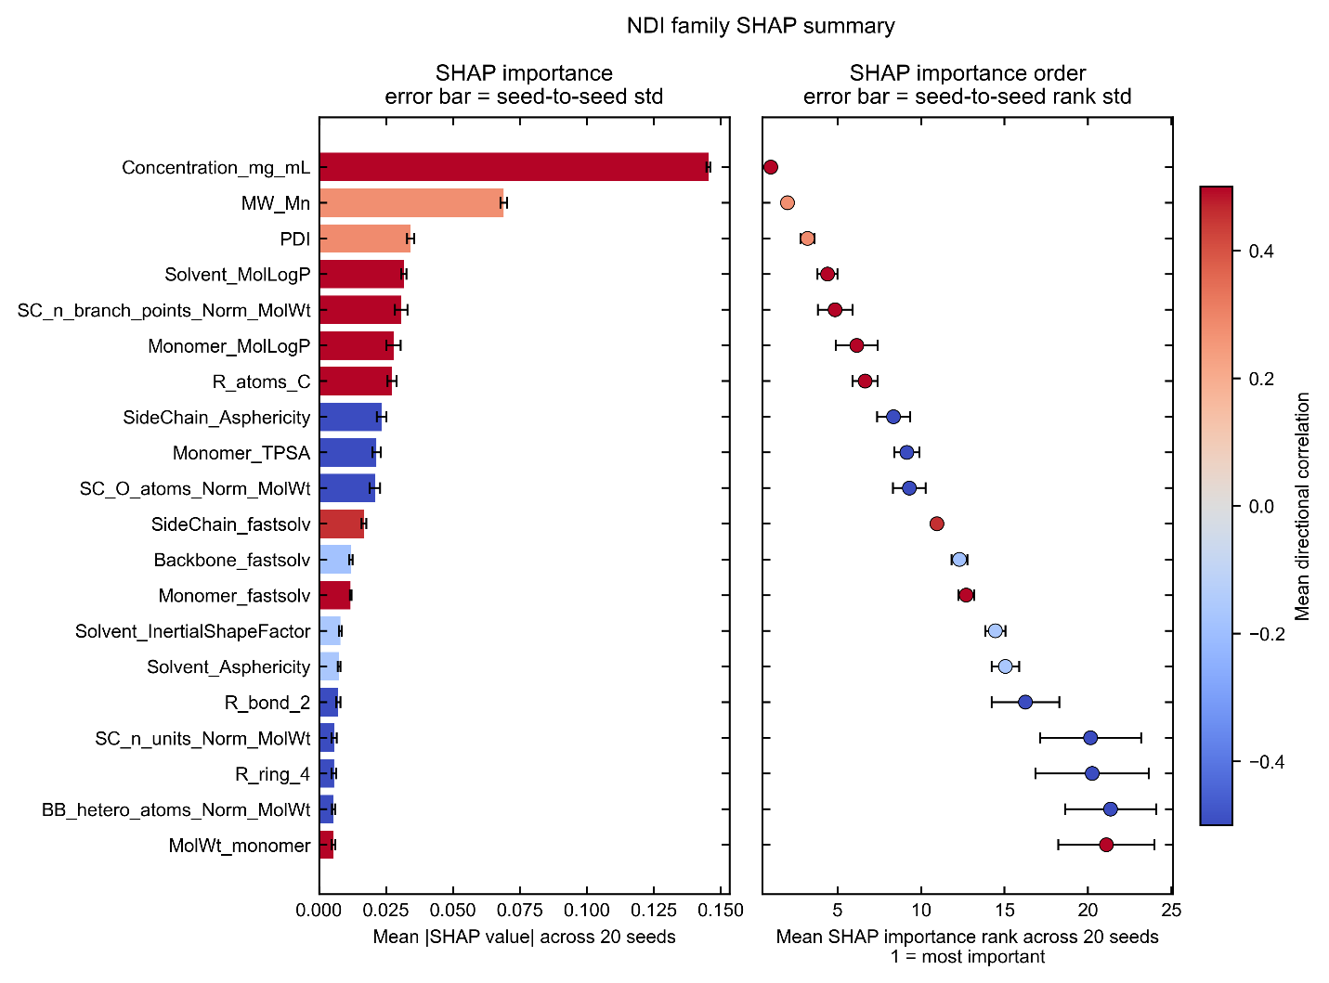
Figure S11. SHAP importance and importance-rank stability of the top 20 features for the RF classification model trained on the NDI family subset. All quantities, error bars, and color conventions are defined as in Figure S4.
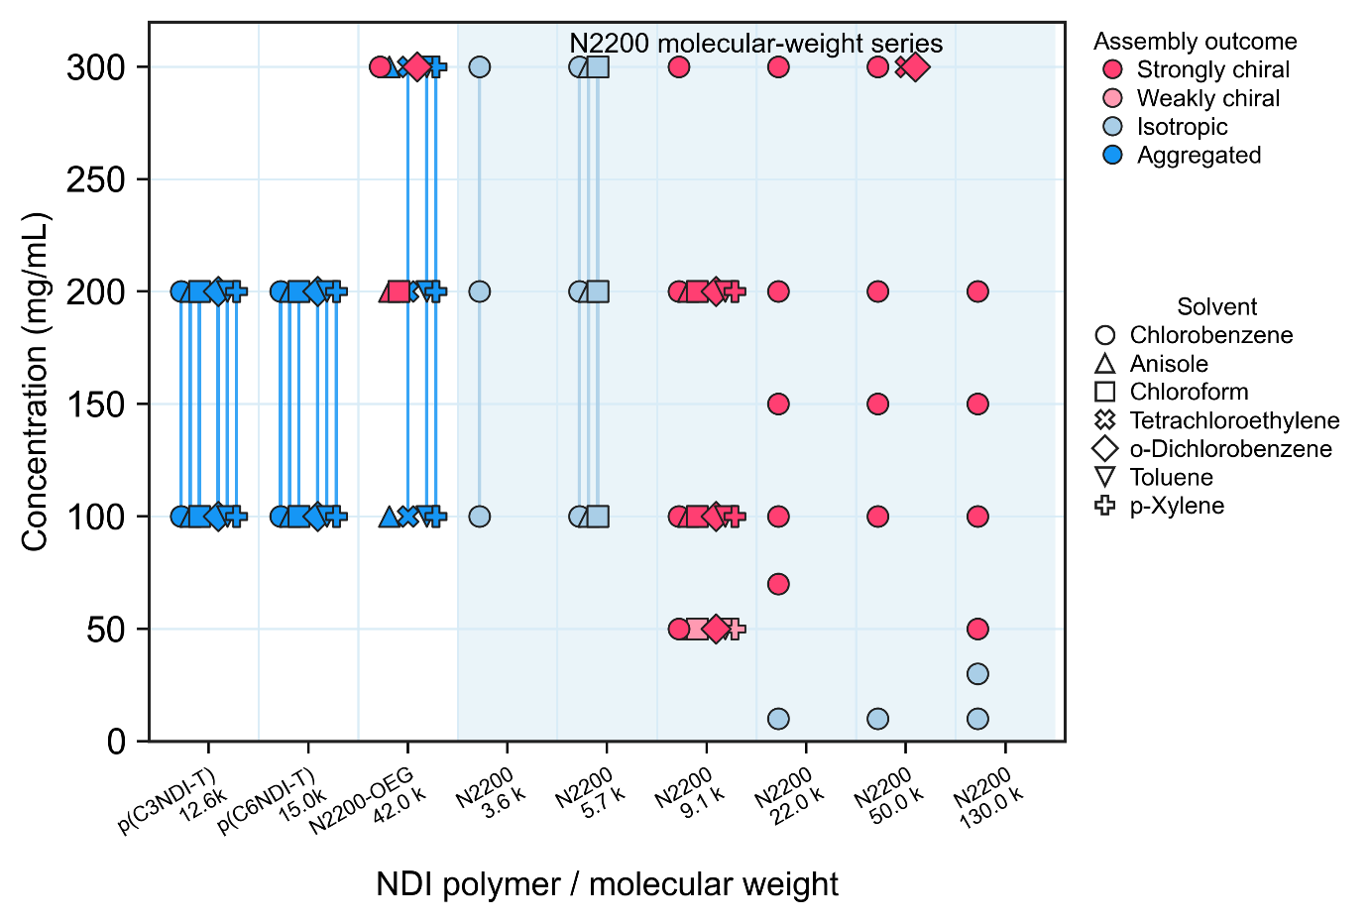
Figure S12. Concentration-resolved experimental assembly outcomes for NDI-family polymers, including p(C3NDI-T), p(C6NDI-T), N2200-OEG, and N2200 with six different molecular weights. Colors indicate strongly chiral (red), weakly chiral (light red), isotropic (light blue), and aggregated (blue) outcomes, while marker shapes distinguish solvent conditions. Vertical segments indicate conditions for which the concentration was reported as a range. The shaded region highlights the N2200 molecular-weight series.

Reference
(1) Yao, Y.; Ugras, T. J.; Meyer, T.; Dykes, M.; Wang, D.; Arbe, A.; Bals, S.; Kahr, B.; Robinson, R. D. Extracting Pure Circular Dichroism from Hierarchically Structured CdS Magic Cluster Films. ACS Nano 2022, 16 (12), 20457–20469. https://doi.org/10.1021/acsnano.2c06730.
(2) Yin, W.; Dong, Y.; Zhang, R.; Zhao, B.; Deng, J. Anisotropic Artifacts Coupled with Light-Scattering Generating “Non-Reciprocal-Like” CD/CPL Signals in Polyurethane Films. Macromolecules 2025, 58 (18), 9660–9671. https://doi.org/10.1021/acs.macromol.5c00577.
(3) Xu, Z.; Wang, Z.; Zhang, R.; Verma, A.; Neu, J. S.; Bairagya, P.; Jeon, S.; Damron, A. M.; Rinehart, J. M.; Wagner, J. S.; Sabury, S.; Luo, X.; Österholm, A. M.; Mei, J.; Moore, J. S.; You, W.; Reynolds, J. R.; Jackson, N. E.; Diao, Y. Ubiquitous Chiral Symmetry Breaking of Conjugated Polymers via Liquid–Liquid Phase Separation. J. Am. Chem. Soc. 2025, 147 (37), 33530–33544. https://doi.org/10.1021/jacs.5c07995.
(4) Attia, L.; Burns, J. W.; Doyle, P. S.; Green, W. H. Data-Driven Organic Solubility Prediction at the Limit of Aleatoric Uncertainty. Nature Communications 2025, 16 (1). https://doi.org/10.1038/s41467-025-62717-7.
(5) Neese, F. Software Update: The ORCA Program System—Version 6.0. Wiley Interdisciplinary Reviews: Computational Molecular Science. John Wiley and Sons Inc March 1, 2025. https://doi.org/10.1002/wcms.70019.
(6) Akiba, T.; Sano, S.; Yanase, T.; Ohta, T.; Koyama, M. Optuna: A Next-Generation Hyperparameter Optimization Framework. In Proceedings of the ACM SIGKDD International Conference on Knowledge Discovery and Data Mining; Association for Computing Machinery, 2019; pp 2623–2631. https://doi.org/10.1145/3292500.3330701.

