Task 1 – Fiji basics

1. Open the two images listed in the presentation. To do so, right-click the link on the presentation, go to “Copy Link Location”, then go to Import -> URL in Fiji. Do it for both images here: “01–Photo.tif” and “02-Biological_Image.tif”.  
   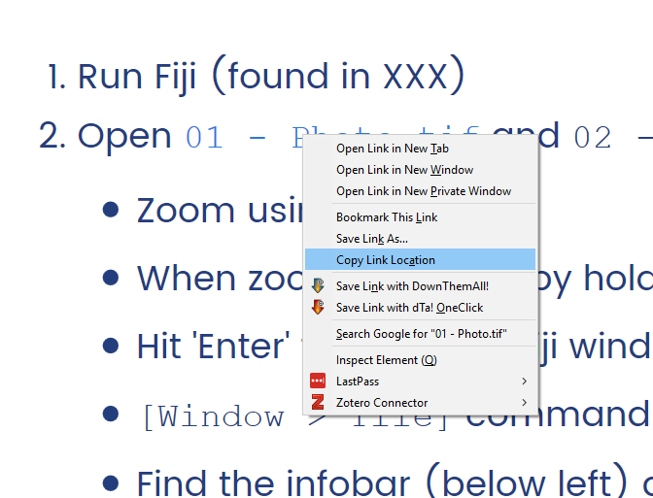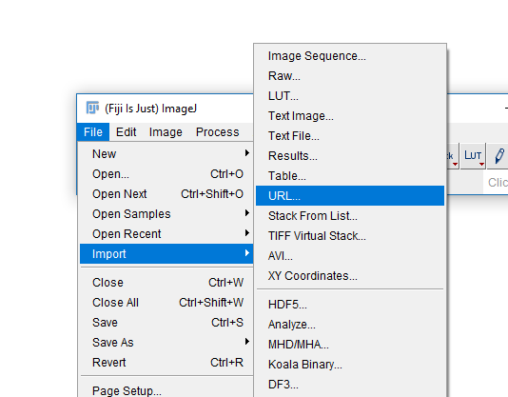
2. You should now have two new windows in Fiji with your two images.  
   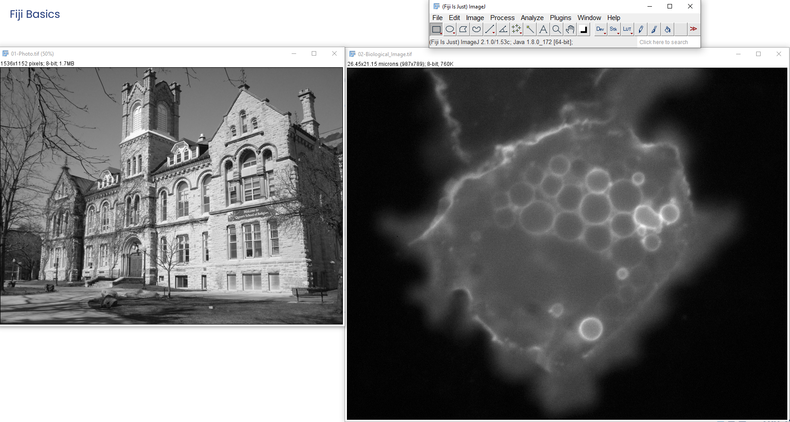
3. If you end up with an image of a clown, you have not copied the link correctly in step 1!
4. With one of the images selected, use the + and – keys to zoom in and out. Alternatively, hold Ctrl and use your mouse wheel.
5. While zoomed in, hold Space and click-and-drag in the image to pan around.
6. Try hitting enter to bring up the main Fiji window to the foreground. This is very useful when you end up with a lot of windows and need to run a specific command from a menu!
7. Go to Window -> Tile. It will arrange windows so that all open images can be seen at the same time.
8. The info bar (on the left top of your image window) gives you some important information on your image.  
   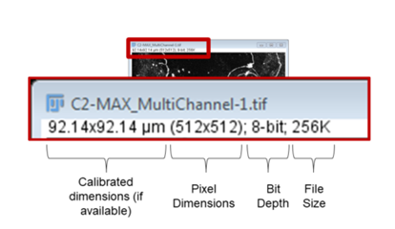
9. The status bar (left bottom of your **main** Fiji window) gives current cursor coordinates and actual pixel values.  
   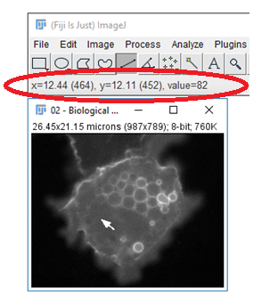
10. By the information in the info bar, you can see whether your image is calibrated (i.e. whether Fiji knows how big things are in “real” units of measurement). Going to Image -> Properties allows you to see and change the calibration if necessary. Make sure those are correct, all measurements Fiji makes will use that data as a starting point!