Task 2 – Basic intensity adjustments

1. Open the image listed in the presentation. To do so, right-click the link on the presentation, go to “Copy Link Location”, then go to Import -> URL in Fiji. Do it for the image we will use: “02-Biological_Image.tif”.  
   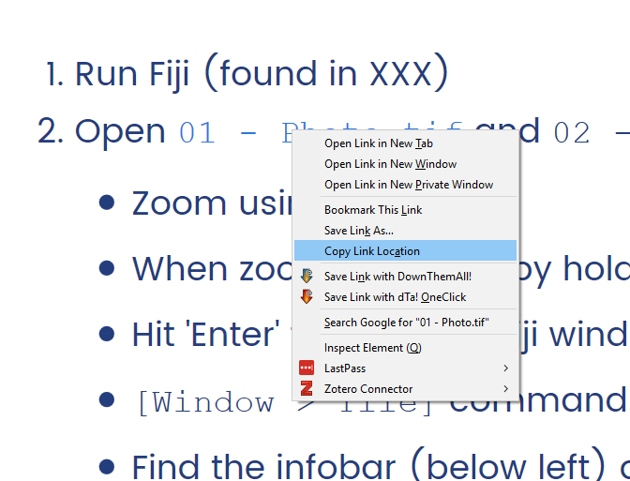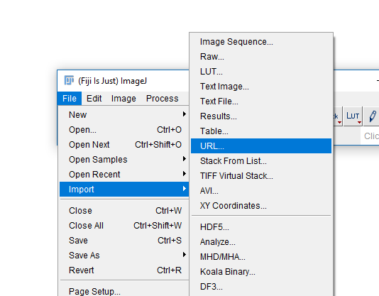
2. You should now have a new window in Fiji with your image.  
   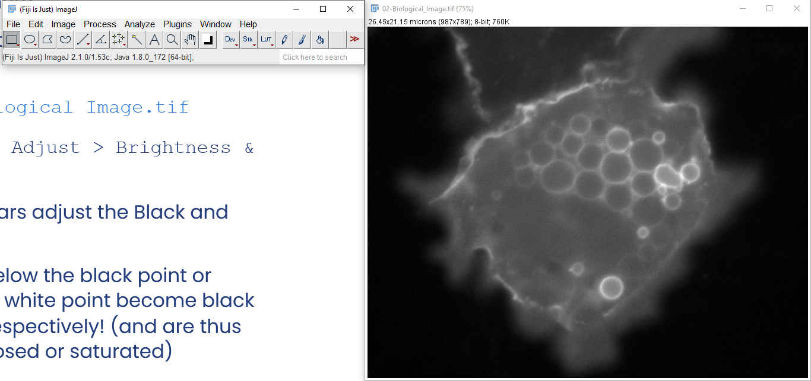
3. If you end up with an image of a clown, you have not copied the link correctly in step 1!
4. Run Image -> Adjust -> Brightness and Contrast.
5. The top two bars will adjust which points will correspond to black and white. All data below the black point and above the white point will become black or white respectively!   
   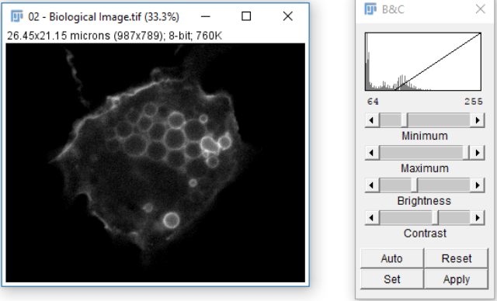
6. The “Reset” button will stretch your black and white point to close to the maximum possible range. The “Set” button will allow you to manually type values for the black and white points, and “Apply” will write in the adjustments to actual pixel values in your image.  
   WORD OF WARNING: NEVER EVER EVER use the “Apply” button on your original image. It will overwrite your original values. (be careful on using this button, even on a copy of the original image. No quantitative measurements should be made after using it.)
7. Draw a large rectangle on your image using the rectangle  tool.   
   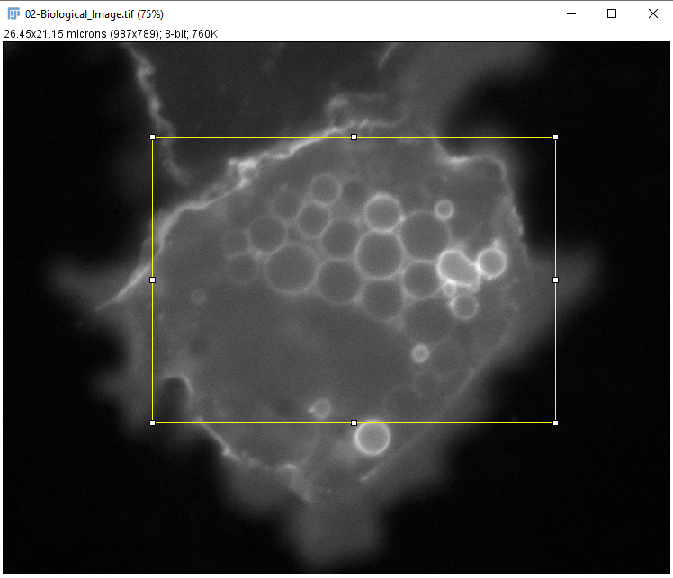
8. Go to Image -> Crop. It will crop the original image to your current selection. Create a copy of this new image by going to Image -> Duplicate. Rename this new copy using Image -> Rename.  
   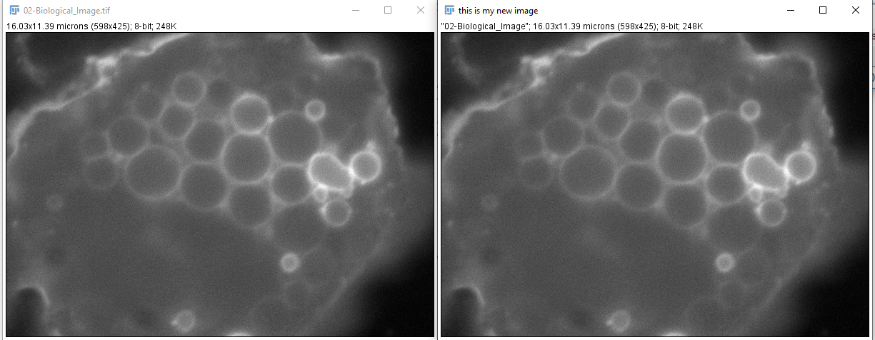
9. Select the copy you have created and go to Image -> Scale. Choose “X Scale” and “Y Scale” to be 2. Press OK.  
   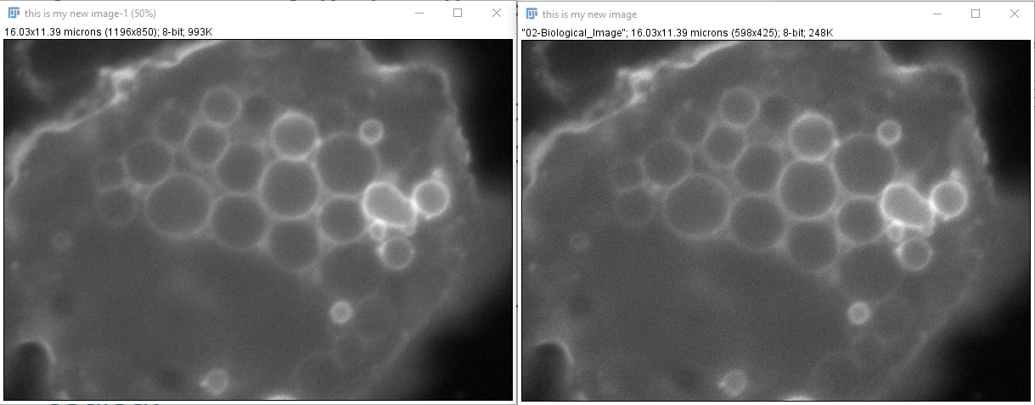
10. Check the calibration of this new, scaled-up version of your image, and the calibration of the version that was not scaled. What is the difference? Why are they different?