Task 3 – Making measurements and adding a scale bar

1. Open the image listed in the presentation. To do so, right-click the link on the presentation, go to “Copy Link Location”, then go to Import -> URL in Fiji. Do it for the image we will use: “02-Biological_Image.tif”.  
   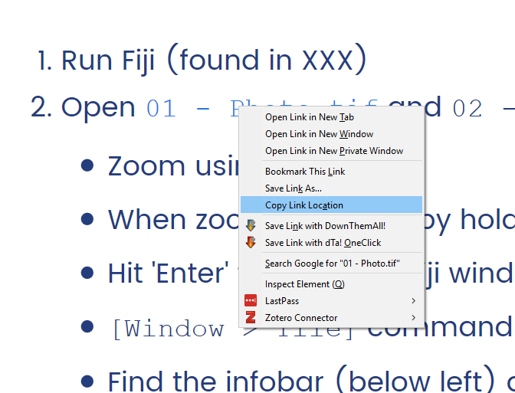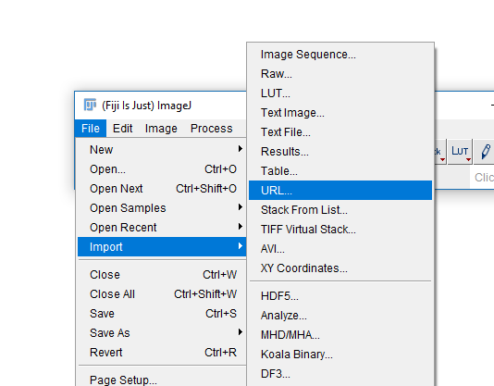
2. You should now have a new window in Fiji with your image.  
   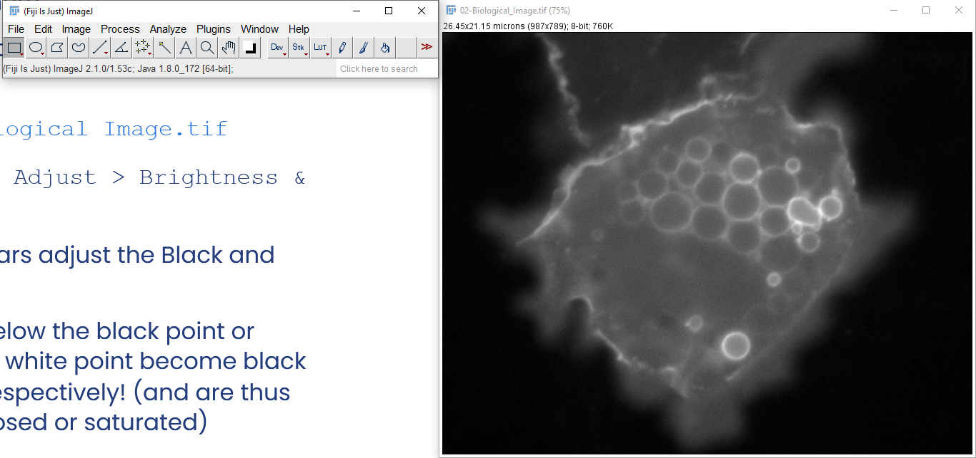
3. If you end up with an image of a clown, you have not copied the link correctly in step 1!
4. Select the Line  selection tool from the main Fiji Window.
5. Draw a line over your image. If you want to make perfectly horizontal/vertical lines, holding Shift makes your line change in 45-degree increments.
6. Hit ‘m’ or run Analyze -> Measure. This should give you some data about the line you have drawn, such as maximum and minimum pixel values along it, and length.
7. The measurements you see here can be changed by going to Analyze -> Set Measurements and picking which measures you want to calculate when using that function.
8. Now, run Analyze -> Plot Profile. What do the results mean?  
   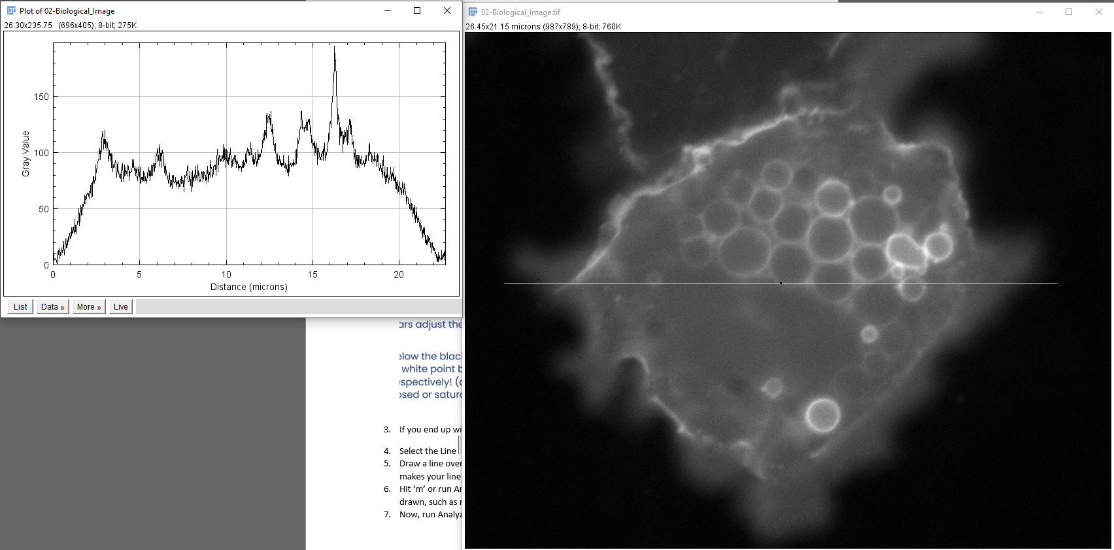
9. Now select the Rectangle  tool. Draw a rectangle on your image and press ‘m’ (or Analyze -> Measure). What are the differences from the previous measures you have seen for your line?
10. Now, we are going to make multiple selections and keep track of them.
11. Make any selection you want; pick any of the selection tools you feel like using and draw a region in our image.
12. Hit ‘t’ or run Edit -> Selection -> Add to Manager.
13. Repeat multiple times drawing new regions every time.   
    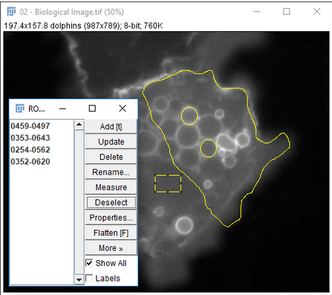
14. Now, on your ROI Manager window, run More -> Multi-measure. You should get measurements for every region you have drawn at once!  
    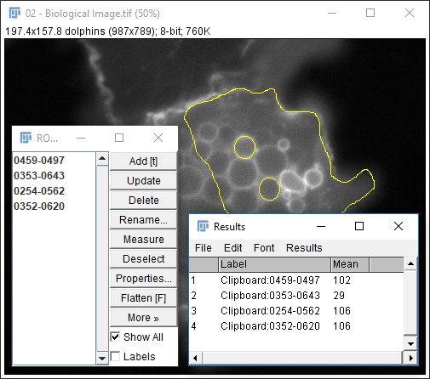
15. For good data provenance, make sure to use More -> Save to save the regions you draw, so that later on you can see exactly which areas you have defined to achieve the measurements you obtained.
16. Finally, let us add a scale bar to the image. First, we need to make sure the image is properly calibrated. Check the info bar or run Image -> Properties.
17. Run Analyze -> Tools -> Scale Bar. If your calibration is correct, this should be automatically correct. Feel free to change the settings here and press ok. That is it!  
    