Task 4 – Channels and colors

1. Open the image listed in the presentation. To do so, right-click the link on the presentation, go to “Copy Link Location”, then go to Import -> URL in Fiji. Do it for the image we will use: “06-MultiChannel.tif”.  
   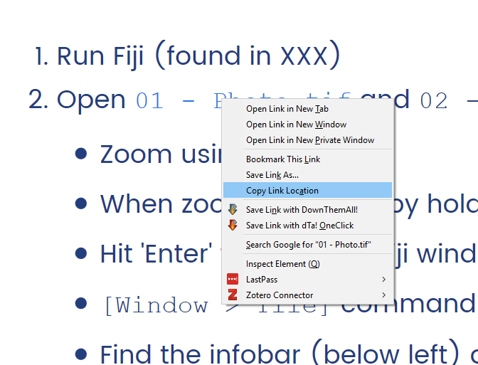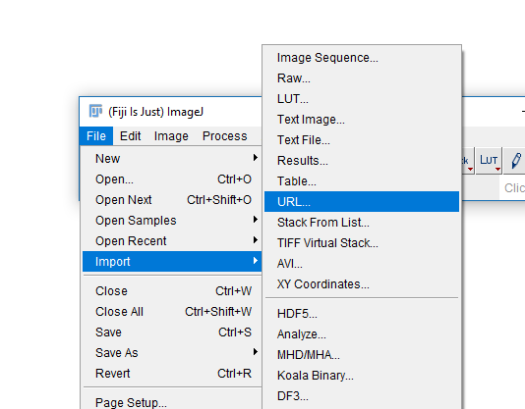
2. You should now have a new window in Fiji with your image.  
   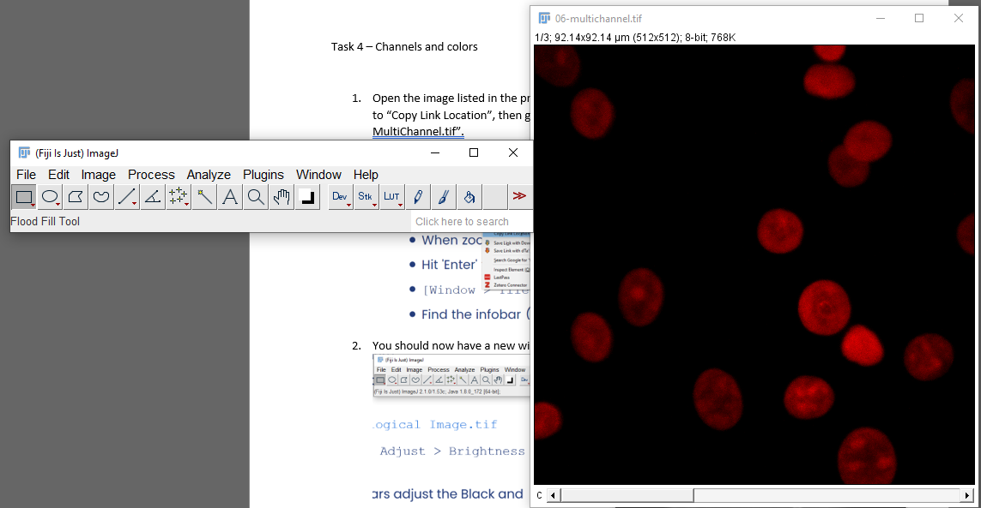
3. If you end up with an image of a clown, you have not copied the link correctly in step 1!
4. Navigate through the channels using the bottom bar in your image window.
5. Run Image -> Color -> Channels Tool. Change the dropdown to “Grayscale”. What changed in the main image? What are the advantages and disadvantages of this change?  
   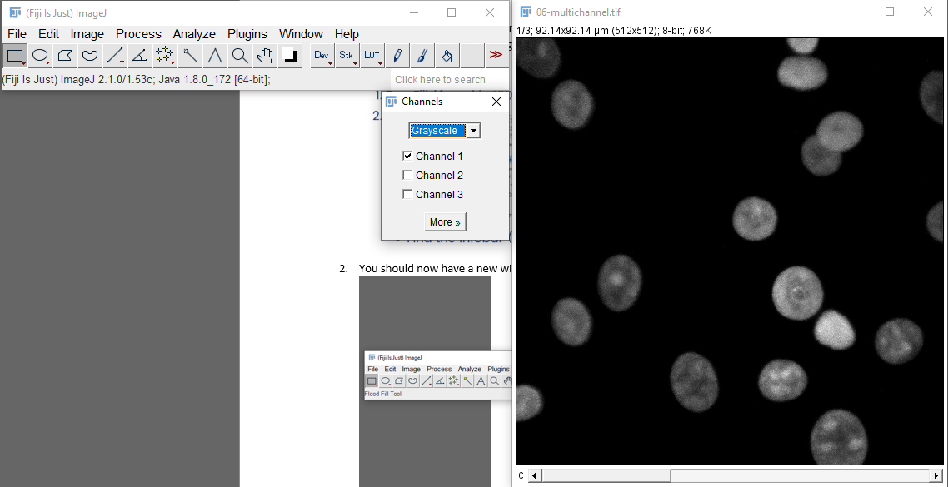
6. Now change the dropdown to “Composite”. What do you see now? Use the checkboxes to turn channels on and off.   
   Map

   Description automatically generated
7. Try changing channels now using the bottom bar in your image window. What happens now? Pay particular attention to the info bar.
8. What happens if you change the black and white points (Image -> Adjust -> Brightness and Contrast)? How does that relate to the image margins and info bar?
9. Try drawing a region on your image and measure it (press ‘m’ or run Analyze -> Measure). What is being measured here? What conclusion can you draw from the last few tasks?