Task 5 – Lookup Tables

1. Open the image listed in the presentation. To do so, right-click the link on the presentation, go to “Copy Link Location”, then go to Import -> URL in Fiji. Do it for the image we will use: “06-MultiChannel.tif”.  
   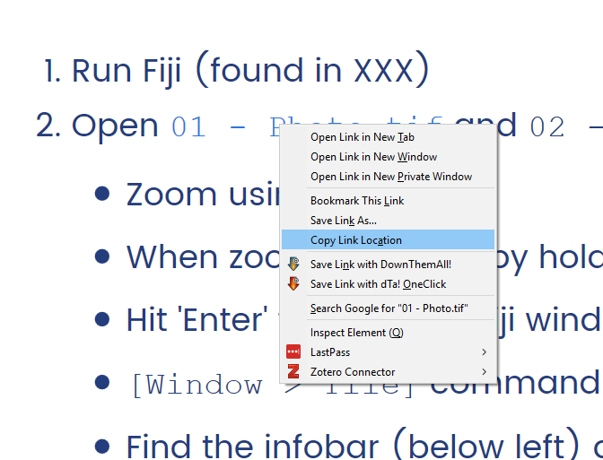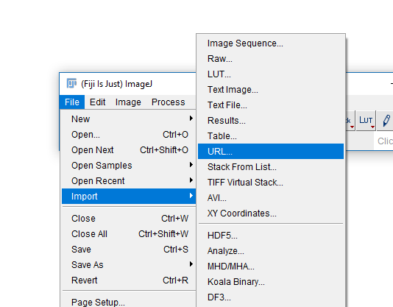
2. You should now have a new window in Fiji with your image.  
   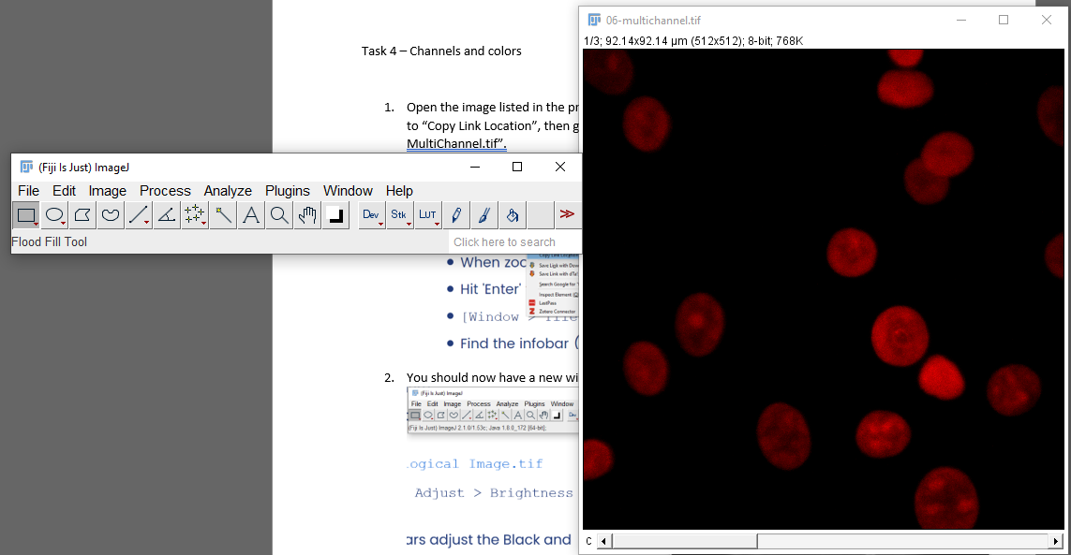
3. If you end up with an image of a clown, you have not copied the link correctly in step 1!
4. Run Image -> Lookup Tables. Try a few different ones. Which ones work well for this data? When would you use “Grays”?
5. Run Image -> Color -> Channels Tool. Change the dropdown to “Composite”.   
   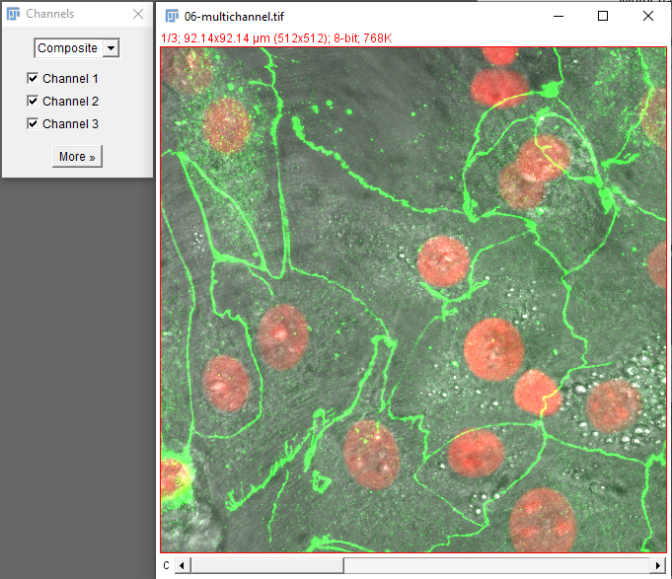
6. Click “More”. You can directly select new LUTs from here and see how they change the composite in real time. Which channel is having its LUT changed?
7. Run Image -> Color -> Display LUTs to get a quick overview of the LUTs you have available. What do the bars mean? What uses can you think of for “glasbey”, “HiLo” and “edges”?  
   