Task 6 – Hands on with Segmentation.

1. Open the first image listed in the presentation. To do so, right-click the link on the presentation, go to “Copy Link Location”, then go to Import -> URL in Fiji. Do it for the image we will use: “07-nuclei.tif”.  
   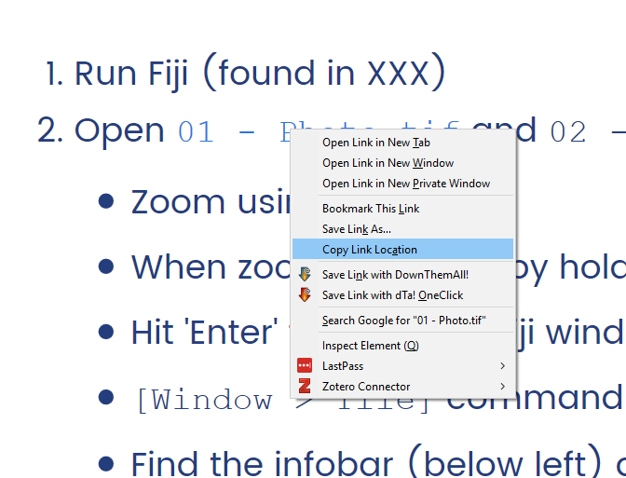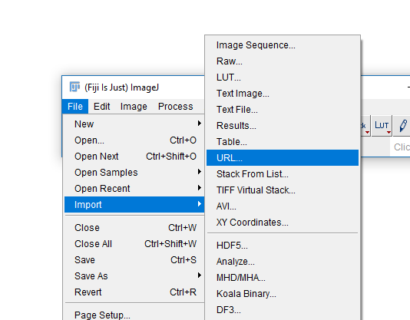
2. You should now have a new window in Fiji with your image.  
   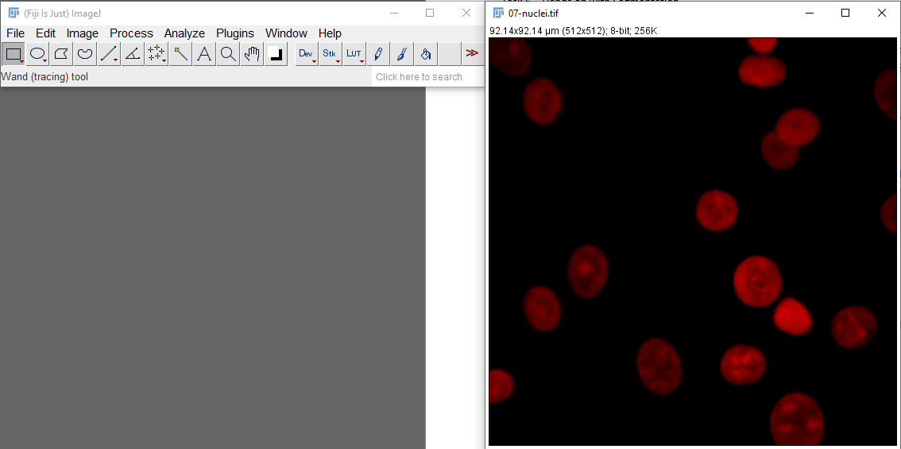
3. If you end up with an image of a clown, you have not copied the link correctly in step 1!
4. Run Image -> Adjust -> Threshold.
5. Try setting the lower threshold to 0, 10 and 253. How has the image changed?  
   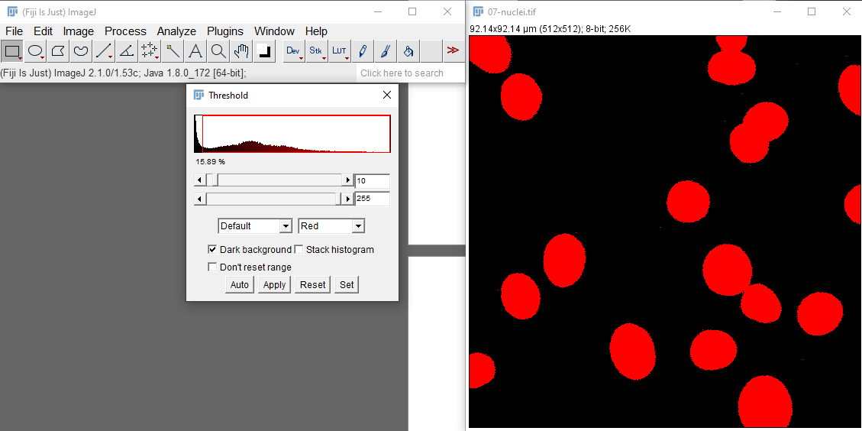
6. Manually choosing a threshold is not always feasible, so let’s try the automatic thresholding feature. Press the “Auto” button. What happened?
7. Try changing the method being applied by the automatic thresholder. Choose a few different options from the dropdown and note how they affect the results.  
   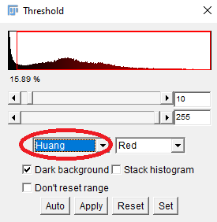
8. You don’t need to try methods manually. We can try all auto-thresholding methods at once by running Image -> Adjust -> Auto Threshold and selecting “Try All” as the method. What does the result look like?  
   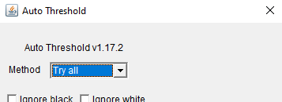
9. It is hard to see from the montage, but each result has the name of the applied method written below it. Pick a result that looks good to you and note its method name.
10. Now, repeat running Image -> Adjust -> Auto Threshold, but pick your method of choice from the dropdown and press OK. I have chosen Li.  
    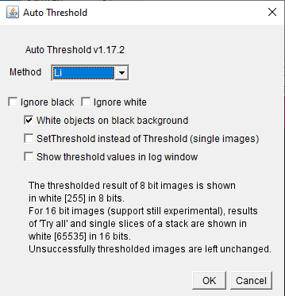
11. What you get after running this is a *mask*. A mask is an image where there are only two possible values (normally, 0 for background, 255 for foreground). It is the first step in our segmentation. Hover over your image and check the info bar on your main Fiji window for the intensity values. Make sure they are only 0 and 255.
12. From a mask, we can count, measure and visualize objects. This is the second part of segmentation.
13. For identifying objects, we will use a method called Connected Component Analysis; it identifies contiguous objects in a mask.
14. If you are happy with your mask, proceed to step 15; if you are not, open image “08-nucleiMask.tif” from the presentation and proceed ahead using that image instead.
15. Run Analyze -> Analyze Particles. Use the settings below and click OK.  
    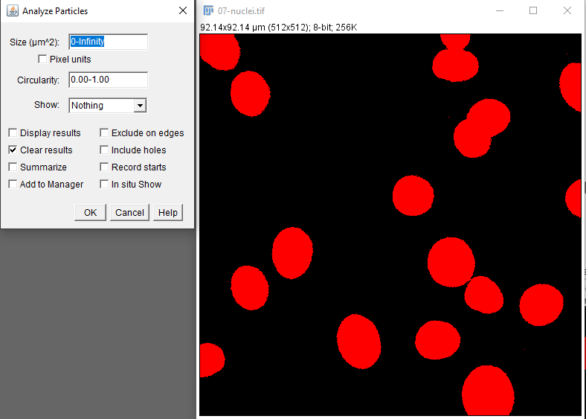
16. You should see a “Summary” table with results like a “Count” that tells you how many objects have been detected, plus some extra statistics. Your actual count might be different from the one I show below depending on which method you have picked in step 10. I am showing the results for Li and for using “08-nucleiMask.tif” as inputs.  
    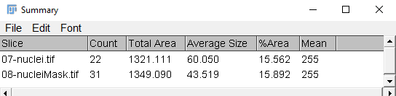
17. This is a good first try, but there are a number of problems with our segmentation. Single-pixel spots are detected as objects, nuclei on the edges of the image are being counted and some nuclei, which are touching, are counted as a single object. We will try to fix these issues.  
    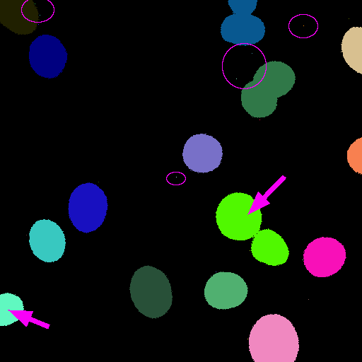
18. First, we will try separating the nuclei that are touching. Run Process-> Binary -> Watershed. The Watershed method is a really good and simple way to separate round-ish objects from each other.  
    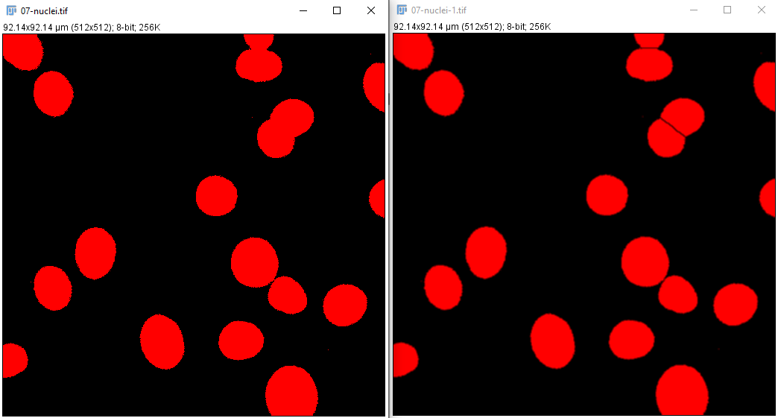
19. Now, let’s repeat our CCA, with some changed settings to avoid the other issues we were having. Run Analyze -> Analyze Particles again, but this time with the following settings. Note that we have included a minimum size for filtering out single-pixel regions, and selected “Exclude On Edges” to remove the nuclei touching the edges of the image.  
    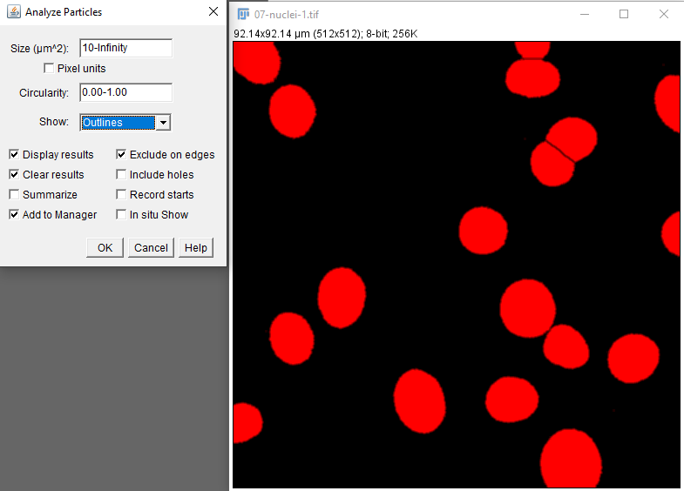
20. We should now have our original image, an “Outlines” image, a Results table and an ROI Manager window. Your segmentation results should be pretty good and pretty clear now!  
    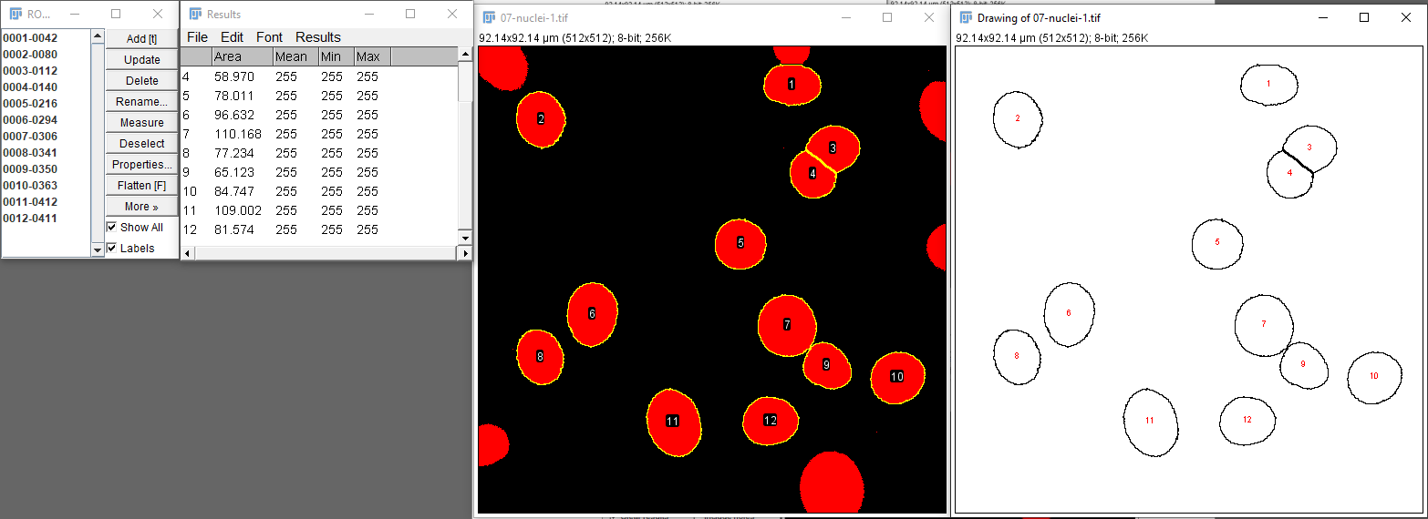
21. Note that in your “Results” table, your mean/min/max values are all 255. That is because these intensity measurements are being made on the Mask itself. You can, however, apply the ROIs that you have saved in your ROI Manager window to your original image and use “Multi-measure” as we have done before.
22. A neat trick for adding to presentations, for example, is applying the ROIs from segmentation back into the original image and selecting “Show All” and “Flatten”. It will create a new image with the ROIs written onto it, and you can import that image into your presentation for a nice display.  
    