Task 7 – Batch processing data

1. This time, we will not open any individual images. We will use the BBBC008 dataset mentioned in the presentation. Make sure to download it and unzip it.
2. Make another folder called “output” to save your batch processing outputs. I have both of them on my desktop, but feel free to put these folders wherever you want.  
   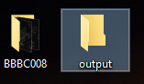
3. First, we will run some very simple batch conversion. Run Process -> Batch -> Convert.
4. Set the Input directory to be your BBBC directory with the images you downloaded, and the Output directory to be the output folder you have created.
5. Set output format to PNG and scale factor to 0.50.  
   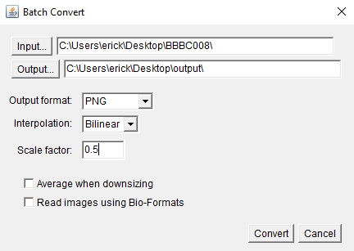
6. In this case, our inputs are simple tiff files; if your input files are proprietary formats, make sure to check the “Read images using Bio-Formats” box.
7. Check your output folder. You should see new PNG files there.   
   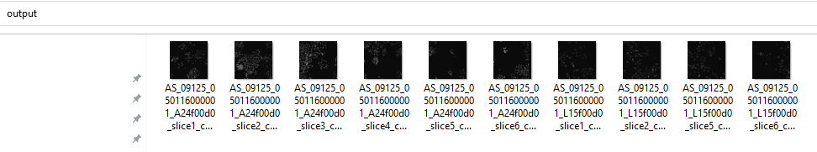
8. If your needs are slightly more complex, you can apply a macro to a batch of files. Run Process -> Batch -> Macro. Again, set the Input and Output folders as they were above, output format to PNG.
9. From the “Add macro code” dropdown, pick “Scale”. It will add some code to the text box.
10. Change the scale fraction to 0.5 and add the following line to the end of the code:  
    run("Red");
11. Hit “Process” and check your output folder. What changed?  
    