Task 7 – Batch processing data

1. This time, we will not open any individual images. We will use the BBBC008 dataset mentioned in the presentation. Make sure to download it and unzip it.
2. Make another folder called “output” to save your batch processing outputs. I have both of them on my desktop, but feel free to put these folders wherever you want.  
   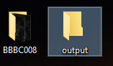
3. First, we will run some very simple batch conversion. Run Process -> Batch -> Convert.
4. Set the Input directory to be your BBBC directory with the images you downloaded, and the Output directory to be the output folder you have created.
5. Set output format to PNG and scale factor to 0.50.  
   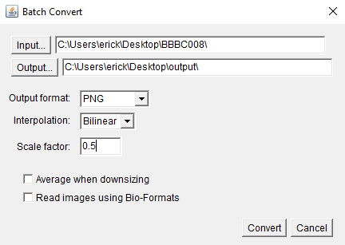
6. In this case, our inputs are simple tiff files; if your input files are proprietary formats, make sure to check the “Read images using Bio-Formats” box.
7. Check your output folder. You should see new PNG files there.   
   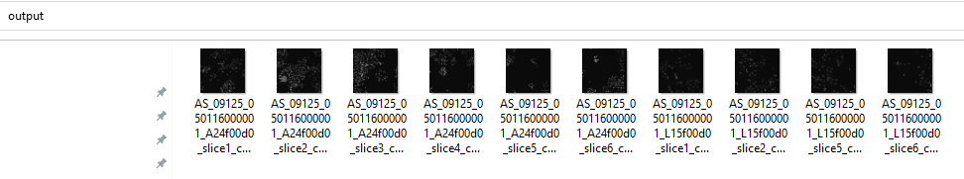
8. If your needs are slightly more complex, you can apply a macro to a batch of files. Run Process -> Batch -> Macro. Again, set the Input and Output folders as they were above, output format to PNG.
9. From the “Add macro code” dropdown, pick “Scale”. It will add some code to the text box.
10. Change the scale fraction to 0.5 and add the following line to the end of the code:  
    run("Red");
11. Hit “Process” and check your output folder. What changed?  
    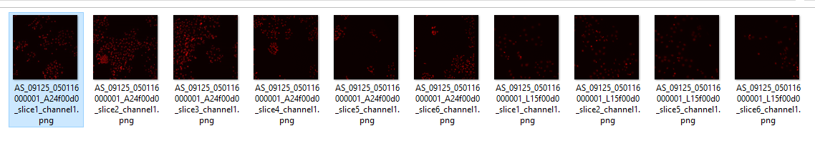
12. But how would you ever guess which line needs to be added to that list of commands? It turns out Fiji can record everything you do as a list of commands! Run Plugins -> Macros -> Record and try running any command. You will see the equivalent macro line in the Recorder window.
13. Now let’s try an exercise: using the macro recorder and the Batch Macro function, try creating new images from our inputs that:  
    a) are TIFF files;  
    b) Are calibrated to 0.1 microns per pixel; and  
    c) have a 10 μm scale bar in the bottom left corner.
14. For bonus marks, also:  
    a) write the filename onto each image (in red); and  
    b) print out the filename and spot count to the log.   
    I am adding a few references below that might help you. Answers in the next page! Peek if you feel stuck 😊

References:

Task 1 (slide 21) in the presentation

Task 3 (slide 33) in the presentation

<https://imagej.nih.gov/ij/developer/macro/functions.html#getTitle>

<https://imagej.nih.gov/ij/docs/guide/146-29.html#sub:Find-Maxima>

ANSWERS!!

Basic exercise:

run("Properties...", "unit=um pixel_width=0.1 pixel_height=0.1");

run("Scale Bar...", "width=10 height=10 font=30 background=None location=[Lower Left]");

Advanced exercise:

//-- [BONUS 2] Estimate and print the counts

run("Find Maxima...", "noise=10 output=[Point Selection]"); getSelectionCoordinates(xPos,yPos);

print("Image: "+getTitle()+" has "+xPos.length+" objects");

run("Select None");

//-- [BONUS 1] Add the title

run("RGB Color");

setFont("SansSerif", 18, "antialiased");

setColor("red");

drawString(getTitle(), 20, 30);

//-- Calibrate

run("Properties...", "unit=um pixel_width=0.1 pixel_height=0.1");

//-- Add the scale bar

run("Scale Bar...", "width=10 height=10 thickness=4 font=30 color=White background=None location=[Lower Left] horizontal bold overlay");

