**Workshop data analysis**

# Pre-workshop setup



Oxford Nanopore Technologies

Oxford Science Park, Oxford OX4 4GA, UK [support@nanoporetech.com](mailto:support@nanoporetech.com)

[**www.nanoporetech.com**](http://www.nanoporetech.com/)

This document contains the instructions to check that your machine (laptop) can connect with the AWS environment that we are going to be using for the data analysis practical session. There is also a video which goes alongside the instructions, to help. Once you have successfully completed these instructions, please close the windows down so that the setup works well for everyone. You may find that you require administrator rights for the setup.

# Installation of SSH Client for Windows

1. Download/Install Bitvise SSH Client and client key
   1. Save the pc_key_jackson.ppk client key file included as an attachment in the email. Take note of where it is [saved.](https://bvdl.s3-eu-west-1.amazonaws.com/BvSshClient-Inst.exe)
   2. Download Bitvise from <https://dl.bitvise.com/BvSshClient-Inst.exe>
2. Configure Bitvise
   1. Paste Host IP and user name in the Host and Username fields
      1. Host: trainXX.us.nanopore.me
      2. Username: ubuntu

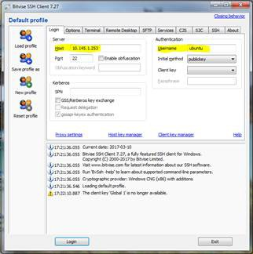

1. Load a client key
   1. Click the Client key manager link

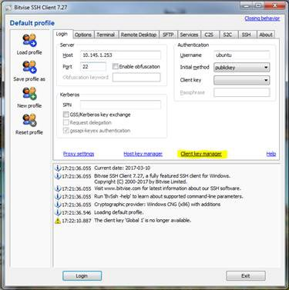

* 1. Click “import” and select the key file (pc_key_jackson.ppk) you downloaded earlier - you will need to choose **“PuTTY Private Key Files”** as the file type (see second screenshot in this section, bottom right) before the key file becomes visible in the dialogue box

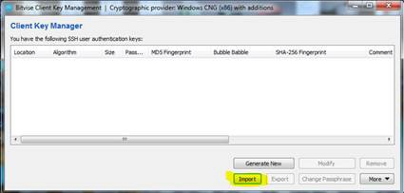

* 1. Select the key file, open, and chose “import” on the Import Client key window.

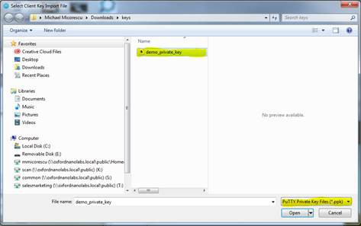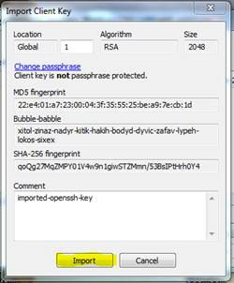

You can now close the Client Key Manager (use “X” in top right corner) after this and return to the main Bitvise SSH Client window

1. Back in the main interface window, chose “Initial method” as “public key” and “Global 1” as the “Client key”. Then Click “Login” to connect

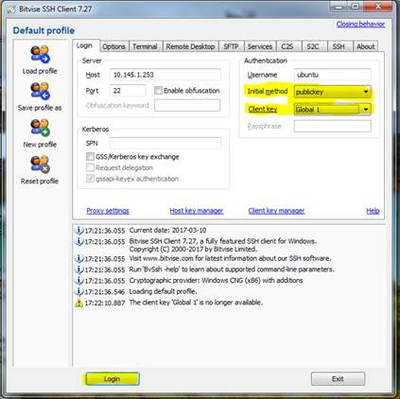

1. Two windows will now open. The windows may open on top of each other with the file transfer window on top of the terminal window (larger, black background). The file transfer window - shown on the left below - will allow for file transfers between your local drives (left pane) and the AWS machine (right pane). The other window (shown on the right) is the terminal (command line interface).

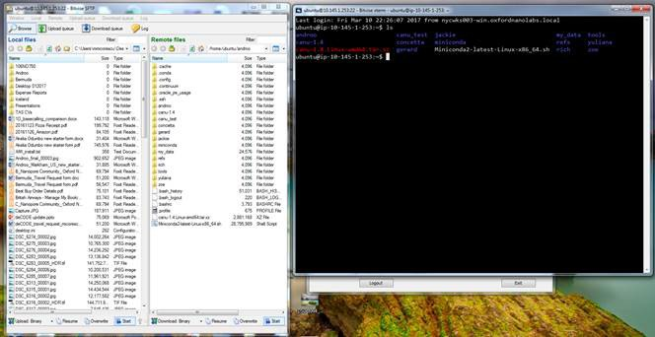

Congratulations, your machine is now ready for the data analysis session in the workshop where a simple genome assembly will be completed using some of the tools available. You can now close down the windows to ensure that other attendees are able to setup quickly as well.

# Installation for Mac

1. Copy the key file (mac_key_jackson.txt) to a known location
2. Open a terminal window
3. At the terminal window prompt (making sure there is a space between chmod and 600, plus a space after 600)

Type chmod 600

Drag and drop the demo_key.txt file after the space Press Enter

NOTES

This changes the permissions of the key file by running chmod 600 (see command below).

In the command example below the key file was copied to /Users/miniont/Desktop, so replace this part of the command with the path to where you saved the key file.

On the Mac you can also drag the key file onto the terminal window to automatically paste its path into the command.

You will see a command similar format to the one below with the path to the demo_key.txt reflecting the location on your own machine.

chmod 600 /Users/miniont/Desktop/demo_key.txt

1. Now connect to the remote AWS machine using ssh: Type ssh –i (again adding a space after i)

Drag and drop mac_key_jackson.txt after the space

Check there is a space and type [ubuntu@trainXX.us.nanopore.me](mailto:ubuntu@trainXX.us.nanopore.me)

The command will appear as:

ssh -i /Users/miniont/Desktop/demo_key.txt [ubuntu@trainXX.us.nanopore.me](mailto:ubuntu@trainXX.us.nanopore.me)

Press Enter

1. Next confirm that you can run commands on the remote machine by running ls). A number of folder names including my_data and canu-1.6 should be displayed.

Type ls (LS in lower case) at the prompt Press Enter

A number of folder names including my_data and canu-1.6 should be displayed.

1. Close the connection by pressing Ctrl+D
2. Initiate a file transfer by entering the following command in a terminal window: sftp -i /Users/miniont/Desktop/mac_key_jackson.txt [ubuntu@trainXX.us.nanopore.me](mailto:ubuntu@trainXX.us.nanopore.me)

PressEnter

1. Check that contents of the refs folder can be copied to the local machine.

Type get refs/* Press Enter

Congratulations, your machine is now ready for the data analysis session in the workshop where a simple genome assembly will be completed using some of the tools available. You can now close down the terminal.

# Insert photo/text box and format shape to “In Front of Text”

Footnotes: Permanent footnote goes here Sit voluptatem accusantium doloremque laudantium, totam rem aperiam, eaque ipsa quae ab illo inventore veritatis et quasi architecto beatae vitae dicta sunt explicabo. Nemo enim ipsam voluptatem quia voluptas sit aspernatur aut odit aut fugit, sed quia consequuntur magni dolores eos qui ratione voluptatem sequi nesciu.