**Workflow 1**

**Description**

Determine protein staining intensities and distances in mitotic apparatus in z-stack intensity images which were stained for the inner-centromere protein INCENP, and compare the results qualitatively and quantitatively. Share the results with colleagues using quick visualization in OMERO.figure.

**Setup**

For this workshop, images have already been imported into OMERO. JAX uses a “dropbox” approach to importing images to OMERO; please contact us if your group wants to start using it and we will walk you through the process.

1. Login to the webclient at <http://ctomeroweb01.jax.org/> with the Username and Password provided. Browse hierarchy of Project “Training Data” and Dataset “siRNAi-HeLa” to find images.

2. Several control images in the Dataset have "scram" in their name. Other images are named with siRNAi targets “IN” for INCENP and other names for minor INCENP variants.

3. Zoom the thumbnails (using the slider below thumbnails) and select multiple images that appear to be in Metaphase (one or two single lines appear in each cell on the image as opposed to one or several round blobs, see screenshot below for the pre-selected images in rows 2 and 3). Use Shift+click or Ctrl+click to multi-select the thumbnails.

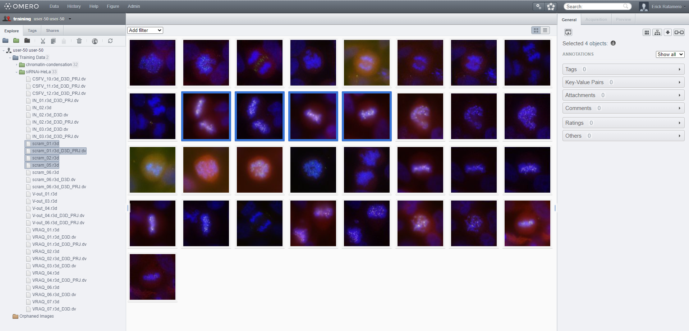

4. In the right-hand panel, expand the *Tags* pane and click on the  button to add tags to all the selected images.

5. In the “Tags Selection” dialog, you can select available Tags from the list on the left (filtering if needed). Find the “Metaphase” Tag and click on the  button to move it into the right-hand list then click “Save”.

6. Add another Tag to the selected images: This time, create a new tag that is likely unique to you (see bottom left of Tag dialog) e.g. could be the name of your favourite gene or simply “Bob likes this”.

7. Click the newly-added *Metaphase* Tag:  in the right-hand panel. This will browse by Tags to show all Images with this Tag, be those your images or images of your colleagues. NB: notice at the top-left of the page that we are now browsing data belonging to Trainer-1, the owner of the Metaphase tag.

8. You can also search for the tag using the search bar on the top right of the screen. By default, it will look for images that belong to you, but you can change the scope of that on the left-hand side of the search screen: 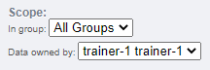

9. Click *Browse* for one of the images in the table to return to the Dataset. 

At this point, make sure you are looking at your own images; check the top left corner of the screen. If you are not, click that bar and navigate back to your user:



10. Above the thumbnails, click *Add Filter > Name* and enter “scram” to filter for all control images in this RNAi experiment.

11. Select an image, click the *Preview* tab of the right panel and Turn off channels 1 and 4.

12. Adjust the intensity levels of the green channel which is INCENP, and channel 3 which is Aurora-B. Use *Histogram* feature:  to help you with the adjustments. We want to compare levels of these targets across all images in the Dataset. Click *Save to All*.

13. Thumbnails will be updated with new rendering settings, allowing comparison across the Dataset. Thumbnails can be zoomed using the slider below.

14. In the left panel hierarchy, right-click on the *siRNAi-HeLa* Dataset and choose *Rendering Settings… > Set Imported and Save* to return to original settings.

15. Filter images by Name “VRAQ D3D” and select the first image “VRAQ_01.r3d_D3D.dv”.

16. In the General tab of the right-hand panel, expand the Ratings panel and click the stars to give this image a rating of 5.

17. Filter images by Name “IN 02 D3D”, select the first image “IN_02.r3d_D3D.dv” and add a rating of 5.

**TIME FOR A BREAK!**

18. Now, clear the filtering by Name and instead, filter images by Rating of 5 to show only the 2 images we have just rated.

19. Select both images, right click on the selected images in the tree and choose *Open with... > OMERO.iviewer.* You can also find the *Open with* option at the top of the right panel. 

20. Click the Crosshairs icon [image3](https://omero-guides.readthedocs.io/en/latest/_images/Iviewer3.png) at the top-right of the viewer to enable the pixel intensity display for the mouse pointer. Then mouse over the Image to see the pixel intensities for the channels turned on.

21. In iviewer, we want to measure distance between Centromeres, stained with ACA in the 4th Channel. Turn on ONLY the 4th channel and open the *ROIs* tab to the right.

22. Try to identify centromere pairs, select the *Line* tool and draw a line between the centers of the centromeres. In the ROIs table, in the Comments column, click the 3 dots in the column header and choose to *Show Area/Length*.

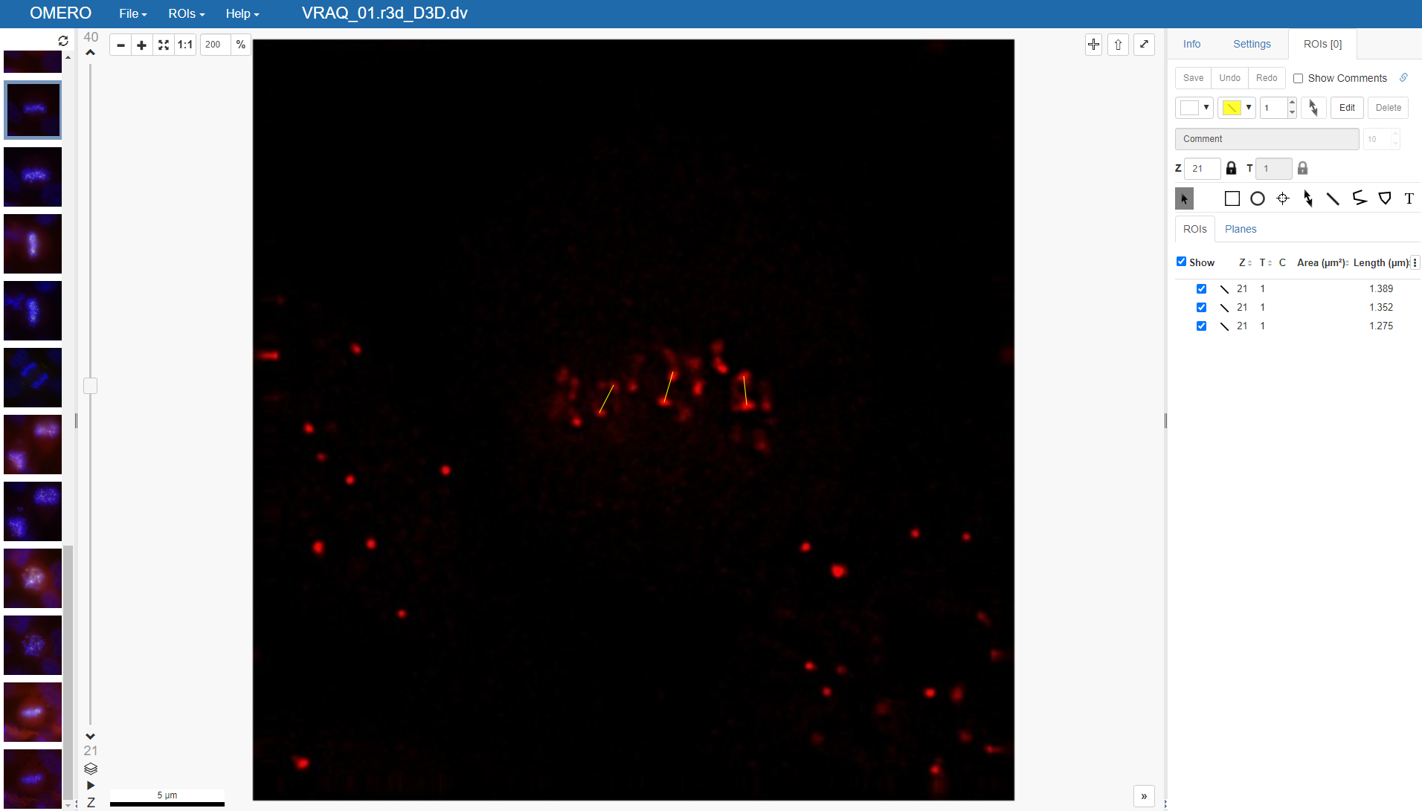

23. Click *Save* to Save ROIs.

24. You can also use Z-Projection ( at the bottom left) which might help find outlying centromeres.

25. Once done with drawing ROIs, click Save again.

26. Click on the *Select* tool: 

27. To export statistics, we first need to select all the ROIs using ctrl+drag (cmd+drag on a Mac) to select a region in the viewer (if ROIs are spread across multiple Z-sections, we can show them all at once using Z-projection). The selected ROIs will be highlighted blue on the image.

28. To export lengths and intensities of ONLY the 3rd channel (Aurora-B) turn on only this channel on the *Settings* tab of the right-hand panel.

29. Export the Intensities, areas and line lengths into Excel. Select in the top-left corner *ROIs > Export as Table*. This will export the values from the selected ROIs.

30. Open the downloaded table in Excel or similar tool to see the lengths and intensity measurements for the ROIs.

31. Back in the webclient window, select both 5-rated, right-click them (on the left-side file list) and select *Open with… -> OMERO.figure*.

32. Drag the images to place one above the other, select both and click the Grid layout button . Resize to make the figure smaller. Copy both images and paste twice to make a grid with 2 rows with 3 columns.

33. Select both panels from each column in turn and toggle on a different channel for each column. Adjust Z index and try Z-projections (see screenshot below).

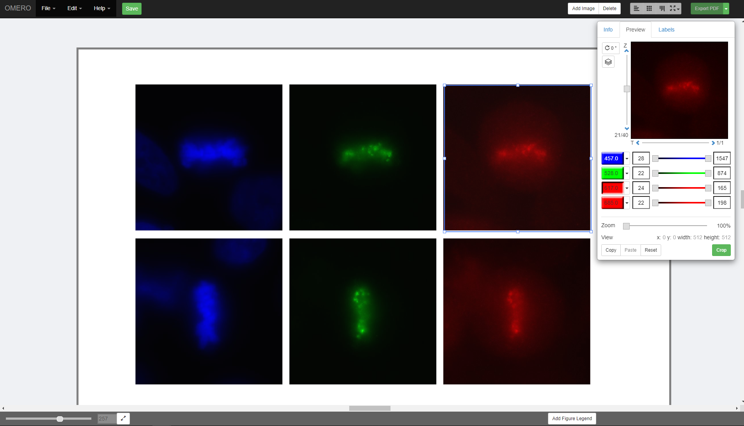

34. Select the 2 panels in the left column, click on the Labels tab in the right panel and under *Add Labels* choose *[image-name]* from the drop-down menu. Click on the *position* chooser and choose *Left* from the options. Click *Add*.

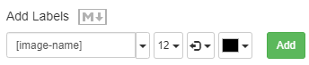

35. Save the figure and see that the URL updates to a new URL for this figure which can be shared with colleagues. *File > Open* can be used to open your own figures or those of colleagues.

36. Click *Export PDF* and then when complete, click the *Download* button. Open the downloaded pdf in any suitable program and find the second page of the pdf. Click on the link to the image and see that you are navigated back to OMERO in your browser and the appropriate image, which was used in the Figure, is highlighted.

37. Click *File > Open*, then click on the *Owner* button  to select a figure of other users (your colleagues). Select and open other users’ figures and study them.

38. With another user’s figure open, select *File > Save a Copy* to save your own copy of your colleague’s figure. Note that you cannot directly save changes on their figure.

39. OMERO.Figure will be revisited in the second session.

**Homework**

**Before next session,** make sure you can run the steps below without any error:

1.Start the Fiji app and use the OMERO plugin to browse data in OMERO i.e. *Plugins > OMERO > Connect To OMERO*

2. In the OMERO login dialog, click the wrench icon  and then add the server address (ctomerodev.jax.org – **NOTE THIS IS A DIFFERENT ADDRESS!**) in the dialog. Click *Apply*. Now, log in with the provided details (the same you have been using for the webpage).

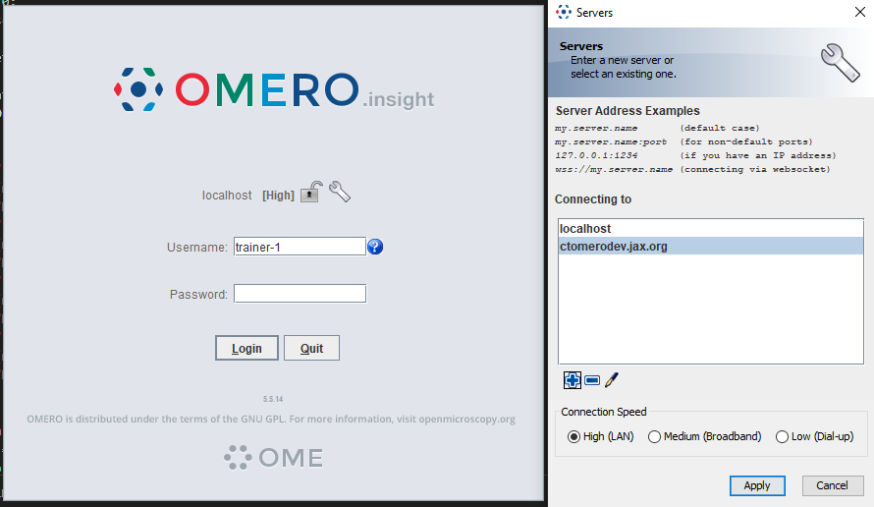

3. Find and open any image (double-click the thumbnail) to make sure things work!