**Workflow 2**

**Description**

Manual analysis of OMERO images using Fiji

**Setup**

For this workshop, images have already been imported into OMERO. JAX uses a “dropbox” approach to importing images to OMERO; please contact us if your group wants to start using it and we will walk you through the process.

1. Login to the webclient at <http://ctomeroweb01.jax.org/> with the Username and Password provided.

2. Search for *mitomycin-A* in the Search field at the top right of webclient. This should find 32 images. To search for key-value pairs, we can use the search string key: value. To narrow down the search, search again for *mitomycin-A:10microM.* This should narrow it down to 8 images. find the “C4.pattern.tif” image in the Dataset “chromatin-condensation”. Click on Browse to get back to this image in webclient.

3. Adjust channel names: Click on the *pen*:  icon in the right-hand pane next to *Channels*. Input “Cy3” (instead of channel “0”) and “eGFP” (instead of channel “1”). Click *Apply to all* button:  and confirm by clicking *Continue*.

4. Open the “C4.pattern.tif” Image with OMERO.iviewer, use the Time-slider below the image to move through time and play the video.

5. Start the Fiji app and use the OMERO plugin to browse data in OMERO i.e. *Plugins > OMERO > Connect To OMERO*

6. In the OMERO login dialog, click the wrench icon  and then add the server address (ctomerodev.jax.org – **NOTE THIS IS A DIFFERENT ADDRESS!**) in the dialog. Click *Apply*.

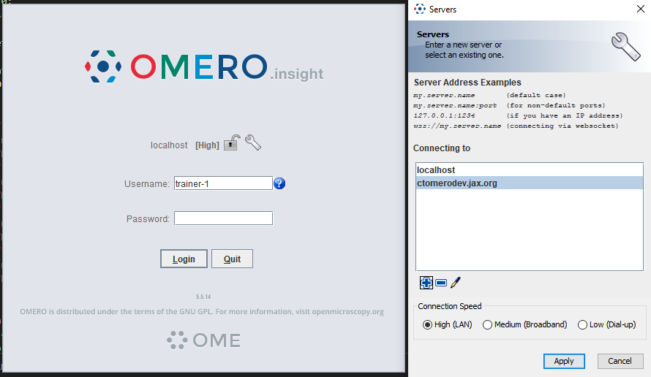

7. Find and open the same image from above “C4.pattern.tif” from Dataset “chromatin-condensation” (double-click on the thumbnail).

8. Select *Image > Adjust > Threshold*

9. The *Threshold* dialog will pop up, click *Apply*.

10. Another window *Convert Stack to Binary* will pop up

11. Select the following parameters:

a. *Method: Default, Background: Dark,* *Calculate threshold for each Image* and *Black background (of binary masks).*

b. Click *OK*.

c. Close the *Threshold* dialog if you want

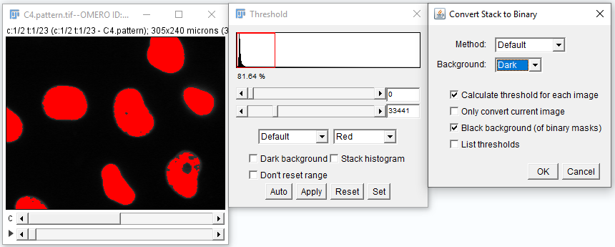

12. Select *Analyze > Analyze Particles*

13. In the Analyze Particles dialog, select the following parameters

a. with *Size: 50-infinity*

b. Show: *Outlines*

c. Check: *Display results, Clear results, Summarize and Add to Manager*.

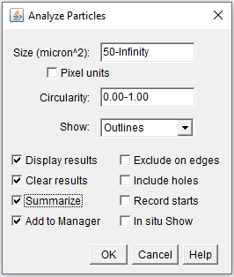

14. Click *OK*.

15. A dialog pops up asking to *Process all 46 images?* Click *Yes*

16. ROIs, Results table, and the mask timelapse with outlines will be generated

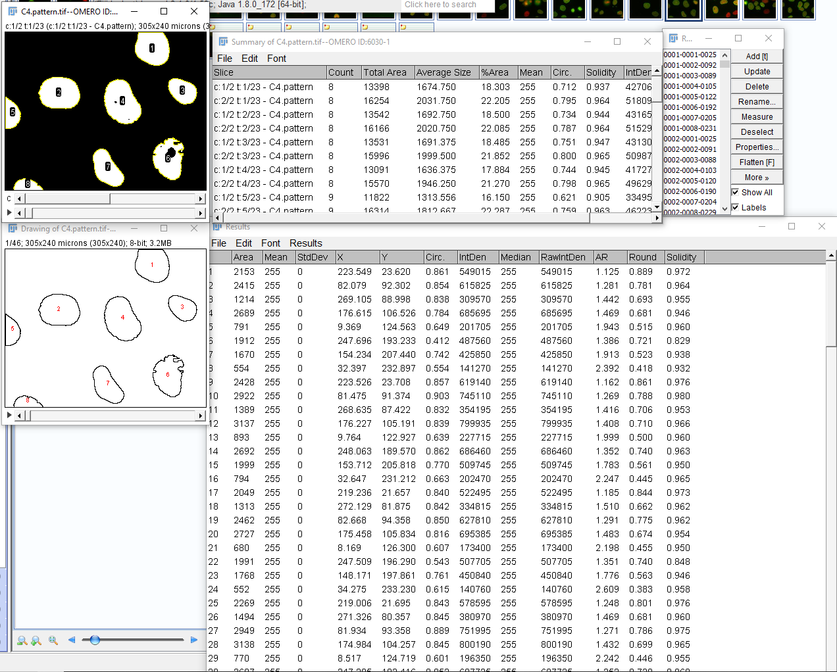

17. Select the *Results* table and Menu *Results > Distribution > OK*

18. In Fiji, select the original image (now also showing ROIs). You might need to do some digging through the sea of new windows you have. Then, select *Plugins > OMERO > Save ROIs to OMERO*.

19. We want to Save ROI and Measurements, which will attach the results as a CSV attachment (to open for example in Excel) to the image in OMERO.

20. Enter a File Name and click *Save* (Note: There is also a manual workflow which you could have used to attach the Excel sheets resulting from Workflow1 to OMERO.)

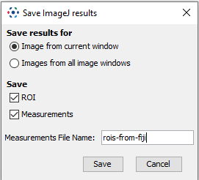

21. Select the image with outlines named *“Drawing of…”*. Select *File > Save As > Tiff…* and give it a meaningful name (*outlines.tiff*, for example).

22. Now we will save the created images back to OMERO. select *Plugins > OMERO > Save Image(s) to OMERO.*

23. You can now select in which project and dataset the new images are going to be imported into on the left-hand side.

24. When you are done selecting project and dataset, check *Add Images from all image windows*. Click *Add to Queue* then *Import*.

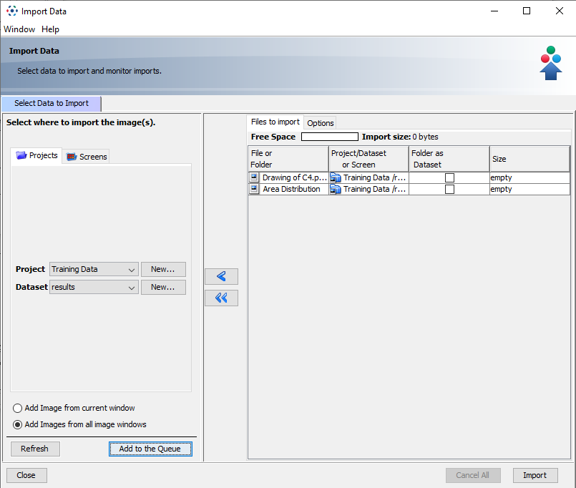

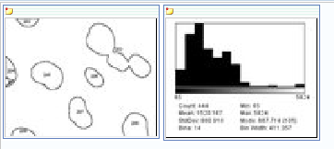

23. Return to the webclient and check that the new images have been placed in the correct project and dataset (you might need to press the refresh  button on the top left). After that, open the original image in OMERO.iviewer and inspect the newly created ROIs. Notice that you have ROIs for each channel on all timeplanes.

24. We will not need Fiji any longer, so you can go ahead and close it if you want.

**TIME FOR A BREAK!**

24. Select the original C4.pattern.tif image, the ROIs image and distribution plot. Click on *Open with… OMERO.figure*.

25. Copy and paste the original image using the Edit menu or keyboard shortcuts to duplicate it.

26. Adjust the rendering settings in this image in the right panel, to turn off the Green channel and enhance the Red.

27. Arrange these 2 images in a column with the ROIs image below, resizing as needed.

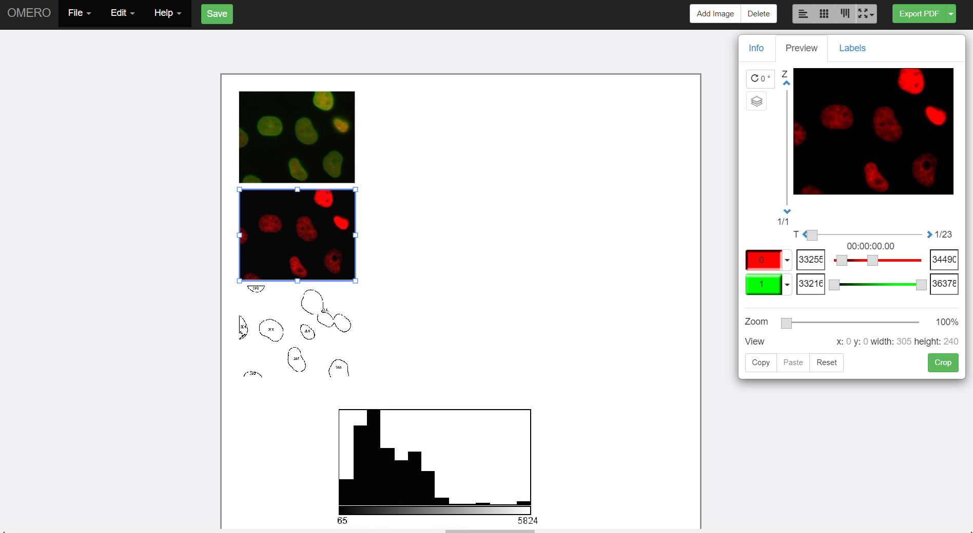

28. Select the 3 panels and use the *Align > Width & Height* toolbar to ensure these panels are all the same size.

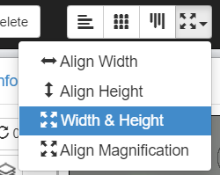

29. Then click the *Grid* layout button in the same toolbar to snap the panels to a grid.

30. Copy the 3 panels and paste several times to create 3 new columns of 3 panels.

31. Select just the upper 2 image panels from each new column in turn and in the right panel, drag the T-slider to set the time to index, e.g. 5 (20 mins), then 6 (25 mins) then 9 (40 mins).

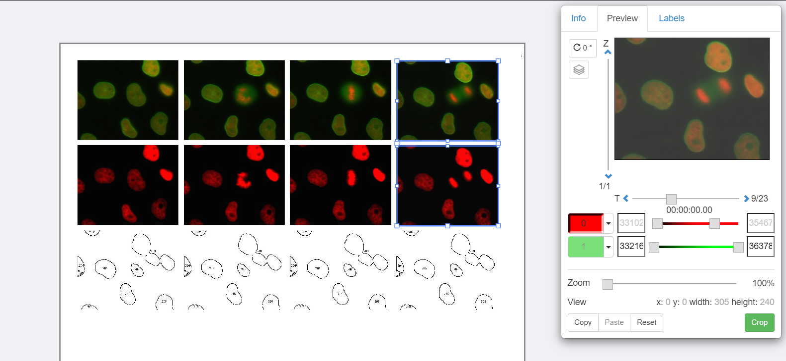

32. NB: the ROIs image is actually a Z-stack so we have to choose the frame using the Z-slider. There are 46 planes in the Z stack, from 2 channels x 23 time points. To pick time-frames that correspond to the 4 images above, set the Z-index for the 4 ROI images to 1, 9, 11 and 17 respectively.

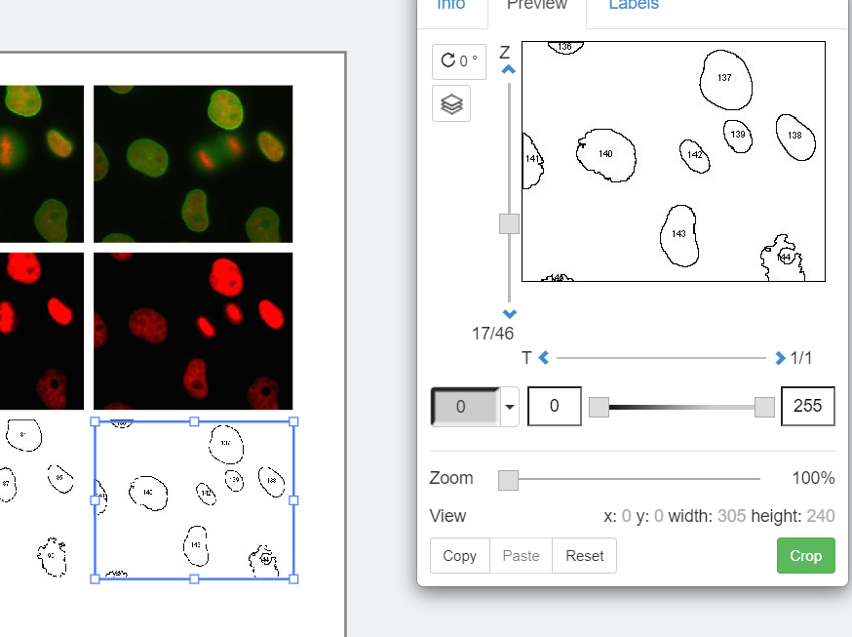

33. Select all the 12 panels in the grid and use the Zoom slider to zoom in.

34. Pan the images by dragging in the right-hand panel Preview image.

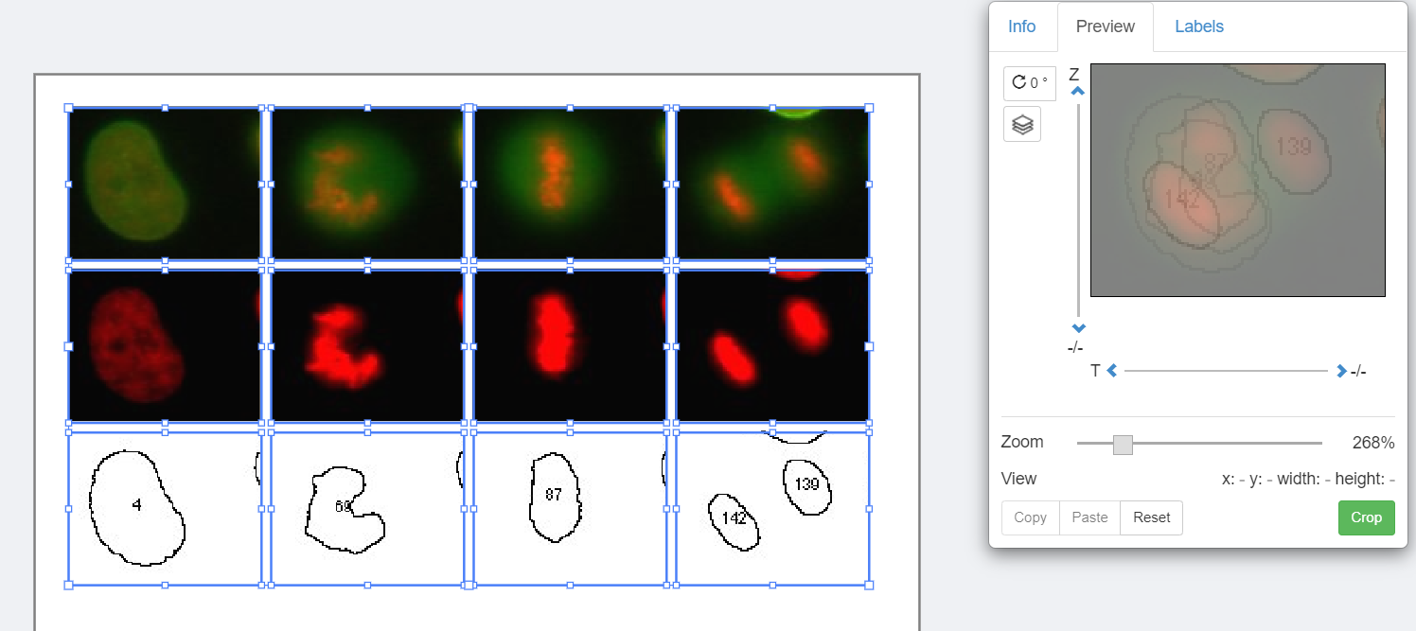

35. Select just the first row of images, click on the Labels tab in the right-hand panel. Under *Add Labels* choose *Time (T-Index)* from the drop-down menu. Choose label color (white), position (top-left) and font-size (12) then click *Add*.

36. Click *Save* to save your figure.

37. To export your figure as PDF, click the *Export PDF* button at the top-right of the screen and wait for the PDF to be created on the server and the *Download* button to appear. Click to download the PDF and import to a PDF editor. You can post-process the PDF in Inkscape or Adobe Illustrator/Photoshop for example.