jit-ui Visualization Rework and Library Extraction
Statement of Work — Sub-SOW of §2.2
A backend-neutral, reusable image-visualization library extracted from jit-ui

Document: JIT_UI_visualization_library_SOW
Status: Substantially delivered on the jit-ui 'openseadragon' branch; library extraction in progress, distribution pending
Owner: Baha Elkassaby
Date: 2026-06-12
Scope: jit-ui (Angular 17 / Nx) — the visualization layer and the new buildable library 'jax-image-visualization'; backed by jit-service tile/histogram/export endpoints
Master SOW: JIT_updates_integration_JDS_SOW §2.2 (Extract a UI plotting library from jit-ui)
Realized library name: jax-image-visualization (Nx buildable library; supersedes the master SOW's placeholder name 'jit-plotting')
Distribution: npm under the @jax-data-science organization scope (Nx publishable library); package name TBD among image-visualization, jax-image-visualization, or jit-image-visualization

1. Executive summary
This SOW covers the rework of the jit-ui visualization layer and its extraction into a standalone, backend-neutral Angular library, jax-image-visualization. It realizes master SOW §2.2 ("Extract a UI plotting library from jit-ui"), whose original placeholder name was jit-plotting.
The visualization layer was redesigned around a single backend-neutral contract with two pluggable rendering backends: a natively-tiled OpenSeadragon viewer for the deeply-zoomable Image plot type (backed by the jit-service tile endpoints), and Plotly for the scientific plot types (heatmap, contour, scatter, surface, scatter-3D, isosurface). A backend-neutral region model and on-canvas tools work identically on either backend, and a Channels and Histogram tool provides per-channel brightness/contrast, pseudo-colour compositing, and true 16-bit support.
Most of the engineering (the contract, both backends, regions/tools, the plot-type framework, and the Channels and Histogram tool including 16-bit) is already implemented on the jit-ui 'openseadragon' branch and the supporting jit-service endpoints are deployed. The remaining work is finishing the library extraction (clean ports/DI boundaries so the package carries no host coupling) and deciding and executing distribution so other JAX Data Science frontends can consume it. Each deliverable in §3 carries an explicit status (Delivered / In progress / Planned).

1.1 Current architecture
The library is organized around one backend-neutral contract and a router that dispatches to a rendering backend per plot type. The host app embeds a single <visualization> component (which wraps the toolbar and the visualizer); the Channels and Histogram dialog and the region editor are sibling embeddable components. Everything app-specific is reached through dependency-injection ports the host supplies, so the library depends on no host code.

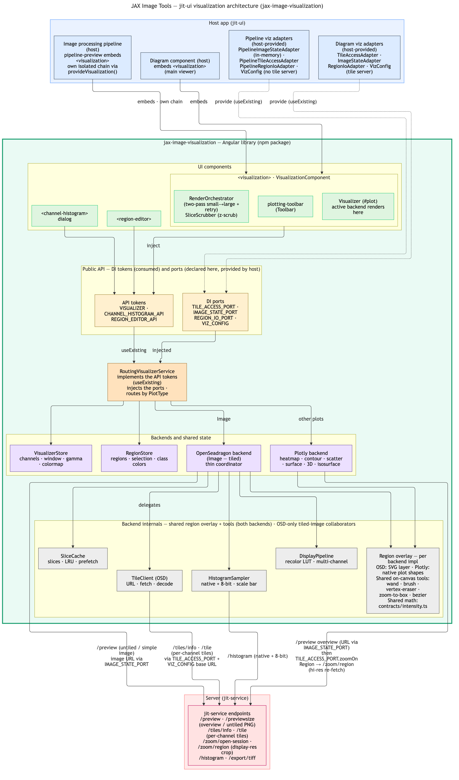
Figure 1 — jit-ui visualization architecture (jax-image-visualization).

- Host app: the diagram component embeds the <visualization> component, which wraps the plotting-toolbar (Toolbar) and the visualizer (#plot, where the active backend renders). The Channels and Histogram dialog and the region editor are sibling embeddable components.
- Public API: IVisualizer (composed of IDataRenderer, IRegionStore, IToolController and IDisplayOptions, plus a ViewerCapabilities descriptor), IChannelHistogramApi (CHANNEL_HISTOGRAM_API) and IRegionEditorApi — plus the DI ports TILE_ACCESS_PORT, IMAGE_STATE_PORT, REGION_IO_PORT and VIZ_CONFIG. Components consume the tokens; the host provides the ports (see 1.2).
- Router: RoutingVisualizerService implements the three API tokens (the host binds them useExisting), injects the ports, and routes the Image plot type to OpenSeadragon and the scientific plot types to Plotly.
- Backends and shared state: the OpenSeadragon and Plotly backends both implement IVisualizer and both read the shared VisualizerStore (display/channel/colormap state) and RegionStore (regions, selection, class colours).
- Backend internals: the backend-neutral region overlay and on-canvas tools (wand, vertex-eraser, zoom-to-box, rectangle/freehand/polyline, bezier) and the OpenSeadragon tile pipeline (recolor LUT, scale bar, slice cache with background loading).
- Server: both backends fetch image data from the jit-service endpoints — /preview (the downscaled overview / untiled image, URL supplied via IMAGE_STATE_PORT), /tiles/info and /tile (per-channel tiles, OpenSeadragon), /zoom/region (Plotly's high-resolution re-fetch via TILE_ACCESS_PORT.zoomOnRegion), /histogram and /export/tiff.
Regions are created and edited through their own small set of contracts, so the tools and overlays stay decoupled from the backends and from the region state. The toolbar routes each tool mode either to the per-backend region overlay (IRegionOverlay — an OpenSeadragon SVG overlay and a thin Plotly native-shapes overlay) or to an on-canvas tool through IToolController. The wand, brush and vertex-eraser tools bind to a small host interface (IViewportHost + IRegionDataHost) and share the WandService geometry helpers; every overlay and tool reads and writes the single shared RegionStore (IRegionStore + IRegionEditApi).

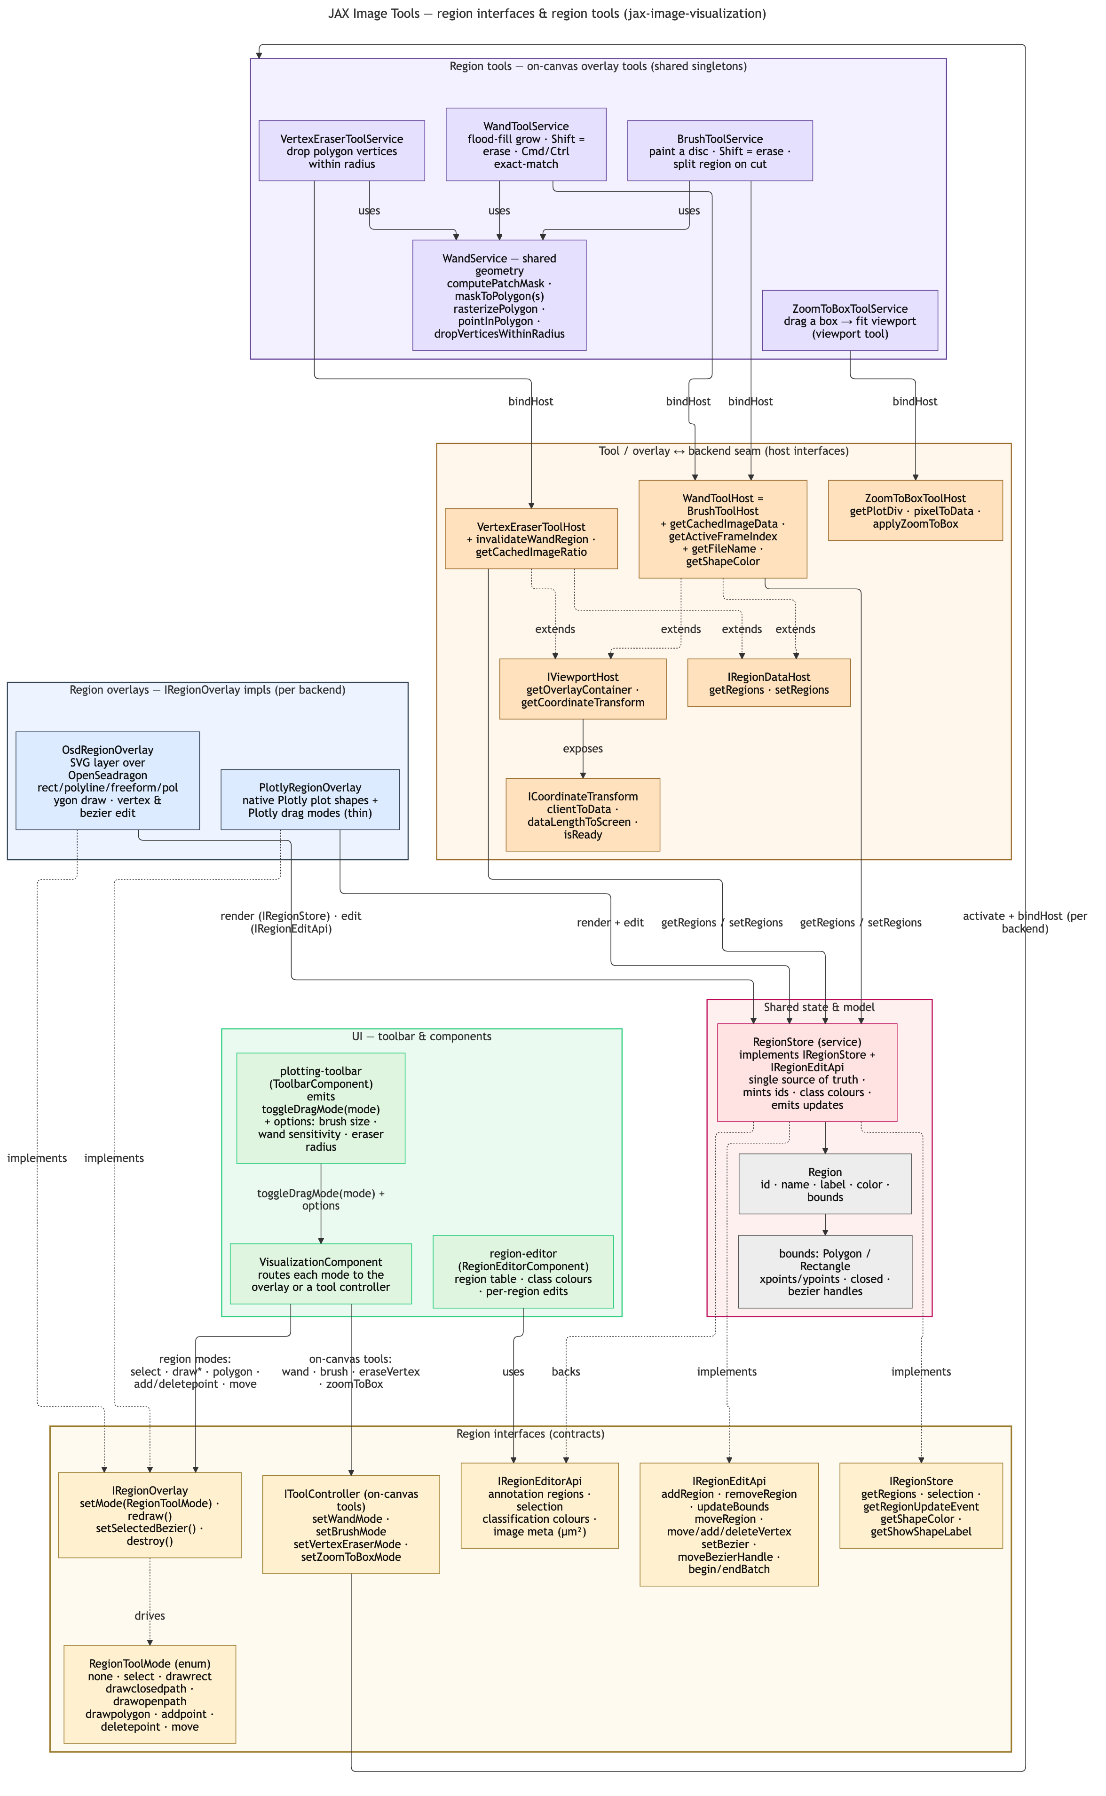
Figure 2 — region interfaces and region tools (jax-image-visualization).

1.2 Host integration: DI ports and adapters
The library is host-agnostic: everything app-specific is expressed as a port (a TypeScript interface plus an Angular InjectionToken). The host application's composition root provides one adapter per port and binds the API tokens to the library's router. This is the seam that lets the package carry no host coupling and be published and reused (deliverables D6 and D7).
Token / port | Provided by | Responsibility
VISUALIZER · CHANNEL_HISTOGRAM_API · REGION_EDITOR_API | RoutingVisualizerService (useExisting) | The render/viewport, channel-histogram and region-editor APIs the embeddable components call. One library service implements all three.
TILE_ACCESS_PORT | TileAccessAdapter (host) | Selected image's base64 FileInfo, bearer auth headers, ROI-zoom and diagram-display selection. The OpenSeadragon backend uses it (with the VIZ_CONFIG base URL) to fetch tiles, histograms and exports from jit-service.
IMAGE_STATE_PORT | ImageStateAdapter (host) | Current image info, filename, loading and cache-progress, zoom flag and panel width (read + write). Bridges the viewer to the app's image/loading state so the right overlays and progress show.
REGION_IO_PORT | RegionIoAdapter (host) | Selected filename, ROI-file existence check and GeoJSON save. Bridges region import/export persistence to the app's storage.
VIZ_CONFIG | useValue (environment) | Backend base URL (slideCropServer) and feature flags (e.g. useOsdForImage).
Because every host touch-point is one of these adapters, the library imports nothing from jit-ui. A downstream JAX Data Science frontend reuses it by providing its own four adapters plus a VIZ_CONFIG value (and the useExisting bindings to RoutingVisualizerService, or its own IVisualizer implementation) — with no library source changes.

2. Scope

2.1 In scope
- A backend-neutral visualization contract (IVisualizer) composed of role interfaces (render/viewport, region store, on-canvas tools, display options), with capability gating so consumers only call what the active backend supports.
- OpenSeadragon backend for the Image plot type: tiled zoomable raster off the jit-service tile endpoints, navigator minimap, physical-units scale bar, stack-slice cache with background preloading, and a client-side recolor pipeline.
- Plotly backend for the scientific plot types and the plot-type selector that routes between backends per plot type.
- Backend-neutral region model and shared region store; region create/edit/select/delete; rectangle/freehand/polyline drawing; magic-wand, vertex-eraser and zoom-to-box tools; bezier regions; QuPath-compatible GeoJSON import/export; the region editor with editable classification colours.
- Channels and Histogram tool: per-channel display window, gamma, visibility, Fiji-style per-channel pseudo-colour compositing, live histogram, publication composite PNG export, and true 16-bit support (native-bit-depth histogram and windowing, plus a data-preserving multi-band 16-bit TIFF export).
- Extraction of all of the above into the Nx buildable library jax-image-visualization: library-owned data interfaces, contracts and DI ports/tokens, ng-packagr build, Jest unit tests, and host (jit-ui) wiring that provides the ports.

2.2 Out of scope
- The jit-service tile/histogram/export endpoints themselves (/tiles/info, /tile, /histogram, /export/tiff and the per-channel + 16-bit backend). They back this library and are tracked as their own jit-service work (issue #76 and the 16-bit support docs); this SOW depends on them but does not own them.
- Migrating other JAX Data Science frontends onto the library (downstream adoption is named as a Planned deliverable, D7, but the actual per-consumer integration is owned by each consumer).
- Server-side rendering or a non-Angular distribution. The library targets Angular consumers.
- Replacing Plotly or OpenSeadragon with a different rendering engine.

3. Deliverables
Each deliverable identifies what is built, where it lives, and its current status. 'Delivered' means it is implemented and verified on the jit-ui 'openseadragon' branch.

D1. Backend-neutral visualization contract and router
What: A single IVisualizer contract composed of role interfaces (data renderer/viewport, region store, on-canvas tools, display options), with a capability descriptor so consumers gate on advertised features rather than backend identity. A RoutingVisualizerService routes the Image plot type to OpenSeadragon and every other plot type to Plotly, keeping shared state (regions, display options) in one place so both backends stay in sync.
Where: libs/jax-image-visualization/src/lib/contracts/visualizer.contract.ts, capabilities.contract.ts, routing-visualizer.service.ts, visualizer-store.service.ts.
Status: Delivered.

D2. OpenSeadragon image backend + server tile integration
What: A natively-tiled, deeply zoomable raster backend for the Image plot type, backed by the jit-service tile endpoints, with a navigator minimap, a physical-units scale bar, click-to-zoom, a stack-slice cache with LRU eviction and background preloading for flicker-free z-scrubbing, and a client-side recolor pipeline (tile-invalidated) that applies the grayscale colormap LUT and per-channel display settings.
Where: libs/jax-image-visualization/src/lib/implementations/osd/* (visualizer service, region overlay, scale bar, coordinate transform).
Status: Delivered.

D3. Backend-neutral regions, on-canvas tools, and GeoJSON I/O
What: A backend-neutral Region model and a shared region store both backends render from; region create/edit/select/delete; rectangle, freehand and polyline drawing; magic-wand, vertex-eraser and zoom-to-box tools implemented against a shared coordinate-transform abstraction; bezier regions; QuPath-compatible GeoJSON import/export; and a region editor that edits classification colours for every class from one dialog.
Where: libs/jax-image-visualization/src/lib/models/region.ts, region-store.service.ts, toolbar/* (wand, vertex-eraser, zoom-to-box), region-editor/*, and the per-backend overlays.
Status: Delivered.

D4. Plot-type framework (Plotly backends, capability gating, intensity profiles)
What: A plot-type selector exposing Image (OpenSeadragon), Heatmap, Contour, Scatter, Surface (3D), Scatter 3D and Isosurface (3D), with scalar/3D types gated to the images that support them; isosurface rendering of grayscale z-stacks with an intensity-band slider; and intensity-profile line ROIs with a live, zoom-aware inset chart.
Where: libs/jax-image-visualization/src/lib/contracts/plot-type.ts, implementations/plotly/* (service + intensity profile), capability gating in capabilities.contract.ts.
Status: Delivered.

D5. Channels and Histogram tool, incl. true 16-bit support and exports
What: A non-modal dialog for per-channel brightness/contrast (display window), gamma, and visibility, with a live per-channel histogram; Fiji-style per-channel pseudo-colour assignment and additive compositing; a publication composite PNG export; and true 16-bit support: a native-bit-depth histogram and native window units computed server-side from the raw pixels (the 8-bit display tiles cannot carry 16-bit values), plus a data-preserving multi-band 16-bit TIFF export of the visible channels. A non-blocking activity indicator and a precomputed recolor LUT keep the controls responsive on large stacks.
Where: libs/jax-image-visualization/src/lib/channel-histogram/*, contracts/channel-histogram-api.contract.ts, and the per-channel/16-bit paths in the OpenSeadragon and Plotly services. Backed by jit-service /histogram and /export/tiff.
Status: Delivered (frontend). Backed by deployed jit-service endpoints.

D6. Extraction into the jax-image-visualization Nx buildable library
What: Move the visualization layer into a standalone Nx buildable library with a clean public boundary: library-owned data interfaces (IImageInfo / IImageMetadata) so the package never imports the host app's concrete models; contracts and dependency-injection ports/tokens (CHANNEL_HISTOGRAM_API, the region-IO port, the tile-access port, and a VIZ_CONFIG injection token) so the host supplies app-specific behaviour; a barrel public API (src/index.ts); an ng-packagr build target; and Jest unit tests. The host app (jit-ui) provides the ports, binding them to its concrete services via useExisting.
Where: libs/jax-image-visualization/ (src/index.ts barrel, src/lib/contracts/ports/*, ng-package.json / project.json build target, *.spec.ts), and apps/jit-ui app module providers.
Status: In progress — the library is buildable (ng-packagr), tested (Jest), and consumed by jit-ui through DI ports; remaining work is auditing for any residual host coupling and finalizing the public API surface.

D7. Distribution and downstream adoption
What: Publish the library to npm under the @jax-data-science organization scope as an Nx publishable package — candidate names @jax-data-science/image-visualization, @jax-data-science/jax-image-visualization, or @jax-data-science/jit-image-visualization. Establish a versioning and breaking-change policy, document the public API and theming/customization surface, remove any remaining host coupling found in D6, and prove reuse by consuming the published package from a second JAX Data Science frontend.
Where: libs/jax-image-visualization packaging config + a downstream consumer repo (TBD).
Status: Planned.

4. Phasing and acceptance criteria
Phases 0-4 are delivered on the 'openseadragon' branch; Phase 5 is in progress and Phase 6 is planned.

4.1 Phase 0 — Contract and router (Delivered)
Acceptance: Image renders through OpenSeadragon and the other plot types through Plotly, behind one IVisualizer contract; region state and display options stay in sync across a backend switch.

4.2 Phase 1 — OpenSeadragon image backend (Delivered)
Acceptance: A whole-slide / z-stack image tiles, zooms, and scrubs through OpenSeadragon with a navigator and scale bar; cached slices scrub without re-fetch.

4.3 Phase 2 — Regions and tools (Delivered)
Acceptance: Create/edit/select/delete, the wand, vertex eraser and zoom-to-box, and QuPath GeoJSON round-trip all work on both backends from the shared region store.

4.4 Phase 3 — Plot-type framework (Delivered)
Acceptance: The plot-type selector switches types with correct capability gating; isosurface and intensity-profile inset render for grayscale stacks.

4.5 Phase 4 — Channels and Histogram + 16-bit (Delivered)
Acceptance: Per-channel window/gamma/pseudo-colour recolor live; composite PNG export works; on a 16-bit stack the histogram and window read in native units and the 16-bit TIFF export downloads a data-preserving multi-band file.

4.6 Phase 5 — Library extraction hardening (In progress)
Goal: Confirm the package carries no host coupling and freeze the public API.
Acceptance: ng-packagr build is green, Jest tests pass, and a dependency-boundary check confirms the library imports nothing from the host app; the barrel exports the full intended public surface.

4.7 Phase 6 — Distribution + downstream consumer (Planned)
Goal: Publish the library and prove reuse.
Acceptance: The library is consumable as a versioned artifact and is rendered in a second frontend with no source copy.

5. Dependencies
- jit-service tile/histogram/export endpoints (/tiles/info, /tile, /histogram, /export/tiff), including the per-channel tiles and the 16-bit histogram + TIFF export. These are deployed; future histogram/export changes require a jit-service redeploy.
- Angular 17 + Nx 16 build toolchain and ng-packagr for the buildable library; Jest for unit tests.
- Third-party rendering libraries: OpenSeadragon (tiled viewer), Plotly (scientific plots), image-js, file-saver.
- Distribution channel decision (D7) depends on the JAX Data Science platform's package-hosting convention.

6. Risks
Risk | Likelihood | Impact | Mitigation
Residual host coupling blocks a clean extraction | Medium | Medium | Enforce a dependency-boundary lint rule; route every app-specific behaviour through a DI port; library-owned data interfaces already replace host models.
Buildable-library AOT / ng-packagr constraints (NG3001, partial-compilation gotchas) | Medium | Low | Keep the public API in the barrel; build the library in CI on every change; these were already hit and resolved during extraction.
OpenSeadragon tiling/recolor performance on large grayscale stacks | Medium | Medium | Precomputed recolor LUT (done); scope per-window-change invalidation to the visible slice if needed; bound tile counts for per-channel rendering.
16-bit display fidelity is limited because viewer tiles are 8-bit | Low | Low | True precision is preserved in the 16-bit TIFF export and the native histogram; the display approximation is documented and does not alter the data.
Versioning / breaking changes destabilize downstream consumers | Medium | Medium | Semantic versioning + a documented breaking-change policy as part of D7; keep the public surface small and contract-first.

7. Open questions
- npm publishing under @jax-data-science — confirm public npm vs a private/internal registry, plus the Nx publishable-library release setup.
- Package name within the @jax-data-science scope — image-visualization, jax-image-visualization, or jit-image-visualization (i.e. @jax-data-science/<name>)?
- Theming / customization API — how do downstream consumers override colours, tools, and the tile-source backend?
- Which residual components (if any) are too jit-ui-coupled to move yet, and what is the deferral plan?
- First downstream consumer — which JAX Data Science frontend proves reuse, and on what timeline?

8. Changelog
2026-06-12: Initial draft. Captures the delivered visualization rework (contract + dual backends, regions/tools, plot-type framework, Channels and Histogram incl. 16-bit) and the in-progress library extraction (D6) and planned distribution (D7). Realizes master SOW §2.2.
2026-06-12: Distribution decided: npm under the @jax-data-science org scope (Nx publishable). Package name to be chosen among image-visualization / jax-image-visualization / jit-image-visualization. Updated D7 and the open questions accordingly.

