Image-Visualization MCP Server
Statement of Work
A Model Context Protocol server that lets a Claude session drive the jax-image-visualization viewer

Document: JIT_image_visualization_MCP_server_SOW
Status: Investigation / proposal — not yet committed work. Spawned from jit-ui#97.
Owner: Baha Elkassaby
Date: 2026-06-18
Tracking issue: jit-ui#97 — "Investigate JIT-mcp server to control the image-visualization".
Scope: jax-image-visualization (Angular 17 / Nx buildable library) — a new opt-in control adapter and a separate MCP server package; the host app (jit-ui) wires the transport. Builds on the stable IVisualizer contract (visualization SOW D7).
References: mcpmarket.com/server/visualization and github.com/xlisp/visualization-mcp-server (both cited in jit-ui#97).

1. Executive summary
This SOW investigates adding a Model Context Protocol (MCP) server so a Claude session (or any MCP client) can control the jax-image-visualization viewer programmatically — open an image, switch plot type, pan/zoom, toggle channels/colormap, create and edit regions, run browser-side SAM/Cellpose segmentation, and read back the current view or region geometry.
The single most important finding, because it determines the whole design: the two reference servers cited in the issue and this library solve opposite problems. The reference servers (mcpmarket visualization and xlisp/visualization-mcp-server) are stateless plot generators — the client sends data, they return a PNG/HTML file. jax-image-visualization is a stateful, browser-resident, interactive viewer (OpenSeadragon + Plotly behind one IVisualizer contract). "Controlling the plotting from a Claude session" therefore means driving a live UI inside a browser, not rendering a file. That is a remote-control bridge problem, not a plot-generation problem.
The library is unusually well-positioned for this because the entire UI is already driven through one backend-neutral command interface — the IVisualizer contract and its concrete RoutingVisualizerService. Every action a Claude session would want is already a typed method there. The work is therefore not to design a new control API but to expose the existing one over a transport an MCP server can reach.
Recommendation: build a live-control bridge (Approach A in §3) — a thin, serializable control adapter over IVisualizer, exposed over a WebSocket the host app opens, with a separate Node MCP server package mapping one MCP tool per command. A headless variant (Approach B) reuses ~90% of the same code for automation/CI. The stateless-generator approach (Approach C) should be explicitly declined: it duplicates the rendering engine and discards everything the library is good at (tiling, regions, browser-side segmentation).

2. Background: the existing control surface
The library already exposes one backend-neutral command interface that the whole UI is driven through, so no new control API is needed — only a transport in front of it.
- IVisualizer contract (contracts/visualizer.contract.ts) — ~80 methods composed from role interfaces: IDataRenderer (load/plot/zoom/stack navigation/pixel readback), IRegionStore (region CRUD, selection, undo/redo, GeoJSON import/export), IToolController (wand, brush, vertex eraser, box/point SAM, Cellpose), IDisplayOptions (colormap/LUT, reverse scale), plus capability-gated 3D / isosurface / intensity controls.
- RoutingVisualizerService — the concrete implementation bound to the VISUALIZER DI token; the composition-root facade the host already calls. Every action the MCP server would expose is already a typed method here.
- PlotType enum — IMAGE (OpenSeadragon), HEATMAP, CONTOUR, SCATTER, SURFACE, SCATTER3D, ISOSURFACE (Plotly). Plot switching is a single setPlotType() call.
- Read-back paths already exist — getRegions()/getGeoJsonString() for geometry, getDisplayedPixelData()/getCurrentImage() for pixels, and downloadImage()/exportComposite() for a rendered PNG the client can be handed as MCP image content.
The architectural gap is purely one of transport and process boundary: an MCP server is a Node/Python process, while the visualizer lives in a browser tab. The whole design question is what bridges the two.
Claude session --(MCP stdio/SSE)--> MCP server (Node process) --( ??? )--> RoutingVisualizerService (Angular, in a browser tab)

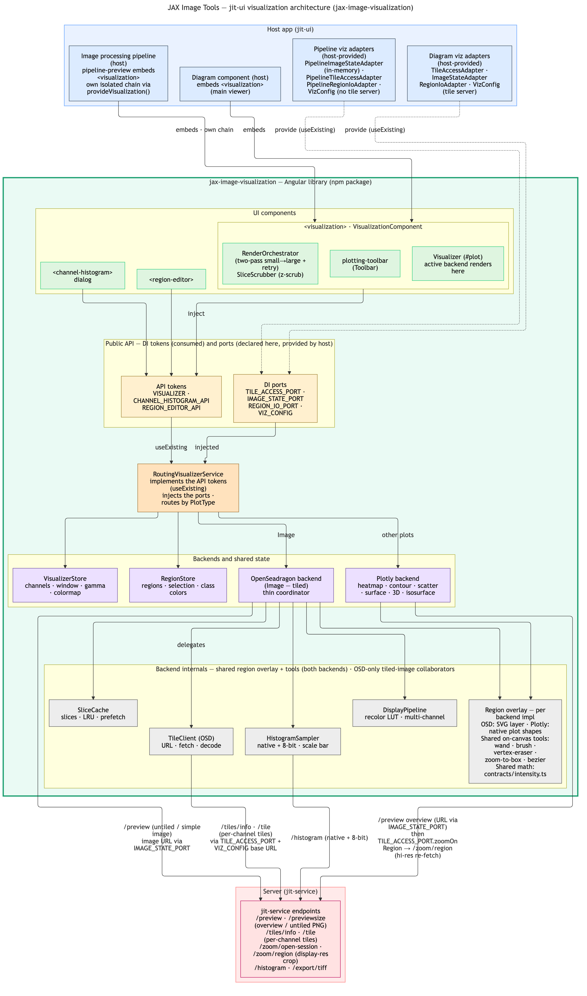
Figure 1 — jax-image-visualization architecture. The MCP control adapter attaches at the RoutingVisualizerService seam (top of the library), reusing the same IVisualizer commands the toolbar and host already drive.

3. Approaches considered
Three approaches are genuinely different products. They differ chiefly in who owns the browser the viewer runs in.

3.1 Approach A — Live-control bridge (recommended)
The MCP server talks over a WebSocket to a thin control adapter wired to the RoutingVisualizerService in the running app — the same tab the scientist is looking at. Claude drives the real UI; results are read back as region GeoJSON or as a screenshot via downloadImage()/exportComposite() returned over the channel.
Controls the real UI the analyst sees: Yes — same tab.
Reuses IVisualizer as-is: Yes — fully.
OSD tiles / SAM / regions: Yes — the host supplies its existing DI ports.
Effort: Medium.
Best for: "Segment the cells in the rectangle and switch to contour view" on the analyst's actual screen.

3.2 Approach B — Headless / embedded renderer
The MCP server launches the library in a headless browser (e.g. Playwright) it owns, drives it, and screenshots back natively. Same control adapter as A; the difference is the server owns the browser instead of attaching to a human's tab. Best for reproducible/automated/CI visualization with no human tab open. Requires the planned example server (visualization SOW D7) to stand in for jit-service so the ports resolve standalone.
Effort: Medium-High (adds headless-browser orchestration on top of A's adapter).

3.3 Approach C — Stateless generator (declined)
Port the Plotly trace-building to Node and render data to a PNG, mirroring the reference servers. Declined: it reimplements the rendering engine and throws away tiling, regions, and browser-side SAM/Cellpose — i.e. everything the library is good at. Recorded here so the issue can close the option explicitly rather than leave it open.

3.4 Comparison
Dimension | A. Live-control bridge | B. Headless renderer | C. Stateless generator
Controls the real UI the analyst sees | Yes (same tab) | A separate headless instance | No (throwaway plots)
Claude can "see" the result | Screenshot over the channel | Native (Playwright) | Returns the image
Reuses IVisualizer as-is | Yes | Yes | No (reimplements rendering)
OSD tiles / SAM / regions work | Yes | Yes (ports stubbed) | No
Effort | Medium | Medium-High | High + duplicates logic
Recommendation | Recommended | Recommended (headless variant) | Declined
A and B share roughly 90% of the code — the MCP tool layer and the control adapter — and differ only in who owns the browser. Building A first yields B for little extra.

4. Proposed architecture (Approach A)
- Control adapter in the library (src/lib/mcp/visualizer-control.adapter.ts): an injectable that takes VISUALIZER and exposes a flat, serializable command set (loadImage, setPlotType, setColormap, setRegionsGeoJson, segmentRectangles, zoomIn/zoomOut, getScreenshotPng, getRegionsGeoJson, ...). A thin JSON-in/JSON-out translation of IVisualizer. This is the only new code inside the library, and it lives behind a new opt-in entry point so the core library stays transport-free.
- Transport: a WebSocket client the host app opens (dev / feature-flagged only) that registers the adapter's commands and relays calls/results.
- MCP server (new package, e.g. tools/jit-viz-mcp/, Node + @modelcontextprotocol/sdk): one MCP tool per adapter command; the server relays over the WebSocket and returns results and screenshots as MCP content. This is the package added to .mcp.json (which already exists in the repo as a scaffold, currently only generic github/filesystem/git servers, all commented out).
This lines up with the "example/test server + demos" task already on the library roadmap (README "In progress / roadmap" and the extraction SOW). That standalone example server is the natural host for the bridge in headless mode (Approach B), so the MCP work can ride on already-planned infrastructure rather than depending on jit-ui being open.

5. Deliverables
All deliverables are Proposed (none started). This SOW is an investigation outcome, not committed work.

M1. Control adapter over IVisualizer
What: A serializable, transport-neutral command adapter that wraps RoutingVisualizerService / IVisualizer: load image, set plot type, set colormap/reverse scale, zoom/pan, stack navigation, region get/set as GeoJSON, run box/point SAM and Cellpose, and read back regions and a screenshot. Behind a new opt-in library entry point so the core library carries no transport dependency.
Where: libs/jax-image-visualization/src/lib/mcp/* + a secondary entry point in the barrel.
Status: Proposed.

M2. WebSocket control transport + host wiring
What: A WebSocket channel the host app opens (dev / feature-flagged) that registers the M1 commands, plus a session/registration handshake identifying which viewer tab is being controlled.
Where: library transport module + apps/jit-ui composition root (flagged).
Status: Proposed.

M3. MCP server package
What: A Node package built on @modelcontextprotocol/sdk exposing one MCP tool per M1 command, relaying over the M2 transport, and returning screenshots as MCP image content. Registered in .mcp.json.
Where: tools/jit-viz-mcp/ (new package) + .mcp.json.
Status: Proposed.

M4. Headless mode (optional, Approach B)
What: Run the library in a Playwright-driven headless browser the MCP server owns, against the planned example server, for automation/CI with no human tab. Reuses M1/M3; adds browser orchestration and example-server data stubs.
Where: tools/jit-viz-mcp/ headless driver + the library example server (visualization SOW D7).
Status: Proposed (depends on the example server).

M5. Design doc
What: A docs/mcp-control-design.md modeled on docs/sam-segmentation-design.md: the command catalogue, transport/handshake, security model, and the serializable subset of the IVisualizer surface.
Where: libs/jax-image-visualization/docs/mcp-control-design.md.
Status: Proposed.

6. Suggested MVP
A compelling first cut is read state plus five commands: load, setPlotType, setColormap, setRegionsGeoJson, and getScreenshot. That alone demonstrates "Claude drives the viewer" and validates the transport and handshake before building out all ~80 IVisualizer methods. Expand the command catalogue (segmentation, tools, 3D controls) only once the transport is proven.

7. Security and open questions
- Auth — both deployments sit behind oauth2-proxy + Auth0. A control channel that can run segmentation and export data needs the same auth story. Simplest first step: gate the channel to dev/local behind a feature flag.
- Single-tab vs multi-session — the bridge controls whichever tab registered; a session/registration handshake is required once more than one viewer can be open.
- any-typed methods — the IVisualizer contract is deliberately permissive (any on several Plotly methods). The adapter is a good forcing function to tighten the serializable subset; decide how strict M1's schema must be.
- Transport choice — WebSocket (live tab) vs an SSE/HTTP control endpoint vs headless-only. Affects how the host registers and how auth is enforced.
- Where the MCP package lives — in this repo (tools/) vs a sibling repo, and how it is versioned against the library's public contract.

8. Dependencies
- A stable IVisualizer / RoutingVisualizerService public contract (visualization SOW D7 — library extraction hardening). The adapter binds to this surface.
- @modelcontextprotocol/sdk (Node) for the MCP server; a WebSocket library for the transport.
- For headless mode (M4): the planned library example server (visualization SOW D7) and Playwright (or equivalent) for the headless browser.
- The host app's oauth2-proxy + Auth0 setup for any non-dev deployment of the control channel.

9. Risks
Risk | Likelihood | Impact | Mitigation
Control channel becomes an unauthenticated remote-control surface | Medium | High | Gate to dev/local behind a feature flag initially; align the channel with oauth2-proxy + Auth0 before any shared deployment; require a session handshake.
IVisualizer's any-typed methods leak weak schemas into MCP tools | Medium | Low | Define a tightened, serializable command subset in M1; validate at the adapter boundary rather than exposing raw methods.
Drift between the MCP command catalogue and the evolving library contract | Medium | Medium | Generate the command list from the contract where possible; version the MCP package against the library's public API; keep the MVP surface small.
Headless mode blocked by the example server not yet existing | Medium | Low | Ship Approach A (live tab) first; treat M4 as dependent on visualization SOW D7.
Single-tab ambiguity when multiple viewers are open | Low | Medium | Registration/handshake that names the controlled tab; reject commands when the target is ambiguous.

10. Phasing and acceptance criteria

10.1 Phase 1 — MVP live-control bridge (M1 partial, M2, M3 partial)
Acceptance: From a Claude session, load an image, switch plot type, set a colormap, push regions as GeoJSON, and get a screenshot back — driving a real jit-ui tab over the WebSocket channel (dev/flagged).

10.2 Phase 2 — Full command catalogue (M1, M3)
Acceptance: Zoom/pan, stack navigation, region read-back, box/point SAM and Cellpose, and 3D/isosurface controls are all exposed as MCP tools with validated schemas; read-back returns region geometry and pixel/screenshot content.

10.3 Phase 3 — Security hardening
Acceptance: The control channel authenticates via oauth2-proxy + Auth0 (or a documented equivalent) and enforces a session handshake; the dev-only flag is no longer required for a controlled deployment.

10.4 Phase 4 — Headless mode (M4, optional)
Acceptance: The MCP server drives a headless browser against the example server and returns screenshots with no human tab open; runnable in CI.

11. Changelog
2026-06-18: Initial draft. Investigation outcome for jit-ui#97: documents the control-surface finding (IVisualizer / RoutingVisualizerService already expose every needed command), the three approaches (live-control bridge recommended, headless variant, stateless generator declined), the proposed architecture, deliverables M1-M5, a five-command MVP, security/open questions, dependencies, risks, and phasing.

