ModernGuild Calendar Features

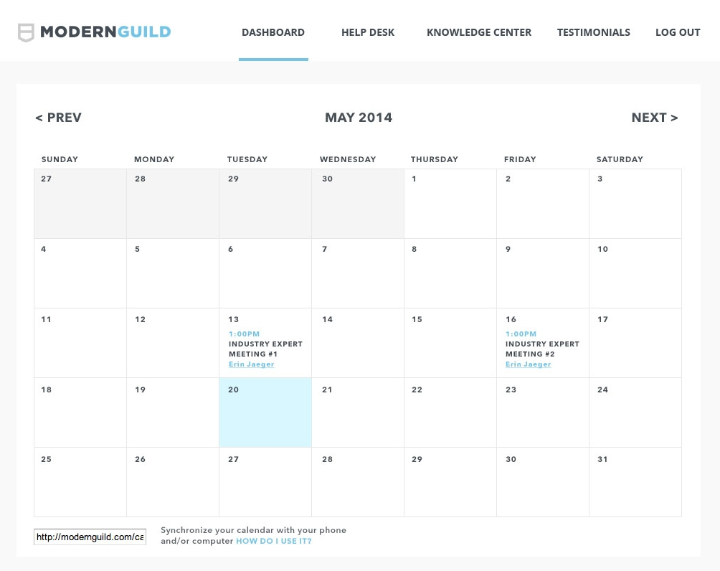

Frameworks: Fullcalendar, Timepicker

User types
- Student / Coach / Industry Expert / Admin

Use Cases
- 1 - Initial Scheduling proposed by student
- 2 - Coach reviews meetings and accept/reject meeting times
- 3 - Student reviews meetings sent by Coach
- 4 - Both can re-schedule a confirmed meeting, and the other party has to accept/reject meeting times

Row highlighting
- The “recommended” week is highlighted for student for a visual representation of when to schedule the meeting
- Re-scheduling - when re-scheduling a confirmed meeting, 1 day before and after the confirmed date is highlighted - if the meeting date is the 29th, the 28th, 29th and 30th are highlighted

Schedule 5 meetings at once
- In the Initial Scheduling use case, the student schedules 5 meetings at once

Timepicker pop up
- Timepicker is a jQuery plug-in that is a drop down list of available times

Calendar Highlighting example

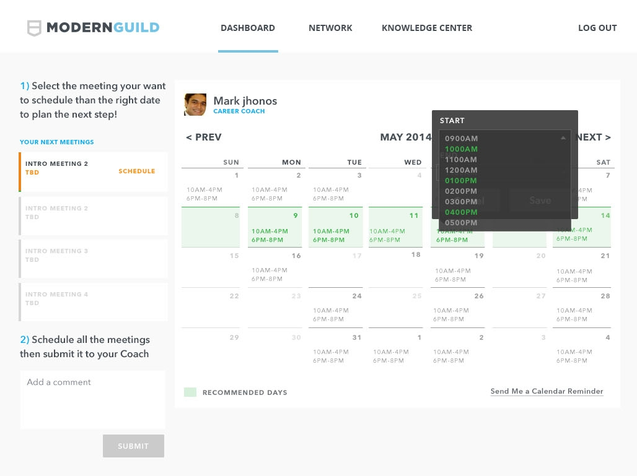

Highlighting is only for student users, unless if re-scheduling

- The “recommended” week is highlighted for user to see which day they should pick
- The border and the shading of the cell is highlighted
- The highlighted row depends on which meeting is being selected - meeting 1, meeting 2, etc.
- Re-scheduling - when re-scheduling a confirmed meeting, 1 day before and after the confirmed date is highlighted - if the meeting date is the 29th, the 28th, 29th and 30th are highlighted
- Days to highlight are calculated in jQuery

Timepicker pop up example

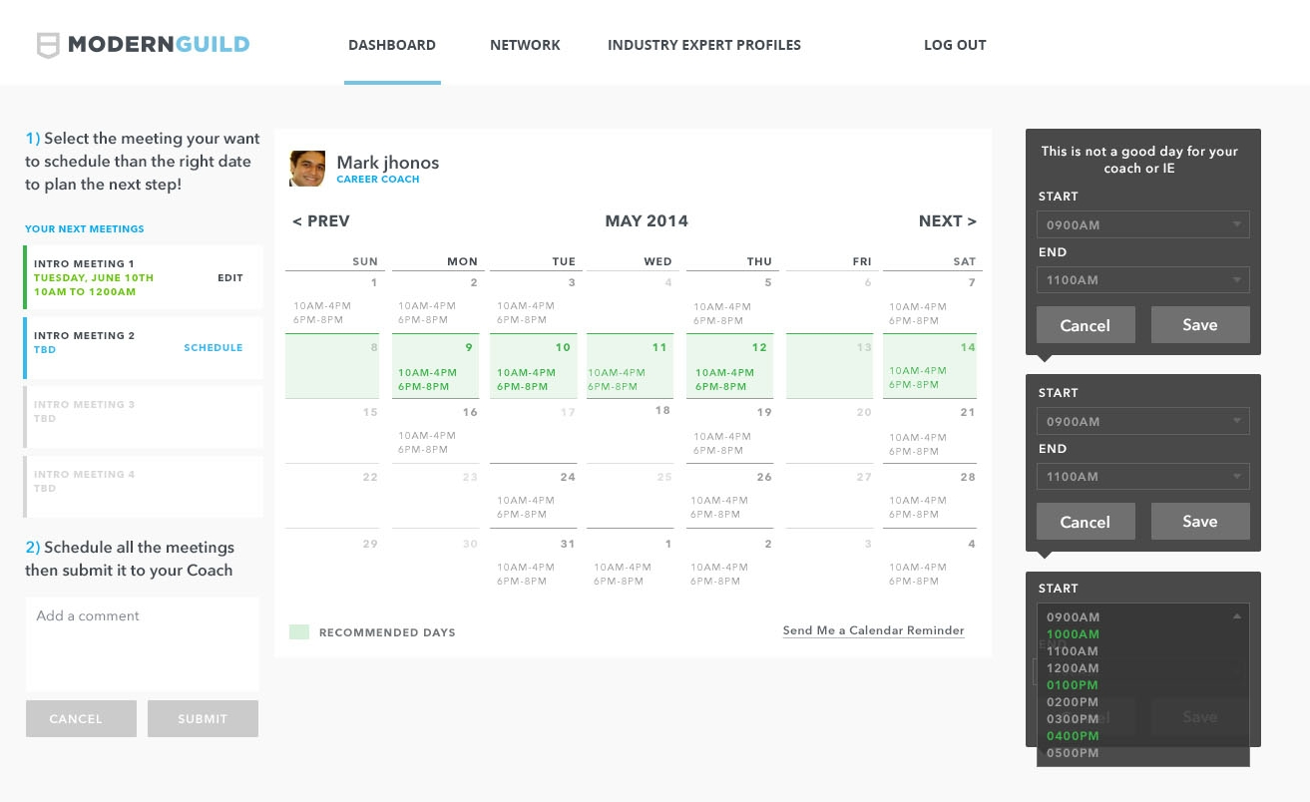

Pop up features

- Pop up activates when you click anywhere on the calendar
- Drop down menu of times of day for scheduling, start time and end time
- Some meetings are 1 hour, some are 1/2 hour, and when you select a start time, the end time is calculated and pre-filled for you
- When you click on a person’s time slot, their available times are highlighted. There is no highlighting if you click on the calendar’s empty space

Schedule 5 meetings at once

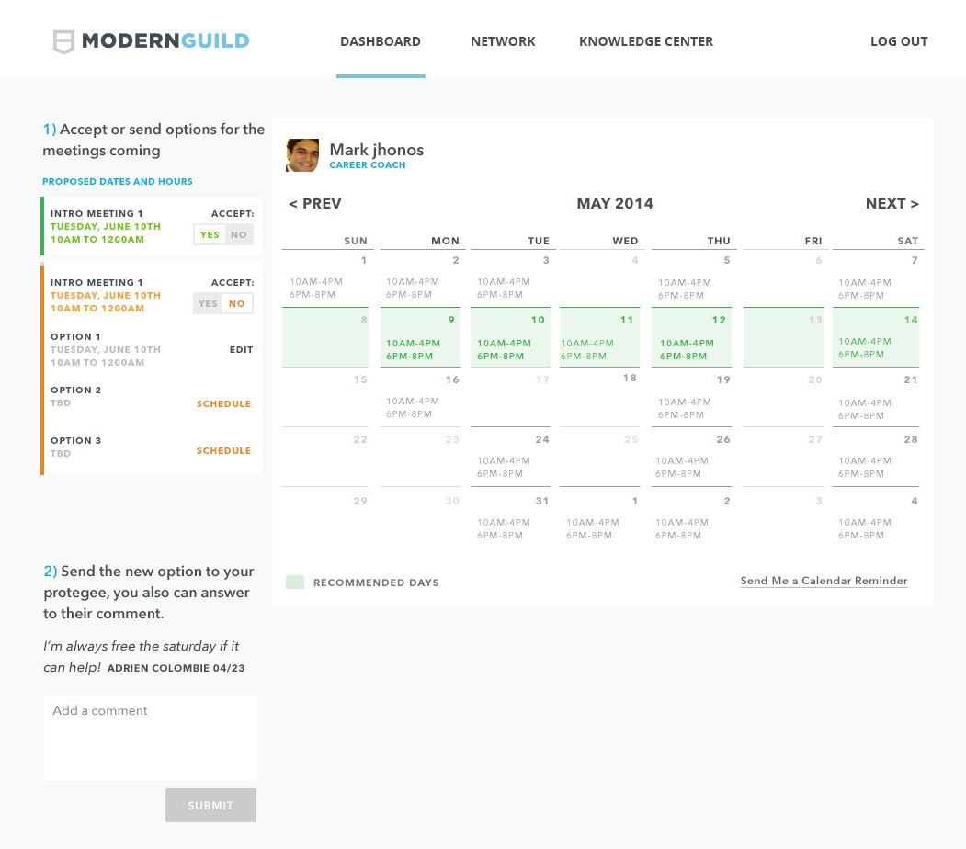

Scheduling features

- Student schedules all 5 meetings in the same screen, for IE meetings it’s 3 meetings at once
- For meeting 1 you click on the calendar, open the pop up and select a time from the timepicker, and the selected date/time appears on the left module
- Then meeting 2 is highlighted, which is the active meeting. You do the same with meeting 1. Then meeting 3 is highlighted.
- When you’re done you can add a comment to your coach and click the submit button and save the meetings to the database

Coach Review Meetings

Review features

- After student hits the submit button, the meeting proposals are sent to the coach for review. The meetings are not scheduled yet, they are proposed and not final.
- Mark reviews all 5 meeting times and he can click “yes” or “no” for each one. If “no” is selected, a div appears where he can select 3 alternate options for that meeting
- If Mark hits the submit button, the “yes” meetings will change their status to scheduled, and the meeting is confirmed. If a meeting is “no” then it is sent back to the student for review. The student can do the same and click yes or no to the meetings.

Re-scheduling Meetings

Re-scheduling features

- After a meeting is scheduled, it is sent to the other user. Both student and the coach can re-schedule a meeting if they need to cancel.
- From the dashboard, the student goes to the calendar and clicks on the meeting to be re-scheduled.
- An email and dashboard alert is sent to the other party. They can go to the calendar and say “yes” or “no” to the new time. If “no” is selected, a div appears with 3 alternate options.

Use Cases Details

- 1 - Initial Scheduling proposed by student - for Coach meetings it’s 5 meetings, for IE meetings it’s 3 meetings
  - Status: Proposed
- 2 - Coach reviews meetings and accept/reject meeting times - coach can say yes/no to the 5 meeting times, and for each no, must provide 3 alternate times, total of 15 alternate times
  - Status: Proposed/Scheduled
- 3 - Student reviews meetings sent by Coach - student reviews each meeting individual, say yes/no to the meeting, and for each no, must provide 3 alternate times
  - Status: Proposed/Scheduled
- 4 - Both can re-schedule a confirmed meeting, and the other party has to accept/reject meeting times
  - Status: Proposed
- 5 - If either party fails to show up at the appointed time, the meeting is updated to No-Show
  - Status: No-Show
- 6 - Only the admin can cancel meetings, he can also schedule meetings for others
  - Status: Cancelled

