ModernGuild Portal

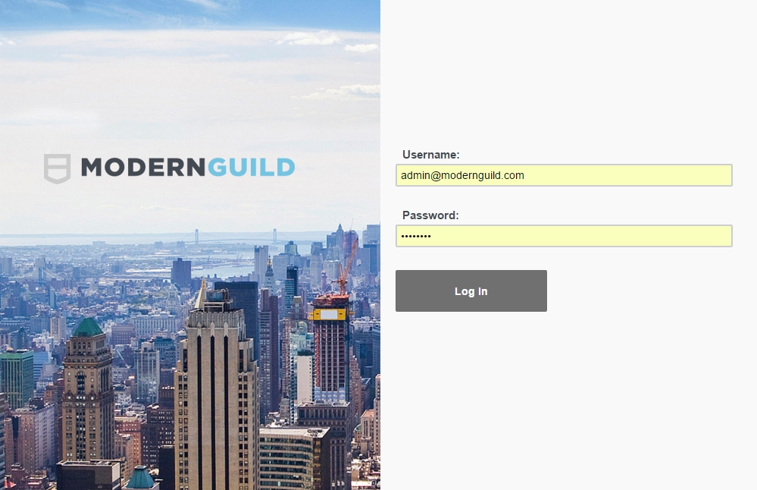

Login Portal

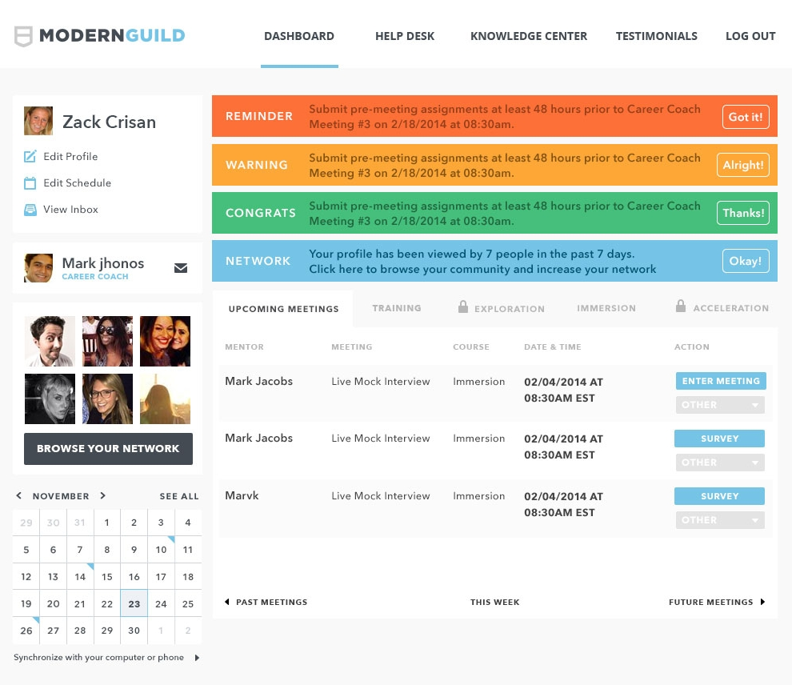

User Dashboard Features

- Top left corner - user can edit their own profile - jQuery pop up
- Edit their schedule - data is linked with calendar
- View their inbox and check for messages and send messages to other users
- Reminder “ribbons” with different colors
- Upcoming meetings tab - jQuery dataTable

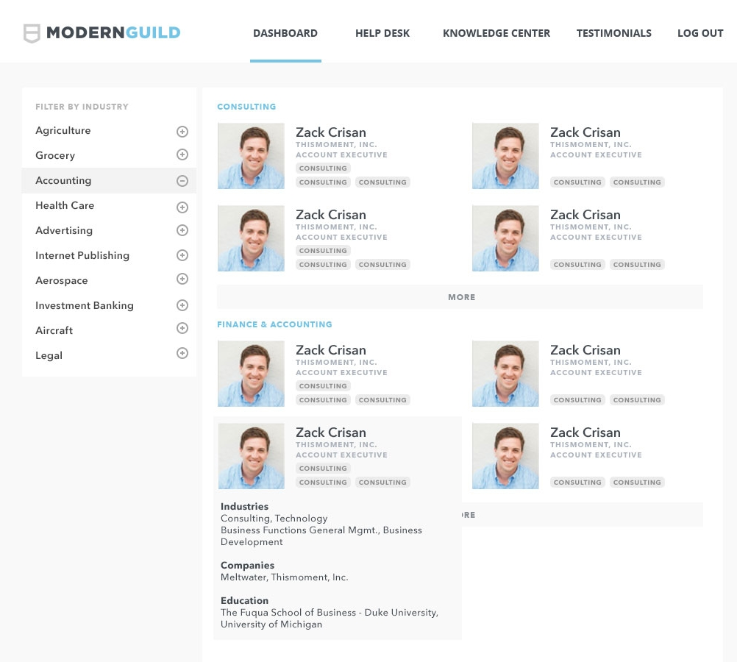

Industry Experts Showcase

- Experts arranged by category
- Shows user’s photo, name, job title and industries

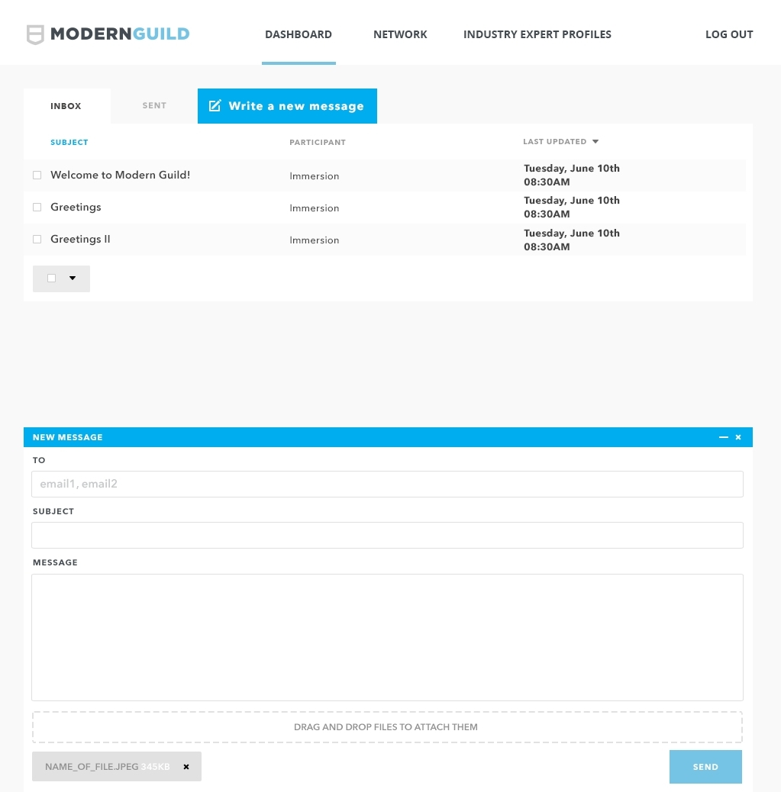

User Inbox

- Send messages to other users internally - when a user receives a message they will be notified via email
- List of inbox messages and sent messages

