Abstract— In this report the modeling of crowds through simulation technology will be explored. This report is focusing on the dynamics of crowd evacuation in an emergency scenario. Measurements involving how a buildings design restricts the flow of a crowd will be used in order to find bottlenecks. The process of alertness spreading through crowds and how that effects evacuation will also be explored.

Crowd Modeling and Simulation Technology
James Hodge, Austyn Trull, and Tyler Gabriel, CS 480, trgabriel@crimson.ua.edu, jdhodge@crimson.ua.edu, agtrull@crimson.ua.edu

INTRODUCTION
THIS paper is based around a crowd simulation. Our simulation focuses on a small to medium sized crowds (from 10s to 100s) and the effects on the crowd in the short term (minutes to hours). The simulation uses an agent-based approach rather than particle/flow based in order to have more control over the individuals of a crowd.
The problem this project seeks to simulate, is the effect that building design and crowd interactions can have on the flow of a crowd. More specifically, how the design of a building can cause bottlenecks to form on the flow of a crowd as people try to evacuate the building in an emergency situation. One of the goals of the simulation is then to determine the most effective design of a building, evaluating such metrics as the number of rooms it takes to reach an exit and the number of doors within a room. The second goal of the simulation is to measure and track how a state of alarm/panic can spread among individuals in an attempt to determine the optimal path that individuals should take to alert other rooms to the threat. With these measurements, it would be possible to then determine how a building can be designed and how individuals should alert other rooms to an emergency such that the amount of casualties caused by an emergency can be minimized, and could possibly even be eliminated.
To model the environment in which the evacuation is taking place a node-based approach was used. The simulation begins with the crowd dispersed through various “Room” nodes and once alerted will begin trying to find a path to the “Exit” node. There are also “Door” nodes which restrict the flow of crowds. Each node holds information about its connection with other nodes. This includes the distance between the nodes.
The simulation starts by setting a node to “alert”. This causes all of the individuals occupying that node to switch to “alert” and try to evacuate. When an “alert” individual enters a node that is not in an “alert” state it switches it to “alert”. This simulates how alertness to an evacuation spreads through a building. Meanwhile, there is also a timer which acts as an alarm such that the state of all of the nodes would be set to “alert”.
When an individual encounters a “door” node it must enter a pool of individuals trying to access the door. This simulates how a crowd can bunch up at a doorway and impede a evacuation. Door nodes are not required, but can be used to attach room nodes together or to attach a room node to the exit node.
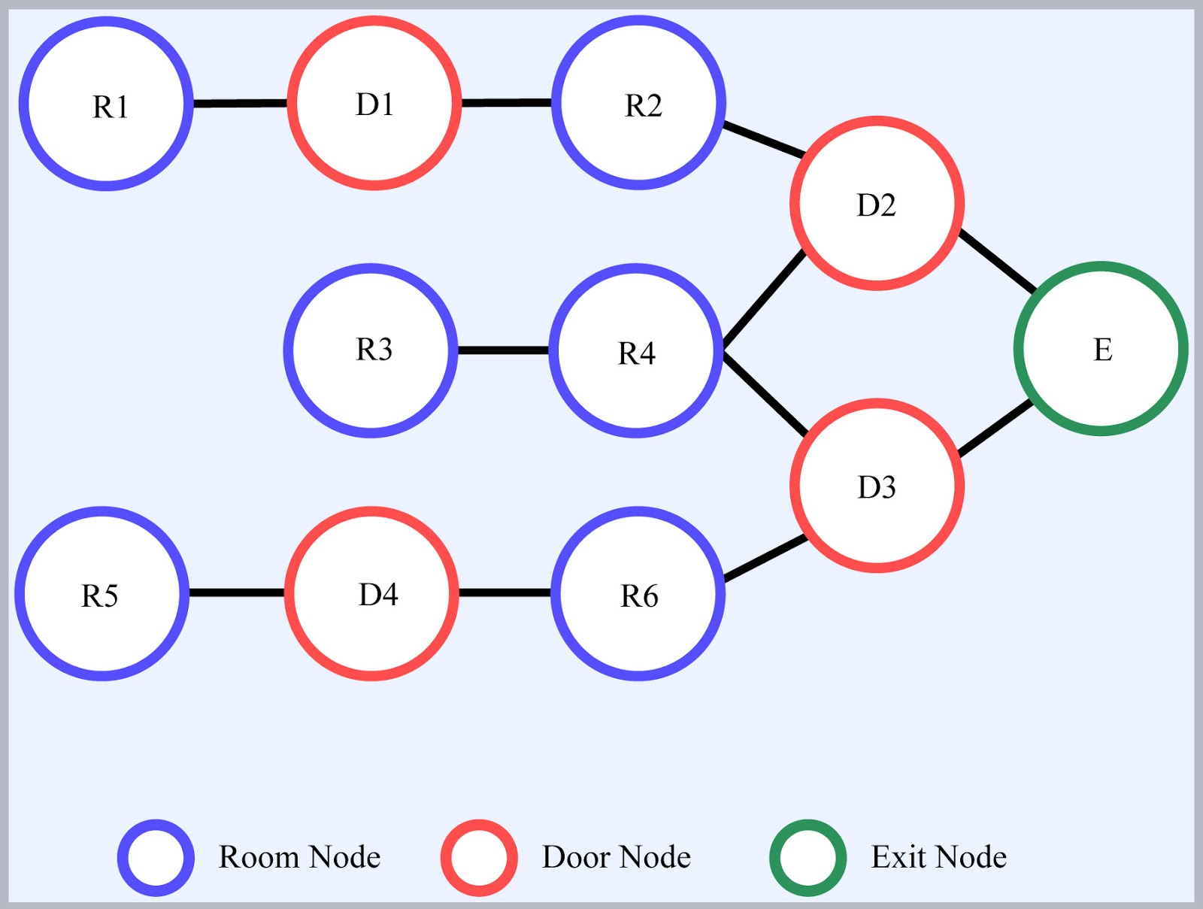
Fig. 1 This is a visual representation of what the node system will look like in implementation.

Procedure

Implementation Discussion
This simulation was modeled so that it used a small or medium crowd size, a time scale that focuses on the short term, and an agent based approach. The crowd size was decided due to limitations of computers and that scaling up the size of the crowd would be an easy step. By implementing the simulation with the intent of focusing on the short term it sets the focus on the physical reactions and outcomes while a long term time scale would focus more on the psychological and social effects of the event. The agent-based approach to a crowd simulation creates a thread for each agent in the crowd. Agent based was chosen over both flow and particle based because it focuses more on the individual rather than seeing the crowd as a homogeneous entity, thereby allowing for more complex interactions within the crowd to better emulate what can be seen in real life. These individuals also have their own physical and psychological profile which effects how they move through the nodes and make decisions. These profiles will contain information such as each agent’s speed, position, emotional state, and whether or not they are safe from danger. The characteristics can then be defined as follows: an agent’s speed indicates the amount of time it takes to move a distance, position indicates their location in the room relative to the exit, and emotional state determines an agent’s reactions to the emergency at hand. These characteristics will then be used so as to broadly model behavior of an individual. Using these characteristics, it can be determined how the interactions between agents and nodes effect the time it takes for a crowd to evacuate the building.
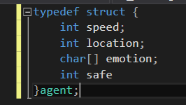
Fig. 2 This is a representation of the structure that we used to represent each actor.
While designing this simulation, it was important to keep these four factors in mind: flexibility, extensibility, scalability, and efficiency. These four factors are used to help determine the effectiveness of a simulation. By ensuring a simulation is flexible, it allows that particular simulation to be adapted to other cases so they may be simulated with little effort. Extensibility ensures that a simulation can introduce new features with minimal difficulty. Scalability ensures that a simulation or program can be scaled up or down to include different scenarios, corresponding to broader or more specific scenarios, respectively. Scalability is always a concern with simulations and computer programs. Efficiency is to ensure that the simulation can be run in a reasonable amount of time. As long are these four factors in mind when building a simulation, then it can be ensured that a simulation can be considered effective for the job at hand.
To create the modular aspect a main program was used that read in and ran simulation programs. The main program starts out by initializing the necessary components for the simulation. This includes the storage for the actors and the nodes. It also creates the “Outside” Node. Once the initialization is completed the main program reads in a simulation program. A simulation program details the aspects of the simulation including the node web, alarm timing, and the characteristics of the actors. The reason that this is all created in a separate program is to allow for multiple simulations of varying characteristics to easily be swapped out. Once the simulation program is read in the main program connects the node web to the “Outside” node. Then the simulation actually begins in the main program. After the simulation is completed the main program writes the data to an output file.
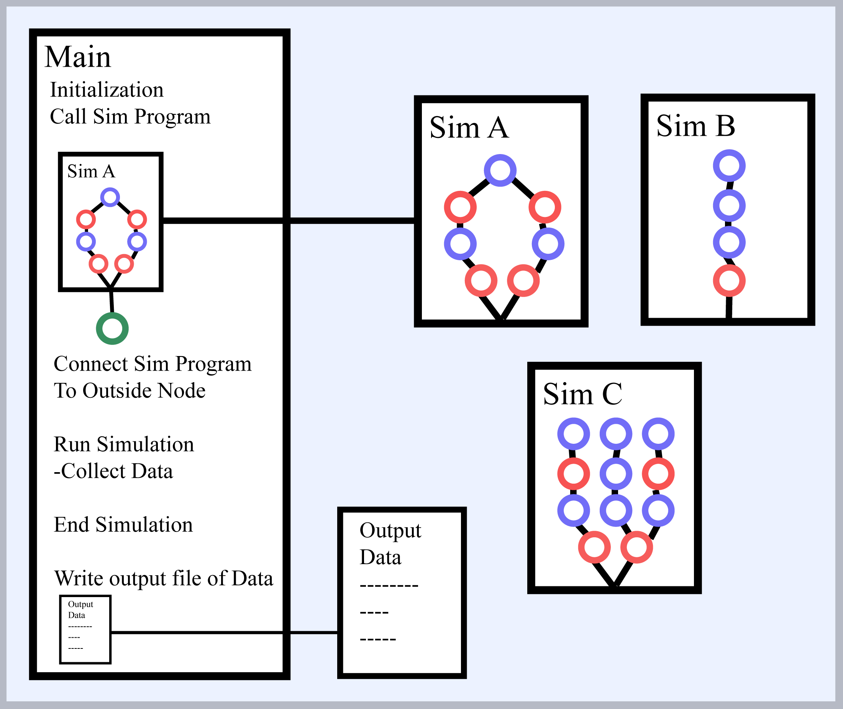
Fig. 3 This is a representation of the modularity of the program.

Simulation Setup/Design
Describe the setup and design.

Results
Describe the results.

Conclusion
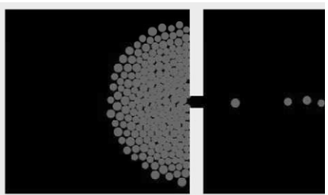
This simulation was designed to be modular so there is room to simulate more complex crowds.
References
- Zhou, S., Chen, D., Cai, W., Luo, L., Low, M. Y. H., Tian, F., Tay, V. S.-H., Ong, D. W. S., and Hamilton, B. D. 2010. Crowd modeling and simulation technologies. ACM Trans. Model. Comput. Simul. 20, 4, Article 20 (October 2010), 35 pages. DOI = 10.1145/1842722.1842725 http://doi.acm.org/10.1145/1842722.1842725

