Abstract— In this report the modeling of crowds through simulation technology will be explored. This report is focusing on the dynamics of crowd evacuation in an emergency scenario. Measurements involving how the design of the building restricts the flow of a crowd will be used in order to find bottlenecks. The process of how alertness spreads through crowds and how that effects evacuation will also be explored.

Crowd Modeling and Simulation Technology
James Hodge, Austyn Trull, and Tyler Gabriel, CS 480, trgabriel@crimson.ua.edu, jdhodge@crimson.ua.edu, agtrull@crimson.ua.edu

INTRODUCTION
THIS paper is based around a crowd simulation. Our simulation focuses on a small to medium sized crowd (from 10s to 100s) and the effects on the crowd in the short term (minutes to hours). The simulation uses an agent-based approach rather than particle/flow based in order to have more control over the individuals of a crowd.
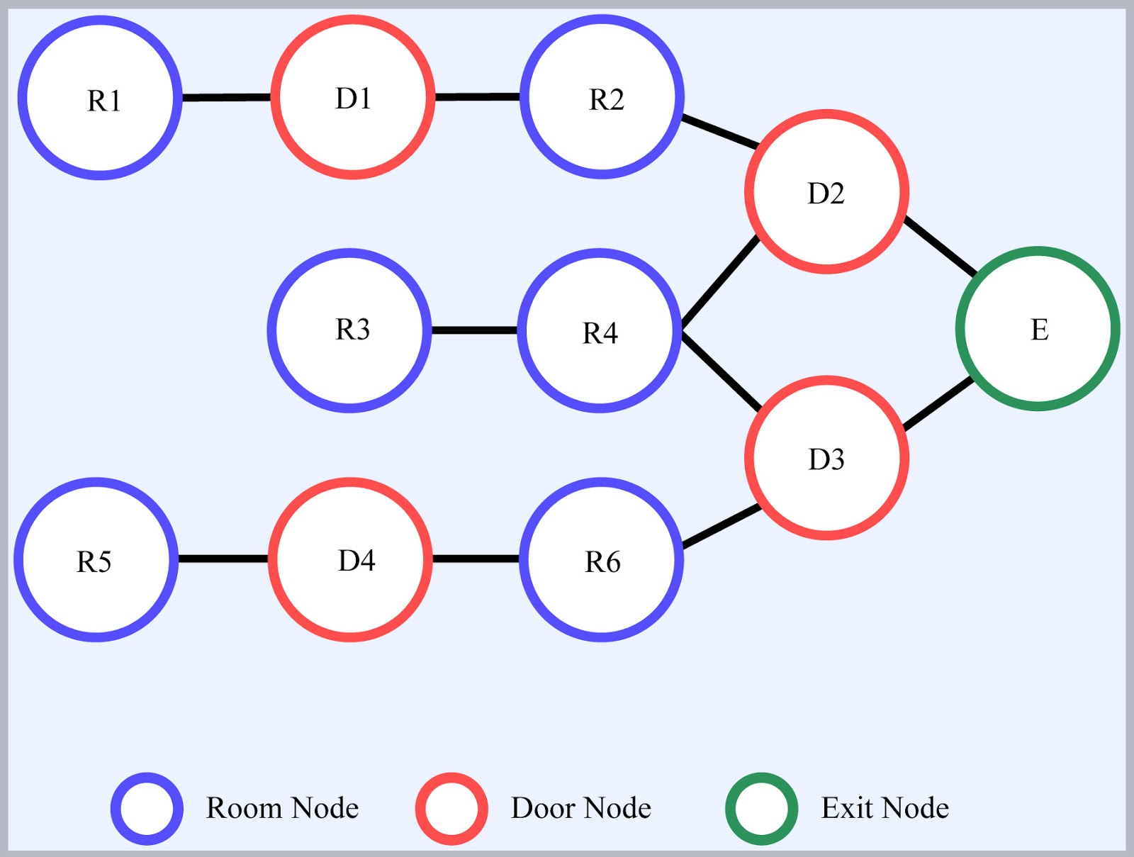
The problem this project seeks to simulate is the effect that building design and crowd interactions can have on the flow of a crowd. More specifically, how the design of a building can cause bottlenecks to form on the flow of a crowd as people try to evacuate the building in an emergency situation. One of the goals of the simulation is then to determine the most effective design of a building, evaluating such metrics as the number of rooms it takes to reach an exit and the number of doors within a room. The second goal of the simulation is to measure and track how a state of alarm/panic can spread among individuals in an attempt to determine the optimal path that individuals should take to alert other rooms to the threat. With these measurements, it would be possible to then determine how a building can be designed and how individuals should alert other rooms to an emergency such that the amount of casualties caused by an emergency can be minimized, and could possibly even be eliminated.
To model the environment in which the evacuation is taking place a node-based approach was used. The simulation begins with the crowd dispersed through various “Room” nodes and once alerted will begin trying to find a path to the “Exit” node. There are also “Door” nodes which restrict the flow of crowds. Each node holds information about its connection with other nodes. This includes the distance between the nodes. (See Fig. 2 for an example)
The simulation starts by setting a node to “alert”. This causes all of the individuals occupying that node to switch to “alert” and try to evacuate. When an “alert” individual enters a node that is not in an “alert” state it switches it to “alert”. This simulates how alertness to an evacuation spreads through a building. Meanwhile, there is also a timer which acts as an alarm such that the state of all of the nodes would be set to “alert”.
When an individual encounters a “door” node it must enter a pool of individuals trying to access the door. This simulates how a crowd can bunch up at a doorway and impede an evacuation (see fig. 1). Door nodes are not required, but can be used to attach room nodes together or to attach a room node to the exit node.

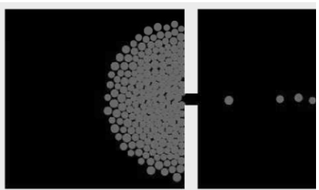
Fig. 1 Visual representation of a crowd bunching up at an exit.[1]

Fig. 2 This is a visual representation of what the node system will look like in implementation.

Procedure

Implementation Discussion
This simulation was modeled so that it used a small or medium crowd size, a time scale that focuses on the short term, and an agent based approach. The crowd size was decided due to limitations of computers and that scaling up the size of the crowd would be an easy step that is not quite necessary for this simulation. By implementing the simulation with the intent of focusing on the short term it sets the focus on the physical reactions and outcomes of the situation while a long term time scale would focus more on the psychological and social effects of the event[1]. The agent-based approach to a crowd simulation creates a thread for each agent in the crowd. Agent based was chosen over both flow and particle based simulations because it focuses more on the individual rather than seeing the crowd as a homogeneous entity, thereby allowing for more complex interactions within the crowd to better emulate what can be seen in real life. These individuals also have their own physical and psychological profile which effects how they move through the nodes and make decisions[1]. These profiles will contain information such as each agent’s speed, position, emotional state, and whether or not they are safe from danger. The characteristics can then be defined as follows: an agent’s speed indicates the amount of time it takes to move a distance, position indicates their location in the room relative to the exit, and emotional state determines an agent’s reactions to the emergency at hand. These characteristics will then be used so as to broadly model behavior of an individual. Using these characteristics, it can be determined how the interactions between agents and nodes effect the time it takes for a crowd to evacuate the building.

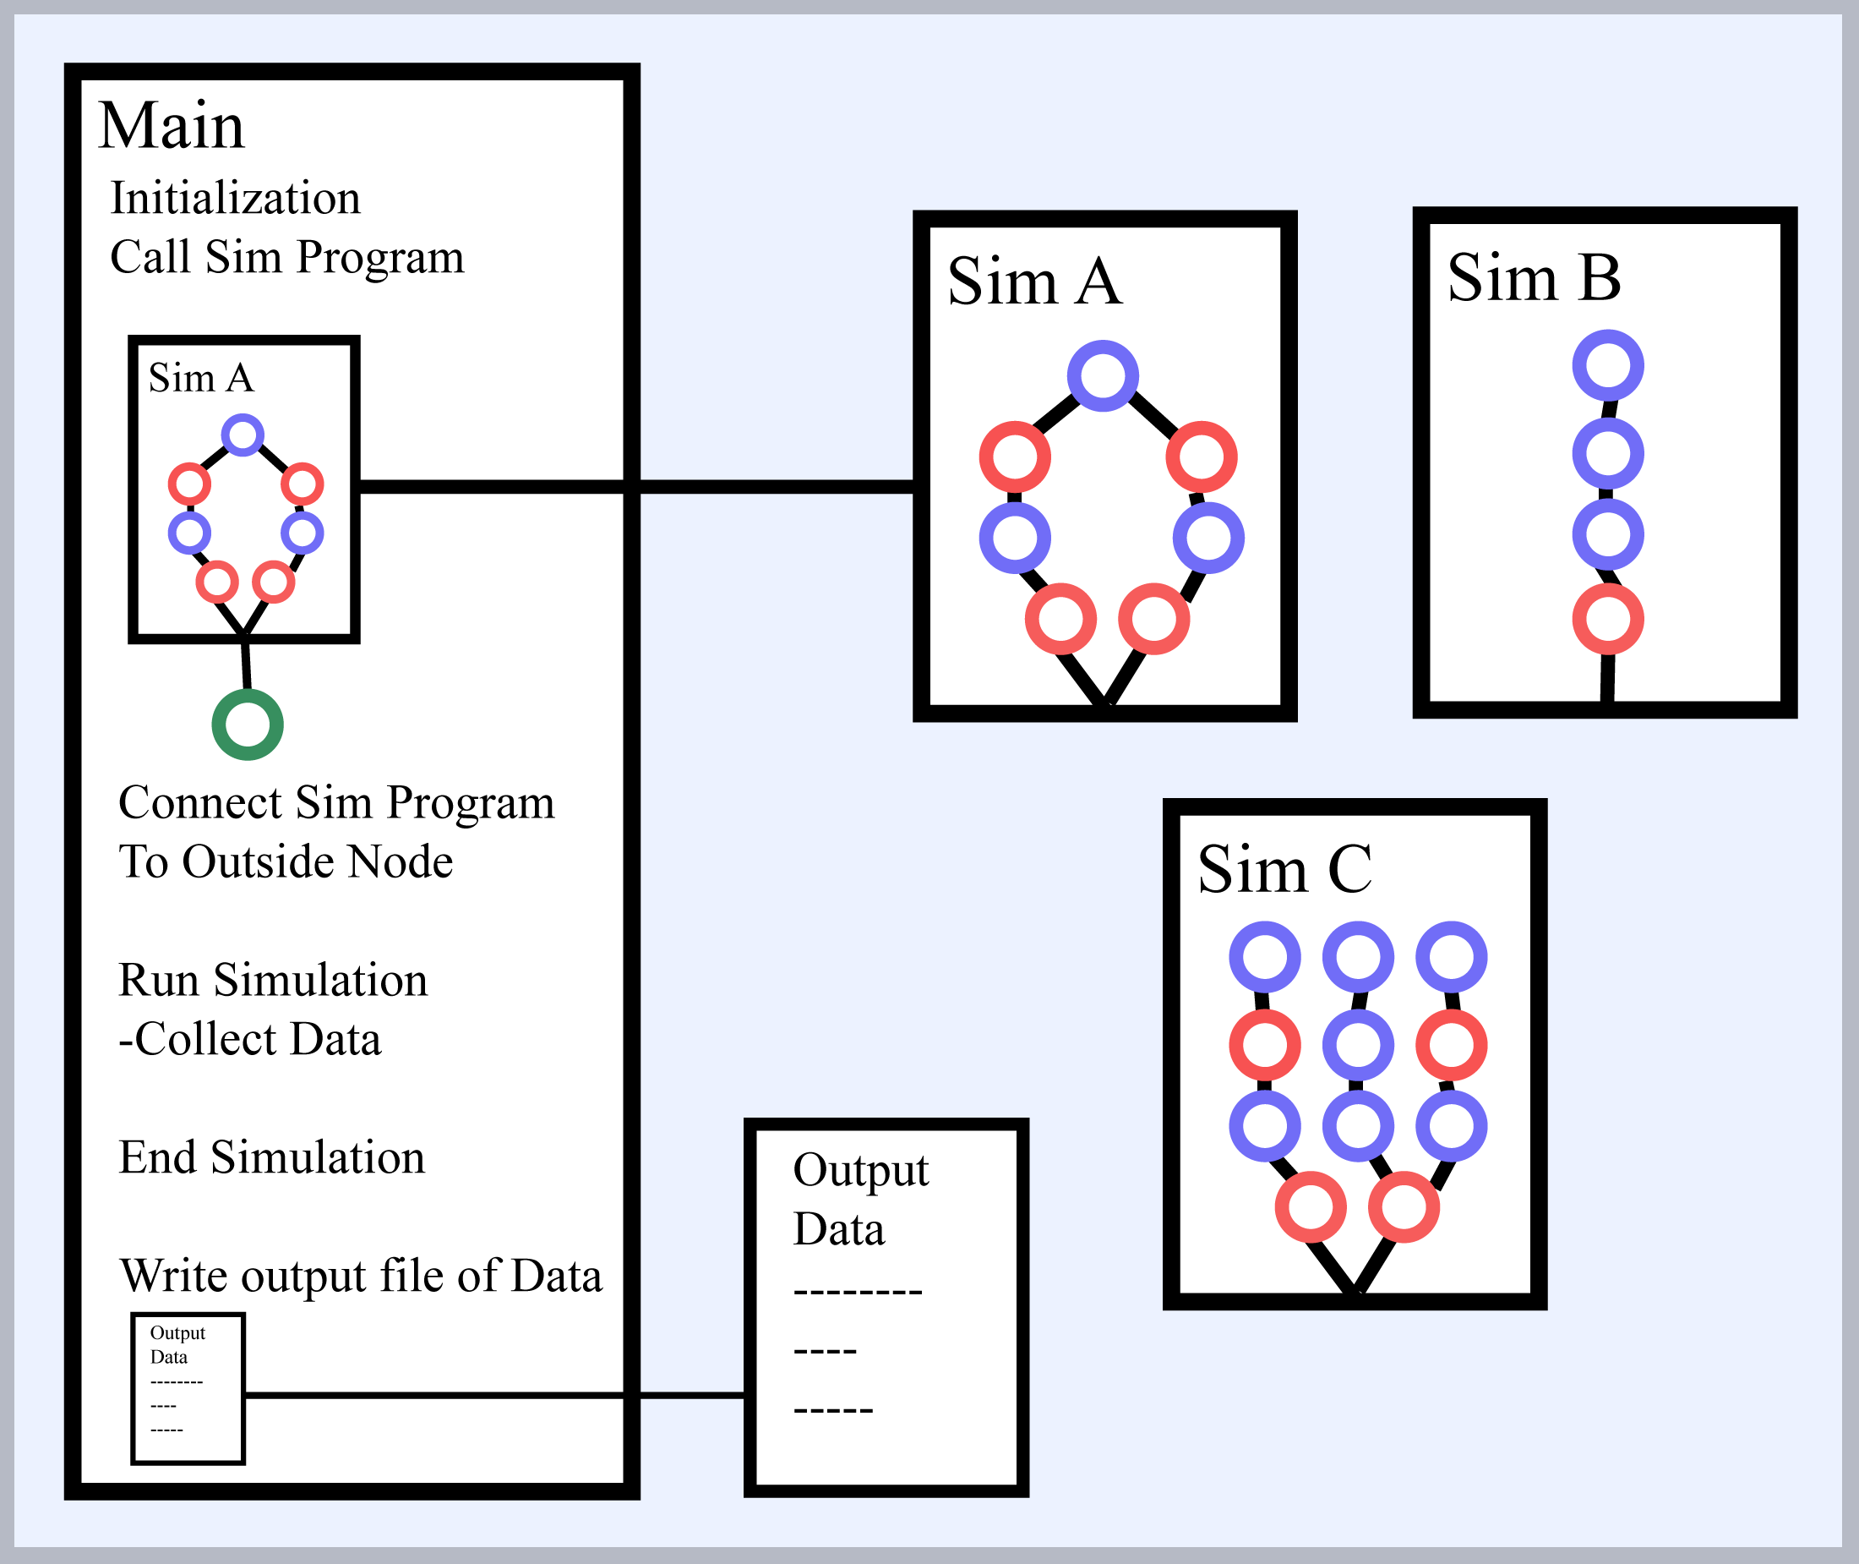
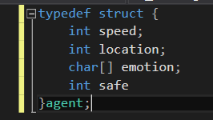

Fig. 3 This is a representation of the structure that we used to represent each actor.

While designing this simulation, it was important to keep these four factors in mind: flexibility, extensibility, scalability, and efficiency [1]. These four factors are used to help determine the effectiveness of a simulation. By ensuring a simulation is flexible, it allows that particular simulation to be adapted to other cases so they may be simulated with little effort. Extensibility ensures that a simulation can introduce new features with minimal difficulty. Scalability ensures that a simulation or program can be scaled up or down to include different scenarios, corresponding to broader or more specific scenarios, respectively. Scalability is always a concern with simulations and computer programs. Efficiency is to ensure that the simulation can be run in a reasonable amount of time. As long are these four factors in mind when building a simulation, then it can be ensured that a simulation can be considered effective for the job at hand.
To create the modular aspect, a main program was used that read in and ran simulation programs. The main program starts out by initializing the necessary components for the simulation. This includes the storage for the actors and the nodes. It also creates the “Outside” Node. Once the initialization is completed the main program reads in a simulation program. A simulation program details the aspects of the simulation including the node web, alarm timing, and the characteristics of the actors. The reason that this is all created in a separate program is to allow for multiple simulations of varying characteristics to easily be swapped out. Once the simulation program is read in the main program connects the node web to the “Outside” node. Then the simulation actually begins in the main program. After the simulation is completed the main program writes the data to an output file.

Fig. 4 This is a representation of the modularity of the program.

To test the validity of this simulation, there are a couple of different variables that can be measured. For this simulation, we will be calculating four different statistics: average escape time, survival rate, average alert time, and average exit delay. These three variables will be calculated and compared. These calculations are evaluated for trends using other situational factors such as the amount of rooms, the severity of the emergency, and the amount of people. These other factors are modified one at a time to ascertain if there is any correlation between the variables and the results.
The four calculations mentioned above that are used to measure the successfulness of the simulation need to be calculated correctly, or else the entire simulation would be a complete failure. Fortunately, the four calculations are quite straightforward. To calculate the average escape time, add every escape time to a total escape time as well as incrementing a counter to keep track of how many agents escape. The final step is to divide the total escape time by the agent counter. To calculate the survival rate, the counter from the previous calculation will be helpful. The survival rate is simply the counter for how many escaped divided by the variable of how many people were initially in the simulation. The third statistic to calculate is the average alert time. The average alert time can be calculated by keeping a variable in memory that keeps track of when the emergency situation began. This variable would then be subtracted from the simulation time variable when the agent goes through the process of changing states from un-alerted to alerted and then again dividing that number by the number of total agents. The final statistic, average exit delay, can be calculated by documenting when the agent enters a “door node” and when the agent leaves the “door node”. Take the difference of these two numbers and add them to a delay total. The final step is to divide that total by the total number of actors in the simulation.

Simulation Setup/Design
The setup for the simulation is fairly straightforward. The program reads in an environment from a simulation program. The program sets up multiple variables. The program defines the node structure of the simulation, including how they connect. It also defines all of the actors and their starting locations. The program also sets the alarm delay. For this report two simulation programs were studied.
. The first environment, known as building plan A, is a simple house model. A single node leads to the exit, and it possesses both an open floor plan and a small number of rooms. This simulation was used as a way to test varying input variables to see how the output correlated with the varying inputs. The experiments performed with this building plan are very similar to the simulations that were run in Labs 1 and 2. The results of these experiments, as well as visual representations can be seen in the 'results' section. The results of these simulations can be used to determine an 'ideal' building plan.
The second environment, known as building plan B, is meant to be an abstracted model of the Science Engineering Complex at the University of Alabama. The various rooms and stairways provide a unique and complex simulation. The reason for choosing this building plan is so it would be possible to validate the results of the simulation through real-world testing. The results from this simulation are mainly used as a way to determine statistically how different the simulation is from the real world.
When the simulation ends, it outputs data into a file named 'panic.out.' The top of the file contains areas for some of the input variables to be repeated for reference. The bottom of the file contains the statistics that were collected from the simulation. The statistics are: average escape time, survival rate, average alert time, and average exit delay. The average waiting time to exit a room is the average amount of time it takes for all the people to exit a room. The average alert time is an average of the amount of time it takes for a person to be alerted there was an emergency; this value being skewed towards alarm time would indicate that few people were alerted to the emergency before the alarm went off. The average escape time is the average amount of time it takes for all people to exit the building. The survival rate is a percentage of the amount of people that successfully escaped the building.
Specifically we tested two dimensions of each of the environments first how an alarm delay effects the escape time and how the number of actors effects the escape time. For the first scenario we iterated through alarm delays of 10 to 25 in increments of 5. In the second scenario we iterated through alarm delays of 20 to 35 in increments of 5. For the second test in the first scenario we ran simulations of actor populations ranging from 12 to 48 in increments of 4. For the second test in the second scenario the actor population ranged from 300 to 750 in increments of 50. The maximum population of each of the doors were also recorded in this final test.
By testing two scenarios the dynamics of crowd evacuations at different scales can be explored. The parameters of the tests reflect that.

Results
When testing the alarm delay in the two scenarios the results were fairly straightforward with the increase of the alarm delay increasing both the total escape time and the average escape time.
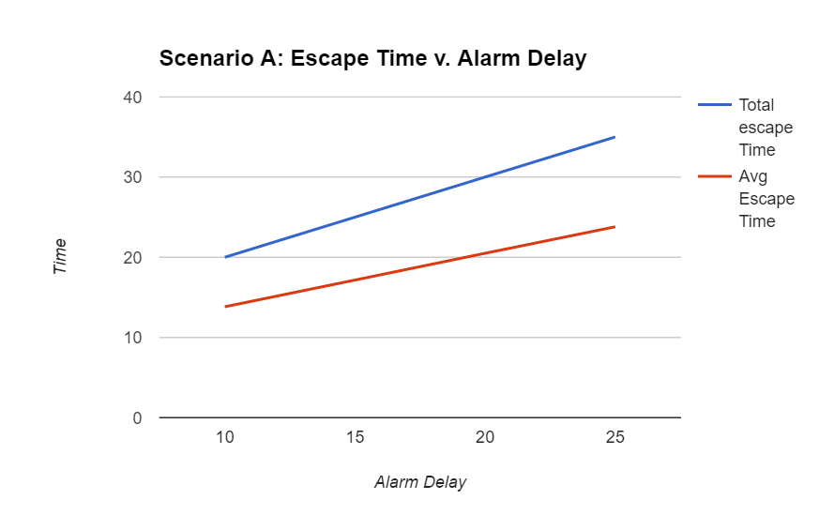
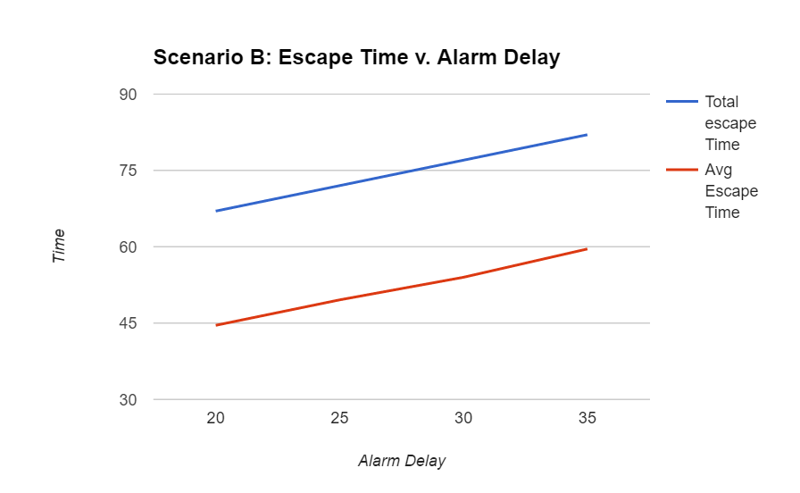
This is the graph generated from the data we recorded in the first test. The results match the results of the same test in Scenario B.

Here are the results of the same test in scenario B. These results show the need for reducing the time that people are alerted in a evacuation scenario.
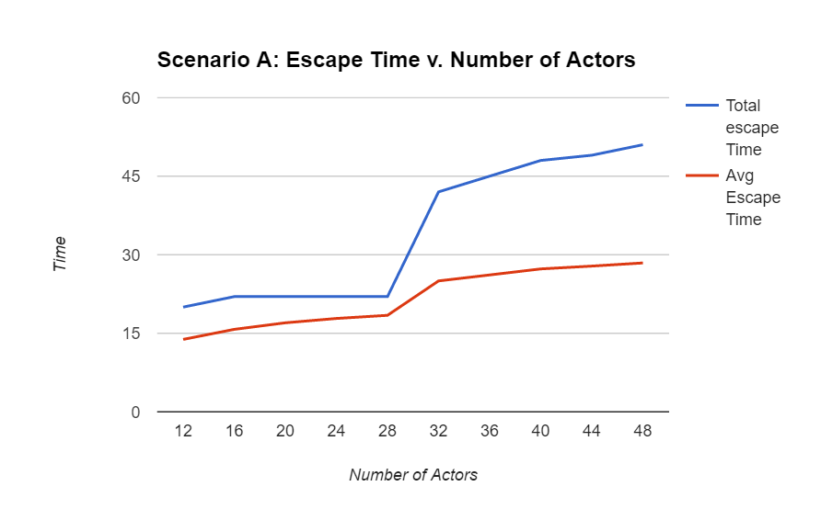
The next aspect we tested was the size of the populations.

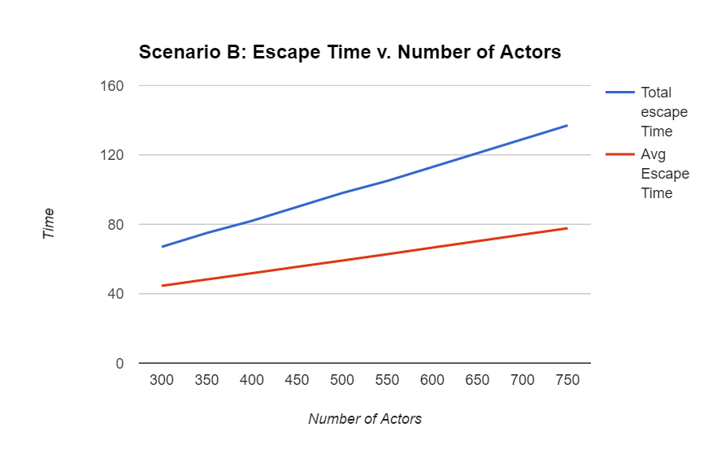
Here are the results from the second test in scenario B. There is a dramatic bump in the middle of the graph when the number of actors reaches 32. This is due to the door creating a bottleneck. Below 32 the door could accommodate all of the actors trying to exit, but once the number of actors grows past that point they are restricted by the flow of the door.

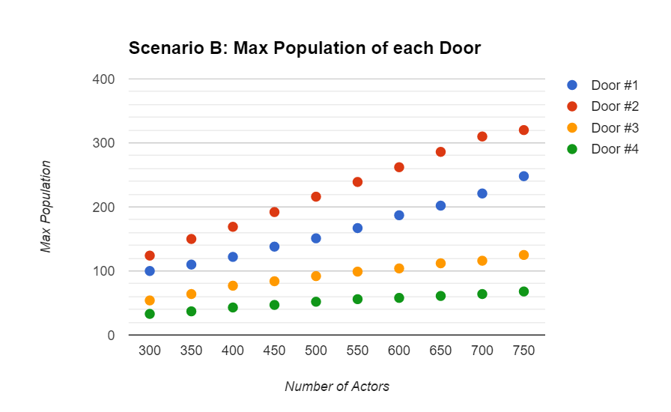
Here are the results of the same test in scenario B This graph doesn’t have the same bump as the first scenario due to the number of actors starting so large that the doors will always be restrictive of the flow. We can see in both of these graphs that the total escape time grows more rapidly than the average escape time as the number of actors increases. This is different to how the alarm delay effects the outcome.

This graph show how the max population of each of the doors increased as the number of actors increased. Door 1 and 2 are much higher due to the nodes in the middle favoring the left over the right. However when accounting for that doors 2 and 3 are higher than 1 and 4. these doors represent the middle two doors and this result shows that these doors create a bigger bottleneck than the outside two doors.

Conclusion
This simulation was designed to be modular so there is room to simulate more complex crowds.
References
- Zhou, S., Chen, D., Cai, W., Luo, L., Low, M. Y. H., Tian, F., Tay, V. S.-H., Ong, D. W. S., and Hamilton, B. D. 2010. Crowd modeling and simulation technologies. ACM Trans. Model. Comput. Simul. 20, 4, Article 20 (October 2010), 35 pages. DOI = 10.1145/1842722.1842725 http://doi.acm.org/10.

