Project Plan

<Project Name>

Student Names

Table of Contents

1.0 Introduction 3

1.1 Problem Background 3

1.2 Scope 3

1.3 Document contents 3

2.0 Work Breakdown Structure 4

3.0 Activity Definition & Estimation 5

4.0 Gantt Chart 6

# Introduction

## Background

The report outlines the development of a graphical user interface that will be utilized in the analysis and visualisation of the Victoria State Accident Dataset. The provided data encompasses accident records for a five-year-period from 2015 to 2020. The primary goal is to provide users a way to effectively interact with the dataset. As per the requirements, the tool should be able to display information of all accidents in a specified time frame, produce a chart that illustrates number of accidents in each hour of the day, search up incidences by accident type, show the trends of accidents caused by drunk driving, and carry out an additional task which will be specified in the later phases of the assignment.

## Scope

The data analysis tool will allow the users to gain unique insights through analysing and visualising the Victoria State Accident Dataset. It should fulfill the basic requirements mentioned above and carry out the tasks seamlessly without major errors. On the other hand, it is important to note that the GUI tool is limited to the five-year period data and it cannot carry out the same functions for complex datasets or other dissimilar datasets. Furthermore, the functionalities are also limited to the aforementioned tasks.

## Document contents

The project plan provides an outline of the problem, scope, tasks, and limitations for the data analysis tool to operate within. The plan also includes a work breakdown structure that deconstructs the project into a manageable hierarchical system, alongside a description of the activities and time frames for completion. The work breakdown structure will be used to create a Gantt Chart that will graphically depict the overall project schedule. The project plan will be a guide for the team members on a structured approach to carrying out the development. It also contains the roles and responsibilities of the team members in different phases of the process.

*Include some background information about the problem, the scope and what this document will contain.*

# Work Breakdown Structure

*This section should include the work breakdown structure for the whole project. The elements from the WBS should be used to generate your activity definition and those activities should then be scheduled in the Gantt Chart. Remember to consider ALL project activities – anything you do or will need to do should be included in the WBS*

*WBS’s are usually presented as some kind of hierarchical diagram/chart etc. The details what is involved each work unit should be provided in section 3:* ***Activity Definition***

*You do NOT need to do a WBS Dictionary for this project – the activity definition (whilst slightly different) will suffice. The WBS is focussed on SCOPE. The Activity definition is focussed on TIME.*

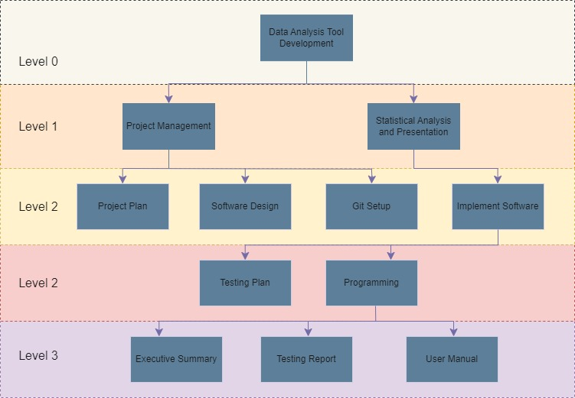

# Activity Definition & Estimation

*From your WBS, define the activities required for your project. You will revise this document and add more detail for part B as you discover more about the project.*

*Each activity should be clearly identified by a number and should match up to your Gantt chart. You should provide some estimations for the time you think each activity will take. This should make it easy to prepare your Gantt chart.*

# Gantt Chart

*This section should contain your Gantt chart. The items in the Gantt chart should match the activity definition from section 3. You should also submit your Gantt chart file separately.*