

**Developer**: Jaden Bryon Knutson

**Date**: 9/22/2022

# IT 145 Global Rain Summary Report Template

## Pseudocode

**START of Check-In for pets:**

INPUT from the customer if the pet being checked in is a cat or a dog.

IF the pet being checked in is a cat.

Check spaces available for cats.

IF cat spaces are available, check the cat in.

OUPUT that there is space available.

INPUT if the cat is a new or returning customer.

IF the cat is a new customer.

Collect appropriate information.

ELSE IF the cat is a returning customer.

Update information as needed.

INPUT the length of stay from the customer.

Assign the pet to a space.

Subtract 1 space from the available cat spaces.

ELSE OUTPUT to the customer that there are no spaces available.

**END.**

ELSE IF the pet being checked in is a dog.

Check spaces available for dogs.

IF dog spaces are available, check the dog in.

OUPUT that there is space available.

INPUT if the dog is a new or returning customer.

IF the dog is a new customer.

Collect appropriate information.

ELSE if the dog is a returning customer.

Update information as needed.

INPUT the length of stay from the customer.

IF the length of stay is at least 2 days.

INPUT if the customer would like their dog groomed.

IF the customer wants grooming.

Assign the dog with grooming appointment.

ELSE don’t assign the dog with grooming appointment.

ELSE the dog is not eligible for grooming.

Assign the pet to a space.

Subtract 1 space from the available dog spaces.

ELSE OUTPUT to the customer that there are no spaces available.

**END.**

## Flowchart

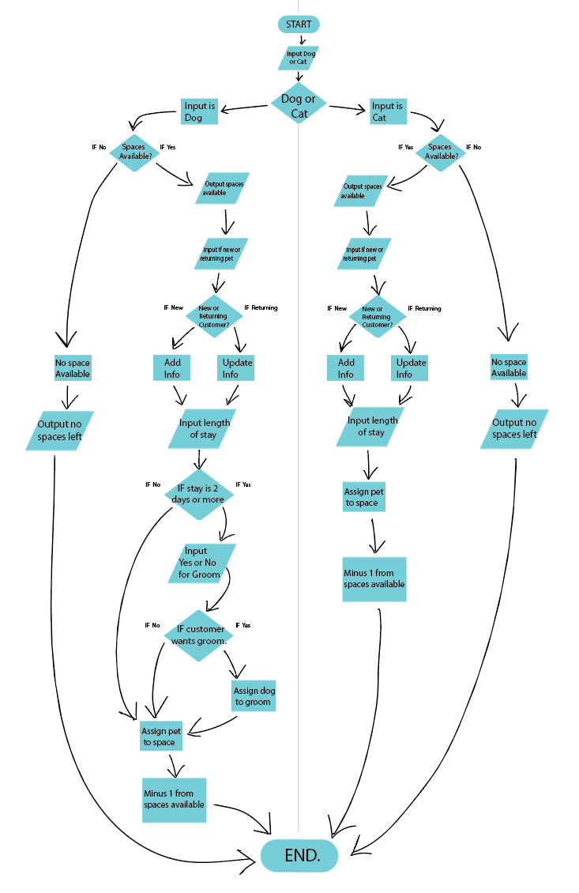

## OOP Principles Explanation

Object-oriented programming is the technique of designing programs with the use of classes and objects. Inheritance will become a big part of the project moving forward as we interlace and make use of our sub-classes with our parent class. Polymorphism is one task performed in different ways or the ability to process objects differently depending on their data type or class. This will come in handy in increasing reusability within our code and making our code easier to read. Encapsulation was used when restricting access to the public methods by using public accessors with private instance variables. Abstraction is used for keeping the extra processing hidden while only showing the important functionality of the program.