Lab 1

Joshua Evans | CS 276 | Due 2024-04-14

# Part 1 - Textbook Questions:

## 1a:

The most appropriate sequence of activities is listed thusly:

1. Obtain a general description of company operations.
2. Interview the shop manager.
3. Interview the mechanics.
4. Create a description of each system process.
5. Create the application programs.
6. Draw a data flow diagram and system flowcharts.
7. Create the file (table) structures.
8. Create a conceptual model using ER diagrams.
9. Normalize the conceptual model.
10. Load the database.
11. Test the system.

Notes:

Steps 1-3 are mostly interchangeable, and the specific order will be based on scheduling. The “general description of company operations” will likely be obtained *by* interviewing the shop manager and mechanics.

“Create the application programs” is at step 5 because once the basic data flows have been established, work on the application layer can be done in parallel to the database layer. This step overlaps with all the remaining steps so that, ideally, application end-to-end testing can be done along with the database tests on step 11. If the application development must be done in sequence, it would be the last step.

Steps 7-8 may be switched around, since brainstorming the table structure will likely be done using ER diagrams, so really these steps happen more or less simultaneously.

## 6:

A: Corrective Maintenance

B: Adaptive Maintenance

C: Adaptive Maintenance

# Part 2 – How to Use Functions

The SQL script file associated with the following screenshots can be found here:

<https://github.com/TheJoshuaEvans/LCC-CS276/blob/main/coursework/queries/module_02/Lab1_Part2.sql>

## Section 1:

1. Write a SELECT statement that returns these columns from the Products table:
   * The ListPrice column
   * The DiscountPercent column
   * A column named DiscountAmount that uses the previous two columns to calculate the discount amount and uses the ROUND function to round the result to 2 decimal places.

## Section 2:

1. Write a SELECT statement that returns these columns from the Orders table:
   * The OrderDate column
   * A column that returns the four-digit year that’s stored in the OrderDate column
   * A column that returns only the day of the month that’s stored in the OrderDate column.
   * A column that returns the result from adding thirty days to the OrderDate column.

## Section 3:

1. Write a SELECT statement that returns these columns from the Orders table:
   * The CardNumber column
   * The length of the CardNumber column
   * The last four digits of the CardNumber column

When you get that working right, add the column that follows to the result set. This is more difficult because the column requires the use of functions within functions.

* + A column that displays the last four digits of the CardNumber column in this format: XXXX-XXXX-XXXX-1234. In other words, use Xs for the first 12 digits of the card number and actual numbers for the last four digits of the number.

## Section 4:

1. Write a SELECT statement that returns these columns from the Orders table:
   * The OrderID column
   * The OrderDate column
   * A column named ApproxShipDate that’s calculated by adding 2 days to the OrderDate column
   * The ShipDate column
   * A column named DaysToShip that shows the number of days between the order date and the ship date

When you have this working, add a WHERE clause that retrieves just the orders for March ~~2012~~ 2020 *(updated so results are present)*.

# Part 3 – How to Design a Database

Live versions of the diagrams shown can be found in this document:

<https://lucid.app/lucidchart/687ab0c2-3bfc-4fde-ad75-c57b65164405/view>

## Section 1:

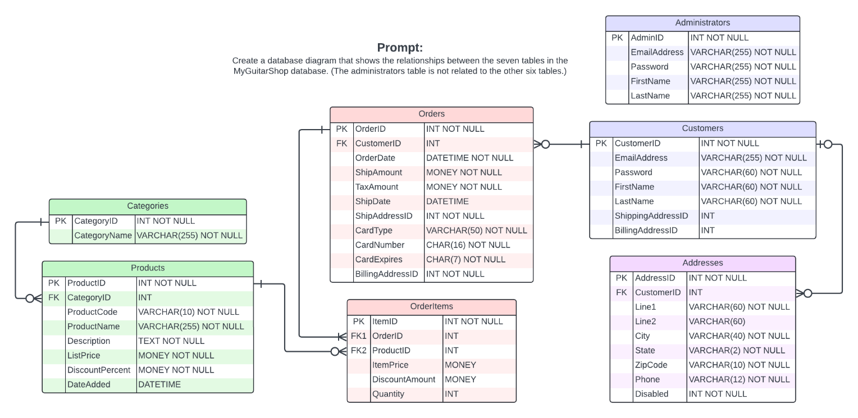

## Section 2:

