Lab 1

Joshua Evans | CS 276 | Due 2024-04-14

# Part 1 - Textbook Questions:

# Part 2 – Create and Modify a Database

The SQL script file associated with the following screenshots can be found here:

<https://github.com/TheJoshuaEvans/LCC-CS276/blob/main/coursework/queries/module_03/Lab2Pt2.sql>

## Section 1

## Section 2

## Section 3

## A screenshot of a computer Description automatically generatedSection 4

## Section 5

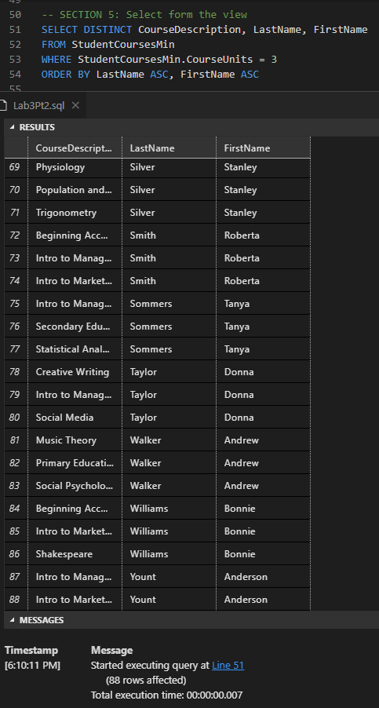

## Section 6