Datalogging

Adafruit Precision NXP 9-DOF Breakout Board - FXOS8700 + FXAS21002

<https://www.adafruit.com/product/3463?gclid=Cj0KCQjwhqaVBhCxARIsAHK1tiPm_dugqNACA1qpoKYiIUcRkEzozLwqOpy1czVeEUHo_wplAhaXH-EaApL6EALw_wcB>

$14.95

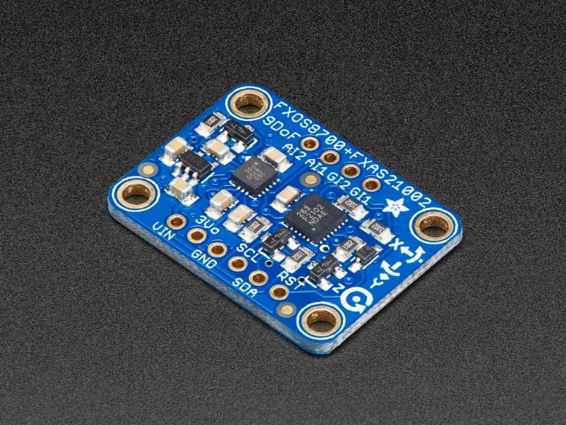

## **Technical Details**

The NXP Precision 9DoF board consists of two separate ICs, described in detail below:

**FXOS8700 3-Axis Accelerometer/Magnetometer**

* 2-3.6V Supply
* ±2 g/±4 g/±8 g adjustable acceleration range
* ±1200 µT magnetic sensor range
* Output data rates (ODR) from 1.563 Hz to 800 Hz
* 14-bit ADC resolution for acceleration measurements
* 16-bit ADC resolution for magnetic measurements

**FXAS21002 3-Axis Gyroscope**

* 2-3.6V Supply
* ±250/500/1000/2000°/s configurable range
* Output Data Rates (ODR) from 12.5 to 800 Hz
* 16-bit digital output resolution
* 192 bytes FIFO buffer (32 X/Y/Z samples)

Benefits: accel(x,y,z), gyro(x,y,z), mag(x,y,z), Ability to increase accuracy of acceleration with accelerometer on cpb

SUCCESFULL LOG ON CPB AND BLUETOOTH UART

Format: (time, gyro (x,y,z), mag(x,y,z), accel(x,y,z), temp)

Raw Code:

<https://github.com/TheJus10Dyer/10/blob/main/Aerospace/NPX9DOFCPBlogger.py>

Raw Data:: GYRO,MAG,ACCEL from IMU, Temp and Time from CPB

<https://github.com/TheJus10Dyer/10/blob/main/Aerospace/CPB_Datalog_NXP9DOF_test.txt>

Strapped on bike saved to circuitplayground

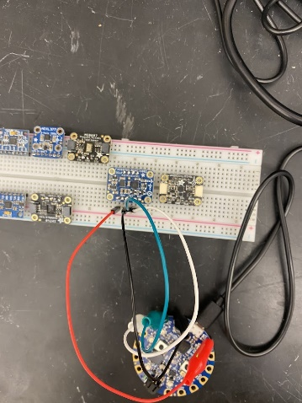

Plot

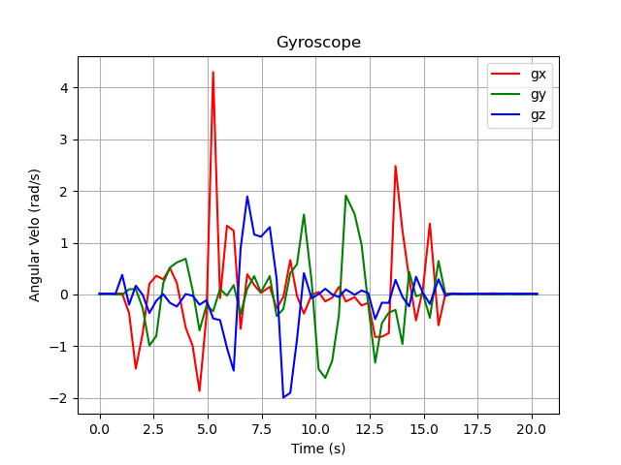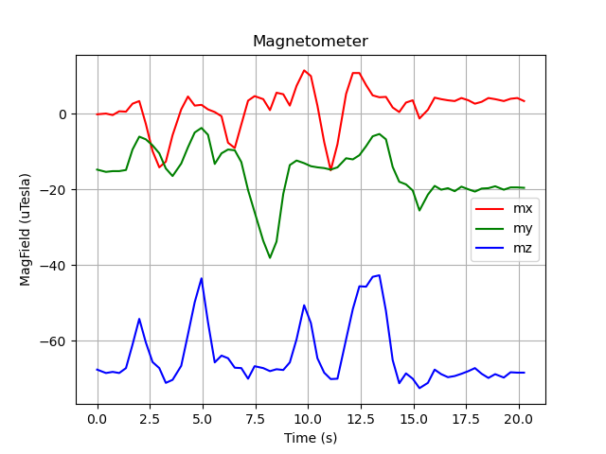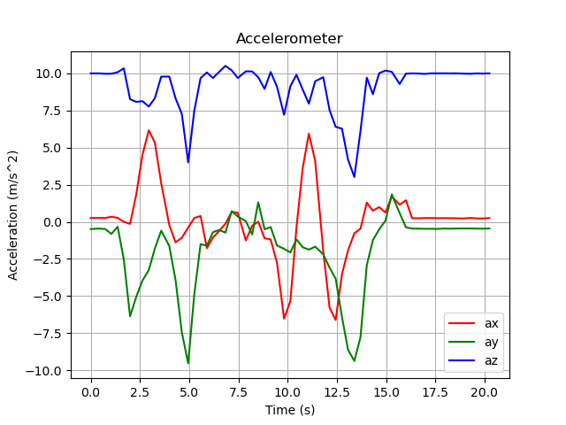

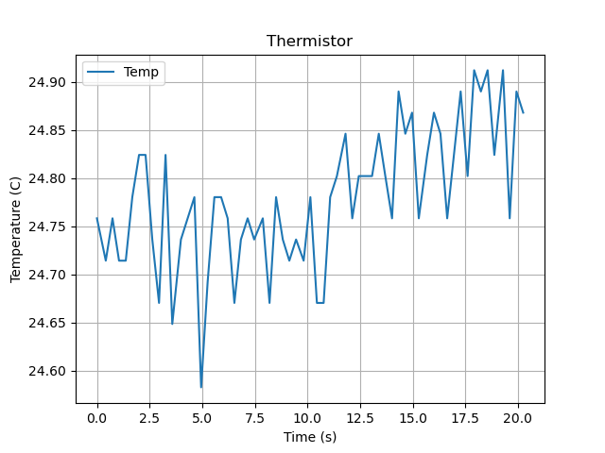

Was included in launch test more to come

Want to test on airplane to see if ideal for model planes

DUAL I2C Issues:::

Not sure if this is circuitplayground or hardware knowledge issue but could not address two separate sensors via I2C on SDA and SCL pins; therefor, could not experiment with multiple sensors that require I2C

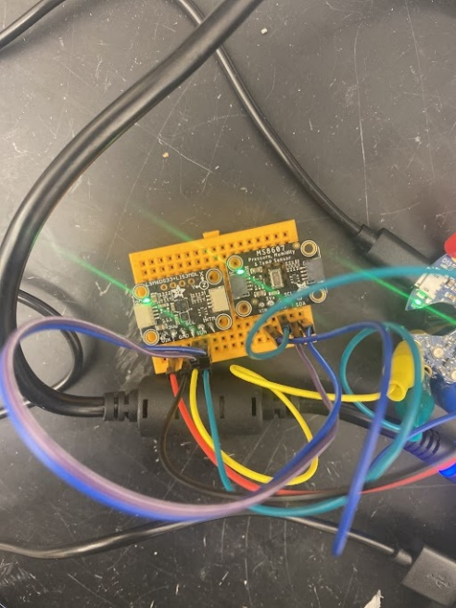

Since dual I2C was not an option, decided to test all sensors individually.

# Adafruit LSM6DS33 + LIS3MDL - 9 DoF IMU with Accel / Gyro / Mag - STEMMA QT Qwiic

<https://www.adafruit.com/product/4485>

**$19.95**

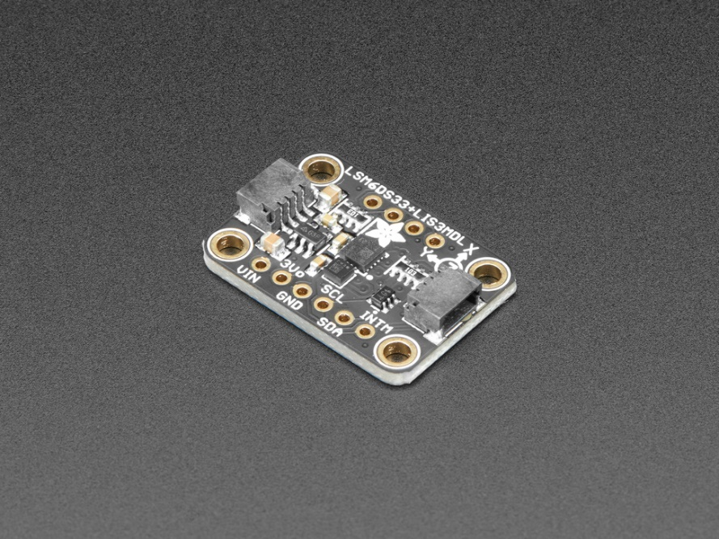

## **Technical Details**

**LSM6DS33 Specifications:**

* ±2/±4/±8/±16 g full scale
* ±125/±250/±500/±1000/±2000 dps full scale
* Up to 1.6 KHz ODR
* Tap and double-tap detection
* Free-fall detection
* I2C Address 0x6A or 0x6B

**LIS3MDL Specifications:**

* ±4/±8/±12/±16 gauss selectable magnetic full scales
* Continuous and single-conversion modes
* 16-bit data output
* Interrupt generator
* I2C Address 0x1D or 0x1E

Product Dimensions: 25.6mm x 17.8mm x 4.6mm / 1.0" x 0.7" x 0.2"

Benefits: accel(x,y,z), gyro(x,y,z), mag(x,y,z), Ability to increase accuracy of acceleration with accelerometer on cpb

FAIL: MAGNETOMETER MALFUNCTIONS

SUCCESFULL LOG ON CPB AND BLUETOOTH UART

Format: (time, gyro (x,y,z), mag(x,y,z), accel(x,y,z), temp)

Raw Code:

<https://github.com/cmontalvo251/Microcontrollers/blob/bd06a7afe87558c23160229cca8c2dbeac980799/Circuit_Playground/CircuitPython/CPB_DataLogger/bluefruit_datalogger_LSMLIS_uart_send.py> Raw Data::

Bike test

Need data and format from C

Need Plots

Setup:

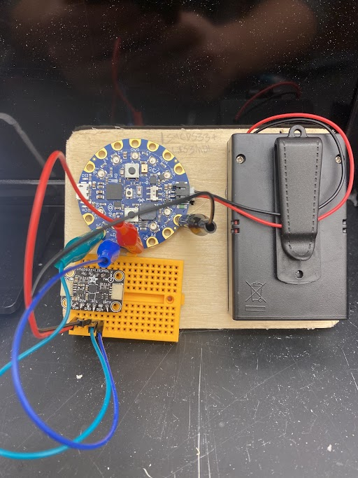

# Adafruit MS8607 Pressure Humidity Temperature PHT Sensor - STEMMA QT / Qwiic

<https://www.adafruit.com/product/4716>

**$14.95**

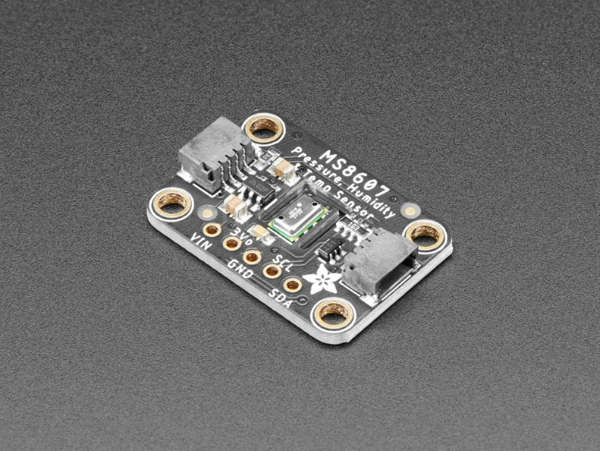

## **Technical Details**

SPECIFICATIONS

* Integrated pressure, humidity and temperature sensor
* QFN package 5 x 3 x 1 mm3
* Operating range: 10 to 2000 mbar, 0%RH to 100%RH, -40 to 85 °C
* High-resolution module: 0.016 mbar, 0.04%RH, 0.01°C
* Fully factory calibrated sensor
* I2C interface

Benefits: Pressure, relative humidity, and temperature. Ability to increase accuracy of temperature with thermistor on cpb

SUCCESFULL LOG ON CPB AND BLUETOOTH UART

Format:

Raw Code:

<https://github.com/cmontalvo251/Microcontrollers/blob/bbb17ac0a4af37bce634ec0f8b4c43bc9b5e61b3/Circuit_Playground/CircuitPython/CPB_DataLogger/bluefruit_datalogger_MS8607_uart_send.py> Raw Data::

Bike test

Need data and format from C

Need Plots

Setup:

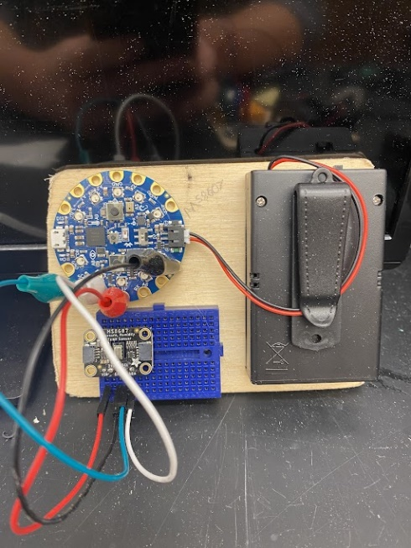

# Adafruit Ultimate GPS Breakout - 66 channel w/10 Hz updates - PA1616S

<https://www.adafruit.com/product/746>

**$29.95**

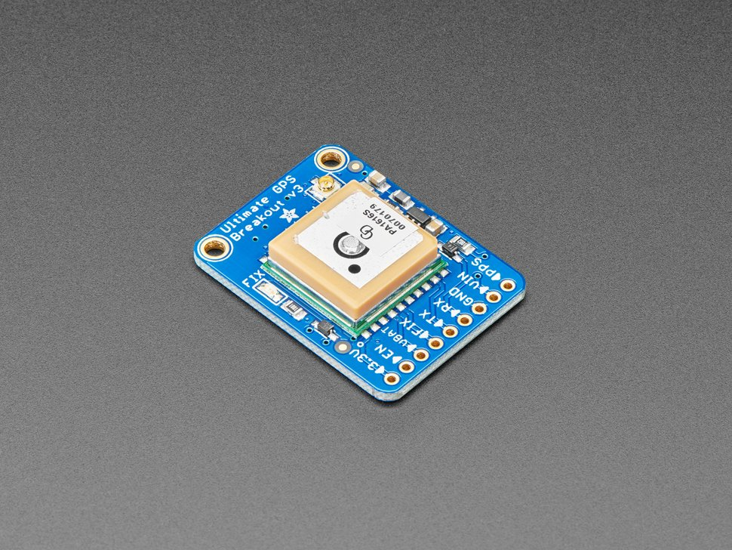

## **Technical Details**

* Satellites: 22 tracking, 66 searching
* Patch Antenna Size: 15mm x 15mm x 4mm
* Update rate: 1 to 10 Hz
* Position Accuracy: < 3 meters (all GPS technology has about 3m accuracy)
* Velocity Accuracy: 0.1 meters/s
* Warm/cold start: 34 seconds
* Acquisition sensitivity: -145 dBm
* Tracking sensitivity: -165 dBm
* Maximum Velocity: 515m/s
* Vin range: 3.0-5.5VDC
* MTK3339 Operating current: 25mA tracking, 20 mA current draw during navigation
* Output: NMEA 0183, 9600 baud default, 3V logic level out, 5V-safe input
* DGPS/WAAS/EGNOS supported
* FCC E911 compliance and AGPS support (Offline mode : EPO valid up to 14 days )
* Up to 210 PRN channels
* Jammer detection and reduction
* Multi-path detection and compensation

Benefits: Location, Time, quality, altitude speed, track angle horizontal dilution, height geoid

SUCCESFULL LOG ON BLUETOOTH UART

Format:

Raw Code:

https://github.com/TheJus10Dyer/Microcontrollers/blob/main/Adafruit%20Bluefruit/GPS_bluefruit.py

Raw Data::

Vehicle Test

Need data and format from C

Need Plots

Need Setup:

LAUNCH