1.

import numpy as np

import matplotlib.pyplot as plt

x = [49.3,50.1,48.9,49.2,49.3,50.5,49.9,49.2,49.8,50.2]

Reading = np.linspace(1,10,10)

plt.hist(x)

plt.show()

print(Reading)

OUTPUT:

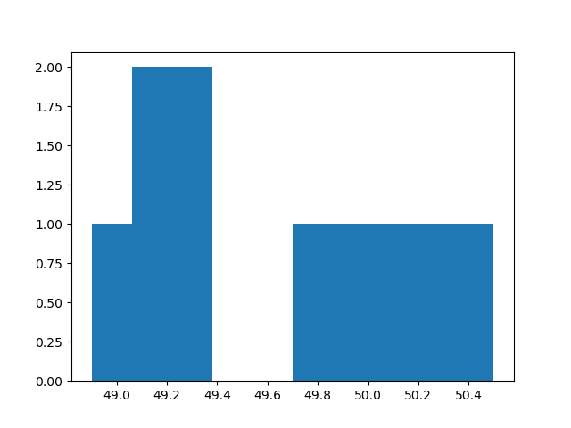

5.

import numpy as np

import matplotlib.pyplot as plt

x = [49.3,50.1,48.9,49.2,49.3,50.5,49.9,49.2,49.8,50.2]

Reading = np.linspace(1,10,10)

val,count = np.unique(x,return_counts=True)

print('Mean: ', np.mean(x))

print('Median: ', np.median(x))

print('Mode: ', val[np.argmax(count)])

print('Standard Deviation: ', np.std(x))

OUTPUT:

Mean: 49.64

Median: 49.55

Mode: 49.2

Standard Deviation: 0.5023942674832191

79.

import numpy as np

import matplotlib.pyplot as plt

T = np.array([20,30,40,50,60,75,100])

V = np.array([1.02,1.53,2.05,2.55,3.07,3.56,4.05])

coeff = np.polyfit(T,V,1)

print(coeff)

Ttrend = np.linspace(20,100,1000)

Vtrend = np.polyval(coeff,Ttrend)

tilde = np.polyval(coeff,T)

res = (V-tilde)**2

plt.plot(T,V,'b*')

plt.plot(T,tilde,'g*')

plt.plot(Ttrend,Vtrend,'r-')

plt.grid()

R2 = 1-np.sum(res) / np.sum((V-np.mean(V))**2)

print(R2)

OUTPUT:

[0.03898425 0.45870079]

0.9611681933065831

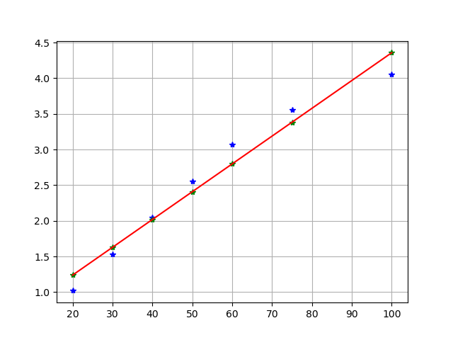

80.

import numpy as np

import matplotlib.pyplot as plt

T = np.array([20,30,40,50,60,75,100])

V = np.array([1.02,1.53,2.05,2.55,3.07,3.56,4.05])

points = np.linspace(20, 100, 1000)

line = np.polyfit(T,V,1)

line_fit = np.polyval(line,points)

plt.plot(T,V,'b*')

plt.plot(points,line_fit,'r-')

OUTPUT:

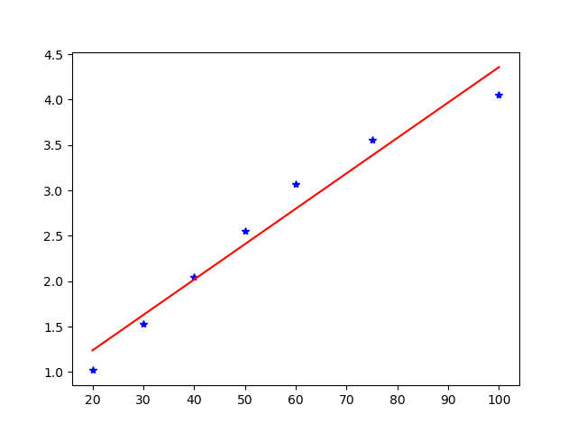

82.

import numpy as np

import matplotlib.pyplot as plt

from sklearn.linear_model import LinearRegression

lb = np.array([0,5,10,15,20,25,30])

reading = np.array([-1.5, 4.34, 9.52, 14.64, 19.2, 26.6,29.55])

plt.plot(lb,reading,'b*')

fit_coeff = np.polyfit(lb,reading,1)

lb_fit = np.linspace(0,30,1000)

reading_fit = np.polyval(fit_coeff,lb_fit)

tilde = np.polyval(fit_coeff,lb)

res = (reading-tilde)**2

R2 = 1-np.sum(res) / np.sum((reading-np.mean(reading))**2)

print(R2)

plt.plot(lb_fit,reading_fit,'r-')

OUTPUT:

0.9954868299686415

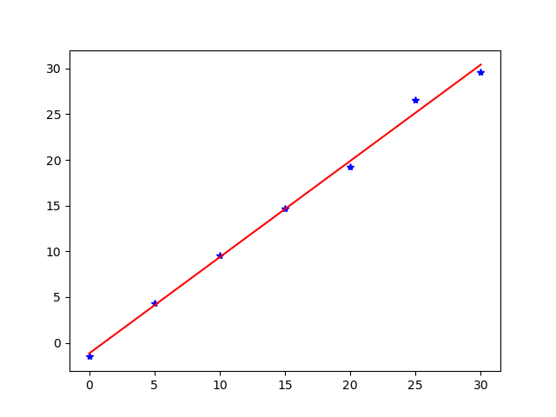

90.

import numpy as np

import matplotlib.pyplot as plt

Vol = np.array([0.01,0.115,0.29,0.48,0.59,0.81,0.88,1.02,1.12,1.325,1.4])

Vel = np.array([0.07,0.08,0.11,0.135, 0.145,0.185,0.19,0.22,0.24,0.285,0.295])

coeff = np.polyfit(Vol,Vel,2)

print(coeff)

OUTPUT:

[0.03725883 0.10999103 0.06984071]