Justin Dyer: Photocell

Below is a link to a video of me setting up MU to read the voltage change of the photocell.

[Video 1](https://drive.google.com/file/d/1Y1tHD5qHBT0GgaVte8k1aBedvjn1EmSw/view?usp=sharing)

Below is my python code used to plot my data from the photocell and a figure of my data plotted in ambient light.

import numpy as np

import matplotlib.pyplot as plt

data = np.loadtxt('hist_1.txt')

time = data[:,0]

time -= time[0]

ambient = data[:,1]

plt.plot(time, ambient)

plt.xlabel('Time (s)')

plt.ylabel('Voltage (V)')

plt.show()

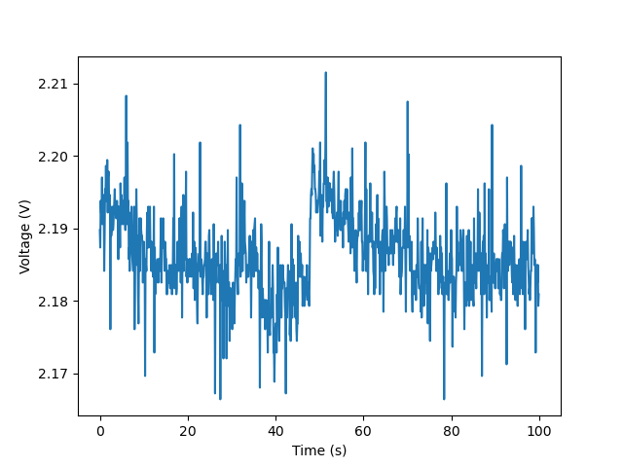

Below is a link to a video of me explaining my circuit and how I acquired my data.

[Video 2](https://drive.google.com/file/d/1G67x3awZDEW1OP2Di_fysshyWtAwQ-sa/view?usp=sharing)

Below is the Mean, Median, and Standard Deviation from my data from all light levels measured.

Low:

* Mean = 0.016048188572572574
* Median = 0.0145022
* Standard Deviation = 0.009957295571863773

Ambient:

* Mean: Mean = 2.18613977977978
* Median: Median = 2.18577
* SD: Standard Deviation = 0.005700021455762066

High:

* Mean = 3.014595885885886
* Median = 3.01403
* Standard Deviation = 0.004517511959618497

Below are my histogram plots from low to high light levels.

Low:

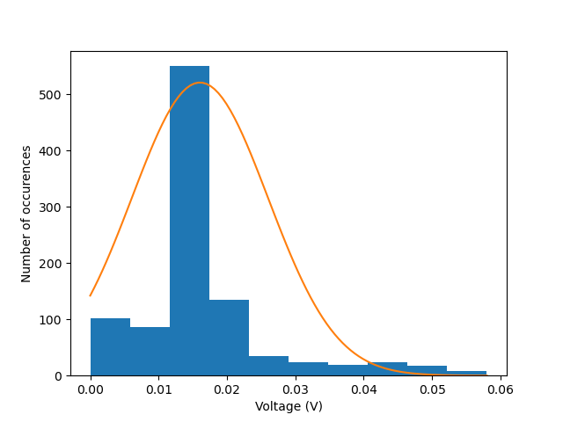

Ambient:

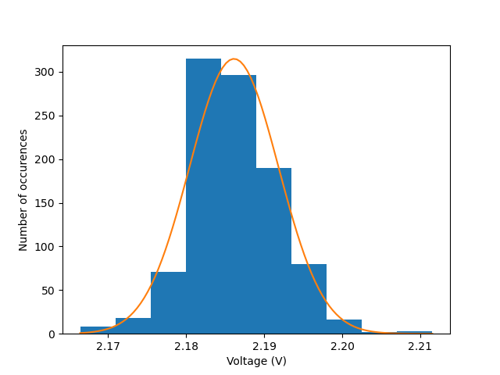

High:

