Justin Dyer

Servo

Below is a video of my servo moving:

[Servo Moving](https://drive.google.com/file/d/1WCEq3pv1NmAVfyXSAFf3Qo2vLaJ-v4OK/view?usp=sharing)

My minimum and maximum values of my servo pulses are as follows:

Min: 0.50 ms

Max: 2.37 ms

Below is a video of me explaining how I took my data:

[Servo Data](https://drive.google.com/file/d/1snAv8Gj-VVG4V_iWcXECHZ1S3v25H4n6/view?usp=sharing)

Below is a Figure of my data plotted in Python with a trend line:

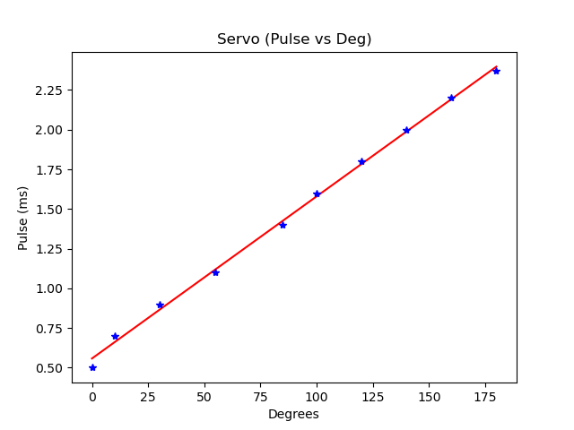

Below is my regression equation:

Pulse = 0.01 $θ$ + 0.56

Below is a video of me using my regression equation to make my servo position at 0, 45, 90, and 135 degrees:

[Click Here Dr. CCCCCCCCCCCC+++++](https://drive.google.com/file/d/1SmwL1j5M1LzcW_VhOrj-cR1sWvwD5Mt0/view?usp=sharing)