Justin Dyer

Time Constant of a Thermistor

Below is a video of me explaining how I plan on taking data and heating up my CPB:

[Thermal Conductivity Video (click here)](https://drive.google.com/file/d/1sK7eNsHMrzzsAOxksevp3cIr9Qj8EXO-/view?usp=sharing)

Below is a plot of the raw data I received from my experiment:

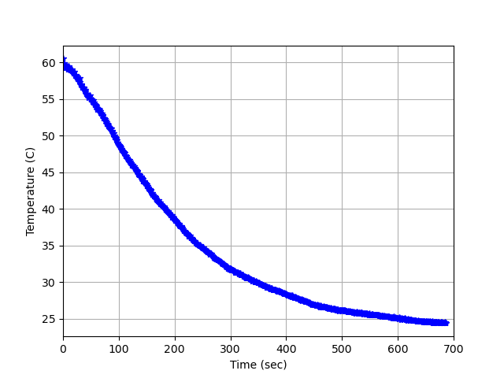

Below is the plot of my equation fitted to my data:

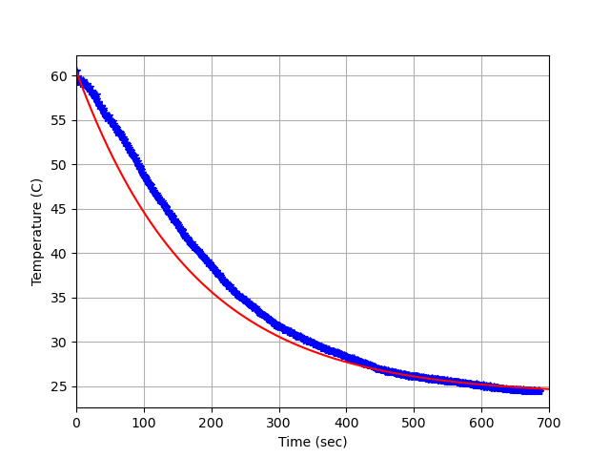

The time constant $σ$ = 0.005714285714285714