VIOPATCH — Brand Audit Report
Date: 9th September 2026 | Version 5.0

1. High-Level Approach
PHASE 01: ASSET AUDIT  Gathered and cataloged 428 files (1.91 GB) downloaded from Google Drive, and did a scrape of the corporate website (unexolifesciences.com) to map the total brand asset footprint. | PHASE 02: DIAGNOSTICS  Isolated immutable brand anchors (two-tone mark, 12h relief triad). Measured 6+ competing blue shades and diagnosed commercial font licensing barriers across print and digital media. | PHASE 03: ACTIONABLES  Created a Brand Style Guide as the single source of truth. Drafted a roadmap for standardizing brand assets across channels.

2. Audit Results

2.1 Fresh Assets for New Product Line
A multi-method hash (SHA-256) and perceptual difference (dHash) matching revealed that the 4 recent packaging files in confirm-assets are not present across brand-assets.
✓ Final Action: Packaging Line Extensions Used As Template
The 4 packaging files in `confirm-assets` (Viopatch Ice Cool, Viopatch XL Back blue redesign, Viopatch Knee blue redesign, and Viopatch Heat Body Warmer) represent upcoming 2026 packaging design evolutions and product line extensions. They have been used as the 2026 visual benchmark.

2.2 Multiple Blues Across Channels
At least six competing blue values in active rotation:
Blue Variant | Swatch | Color Space / Value | Source Touchpoint | Analysis & Diagnosis
Palette Blue | ■ | #0054A6  RGB (0, 84, 166)  CMYK (100, 65, 0, 5) | Viopatch Pallete.png | RETAINED: Primary Brand Color. Official brand swatch; optimal clinical authority and shelf pop.
Packaging Navy | ■ | #123160  RGB (18, 49, 96)  CMYK (100, 80, 30, 35) | Knee / XL Artworks | ELIMINATED: Retired from all touchpoints. Use #0054A6 with a 30–40% shade overlay to achieve deep packaging gradient depth; no separate hex required.
Corporate Blue | ■ | #0040A6  CMYK (100, 75, 0, 0) | Unexo Logo.pdf | RETAINED: Darker royal tone retained exclusively for Unexo parent corporate seal.
Presentation Blue | ■ | #3044A6  RGB (48, 68, 166) | July 2026 Pitch Deck | DEPRECATED: Slide presentation accent; softer saturation designed for computer monitors.
Website Blue | ■ | #0153A7  RGB (1, 83, 167) | style-main.css | DEPRECATED: Minor 1-bit digital rounding variation. Re-align CSS directly to #0054A6.
Web Action Blue | ■ | #2962FF / #0D47A1  RGB (41, 98, 255) | Website CSS Buttons | DEPRECATED: Generic Bootstrap action blue; completely disconnected from brand identity.
✓ Final Color Standardization Decision
#0054A6 (PMS 2145 C / CMYK 100, 65, 0, 5) as the single, authoritative Primary Viopatch Blue across all packaging, marketing, and web interfaces.
All other blues should be deprecated.

2.3 Typography Audit & Font Licensing Analysis
Severe typographic fragmentation across print packaging, digital touchpoints, and marketing channels:
Touchpoint | Font Family | Functional Role | Licensing Status | Free? | Strategic Action
Print Keylines | Futura Bold Condensed  (Geometric 706 BT) | Wordmark & Major Titles | Commercial License  (Bauer / Bitstream) | ❌ NO | RETAIN for factory packaging press plates.
Print Keylines | Century Gothic Bold | Corporate Mark & Claims | Proprietary Monotype  (Windows desktop only) | ❌ NO | RETAIN for press; use Montserrat Bold in digital.
Print Keylines | Arial Narrow (Reg/Bold) | Drug Specs & Formula | Proprietary Microsoft  (Desktop bundled only) | ❌ NO | RETAIN for press; use Roboto Condensed in digital.
Print Keylines | OCR-B 10 Pitch BT | Barcodes & Lot Stamps | Open Industry Standard | ✓ YES | RETAIN permanently for packaging barcodes.
Social Media | Roboto Regular / Medium | Monthly Campaigns | Open Source  (SIL Open Font License) | ✓ YES | RETAIN as canonical digital brand standard.
Corporate Web | FF Clan (Clan-Bold.woff2) | Navigation & Headers | Commercial FontFont  (Recurring pageview fee) | ❌ NO | DEPRECATE - Migrate to Barlow Condensed Bold.
Corporate Web | Corbel (Corbel.woff2) | Body Text & Copy | Proprietary Microsoft  (Paid web license) | ❌ NO | DEPRECATE - Migrate to Roboto Regular.
Pitch Deck | Arial Regular / Bold | Presentation (38 slides) | Generic System Font  (Unbranded appearance) | ✓ YES | DEPRECATE - Migrate to Montserrat & Barlow.
✓ Two-Tier Typographic System to avoid licensing risk:
• Tier 1: Industrial Print Packaging (> Retain Production Standards): Futura Bold Condensed (Headings), Century Gothic Bold (Corporate Sub-brand), Arial Narrow (Statutory Specs), OCR-B (Barcodes). Retain existing factory tooling; industrial printer press licenses are established. Zero switching cost on active packaging runs.
• Tier 2: Digital, Web & Marketing (Google Fonts Stack): Barlow Condensed Bold (H1 / Display Titles), Montserrat Bold (H2 / Corporate Headings), Roboto Regular / Medium (Body Copy & Claims), Roboto Condensed (Dense specs & tables). Free under SIL Open Font License. Zero recurring fees, universal cross-platform rendering.

2.4 Packaging Evolution & Logo Standardization
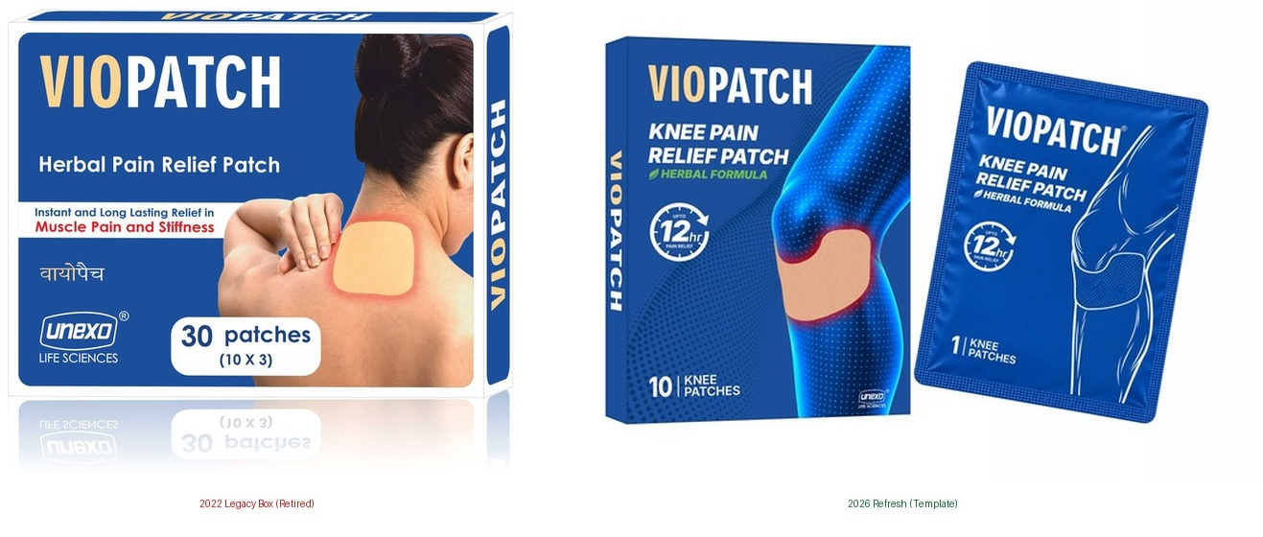 | Packaging Evolution: Legacy 2022 Box vs. 2026 Refresh  • Background: Shifted from early 2022 horizontal white display boxes (generic pharmacy appearance with low retail shelf pop) to vertical hanging display boxes featuring deep-blue luminous anatomical heat illustrations, foil pouches, and high-contrast callouts.  • Strategic Action: 2026 Refreshed Packaging is adopted as the single standard template. The early 2022 horizontal white box format is officially decommissioned across all SKUs.
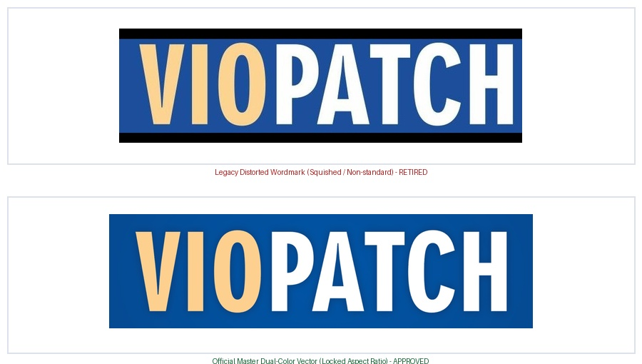 | Logo Drift: Distorted Legacy vs. Locked Master Vector  • Background: Historical creatives suffered from horizontal aspect ratio distortion (squished or stretched typography), unapproved color alterations, and sporadic omission of the registered trademark symbol (®).  • Strategic Action: The dual-color vector master (VIO in Skin #FDCD8B, PATCH in Blue #0054A6 / White on dark) with locked aspect ratio, 1X clearspace, and mandatory registered trademark (®) at cap-height is established as the standard. Manual font re-typing and stretching are strictly prohibited.

✓ Final Decision
• Packaging Standardization Outcome: 2026 Refreshed Packaging to be used as the final version. The early 2022 horizontal white box format is officially decommissioned and retired across all SKUs.
• Master Logo Standard Outcome: The dual-color vector master (VIO in Skin #FDCD8B, PATCH in Blue #0054A6 on white / White on dark) with locked aspect ratio, 1X clearspace, and mandatory registered trademark (®) at cap-height is established as the standard. Manual font re-typing and horizontal/vertical stretching are strictly prohibited.

3. Implementation Roadmap

Prioritization of Agenda (TBD)
Stream Dimension | Priority 1: Packaging & Print | Priority 2: Web & Digital | Priority 3: Governance & Comms
Target Timeline | Immediate  (0–30 Days) | Near-Term  (1–3 Months) | Ongoing  (Quarterly)
Strategic Focus | Factory Tooling & Press Plate Calibration | Interface Unification & Font Licensing Elimination | Enterprise Alignment & Supplier Enablement
Action 1 (Assets) | Lock Master Vector Artwork:  Distribute standardized .AI / .EPS master vectors with locked aspect ratios. | Unify Web Action Colors:  Update CSS buttons from Bootstrap blue to official Viopatch Blue (#0054A6). | Corporate Deck Migration:  Update master 38-slide CDMO presentation deck with official colors & fonts.
Action 2 (Standards) | Standardize Converter Inks:  Calibrate press inks to Pantone 2145 C, 1345 C, and 361 C across converters. | Implement Google Fonts Stack:  Migrate web headers from commercial Clan-Bold to Barlow; body to Roboto. | Brand Asset Centralization:  Centralize verified shoot images, vector masters, and guidelines in cloud DAM.
Action 3 (Deprecation) | Retire Legacy White Boxes:  Phase out remaining distributor stock of 2022 white boxes; transition SKUs to vertical display. | Update E-Commerce Listing Kits:  Re-align Amazon & Flipkart carousels with new typography and benefit badges. | Distribute Supplier Style Guide:  Issue companion Brand Style Guide to all packaging converters and agency partners.
Key Governance Metric | 100% Press plate CMYK / Pantone compliance | Zero recurring commercial web font fees | Single source of truth cloud repository active

Appendix: Resources Used (Asset Inventory & Scope)
The audit used “New Creatives” as the base, and used “Old Creatives” only for reference and gap filling. The table below captures what was used where.
Asset Category | Repository Path | Volume | Parts Used in Audit & Style Guide | Parts Retired / Excluded & Rationale
New Creatives  (Primary Base) | brand-assets/New Creatives | 245 files  (345.4 MB) | • Primary baseline for all digital, e-commerce, and listing creatives.  • Amazon & Flipkart listing carousels, store banners, and feature callouts.  • High-resolution 3D anatomical heat visualization renders.  • Macro patch fabric scans showing micro-porous breathable weave. | • None. Active current digital production assets.
Recent Mockups | confirm-assets | 4 files  (1.24 MB) | • WhatsApp packaging mockups (Sept 8, 2026) verified as the upcoming 2026 visual benchmark.  • Deep-blue luminous anatomical illustrations on foil pouches.  • New product line extensions: Viopatch Ice Cool and Heat Body Warmer. | • None. Verified legitimate upcoming packaging assets.
Brand Identity & Logos | brand-assets/Logos and Icons | 4 files  (1.88 MB) | • Master vector corporate logo (Unexo Life Sciences - Logo.pdf).  • Icon_master.png benefit badges (12-Hour Relief clock, Herbal leaf, contour fit).  • Square corporate avatar emblems. | • None. All files retained as official vector identity references.
Master Swatch | brand-assets/Viopatch Pallete.png | 1 file  (2.30 MB) | • Authoritative raster swatch defining official brand hex values (#0054A6, #FDCD8B, #379131, #0054A6, #2A2A28). | • None. Baseline reference for core color reconciliation.
Official Packshots | Old Creatives/Images/Packshots | 14 files  (39.5 MB) | • Master vector print keylines and pouch PDFs (Knee, XL Back, Large, Headache, Acne Relief).  • Extracted production fonts (Futura Condensed, Arial Narrow), CMYK separations, and statutory copy. | • Legacy 2022 horizontal white display box designs (Viopatch - Box.png, Large - Display Box.pdf) retired due to low pharmacy shelf visibility.
Corporate CDMO Deck | pitch-deck-dated | 1 file  (17.4 MB) | • 38-slide investor presentation (July 26, 2026) for corporate narrative, manufacturing capabilities, and corporate color usage (#3044A6). | • None. Authoritative corporate and B2B manufacturing reference.
Studio Shoots | Old Creatives/Shoot Images | 49 files  (433.9 MB) | • High-res model application shoots (XL Back, Regular).  • Dr. Rajat Bawa clinical endorsement photography (Doctor Rajat Image - Brighter.jpg, Rajat Holding the Patch.tif). | • Raw unedited photoshoot outtakes with studio backdrop artifacts.  • Outdated pouch packaging labels superseded by 2026 designs.
Listing Graphics | Old Creatives/Listing Images | 17 files  (17.8 MB) | • Historical feature callout concepts and composite graphic structures for gap filling. | • Low-resolution marketplace infographics with stretched logos and non-standard typography.
Social Campaigns | Old Creatives/Social Media | 63 files  (1.07 GB) | • Marketing claims review (100% Herbal, Up to 12hr Relief) and calendar font choices. | • Outdated 2022–2023 promotional video reels (.mp4, .mov) and expired monthly campaign schedules.
Claude Output  (Excluded) | claude_output | 4 files  (799 KB) | • VIOPATCH-PRESENTATION-TEMPLATE.potx promoted to ratified official status (now the master corporate presentation template). HTML brand book spreads and layout preview PNG remain experimental. | • Preliminary PowerPoint template (.potx), layout preview PNG, and draft HTML spreads identified as experimental drafts.

