Statistical Inference Week 2, Part 1: Simulation Exercise Instructions

Kaushik Basu

December 23, 2017

The exponential distribution can be simulated in R with rexp(n, lambda) where lambda is the rate parameter. The mean of exponential distribution is 1/lambda and the standard deviation is also also 1/lambda. Set lambda = 0.2 for all of the simulations. In this simulation, you will investigate the distribution of averages of 40 exponential(0.2)s. Note that you will need to do a thousand or so simulated averages of 40 exponentials. Illustrate via simulation and associated explanatory text the properties of the distribution of the mean of 40 exponential(0.2)s.

##### Question 1

Show the sample mean and compare it to the theoretical mean of the distribution. ##### Question 2 Show how variable the sample is (via variance) and compare it to the theoretical variance of the distribution.

lambda = 0.2  
n = 40  
nsms = 1:1000  
set.seed(820)  
means <- data.frame(x = sapply(nsms, function(x) {mean(rexp(n, lambda))}))  
head(means)

## x  
## 1 5.750000  
## 2 3.808205  
## 3 4.058154  
## 4 3.999241  
## 5 4.312532  
## 6 4.418246

mean(means$x)

## [1] 4.998812

sd(means$x)

## [1] 0.7909422

(1/lambda)/sqrt(40)

## [1] 0.7905694

var(means$x)

## [1] 0.6255895

((1/lambda)/sqrt(40))^2

## [1] 0.625

Center of the distribution: 4.9988. Expected center: 5.0. The mean of the means of the exponential of 1000 simulations of 40 exponential(0.2)s is 4.9988, which is very close to the expected mean of 1/0.2 = 5.0.

Variability of the distibution. The standard deviation of 0.7909 is also close to the expected standard deviation of 0.79056

##### Question 3

Show that the distribution is approximately normal.

Below is a histogram plot of the means of the 1000 simulations of rexp(n, lambda). It is overlaid with a normal distribution with mean 5 and standard deviation 0.7909. Yes, the distribution of our simulations appears normal.

library(ggplot2)  
ggplot(data = means, aes(x = x)) +   
 geom_histogram(aes(y=..density..), fill = I('#00e6fa'),   
 binwidth = 0.20, color = I('black')) +  
 stat_function(fun = dnorm, arg = list(mean = 5, sd = sd(means$x)))

## Warning: Ignoring unknown parameters: arg

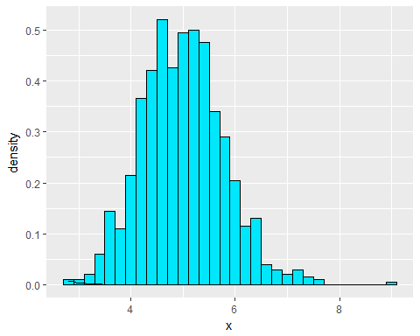

##### Question 4

Evaluate the coverage of the confidence interval

mean(means$x) + c(-1,1)*1.96*sd(means$x)/sqrt(nrow(means))

## [1] 4.949789 5.047835