**20279984S**

*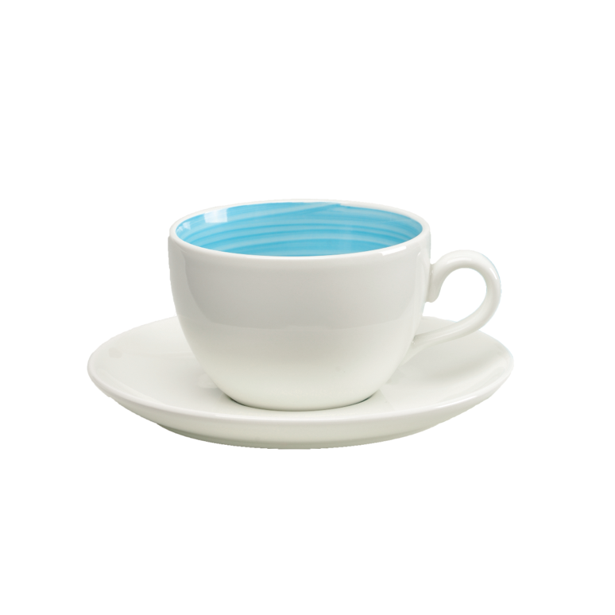Dolce Peacock Cup & Saucer Natural*