

F.A.I.T.H. SRS

Have F.A.I.T.H. with us



2020-2021

The Kiddos

**Table of Contents**

**1.0 Introduction 2**

**1.1. Purpose 2**

**1.2. Scope 2**

**1.3. Glossary 2**

**1.4. Document overview 3**

**2.0 Overall Description 4**

**2.1. System Environment 4**

**2.2. Functional Requirements Specification 4**

**2.3. Use cases 5**

**2.3.1. User Registration 6**

**2.3.2. User Login 7**

**2.3.3. Set Freelancer Resume Details 8**

**2.3.4. Bid on Project 9**

**2.3.5. Show Biddings 10**

**2.3.6. Comment on Bidding 11**

**2.3.7. Freelancer Post Software 11**

**2.3.8. Report Software 12**

**2.3.9. Create Team 12**

**2.3.10. Set Team Availability 13**

**2.3.11. Invite Freelancer to Team 13**

**2.3.12. Remove Freelancer from Team 13**

**2.3.13. Send Message 14**

**2.3.14. Post in Forums 14**

**2.3.15. Create Project 16**

**2.3.16. Complete Project 17**

**2.3.17. Cancel A Project 17**

**2.3.18. Review Freelancer 17**

**2.3.19. Propose a job 18**

**2.3.20. Accept/Reject Proposal 19**

**2.3.21. Close Proposal 19**

**2.3.22. Change Proposal 20**

**2.3.23. Create Task 20**

**2.3.24. Complete Task 21**

**2.3.25. Send Task for Feedback 21**

**3.0 The End 22**

1. Introduction
   1. Purpose

The SRS (Software Requirements Specification) provides a complete description of the systems functions, interfaces and resources of our F.A.I.T.H (Freelancers Association & Information Technology Hub). It will also explain interactions with users and applications.

This document will also serve as a reference for developing the system and a guide for the project supervisor.

* 1. Scope

This system will serve as a software developing market online, it will be designed to run on a server (or multiple servers). There will be three kinds of users: Stakeholders, Freelancers, and Admins.

**Freelancers** can create a software and put it on sale on the website, or they can bid or be assigned to projects published by the stakeholders.

**Stakeholders** provides payment and they can also create project, rate freelancers that they have assigned and worked with.

**Admins** will be responsible for the management of the website.

Note: Only cash payment will be supported for now.

Furthermore, freelancers have skills, types, qualifications and levels where they can be rated according to how many tasks or jobs they’ve accomplished and they can be rated by stakeholders they’ve worked with through specific rules and standards, however to strike a deal a freelancer must mark himself as available.

Jobs/Projects have categories, requirements and specialties.

* 1. Glossary

|  |  |
| --- | --- |
| Term | Definition |
| Freelancer | A user of the system with the role of a developer. |
| Stakeholder | An individual or a company, which has a project that needs developers. |
| Admin | A user with the role of a manager of the platform, possesses the highest authority among users. |
| F.A.I.T.H. | An abbreviation for the name of the platform (Freelancers Association & Information Technology Hub) |
| Field | A cell within the form used to enter personal data of the user |
| Software requirements specification (SRS) | A document that completely describes all of the functions of a proposed system and the constraints under which it must operate |
| Database | A collection of all information that is stored by the system. |
| Server | The device that provides service for all users of the system |
| Contract list | A list where every contract whether it’s a recruitment contract or a software project contract is published |
| available | A term that means a developer is not fully engaged to any company or the employee has the time to start another project |
| PM | A project manager which will be responsible for creating tasks and changing project status and info. |
| Functional Requirements | Text that describes that the system must do and serve. |
| The Office | Any physical location that is owned by this project’s owner |
| BDD | Behavior-Driven Development is a way of writing and describing tests. |

* 1. Document overview

The remainder of this document gives an overview of the functional requirements-use cases and the design of the platform.

1. Overall Description
3. 1. System Environment

The system will consist of a website that is run on a remote sever that operates most of the websites functions, a database with users information and personal data along with their software when they upload it ,the server must be able to connect multiple users to the database which in turn must be able to handle pressure and commit the necessary amount of transactions.

* 1. Functional Requirements Specification

Functional Requirements are those that refer to the functionality of the system, i.e., what services it will provide to the user. Nonfunctional (supplementary) requirements pertain to other information needed to produce the correct system and are detailed separately.

**Site Registration, Permissions and Payment System:**

The current site will be a demo one only, as such payment will be done through cash only, this requires both parties to be known so legal action can be taken, if any party breaks the terms of use.

Payment will be through a middle-man, working in the office.

The system must provide a way for logging in, accounts can only be created by the admin, after a user visits an employee working in one of our offices or contacts the admin, so all his info can be verified.

As this is just a graduation project, and in Syria online payment didn’t thrive yet, support for online payment probably won’t happen any time soon.

**Rating and Experience Levels:**

Each freelancer will be rated based on several factors:

* Stakeholder reviews: after each completed project the stakeholder will be asked to give the freelancer (or the team of freelancers) a 0-5 stars rating with an optional review comment.
* Number of Completed Tasks: points for every completed task/project.
* Forum activity: freelancers have a dedicated forum where the can ask other freelancers for anything, any freelancer can upvote another freelancer answer.

Then a formula will be applied to the criteria’s above generating a final rating and a level.

**Teams System:**

Any freelancer can create a team of freelancers, this team can then also have a rating (the average rating of the team members), there creator can send invitations to other freelancers or remove them from the team. Once the team is marked as active it can be available for stakeholders to hire, or the team can bid on projects.

A freelancer can join several teams.

**Project Management:**

After a stakeholder creates a project, a page for the project will be created.

The stakeholder will be the project manager, he can assign freelancers/teams, or open the project for bidding. The project is private (no one except the stakeholder and the assigned freelancers can access it).

The PM can create tasks and assign them, mark the project as done.

**Messaging System:**

The system will provide a message system so stakeholders can contact freelancers via the website, also each project will have a conversation where project members can talk directly, possibly a video/voice meeting will be implemented too.

**Freelancers Forums:**

As mentioned earlier, freelancers have a forum where they can ask questions, upvote each other’s answers. And mention each other in comments/answers.

**Suggestion and Filtering:**

As a freelancer work suggestion will appear based on the freelancer qualifications and skills.

As a Stakeholder freelancer suggestion will appear based on projects tags and freelancer experience.

**Payment:**

While payment will be with cash

The payment can be hourly or a one-time payment

Whatever the type the payment field will be the same.

Website will remind the stakeholder to pay the freelancer once the project is done.

Freelancers can report a stakeholder of course.

* 1. Use cases

Use cases will be described and scenarios will be written with BDD.

**NOTE:** only important use cases and scenarios will be discussed e.g.: a “Edit Account Information Scenario” or “Change Language” won’t be explicitly mentioned.

* + 1. User Registration

In order for a user (be it a freelancer or a stakeholder) to create an account, the user must contact the admin, or visit The Office.

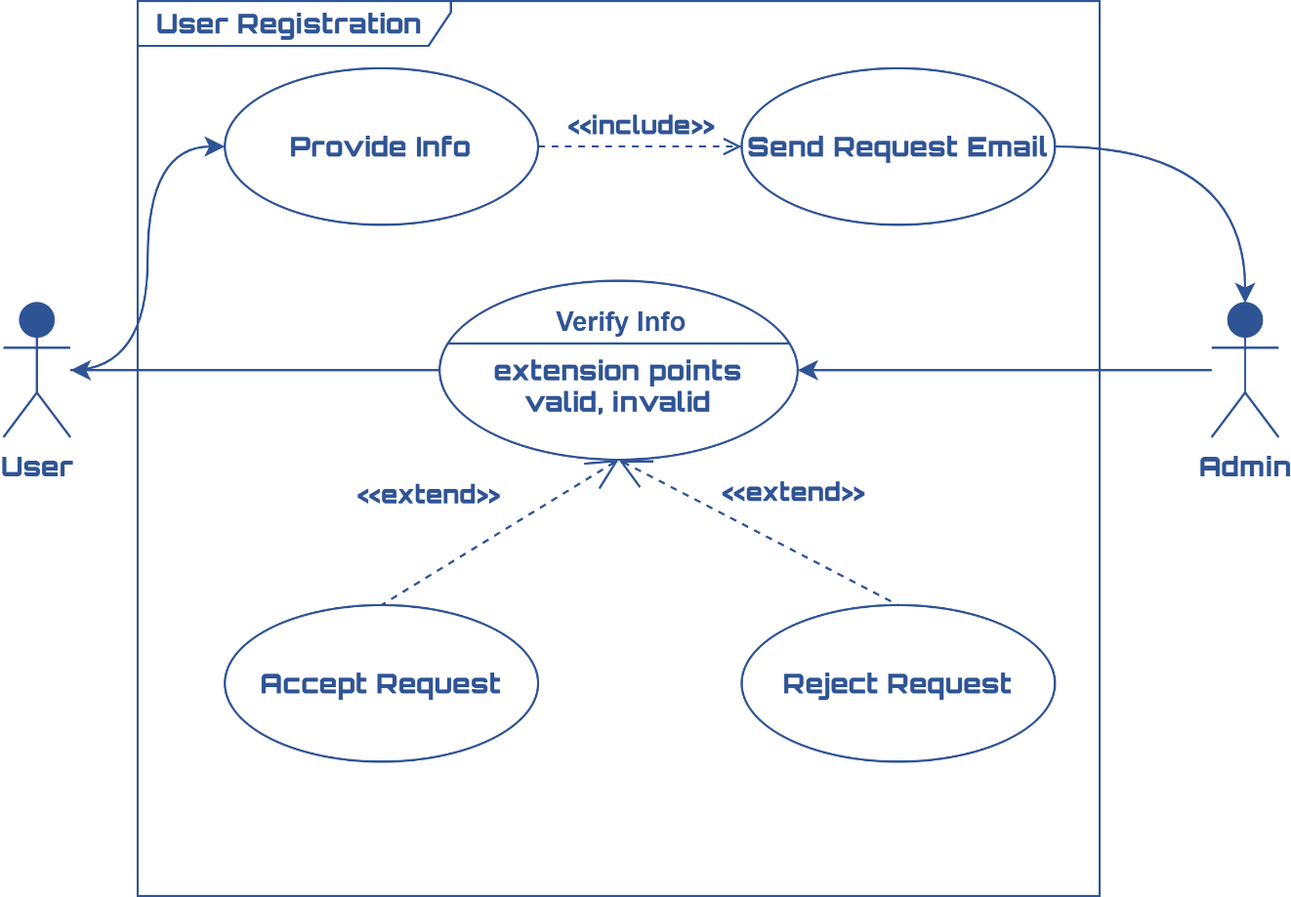

**Scenario:** Submit Request:

Given a user wants to create an account,

And the user does not have an account,

And the user provides the admin with Email

And full name

And civil ID

And company name

And Picture of himself

And Phone

And Address

And his type (freelancer or stakeholder)

When the user clicks the submit button

Then an email is sent to site admin informing him about the request.

**Scenario:** Accept Request

Given admin is on a request page

And the admin verifies the info

When the admin clicks the accept button

Then the account is created with an expired password

And an email is sent to the user.

**Scenario:** False info provided

Given admin is on a request page

And the info is invalid

When the admin clicks the reject button

Then the request is deleted and an email is sent to that user.

**Scenario:** Account disabling

Given the Admin in the admin panel

And the admin wants to disable an account for a reason (user temporarily unavailable, user breaks terms of use, etc.…)

When the Admin clicks the disable button on the user account

Then the account is disabled and the user can no longer log in.

* + 1. User Login

Each registered user must be able to login to access many site’s functionality.

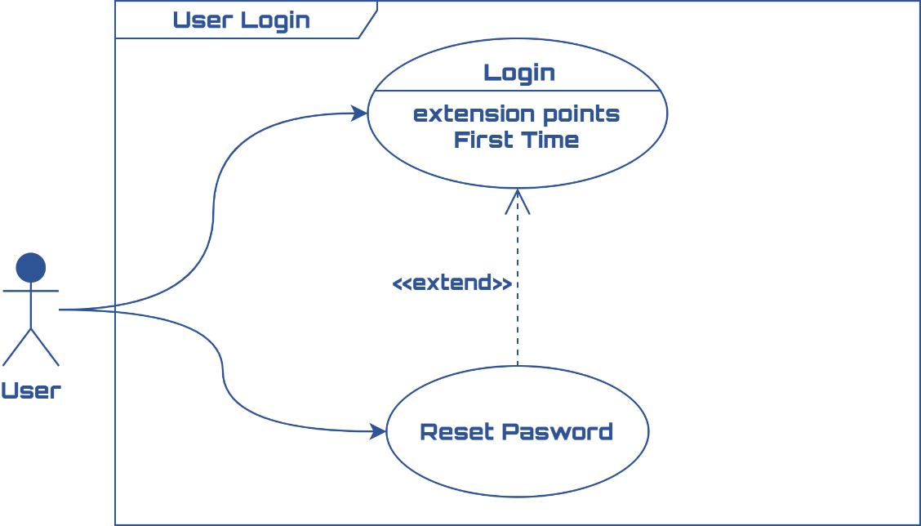

**Scenario:** First Login

Given the user is on the login page

And the user has an account

And the user never logged in

And the user enters email

And the user enters password

When the user clicks the submit button

Then the user receives password expired error and promoted to reset it.

**Scenario:** Normal Login:

Given the user is on the login page

And the user has an account

And the user enters email

And the user enters password

When the user clicks the submit button

Then the user gets logged in

And is redirected to the home page.

**Scenario:** Password Reset

Given the user is on the password reset page

And the user has an account

And the user forgot his password

And the user entered his email

When the user clicks the submit button

Then the user should receive an email link containing a one-time link to set his password.

* + 1. Set Freelancer Resume Details

Freelancer must be able to set his resume details like skills, availability and other important details that will affect how he will interact with the site.

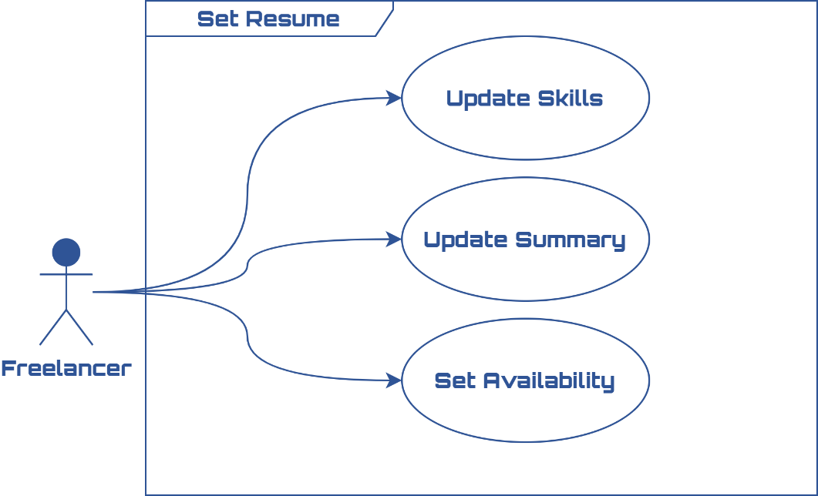

**Scenario:** Successful Update

Given the user is logged in,

And the user is a freelancer,

And the user is on the My Resume Page

And the user sets his skills

And the user sets his summary

And the user sets his availability

When the user clicks the update button

Then his new info is saved.

**NOTE:** freelancer availability means that he won’t be seen when a stakeholder wants to hire him. The freelancer can still bid, and will continue to work on projects that is currently assigned to.

* + 1. Bid on Project

All freelancers and teams must be able to bid on an open project.

Stakeholders are informed by email when a new bid happens.

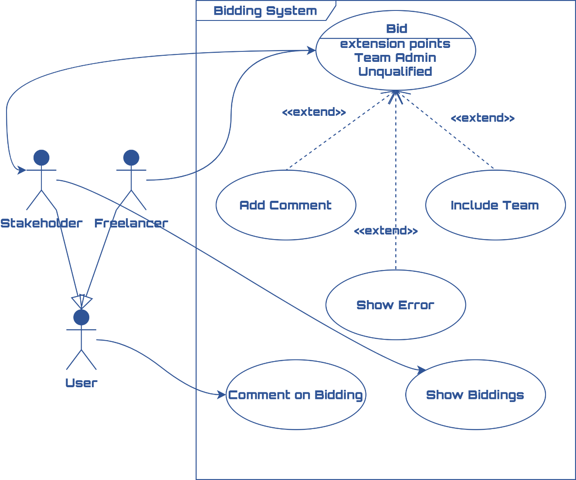

**Scenario:** Bid on Project

Given the user is a logged in freelancer

And the user selects a project he would like to work on

And the user enters his price/fee

And the user enters a comment

When the user clicks the submit button

Then Project Bidders gets updated and the stakeholder gets informed by email that a new bid happened.

**Scenario:** Team Admin Bid on Project

Given the user is a logged in freelancer

And the user is an admin for at least a team

And the user selects a project he would like to work on

And the user enters his price/fee

And the user enters a comment

And the user selects who will work on the project (himself, or some team he manages)

When the user clicks the submit button

Then Project Bidders gets updated and the stakeholder gets informed by email that a new bid happened.

**Scenario:** Unqualified Freelancer

Give the user is logged in freelancer,

And the user selects a project he would like to work on

And the user enters his price/fee

And the user enters a comment

And the Project requirements are above the user level

When the user clicks the submit button

Then the user info gets rejected and an error message appears.

* + 1. Show Biddings

A stakeholder can see all biddings on his project if the project is open

**Scenario:** Show biddings

Given the stakeholder is on the project workers page

And the project is public

When the stakeholder clicks the show biddings button

Then a popup list of all bidders is shown

And the stakeholder can from it Propose the job or comment on the bidding.

* + 1. Comment on Bidding

Stakeholders And freelancers can negotiate with each other on the bidding page.

**Scenario:** Post Comment

Given a user is on the biddings page

And the selects a bidding

And the user types a comment

When the user clicks the submit button

Then the comment is posted on that bidding.

* + 1. Freelancer Post Software

Freelancers must be able to sell software that the own/created on the site.

The freelancer is completely responsible for the correctness of the information.

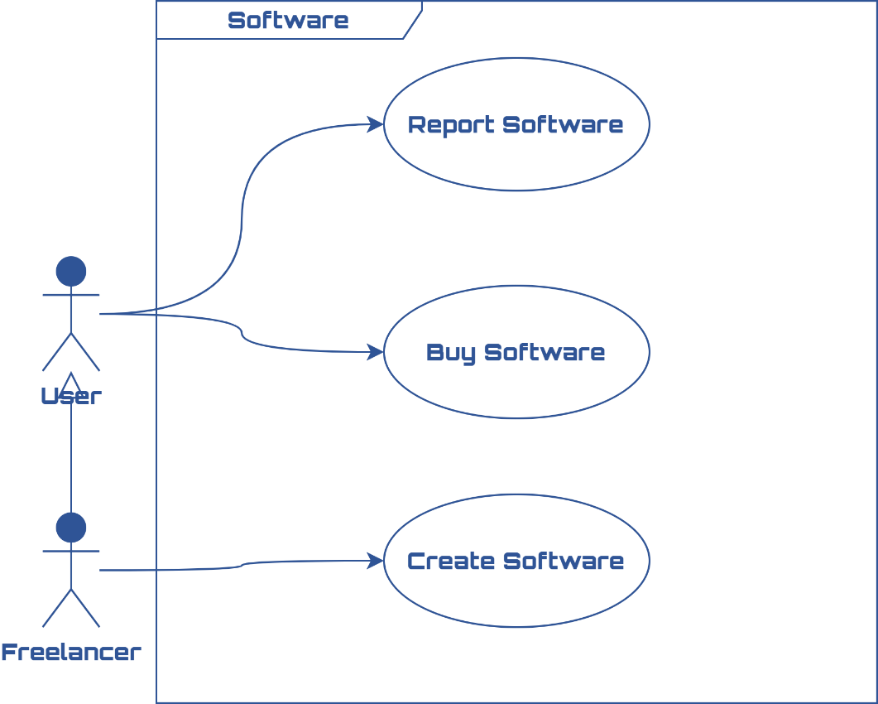

**Scenario:** Post Software

Given a freelancer wants to sell a software

And the freelancer filled the software info (name, type, price, description)

When the freelancer clicks the submit button

Then his software gets saved and is shown in the buy software page.

* + 1. Report Software

**Scenario:** Report Software

Given a user on the buy software page

And the user sees a project that breaks the terms of use

When the user clicks the report button

Then an email is sent to the admin to verify the report.

* + 1. Create Team

Freelancers can create and join teams so they can work together and be rated as a whole.

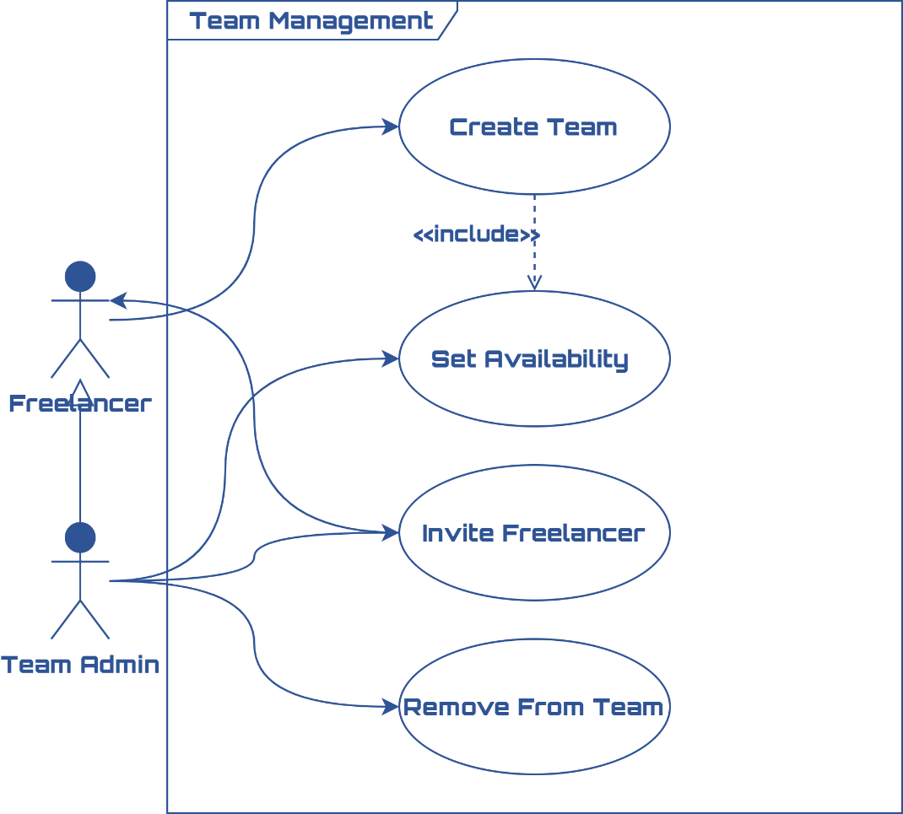

**Scenario:** Create team

Given a freelancer is on the create team page

And the freelancer enters (team name, logo, details)

When the freelancer clicks the submit button

Then a new team is created and is unavailable by default

* + 1. Set Team Availability

Just as a single freelancer can be marked Active or not so stakeholders can see him when they want to hire, teams also can have that.

**NOTE:** even if a freelancer marks himself as unavailable, if he belongs to an active team that team availability will not be affected.

**Scenario:** Mark team as available

Given a team admin is on the team settings page

And the admin wants to make the team available for hire

When the admin clicks the make available button

Then the team will be available for hire by stakeholders.

**Scenario:** Mark team as unavailable

Given a team admin is on the team settings page

And the admin wants to make the team unavailable for hire

When the admin clicks the make unavailable button

Then the team will be unavailable for hire by stakeholders

* + 1. Invite Freelancer to Team

Team admin can invite other freelancers to join the team

**Scenario:** Invite freelancer

Given a **Team Admin** is on the team members page

And the admin wants to invite another freelancer

And the admin entered the freelancer’s email address/name that he wants to invite

When the admin clicks the send invitation button

Then an email and a message are sent to that freelancer with a link to the team page.

* + 1. Remove Freelancer from Team

Team admin must be able to remove any other member from the team.

**Scenario:** Remove freelancer from team

Given a team admin is on the team members page

When the team admin clicks the remove button on a member

Then that team member is removed from the team.

* + 1. Send Message

Any user can send a message to any other user. Messages will be sent via the website messaging system and the user can optionally enable email notifications.

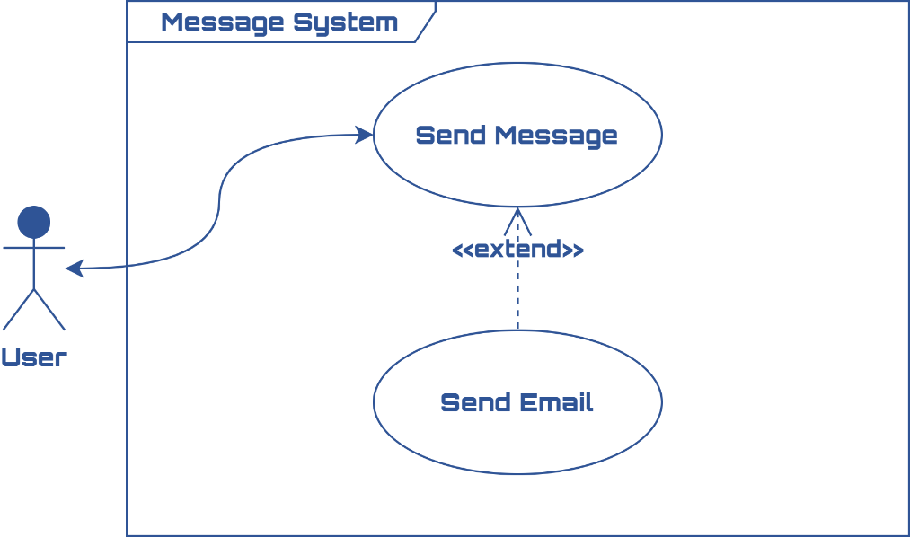

**Scenario:** Send message

Given a user is on the messenger page

And the user selects another user to send a message to

And the user types the message

When the user clicks the send button

Then the message gets saved and appears in the other user messenger

And an email is sent to that user if he has the ‘email message notifications’ checkbox enabled in his account settings.

* + 1. Post in Forums

Users can go to the forums and must be able to post a question

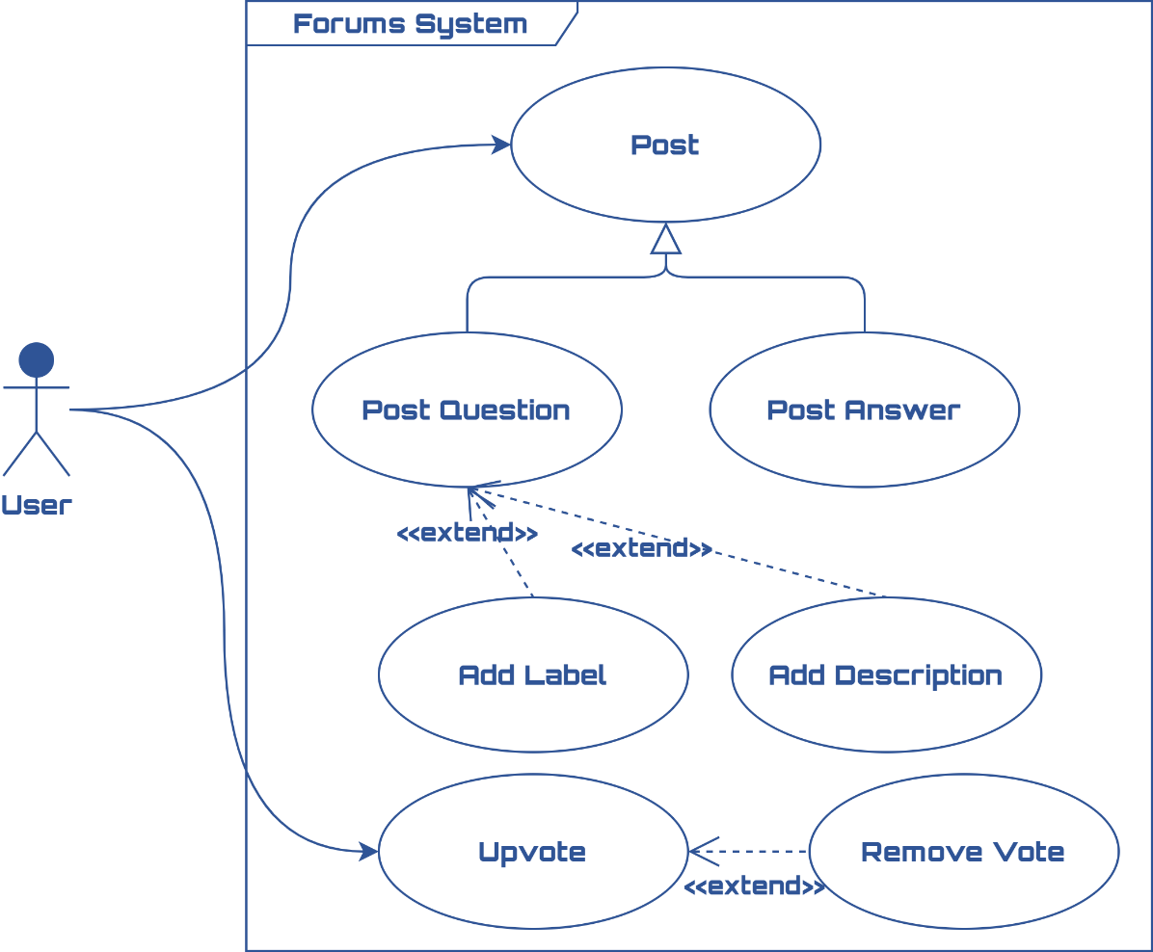

**Scenario:** Post Question

Given a user is on the post question page

And the user types a question

And the user types the description

And the user adds labels

When the user clicks the post button

Then the post is saved and is available for other user to upvote/answer.

**Scenario:** Post Answer

Given a user is on a specific post page

And the user types a comment/answer

When the user clicks the post button

Then the comment is available for other user to upvote/answer.

**Scenario:** Upvote

Given a user is on a specific post page

When the user clicks the upvote button (on question or answer)

Then the vote is saved and the author of the question/answer rating gets updated.

**Scenario:** Remove Vote

Given a user is on a specific post page

And the user upvoted a question or an answer

When the user clicks the upvote button on that same question/answer

Then the vote is removed and the author of the question/answer rating gets updated.

* + 1. Create Project

A stakeholder can post a project with two types of visibility:

* **Private:** The project won’t be available in the projects screen and no one ca see it was posted. The stakeholder needs to hire the freelancer/team.
* **Public:** Freelancers can see the project on the website and bid on it, the stakeholder can of course hire whomever he wants.

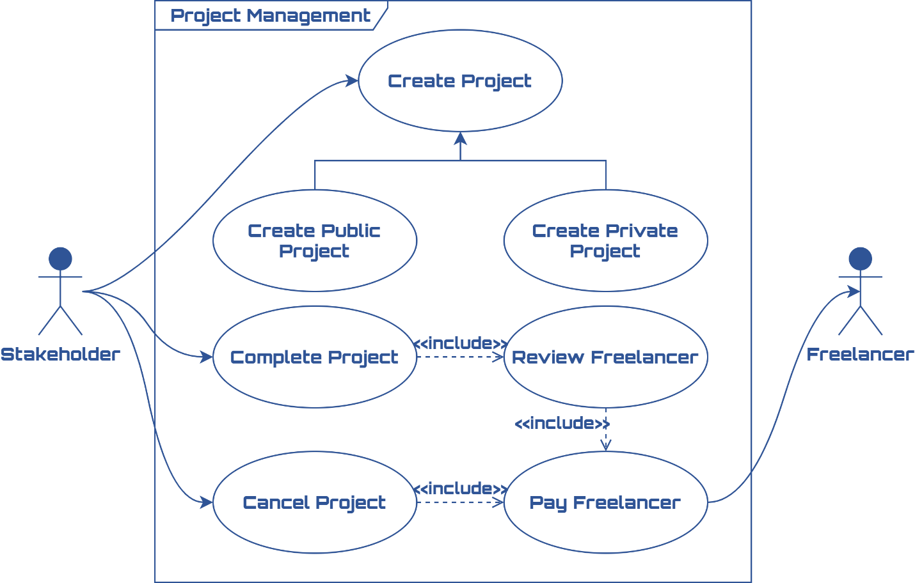

**Scenario:** Create Public Project

Given that the stakeholder on the create new project page

And the stakeholder fills the following details (Project Name, description, labels, minimum qualification, preferred bid, duration)

And selects Payment schedule (hourly, one-time payment)

And the stakeholder sets the project public

When the stakeholder clicks the submit button

Then the project is posted and is available for freelancers to bid on it.

**Scenario:** Create private Project

Given that the stakeholder on the create new project page

And the stakeholder fills the following details (Project Name, description, labels, minimum qualification, preferred bid, duration)

And selects Payment schedule (hourly, one-time payment)

And the stakeholder sets the project private

When the stakeholder clicks the submit button

Then the project is saved and the stakeholder can start hire a freelancer or a team.

* + 1. Complete Project

Stakeholder can mark the project as completed once satisfied with the work. After that he needs to review the freelancers.

**Scenario:** Mark Project as complete

Given a stakeholder is one of his projects’ page

When the stakeholder clicks the complete button

Then a project is marked as completed

And the stakeholder is redirected to the review freelancer/team page.

* + 1. Cancel A Project

Stakeholder can cancel the project if they want however, the stakeholder must pay the freelancer/team for any work that they have done.

**Scenario:** Cancel Project

Given a stakeholder is one of his projects’ page

When the stakeholder clicks the cancel button

Then a project is canceled

And the stakeholder is asked to pay the freelancer/team the owed amount.

* + 1. Review Freelancer

Stakeholder must review freelancer/team after each project completed. Stakeholder can write an optional comment also.

**Scenario:** Review freelancer

Given that a stakeholder is on the freelancer review page

And the stakeholder rates the freelancer/team

And the stakeholder writes a comment

When the stakeholder clicks the review button

Then the freelancer/team experience is updated

And the stakeholder is asked to pay the freelancer/team the owed amount.

**NOTE:** The owed amount is the one both parties agreed on in the proposal.

* + 1. Propose a job

A stakeholder can hire a freelancer or a team to work on one of his projects.

However, after selecting the freelancer both must agree on the job and payment.

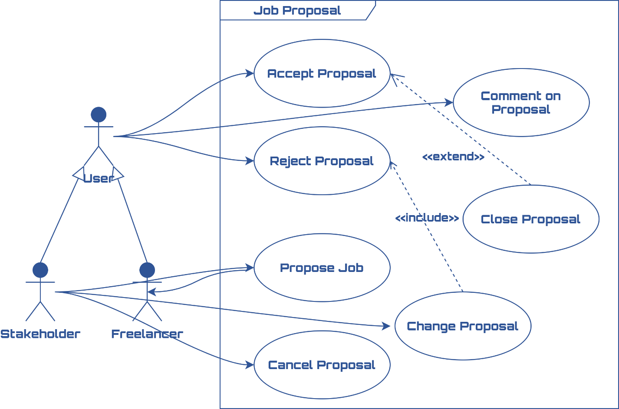

**Scenario:** Propose Job to freelancer

Given that the stakeholder is on the project workers page

And the stakeholder typed email or username of the team/freelancer he wants to hire

When the stakeholder clicks on the propose button

Then a request and an email are sent to that freelancer team

And a link to that request is given so freelancer can go to it and accept or reject it.

* + 1. Accept/Reject Proposal

Both stakeholder and freelancer must click accept the latest project agreement before the freelancer is assigned.

**Scenario:** Accept Proposal

Given that a user is on the proposal page

When the user clicks on accept proposal

Then a popup appears with the latest project agreement details

With confirmation button.

**Scenario:** Reject Proposal

Given a user is one the proposal page

And the user has accepted the proposal

And the other party didn’t accept the proposal yet

When the current user clicks on reject

Then the user is removed from the users which accepted the proposal and can accept it again.

**Scenario:** Cancel Proposal

Given a stakeholder is on the proposal page

And the proposal wasn’t accepted yet by both parties

When the stakeholder clicks the cancel button

Then the proposal is removed.

* + 1. Close Proposal

When both parties accept the proposal then the proposal is saved and closed.

Given the user is on the proposal page

And the user didn’t accept the proposal yet

And the other party did accept the proposal

When the current user clicks on accept

And Confirm

Then the proposal is accepted and is saved and can no longer be edited

And the freelancer/team can start working on the project.

**NOTE:** If the proposal is between a team and a stakeholder

Then only the team admin can access and accept the proposal.

* + 1. Change Proposal

When the stakeholder changes the proposal details then the proposal needs to be accepted again (even if one party accepted it before)

**NOTE:** That the comment does **NOT** affect the proposal details.

**Scenario:** Comment on proposal

Given a user is on the proposal page

And the user types a comment

When the user clicks the submit button

Then the comment is posted

And the proposal needs to be accepted again.

**Scenario:** Change Proposal

Given the stakeholder is on the proposal edit page

And the stakeholder edits the proposal details

When the stakeholder clicks on update button

Then the proposal is updated and needs to be accepted again.

* + 1. Create Task

Stakeholders can create tasks with due dates, priorities, labels and assign them to the member of the project.

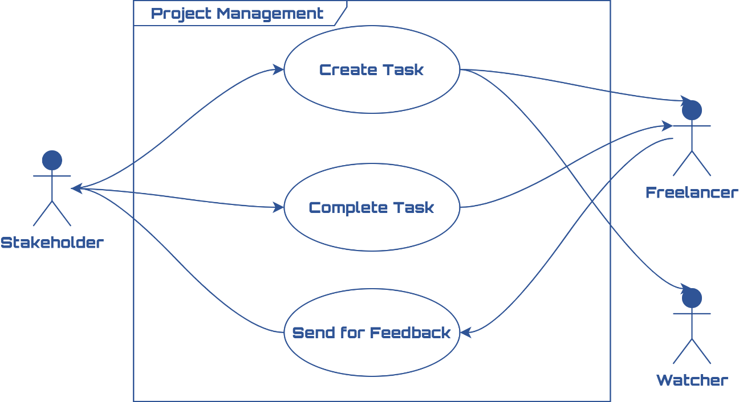

**Scenario:** Create Task

Given the stakeholder is on the new Task Page

And the stakeholder fills task Title

And Fills task description

And sets task priority

And sets task due date

And sets task status

When the stakeholder clicks the submit button

Then that task is created

And if the task is assigned to any member that member is informed by message and email

And if anyone watching the tasks they are also informed.

* + 1. Complete Task

Stakeholder can change the task status and mark it as complete once satisfied with the work.

**Scenario:** Mark Task as complete with one member working on it

Given the stakeholder is one a project tasks page

And the stakeholder selects a task

When the stakeholder changes the status to complete

Then the task is marked as complete and saved

And the freelancer that worked on that task gets a point for completing the task.

**Scenario:** Mark Task as complete with several members working on it

Given the stakeholder is one a project tasks page

And the stakeholder selects a task

When the stakeholder changes the status to complete

Then the task is marked as complete and saved

And **only** the last freelancer that worked on task (the one currently assigned) gets a point for completing the task.

* + 1. Send Task for Feedback

Freelancer can **only** change the task status to feedback, the freelancer can’t mark it as done or change the assignee only the stakeholder/pm can do that.

**Scenario:** Send task for feedback

Given the freelancer is one a project tasks page

And the freelancer selects a task

When the freelancer changes the status to feedback

Then the task is marked as freelancer and saved

And the stakeholder is informed to by message and email to check that task.

1. The End