*Android Project Report on*

Calculator.apk

Ayush Mangukia

– 191IT211

Bhuvaneswar Dharmasivam

– 191IT107

Mohammed Ibrahim

– 191IT230

*Date of Submission: 14 June 2020*

in partial fulfillment for the award of the degree of

**Bachelor of Technology**

In

**Information Technology**

At



**Department of Information Technology**

**National Institute of Technology Karnataka, Surathkal**

**June 2020**

**Department of Information Technology, NITK Surathkal Android Project**

**Final Semester Evaluation Report (June 2020)**

**Course Code:** IT150

**Course Title:** Object Oriented Programming

**Project Title: Calculator.apk**

**Project Group:**

Name of the Student Register No.

Ayush Mangukia 191IT211

Bhuvaneswar Dharmasivam 191IT107

Mohammed Ibrahim 191IT230

Place: NITK Surathkal

Date: 11/06/2020

**Contents**

1. **I****ntroduction 1**
2. Work Done 15
3. Results and Discussion 18
4. Conclusion and Future work 21

# Introduction

Android is an operating system and programming platform developed by Google for mobile phones and other mobile devices, such as tablets. It can run on many different devices from many different manufacturers. Android includes a software development kit (SDK) that helps you write original code and assemble software modules to create apps for Android users. Android also provides a marketplace to distribute apps. Altogether, Android represents an ecosystem for mobile apps.

As the world's most popular mobile platform, Android powers hundreds of millions of mobile devices in more than 190 countries around the world. It has the largest installed base of any mobile platform and is still growing fast. Every day another million users power up their Android-powered devices for the first time and start looking for apps, games, and other digital content.

**Calculator.apk** is an application developed on Android Studio with the skills gained through the android programming aspect of the course IT150. The application enables the user to run basic and scientific calculations through an input and output process. The students have gone over the top to add additional features with the help of good research into the subject of android programming.

**Key Features of the Project:**

The project has a history function which enables the user to refer to previous calculations.

The UI is very simplistic and user-friendly which helps boost the practicality of the application. The layout of the application is that of a linear type. This feature enables the smooth functioning of the program on all devices from mobile phones, laptops to tablets without drastic changes in the UI. The app can run in both portrait and landscape mode;

Coding concepts

Basic Java coding concepts of switch case, if-else statements, for loops, classes, objects, exception handling and user-defined functions coupled with features exclusive to android programming such as buttons, textview, layouts, and android functions have been implemented successfully in the aforementioned project.

Ability to run on all android versions from the cupcake to Android 10.

Well commented and simplistic code which enables anybody with a basic knowledge of android and object-oriented programming to understand the basic working and purpose of the code;

# 2 Work Done

The programming has included setting up the basic layout of the UI with the help of features such as buttons and textviews. The button features were further used to get the input from the user. To provide evidence of further work that was put in to improve on the skills attained through class, the background has been edited.

The code then had to be filled in to enable the application to just start and from there on logical code which allowed input output functionality was added.

We have then implemented code for several basic and scientific calculations which have been all mentioned below.

The code has also been well explained using comments.

The calculator has the following functions:

* sin ()
* cos ()
* tan ()
* square root
* exponential (e^x)
* log (base 10)
* ln (base e)
* power (x^y)
* factorial (x!)
* history
* delete
* addition (+)
* subtraction (-)
* multiplication (*)
* division (/)
* modulus (|x|)
* brackets
* clear

We use an external library named exp4j, which is an expression builder and executor. We import the Expression, ExpressionBuilder and Operator packages of the library.

We used the operator package of the library to implement our own Factorial function into the program.

We input the string from the user, and we pass it through the expression package of the library, and we get a float output, which is then displayed to the user.

The clear button erases the screen and is ready for a new input.

Meanwhile, on the side we record the calculations done by the user and pass it to the History activity and post it there. We do this using the startActivity function.

It also takes care of invalid cases, where we implement the try and catch module of Java exception handling with which we try to eliminate the chances of the app crashing.

# 3 Results and Discussion

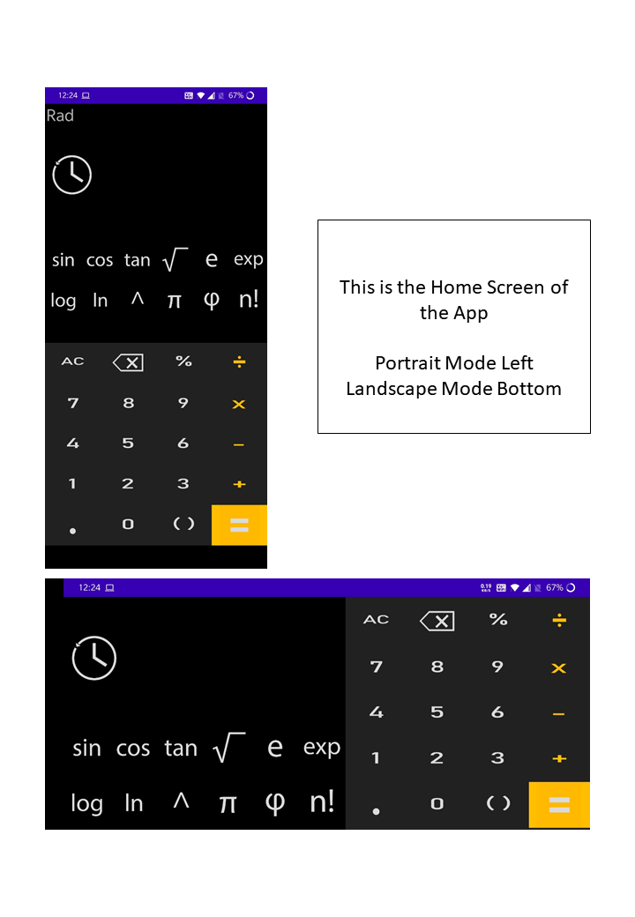

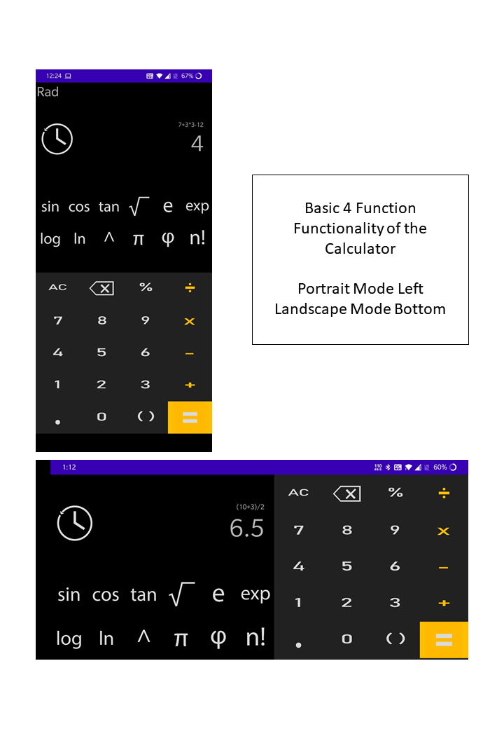

# Picture 31

# Picture 37Picture 36Picture 35

# Picture 39

# 4 Conclusion and Future work

In all honesty, the application developed is well capable of practical functionality. It is well thought of and equally well implemented. However, there is definitely scope of improvement. Several additional features could be included for a more complete application experience.

Some of which could include:

1. Customisable background and theme,
2. Enabling users to add in constants of their choosing,
3. Plotting and comparing graphs,
4. Equation solving;

The drawback of the app would definitely be its simplicity. However, this comes down to the lack of in depth knowledge in the subject, which will definitely be overcome by further analysis and research into the subject. Hopefully, in the future we will be well equipped to improve on the app by adding on the additional features mentioned above and more.

The program is in short a calculator like no other which helps you calculate even complex scientific expressions in no time. It is well designed, so that even the average man with no previous knowledge about android programming could use it as well.

To conclude, the application has a culmination of effort and talent which has spanned the course of this semester. It is one that we can proudly use with ease in our day to day lives with satisfactory results. It has made great use of the topics covered in the course of IT150 and we as programmers have ensured that it ticks off most if not all the boxes in question.

