Secure Web Development CS 3870

Assignment01 Catalog of Products

Christian Gasmund [gasmundc@uwplatt.edu](mailto:gasmundc@uwplatt.edu)

Dylan Brodie [brodied@uwplatt.edu](mailto:brodied@uwplatt.edu)

Abraham Aldaco

Christian Gasmund:

I used ChatGPT to generate the class information element at the bottom of the about page (about.html).

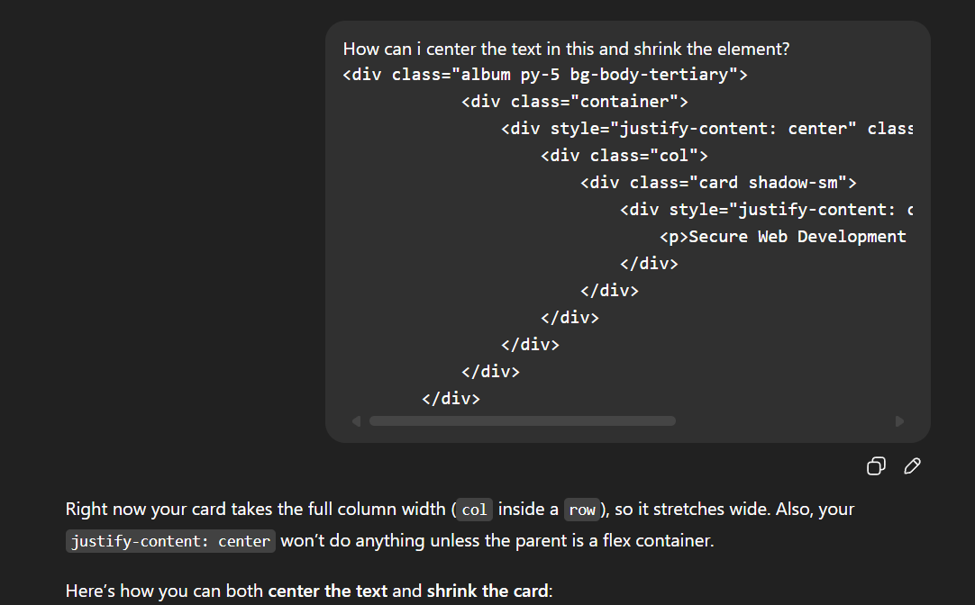

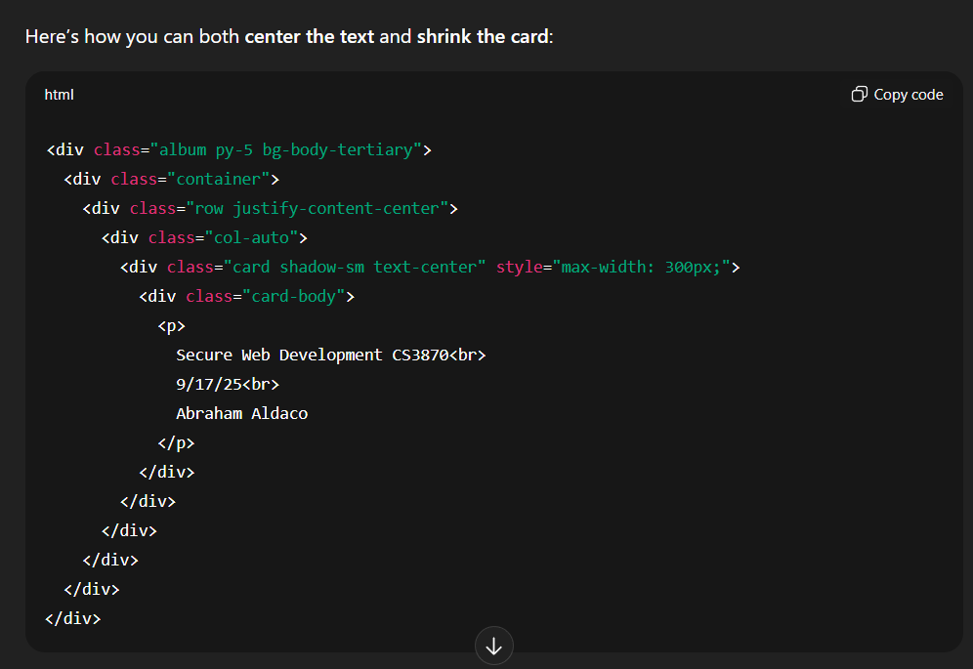

ChatGPT, accessed on 9/17/25