Feature doc: Lava Gun

IMPORTANT: Everything I have added is highlighted in green.

IMPORTANT: ~~Everything I have removed is slashed and written in red.~~

# IMPORTANT: Everything that is highlighted in yellow is basically TBDExecutive Summary –

## Goals:

* + The lava gun should be a utility weapon, aimed at hindering the opponent’s movement or line of sight.
  + The projectile should be hard to land, but it will stick to its landing spot which will zone the opponents.
  + The ammo is refillable through pickups.
  + Does tick damage.
  + A cartoon character in a red and black garment

    Description automatically generatedA group of black objects on a white surface

    Description automatically generatedThis is inspired by the goo gun in “The Invincible” movie.

## High Level Summary:

* + No damage on impact but has minimal damage over time~~: its lethality ranges from mildly bothersome to a death warrant depending on the area hit (damage unchanged).~~
  + Will stick to any surface: on terrain, it will remain stuck and block line of sight temporarily before disappearing. ~~On a player, it stays indefinitely.~~
  + The projectile explodes on impact and becomes lava goo. It becomes a lava goo puddle if it explode on terrain, which blocks line of sight. If it explodes on a player, it coats him in goo and deal damage over time temporarily.
  + (precise the block LOS and windows stuff
  + ~~Players may remove a Lava projectile stuck to them by melee hitting them.~~
  + ~~The damage/hindrance a player suffers depends on the area the projectile is stuck in.~~

## ~~Legs = projectile bound the player to a small area around the player’s current position.~~

## ~~Body/arms = Projectile stuck, slowing the player (multiple projectiles stacks the slowing effect). If the player rolls, the same effect as above is applied.~~

## ~~Head = No penalty, but the projectile is now immovable (death assured). Only way to remove the projectile is by killing the owner of the projectile.~~

# Feature breakdown –

## Controls:

* + May only be pressed or shot if the player has ammo.
  + LMB shoots a projectile, one at a time at a rate of 1 RPS, need to be activated every single shot.

## Mechanics:

* + Sticks to enemy players as lava goo or on terrain. Destroy itself automatically after 5 sec ~~on terrain, or until melee hit on player (except if stuck on player’s head, then stays indefinitely).~~
  + Does tick damage the player (TTK: 15 seconds if the goo is refreshed constantly).
  + Give the player the ability to shoot the projectile. The projectile, if fired straight forward on a flat surface, should travel in an arc that starts straights and then slowly falls toward the ground, covering a distance of half the HUB arena room before touching the ground (Not sure about this, the reason is mainly for the player to be able to block LOS at the window in the HUB arena, still need to think about it **TBD**)
  + ~~If a player is hit on the upper body/arms, slows them by 25%, increase by 5% for each additional projectile stuck on the same player (max 4 projectile, 40% slow), if more projectile on the same player destroy previous one.~~
  + If the player is hit by a projectile it explodes into lava goo and cover the player. The player may also be covered if he rolls into lava goo. Lava goo coats the player and remains there for 5s, dealing damage every second and slowing down the player. This effectively zones the player from moving/rolling into the area where a lava goo puddle is located at.
  + Size of lava goo puddle: **TBD** (Probably something not too small that the player can evade it by chance, but also not too big for it to take a tremendous amount of effort to evade it or need to make a huge adjustment in pathing to go around. It needs to be enough just to make the player actively mind it’s position).
  + Being hit by a projectile and covered in goo this way slows the player down by 25%. If other projectile lands on the player, the lava goo coat timer on the player is refreshed, and the slow is increased by 5% (up to 40%). (Next part is TBD, not sure) Rolling into lava goo puddle always apply a 40% slow.

-> this part has been iterated and did not feel slow enough, so the initial slow has been increased to 30%, and each additional projectile adds a 10% slow up to 60%.

* + ~~If a player is hit in the legs, create a tether between the player’s legs and the location the player is in contact with to the ground (player must be grounded, if he is airborne then the effect waits for him to be grounded to take effect).~~
  + Ammo is refillable on pickups. Add 6 ammo/projectiles when picked up. (Refer to pickups Feature Doc)
  + Reload between shots automatically, part of the firing mechanism (Shot by Shot weapon like Doom mega shotgun: <https://youtu.be/HIz0zGZyJcQ?t=282> ).
  + Has a curved trajectory, the projectile falls off quite rapidly (medium range TBD).
  + TBD, Not sure about this -> The melee hit (the knife strike) can send back a projectile toward the player’s cursor if it is struck in midair, a bit like a ghast projectile in Minecraft: <https://www.youtube.com/shorts/Etac830h5OM>

## Visuals:

* + Large, like a basketball
  + Made of lava, gooey.
  + Lava goo puddle is made of the same material (with lighter color if possible to make puddle more visible),has a simple spherical messy puddle shape.
  + Blocks line of sight (opaque)
  + Every player mesh needs to have a version which can be coated by the same material as the Lava goo, either by directly modifying the mesh, or by adding a layer above it.

## Sound Effects:

* + Sounds like an air-pumped spherical object being shot.
  + Makes “Wobbly, slimy” noise.
  + Being hit by one of them makes a burning/hissing noise, same goes for rolling into a lava goo puddle.
  + Colliding with terrain makes a platter/sticky noise.

## Challenge & Connections:

* + ~~The tether between the player and the terrain might be tricky, depending on the terrain.~~
  + ~~Need to make sure that the melee hit destroys the projectile as this is a core part of this feature.~~

## Backstory:

* + The lava gun was made as a reminder that the powerful and imposing Volcano is first and foremost a “provider deity” for the crystal tribe, since it is within the formidable pressure inside his guts that are created the Clan’s precious Crystal. To this end, it was designed to provide utility to its user without overshadowing the power of the precious crystal gun. It stores lava into it’s wide air-chamber and simply launches it at high speed, however as some may know Lava is molten rocks, and as such is incredibly heavy and cannot be launched extremely far.

Flags:

* Many various and complex little rules. SOLUTION: Removed a lot of the small nitpicky interaction which didn’t serve (or added too little compared to their complexity).
* Inconsistent interactions. SOLUTION: Made it more consistent :D.
* Technically too hard compared to the desired goal, could be made simpler and better for less technical price & difficulty. SOLUTION: Linked to the first flag, removed all the complex little rules which also removed most of the technically complex aspect of the feature. Everything that was added to replace those little rules was made as “simple and stupid” as possible.
* Need to add a maximum bullet count :^).
* Stripped down the lethality of the utility, so the damage is not enough to encourage it’s usage: need to find a way to encourage it and make it more useful/deadlier/more useful (example: player coated in goo takes critical damage from gun shot)

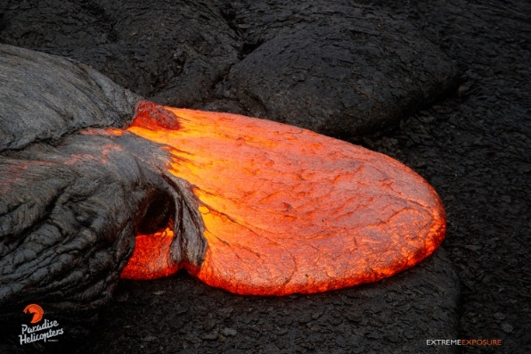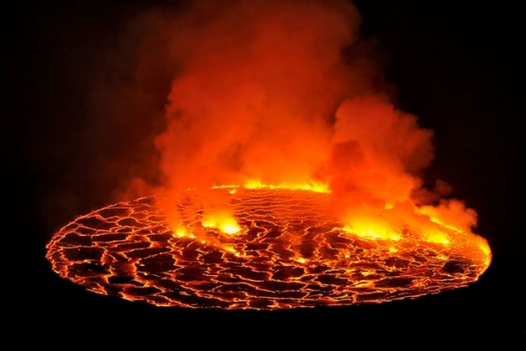

What the lava should look like. I like this image (the one on the left) a lot because the lava is clearly liquild since it is spilling and spreading, but it also looks extremely gooey and sticky. The material color should be inspired by this and slapped onto a sphere for the projectile, and the lava goo puddle should look like something like this but more spherical.

The next image (to the right)size and shape is too large, but it shows what I envisioned for the shape of the puddle. However the material and feeling of it is not what I am looking for.