

**Silesian University of Technology**

**Faculty of Automatic Control, Electronics and Computer Science**

Internet Technologies – project work

**Moody web**

Authors: Michał Kurek, Samir Abu Safieh

Year, semester, group, section: 2022, semester 5, group 6, section 9

### Project supervisor: M.Eng Oliwia Krauze

Gliwice, December 2022

Table of Content

1. Introduction 3

2. Aim and scope of the project 3

3. Schedule 3

3.1. Schedule approved at the begining 3

3.2. Schedule reflecting actual wok 3

4. Software and/or hardware implementation (correct section title) 3

4.1. Defining the problem 4

4.2. Analysis of possible solutions 4

4.3. The proposed solution 4

4.4. Implementation 4

4.5. Problems during application development 4

5. Summary 4

6. Literature 4

# Introduction

Moody web is a website application dedicated to control robotic arm model. IT project is combined with SM project. We want to include on our website sections like:

* Main site – with basic control panel of the robot and statistics.
* Login page – to give access only for admins and trusted people.
* About project page – site with information about project
* Developers page – site with brief information about us
* Stats and diagnostic page – site with basic statistics and diagnostics

Main purpose of website like we said is to control robotic arm through online website, with desktop resolution and mobile phone resolution. It means that we want to do responsive website. With basic control comes basic simulations, that’s why we also want to add them to visualize basic moves of robot. Additionally we want to implement database with basic move sequences and in future add new ones by user interface on MoodyWeb.

Communication with robot will be by ESP8266 wifi module integrated on Arduino, by today we don’t know how to communicate with the module.

Whole page will be hosted on Github pages and our work can be viewed live everyday. By checking repository: [TheKureq/UniversityProject_Website: This is a university project including website (github.com)](https://github.com/TheKureq/UniversityProject_Website) you can observe source code everyday.   
Link for hosted page: [UniversityProject (thekureq.github.io)](https://thekureq.github.io/UniversityProject_Website/)

**This part should contain approx. 1 page**.

# Aim and scope of the project – work in progress

Describe the aim and scope of the project and how the results may be used. Determine the requirements of the hardware or software needed for the project.

Exemplary stages of the project may include the following:

* Identification of the problem and formulation of assumptions.
* Analysis of possible solutions, along with selection criteria.
* Selection on the basis of established criteria and reasons for such solution.
* Implementation of the project.
* Start-up, verification and tests of the applications.
* Outline the possible directions of development of the project.
* Conclusions.

**This part should contain approx. 1-2 page**.

# Schedule

## Schedule approved at the beginning

**Week 3:**

* Learning the basics of website development (Html + Css)
* Github repository inicjalization

**Week 4:**

* Learning the basics of website development (Html + Css)
* Building basic structure of project website (navigation etc.)

**Week 5:**

* Learning the basics of website development (Html + Css + Php + Sql)
* Creating database and login system (Php)

**Week 6:**

* Learning the basics of website development (Js)
* Adding custom made graphics to the website
* Preparing animations and graphic design, basic vector objects

**Week 7:**

* Including responsive design for website

**Week 8:**

* Working on a simple robot controlling section (Js)
* Working with database, creating move sequences (optionally)

**Week 9:**

* Improving website appearance
* Providing wireless connection from website to board

**Week 10:**

* Checking everything and fixing mistakes
* Adding text content, photos for gallery etc.

**Week 11:**

* Improving website with additional functionalities (online hosting, privacy politics, ssl certificate, domain)
* Improving website with additional functionalities (sql database for move sequences, working with Arduino communication improvement, online host)

## Schedule reflecting actual wok

**Week 3: - as planed**

* Learning the basics of website development (Html + Css)
* Github repository inicjalization

**Week 4: - as planed**

* Learning the basics of website development (Html + Css)
* Building basic structure of project website (navigation etc.)

**Week 5: - as planed**

* Learning the basics of website development (Html + Css + Php + Sql)
* Creating database and login system (Php)

**Week 6: - not entirely as planed**

* Learning the basics of website development (Js)
* Adding custom made graphics to the website (task moved to next week)
* Preparing animations and graphic design, basic vector objects (task moved to next week)

# Software and/or hardware implementation (correct section title)

**WEEK 3:**

1. **Learning basic of website development (html + css + sass)**

At first we ware doing some courses on udemy including frontend part of website development. Where we have learned basics like building structure in html, styling site using css and sass, we prepared files for work, and basic variables like colors.

Figure 1: file structure and pices of code examples

Figure 2: learning basic animations

1. **Github / Git repository inicjalization**

Whole page is hosted on Github pages and our work can be viewed live everyday. By checking repository: [TheKureq/UniversityProject_Website: This is a university project including website (github.com)](https://github.com/TheKureq/UniversityProject_Website) you can observe source code everyday.   
Link for hosted page: [UniversityProject (thekureq.github.io)](https://thekureq.github.io/UniversityProject_Website/)

By learning git we can upload our files in around 10sec for repository by typing 3 commands in visual studio terminal:

Figure 3: terminal git comments to push changes to repository on Github

1. **Working with courses.**

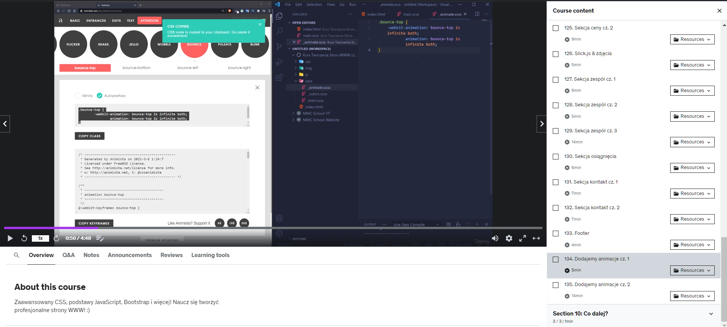

Figure 4: Doing couse on udemy - working with animations

**WEEK 4:**

1. **Constructing the basics structure of Moody Website.**

For the 2nd week we were planning to construct the website. And we did so. We created the files and basics of every subpage we want to implement in later work. Also we made our logo and the HOMEPAGE. We also styled it all out using Css. The whole process took a lot of time because of making everything symmetric and evened out. We created navigation and footer that will be used in every subpage. We implemented and created simple animations that are used for navigation section. Additionally we decided on website main design.

This week we also started to prepare for the next week since we will implement database to our website and we studied SQL and PHP in hope that everything will go smoothly next week.

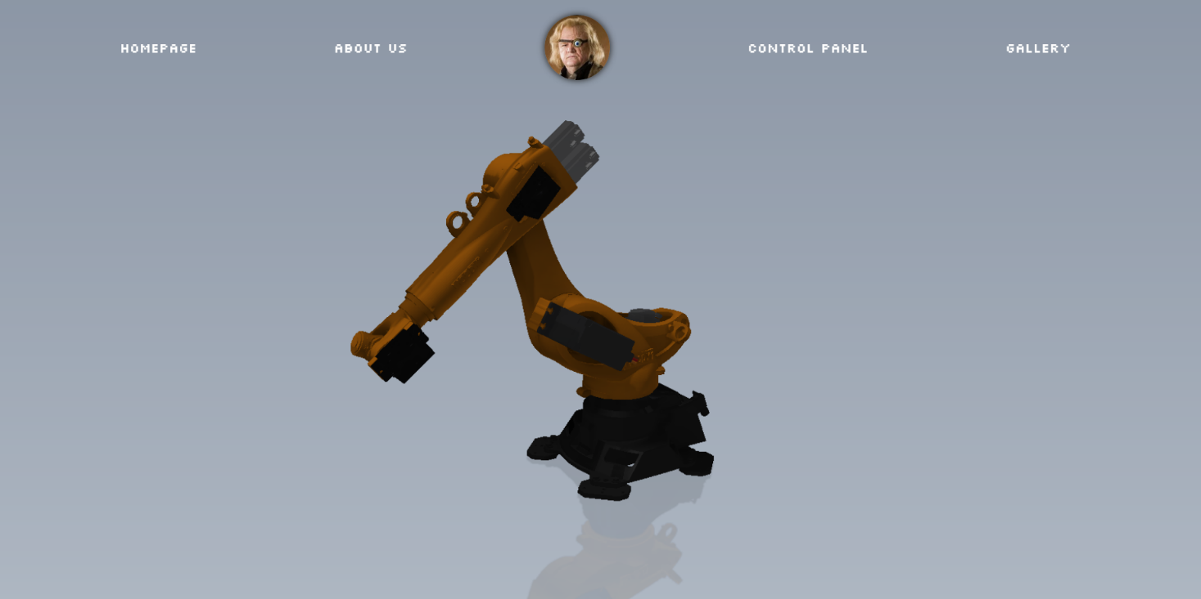

Figure 5: First version of Moody Website

**WEEK 5:**

1. **Constructing simple Login menu to access Control Panel**

For the 3rd we were planning to construct a SQL database to connect with our website for Log In function. We did that and additionally we made some design features to show that we are eather logged in or logged out. Whole function was made in PHP language. We constructed very small database with just one LOGIN informations since we only want the designers to control the robot.

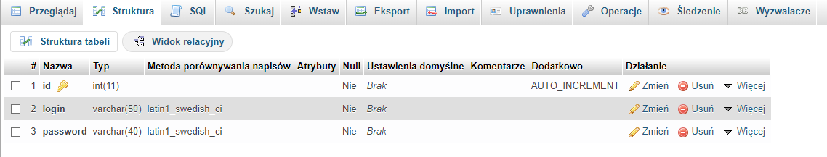

Figure 6: SQL database

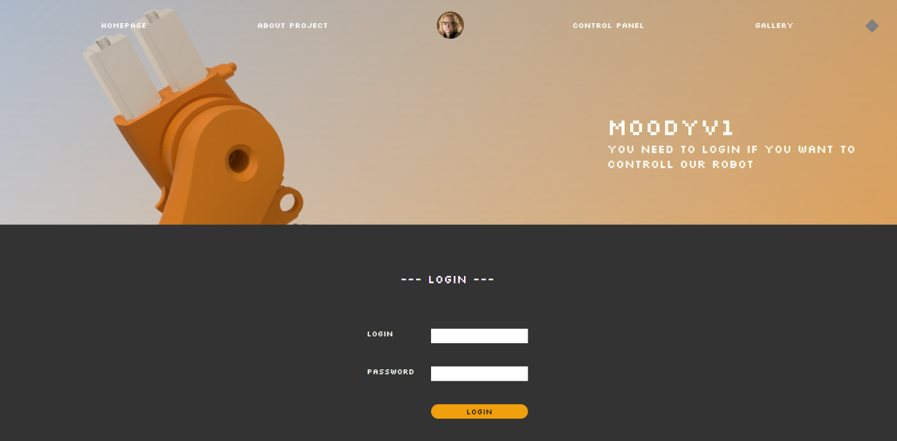

Figure 7: Login panel

Unfortunately we run into some problems with Github hosting. It just wasn’t working there and we will have to do everything on a localhost and maybe in the future we will make our website work on a normal hosting that we rent for free.

1. **Changing the website**

Since we had some additional days and also a free week this time we change our website design completely. We added simple JS script and also a contact section in the bottom of a website. We made everything look more “clean”.

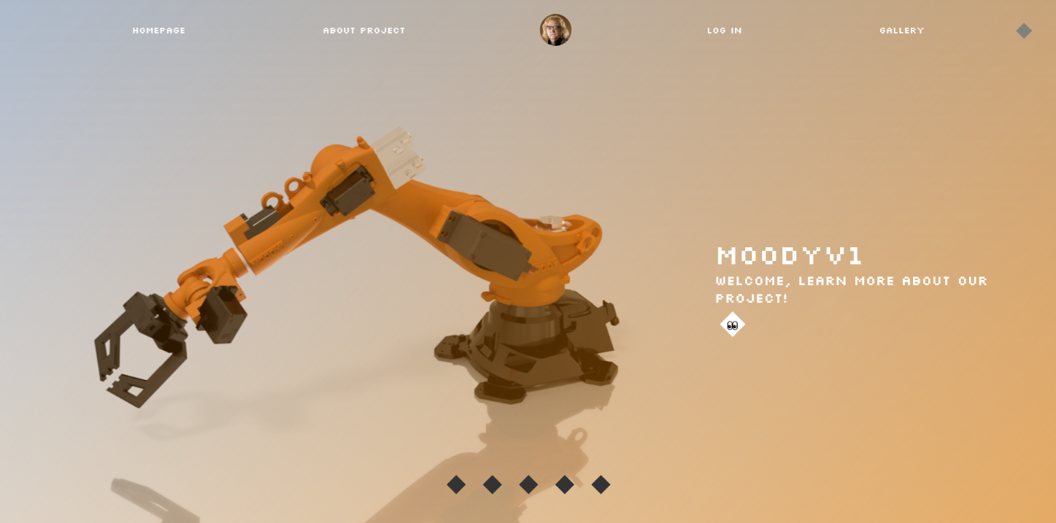

Figure 8: Second version of Moodie Website

1. **Working with github**

Additionally we are learning some git functions and version control skills. We added some branches with different versions of website. This specific feature can provide us a possibility to work independently on different features / subpages in the same time and at the end of the day merge those branches. That way of working together definitely speed up working together. Like we said above we still have to learn how to do sql and php working on github pages host.

**Week 6:**

**1. learning basic JavaScript**

Basically at the beginning we have to learn JavaScript. We started with beginner course on youtube and udemy. We have learn basic functions, eventlisteners, query selectors etc.

**2. Implementing basic JavaScript components**

We add components like carusel on a main page. To make it working correctly, we have to download and include jQuerry library.

Figure 8: Carusel on a main page working on slick library

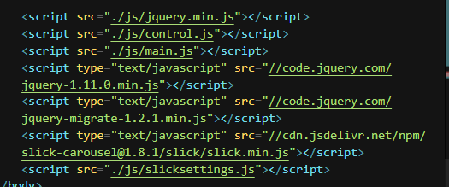

Figure 9: Implementing js files and libraries

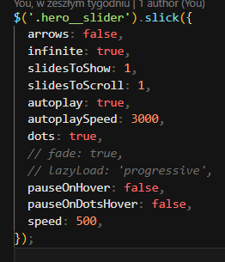

Figure 10: Slick settings for carusel

**Including mobile navigation, opening and closing it thanks to JavaScript:**

Thanks to js code in main.js we have managed to shows and hides new mobile navigation and animate it, add new classes and implement advanced animations on hovers.



Figure 11: Hamburger icon with click listener coded is JS

Figure 12: Js main code to shows and hides mabile navigation

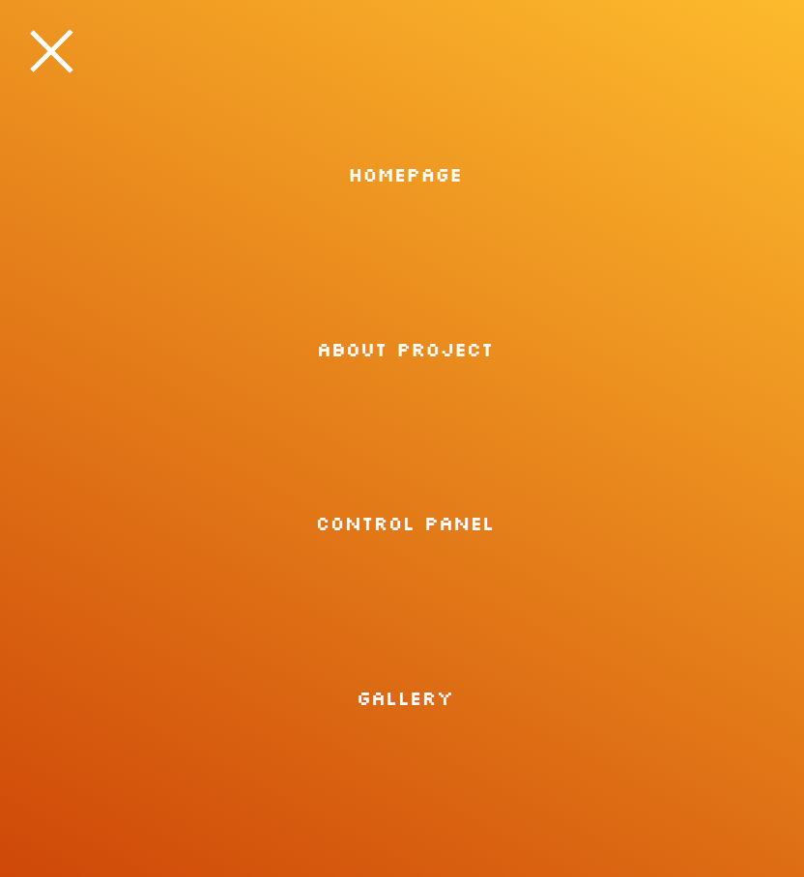

Figure 1: mobile navigation

# Summary - work in progress

The last point should describe what have been done, or what part of the assumptions was not carried out and why, what can be added / changed to improve the project and in which direction it can be further developed.

# Literature - work in progress

It is required to reference the used literature/other sources of information, e.g. like this [1]. If anywhere were adopted drawings, texts, part of the program code, you must put this information in the list of references, and use a link in the text pointing to a position in the given literature [2].

1. Last name, first name, title, publisher, year of publication.
2. Website URL, with the date of download.

**Note 1:** The titles of the sections are only exemplary - do not adopt them literally!

**Note 2: Full program code with possible database content, other supporting files and a description of the installation and requirements for the installation have to be delivered in an electronic form, together with the electronic version of this report! Provided software and given description should enable a test installation of the project. If the software and/or related environment are not standard, and it can make difficulties to test the project, then it should be clearly described and justified!**