

Silesian University of Technology
Faculty of Automatic Control, Electronics and Computer Science

Internet Technologies – project work

Moody web

Authors: Michał Kurek, Samir Abu Safieh
Year, semester, group, section: 2022, semester 5, group 6, section 9

Project supervisor: M.Eng Oliwia Krauze

Gliwice, December 2022

Table of Content
1. Introduction 3
2. Aim and scope of the project 3
3. Schedule 3
3.1. Schedule approved at the begining 3
3.2. Schedule reflecting actual wok 3
4. Software and/or hardware implementation (correct section title) 3
4.1. Defining the problem 4
4.2. Analysis of possible solutions 4
4.3. The proposed solution 4
4.4. Implementation 4
4.5. Problems during application development 4
5. Summary 4
6. Literature 4

- Introduction
Moody web is a website application dedicated to control robotic arm model. IT project is combined with SM project. We want to include on our website sections like:
- Main site – with basic control panel of the robot and statistics.
- Login page – to give access only for admins and trusted people.
- About project page – site with information about project
- Developers page – site with brief information about us
- Stats and diagnostic page – site with basic statistics and diagnostics

Main purpose of website like we said is to control robotic arm through online website, with desktop resolution and mobile phone resolution. It means that we want to do responsive website. With basic control comes basic simulations, that’s why we also want to add them to visualize basic moves of robot. Additionally we want to implement database with basic move sequences and in future add new ones by user interface on MoodyWeb.

Communication with robot will be by ESP8266 wifi module integrated on Arduino.

Whole page will be hosted on Github pages and our work can be viewed live everyday. By checking repository: TheKureq/UniversityProject_Website: This is a university project including website (github.com) you can observe source code everyday.
Link for hosted page: UniversityProject (thekureq.github.io)

This part should contain approx. 1 page.
- Aim and scope of the project – work in progress
Describe the aim and scope of the project and how the results may be used. Determine the requirements of the hardware or software needed for the project.

Exemplary stages of the project may include the following:
- Identification of the problem and formulation of assumptions.
- Analysis of possible solutions, along with selection criteria.
- Selection on the basis of established criteria and reasons for such solution.
- Implementation of the project.
- Start-up, verification and tests of the applications.
- Outline the possible directions of development of the project.
- Conclusions.

This part should contain approx. 1-2 page.

- Schedule
  - Schedule approved at the beginning
Week 1:
- Learning the basics of website development (Html + Css)
- Github repository inicjalization
Week 2:
- Learning the basics of website development (Html + Css)
- Building basic structure of project website (navigation etc.)
Week 3:
- Learning the basics of website development (Html + Css + Php + Sql)
- Creating database and login system (Php)
Week 4:
- Learning the basics of website development (Js)
- Adding custom made graphics to the website
- Preparing animations and graphic design, basic vector objects
Week 5:
- Including responsive design for website
Week 6:
- Working on a simple robot controlling section (Js)
- Working with database, creating move sequences (optionally)
Week 7:
- Improving website appearance
- Providing wireless connection from website to board
Week 8:
- Checking everything and fixing mistakes
Week 9:
- Checking everything and fixing mistakes

  - Schedule reflecting actual wok
Week 1: - as planed
- Learning the basics of website development (Html + Css)
- Github repository inicjalization

- Software and/or hardware implementation (correct section title)
WEEK1:
- Learning basic of website development (html + css + sass)
At first we ware doing some courses on udemy including frontend part of website development. Where we have learned basics like building structure in html, styling site using css and sass, we prepared files for work, and basic variables like colors.
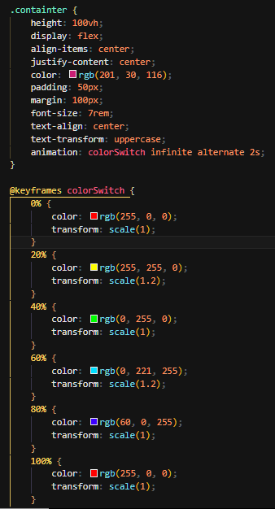

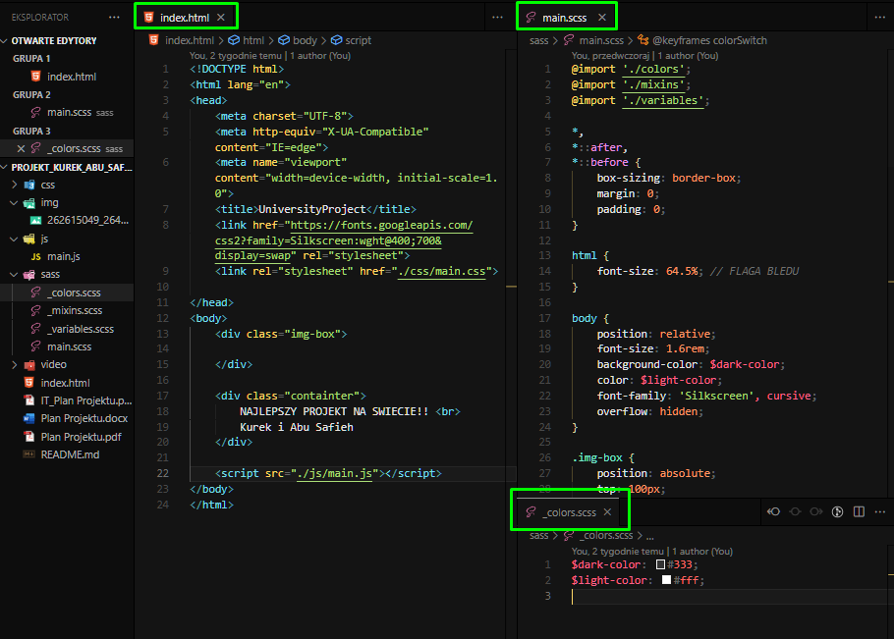

Figure 1: file structure and pices of code examples
Figure 2: learning basic animations

- Github / Git repository inicjalization
Whole page is hosted on Github pages and our work can be viewed live everyday. By checking repository: TheKureq/UniversityProject_Website: This is a university project including website (github.com) you can observe source code everyday.
Link for hosted page: UniversityProject (thekureq.github.io)

By learning git we can upload our files in around 10sec for repository by typing 3 commands in visual studio terminal:
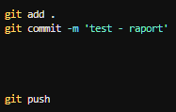
Figure 3: terminal git comments to push changes to repository on Github

- Working with courses

- Summary - work in progress
The last point should describe what have been done, or what part of the assumptions was not carried out and why, what can be added / changed to improve the project and in which direction it can be further developed.
- Literature - work in progress
It is required to reference the used literature/other sources of information, e.g. like this [1]. If anywhere were adopted drawings, texts, part of the program code, you must put this information in the list of references, and use a link in the text pointing to a position in the given literature [2].
- Last name, first name, title, publisher, year of publication.
- Website URL, with the date of download.

Note 1: The titles of the sections are only exemplary - do not adopt them literally!
Note 2: Full program code with possible database content, other supporting files and a description of the installation and requirements for the installation have to be delivered in an electronic form, together with the electronic version of this report! Provided software and given description should enable a test installation of the project. If the software and/or related environment are not standard, and it can make difficulties to test the project, then it should be clearly described and justified!

